**Manual of QPST Download Tool**

1. download the **QPST tools** from “tools.tar.bz2” and install it

2. Download the FOTA Build Images from below links

[FOTA-1-Build images](https://tcloud.smartron.com/app/storage/res/share/4NIKSUvPmqMTpB77F46Ir9/public)

[FOTA-2-Build images](https://tcloud.smartron.com/app/storage/res/share/2XG3bt0k4I189xShiuD4cz/public)

[FOTA-3-Build images](https://tcloud.smartron.com/app/storage/res/share/2R8wtm2fE0CzHB8tRzwoH1/public)

[FOTA-4-Build images](https://tcloud.smartron.com/app/storage/res/share/1e1BGQUl7Rp3ygJhZ86O9s/public)

[FOTA-5-Build images](https://smartron.cloud/rJjoDexlM)

[FOTA-6-Build images](https://smartron.cloud/HJUzddIx7) (SRT-Oreo fota update)

[T5524-Kernel OREO Source code](https://github.com/smartronscm/T5524-Kernel-Sourcecode) (uploaded the T5524 kernel oreo source code to git hub, commit-id: (bdb3f17ef21765eb8ce5b8a65fbca4e29eb3))

[Open QFIL from Start Menu like this:](https://smartron.cloud/rJjoDexlM) **Start-> QPST -> QFIL.**

**2. Software Download by using QFIL**

2.1 Run QFIL. If the phone is connected, the port will recognized automatically. If not, click the button s**elect Port”**.

Note : If userbuild is there in device then port will not be detected,get the device in edl(emergency downloader) mode.by using below command then USB port will be detected.

>>adb shell

>>reboot edl

**>>**press Power button + vol up + vol down key together till device vibrate.then connect device to PC .

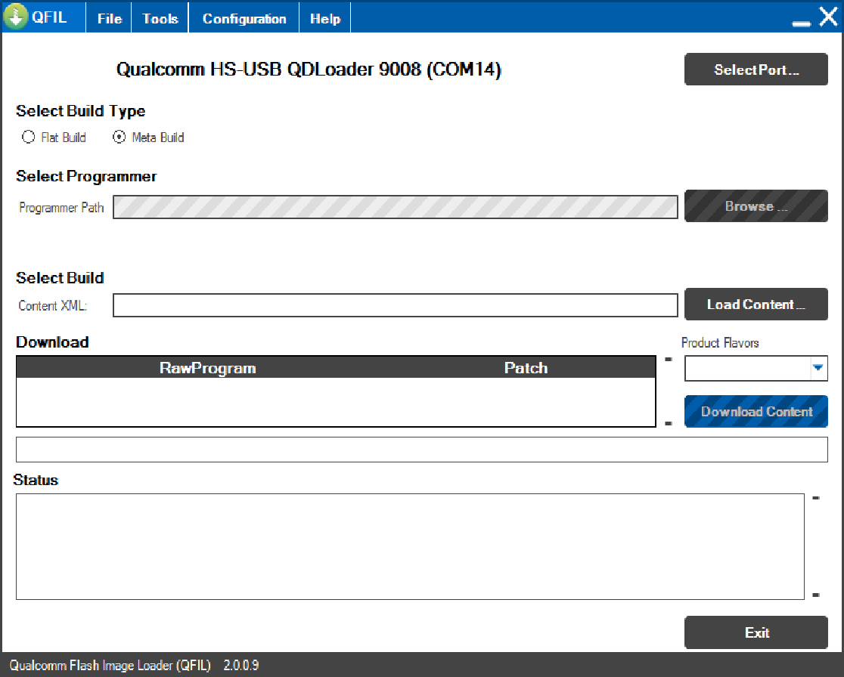

**PORT Selection**

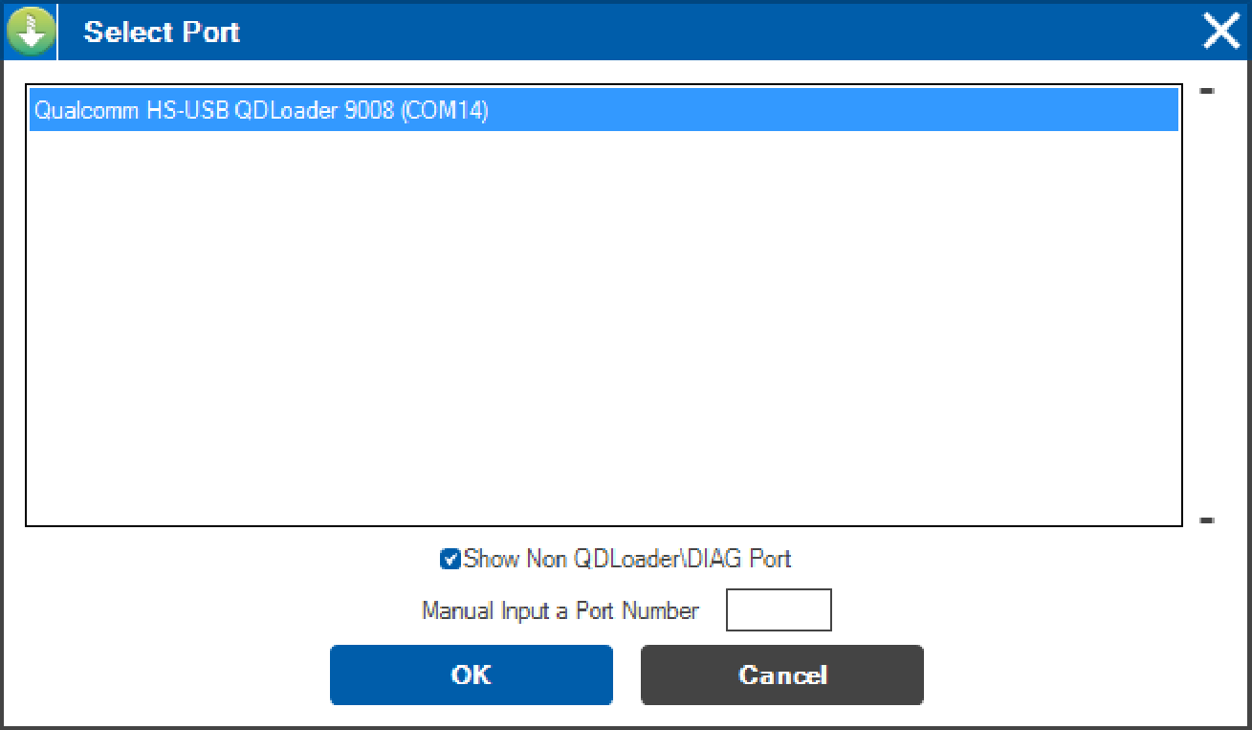

2.2 If any another programs except QFIL, the software will prompt you to close them. We suggest that you click the button **Configuration”** and select the option **reset After Download”**.

Select the option **Flat build** in **select build type”**.

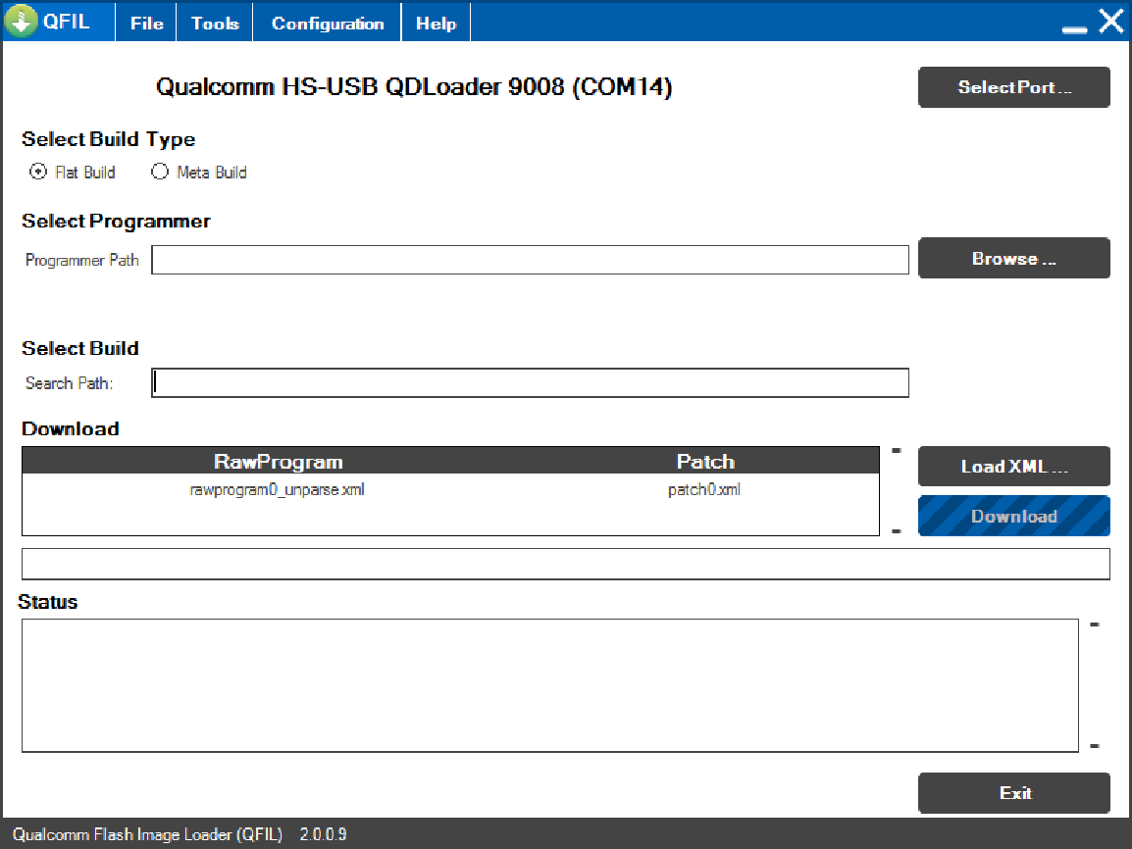

Click the button Browser beside **select Programmer”** and choose the file **prog_emmc_firehose_8976_ddr.mbn** in the phone software folder, and Search Path will be filled automatically.

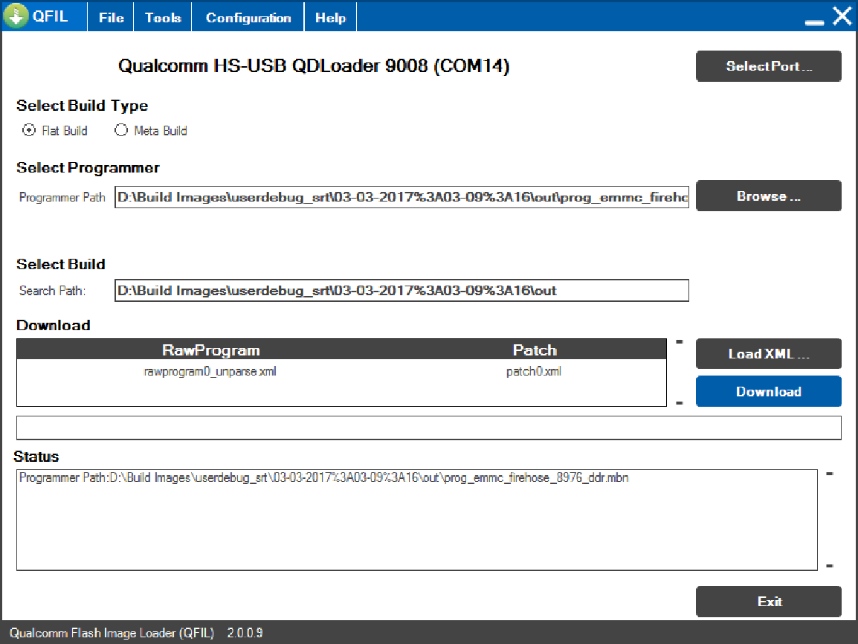

2.4 Click the button **Load XML”**, the dialog box will pop up twice to let you select the **rawprogram0_unparse** and **patch0.xml.**

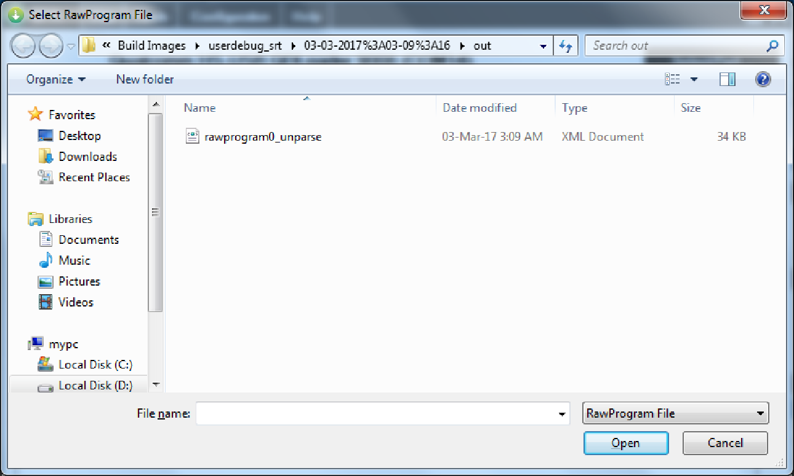

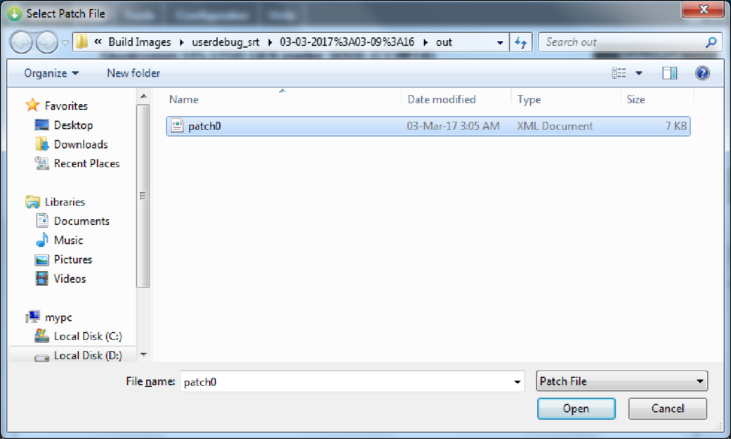

2.5 Finally, click the button **Download”**. Then the progress bar will be visible, and downloading begins.

2.6 Downloading finished as follows. (**Pay attention to the textbox Status**)

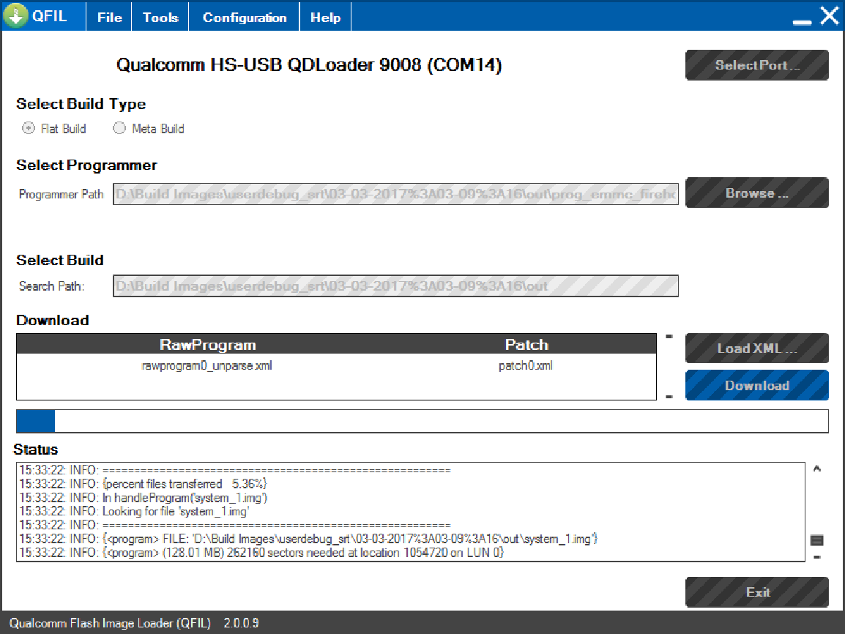

**Download Success**

