A Project Report On

# COLLEGEWEBSITE

submitted in partial fulfillment of the requirements for the Award of Degree of

**BACHELOR OF TECHNOLOGY**

in

COMPUTER SCIENCE ENGINEERING

By

**AMAN PATEL (2004500100008)**

Under the supervision of

## Mr. Sachin Raj Saxena

(Assistant Professor)



Department Of Computer Science And Engineering SHRI RAM MURTI . SMARAK COL EGE OF ENGINEERING & TECHNOLOGY

Acknowledgement

I would like to thank SRMS CET&R for giving the platform to show my project.

I also want to thank Dr. Ritu Singh ma’am (Principle) for the constant support. I

would like to thank my project mentor Ankur Kumar (Assistant Professor) Sir for

his constant support and solving all my project queries management and

professional skills have greatly inspired me and taught me the basics of

management and leadership. I will strive to use gained skills and knowledge in

the best possible way, and I will continue to work on their improvement in order

to attain my desired career objective.

Aman Patel

(2000450010008)

# CONTENTS

* INTRODUCTION
* WORK ASSIGNED
* HARDWARE & SOFTWARE USED
* SOURCE CODE
* SCREENSHOTS
* CONCLUSION
* BIBLOGRAPHY



This is a web oriented application allows us to access the whole information about the college, staffs, students, facilities etc. This application provides a virtual tour of Campus. Here we will get the latest information about the students and staffs. This generic application designed for assisting the students of an institute regarding the information on the courses, subjects, classes, assignments, grades and timetable. It also provides the support that a faculty can also check about his daily schedule, can upload assignments, and notices to the students. Here administrator will manage the accounts of the student and faculties, makes the timetable, and upload the latest information about the campus.

HTML

Hypertext Markup Language is popularly known as HTML. It is the language that the web

browser understands. Every web developer should learn this language and it is the basic

language to start with. So now it might be clear to you, running HTML code you don’t

require installing any software. You can execute the HTML file in any of your internet

browsers. HTML is the common language that is understood by all the web browsers. which

is the most widely used language on Web to develop web pages. HTML was created by

Berners-Lee in late 1991 but "HTML 2.0" was the first standard HTML specification which

was published in 1995. HTML 4.01 was a major version of HTML and it was published in

late 1999. Though HTML 4.01 version is widely used but currently we are having HTML-5

version which is an extension to HTML 4.01, and this version was published in 2012.

. HTML DOCUMENT:

<!DOCTYPE html>

<html>

<head>

<title>Page Title</title>

</head>

<body>

<h1>My First Heading</h1>

<p>My first paragraph.</p>

</body>

</html>

• EXPLAINATION:

• The <!DOCTYPE html> declaration defines that this document is an HTML5

document.

• The <html> element is the root element of an HTML page.

• The <head> element contains meta information about the HTML page.

• The <title> element specifies a title for the HTML page (which is shown in the

browser's title bar or in the page's tab).

• The <body> element defines the document's body, and is a container for all the visible

contents, such as headings, paragraphs, images, hyperlinks, tables, lists, et



**We assigned a work on the HTML technology and by support of this technology we had prepared a website named College Website.**

**We have given various option to this site so that it may be beneficial and easy to the user to access the site. First of all, student have to register itself and get username and password. Only users who are authorized register can access their results . We had given upload facility so that it provides benefits to organization for uploading the Events. Eventswill be uploaded through the administrator according to type(student requirement) demand.**

**There is also a option for feedback. Users can create query as per their requirement. For these they have to give some information like email id through which we can contact them and give quick response.**



This software entitled SCHOOL RESULTS has been developed on the following configurations:

* Hardware Used
  + intel CORE i5, 3 GHz. Micro Processor ❑ 500 GB Solid State Drive.
  + 8 GB RAM.
  + 17-Inch Color Monitor.
* **Software Used**
  + - VISUAL STUDIO CODE
    - ADOBE PHOTOSHOP
    - GOOGLE CHROME
    - NOTEPAD

## ➢ Operating System

❑ Windows 11

**SOURCE CODE**

<html>

<head>

    <link rel="stylesheet" href="style.css"></a>

    <title>SRMS website</title>

</head>

<body>

    <nav class="navbar navbar-expand-lg navbar-dark; bg-light">

        <div class="container-fluid">

            <a class="navbar-brand" style="font-size: 42px; color: #b11616;"><img src="images\w.png" style="height:100px;">INSTITUTIONS</a>

            <button class="navbar-toggler" type="button" data-bs-toggle="collapse"

                data-bs-target="#navbarSupportedContent" aria-controls="navbarSupportedContent" aria-expanded="false"

                aria-label="Toggle navigation">

                <span class="navbar-toggler-icon"></span>

            </button>

            <div class="collapse navbar-collapse" id="navbarSupportedContent">

                <ul class="navbar-nav me-auto mb-2 mb-lg-0">

                    <li class="nav-item">

                        <a href="index.html" class="nav-link active" aria-current="page" style="color: black;">Home</a>

                    </li>

                    <li class="nav-item">

                        <a class="nav-link" href="https://www.srms.ac.in/cetr/about-us/srms-trust/" target="_blank" style="color: black;">About Us</a>

                    </li>

                    <li class="dropdown">

                        <button class="btn btn-secondary dropdown-toggle bg-light " type="button"

                            id="dropdownMenuButton2" data-bs-toggle="dropdown" aria-expanded="false" style="color: black;">

                            Institutes

                        </button>

                        <ul class="dropdown-menu dropdown-menu-light" aria-labelledby="dropdownMenuButton2">

                            <li><a class="dropdown-item active" href="https://www.srms.ac.in/cet/" target="_blank">SRMS College of Engineering and Technology, Bareilly</a></li>

                            <li><a class="dropdown-item" href="https://www.srms.ac.in/ims/" target="_blank">SRMS Institute of Medical Sciences, Bareilly</a></li>

                            <li><a class="dropdown-item" href="https://www.srms.ac.in/cetr/" target="_blank">SRMS College of Engineering, Technology & Research, Bareilly</a></li>

                            <li><a class="dropdown-item" href="https://www.srms.ac.in/ibs/" target="_blank">SRMS International Business School, Lucknow</a></li>

                            <li><a class="dropdown-item" href="https://www.srms.ac.in/paramedical/" target="_blank">SRMS Institute of Paramedical Sciences, Bareilly</a></li>

                            <li>

                                <hr class="dropdown-divider">

                            </li>

                            <li><a class="dropdown-item" href="https://www.srms.ac.in/" target="_blank">Other Courses</a></li>

                        </ul>

                    </li>

                    <li class="nav-item">

                        <a class="nav-link" href="contact.html"  style="color: black;">Contact for Inquiry</a>

                    </li>

                </ul>

            </div>

        </div>

    </nav>

    <div id="carouselExampleDark" class="carousel carousel-dark slide" data-bs-ride="carousel">

        <div class="carousel-indicators">

            <button type="button" data-bs-target="#carouselExampleDark" data-bs-slide-to="0" class="active"

                aria-current="true" aria-label="Slide 1"></button>

            <button type="button" data-bs-target="#carouselExampleDark" data-bs-slide-to="1"

                aria-label="Slide 2"></button>

            <button type="button" data-bs-target="#carouselExampleDark" data-bs-slide-to="2"

                aria-label="Slide 3"></button>

            <button type="button" data-bs-target="#carouselExampleDark" data-bs-slide-to="3"

                aria-label="Slide 4"></button>

            <button type="button" data-bs-target="#carouselExampleDark" data-bs-slide-to="4"

                aria-label="Slide 0"></button>

        </div>

        <div class="carousel-inner">

            <h1>Welcome to SRMS INSTUTIONS !</h1>

            <div class="carousel-item active" data-bs-interval="2000">

                <img src="images/cetr.jpeg" class="d-block w-100">

                <div class="carousel-caption d-none d-md-block">

                </div>

            </div>

            <div class="carousel-item" data-bs-interval="2000">

                <img src="images/DSC_9540.JPG" class="d-block w-100">

                <div class="carousel-caption d-none d-md-block">

                </div>

            </div>

            <div class="carousel-item" data-bs-interval="2000">

                <img src="images/Unnao.jpg" class="d-block w-100">

                <div class="carousel-caption d-none d-md-block">

                </div>

            </div>

            <div class="carousel-item" data-bs-interval="2000">

                <img src="images/DSC_9584.JPG" class="d-block w-100">

                <div class="carousel-caption d-none d-md-block">

                </div>

            </div>

            <div class="carousel-item" data-bs-interval="2000">

                <img src="images/DSC_9529.JPG" class="d-block w-100">

                <div class="carousel-caption d-none d-md-block">

                </div>

            </div>

        </div>

        <button class="carousel-control-prev" type="button" data-bs-target="#carouselExampleDark" data-bs-slide="prev">

            <span class="carousel-control-prev-icon" aria-hidden="true"></span>

            <span class="visually-hidden">Previous</span>

        </button>

        <button class="carousel-control-next" type="button" data-bs-target="#carouselExampleDark" data-bs-slide="next">

            <span class="carousel-control-next-icon" aria-hidden="true"></span>

            <span class="visually-hidden">Next</span>

        </button>

    </div>

<div align="center">

    <div class="row my-4">

        <div class="col-lg-20 mt-19">

            <img class="bd-placeholder-img rounded-circle" width="140" height="140"

                src="images\placement.jpg" alt="">

            <h2>100% Students Placement</h2>

            <p>We help students to achieve their dreams.The support system in the form of facts ,staff, alumni and seniors, here has been instrumental in providing  all-round develts , opportunities through diverse learning and knowledge sources, which have helped students broaden their horts , we provide you with the possibility of working alongside a leading employer in your area of study where you will rets , credit towards your degree, develop professional skills and gain a real-life overview of your potential future </p>

            <p><a class="btn btn-primary" href="https://www.srms.ac.in/engineering/latest-placements/" target="_blank">Read More »</a></p><br><br><br>

        </div>

        <div class="row-8">

            <img class="bd-placeholder-img rounded-circle" width="140" height="140"

                src="images\teacher.jpg" alt="">

            <h2>World Class Faculty and Facility</h2>

            <p>We help students to learn in depth through technological and anatomical models.The Faculty of Engineering and Applied Science will strive to be a dynamic centre of innovation dedicated to teaching, lifelong learning, professionalism, research, entrepreneurship, and partnership with local and global communities.

               </p>

            <p><a class="btn btn-primary" href="https://www.srms.ac.in/cetr/academics/faculty-members/" target="_blank">View details »</a></p><br><br><br>

        </div>

        <div class="row-18">

            <img class="bd-placeholder-img rounded-circle" width="140" height="140"

                src="images\startup.jpg" alt="">

            <h2>Startup & Innovation Hub</h2>

            <p>We bring the best opportunities and exposure to multiple disciplines and diverse cultures which enriches your knowledge.The most efficient way to force yourself or your company t of innovation is to share what you are doing with ever If your customers can constantly see what you are workican copy your product and adapt it and develop it further, yobest to thrive. Some software startups are amongst the world’s most innovatiThey offer the environment that developers, engineers  have ideas and develop products. Many of these c internal hierarchies in order to quickly realize the poten bogged down by internal politics and bureaucracy.Online collaboration tools allow developers to work togeteveryone else is working on. They focus on nothing but joint proin a collaborative and very flexible way, enabling respond to requirement changes and problems that emerge along the way. </p>

            <p><a class="btn btn-primary" href="https://www.srms.ac.in/innovation/"  target="_blank">View details »</a></p><br><br><br>

        </div>

        <div>

            <img class="bd-placeholder-img rounded-circle" width="140" height="140"

            src="images/cetr.jpeg" alt="">

         <h2>Campus Life</h2>

         <p>SRMSCET has an independent residential gigantic campus spread over 35 acres of land with, Hostels,Playgrounds, Cafeteria, Multi-Purpose Halls, Gymnasium, Squash Court surrounded with lush green lawns andpollution free surrounding, having 40000sqm. built-up area, which is aesthetically planned and designed with allfacilities.Hundreds of students across the country are provided residential facility available in the College Campus, which come closest to being a home away from home. The separate facilities for boys and girls, caring wardens and a alert security ensures a pleasant stay and ensuring students to focus on academics.</p>

         <img src="images/DSC_9494.JPG"  width="500" alt="" >

         <img src="images/DSC_9496.JPG"   width="500" alt=""><br><br>

         <img src="images/DSC_9584.JPG"   width="500" alt=""><br><br>

         <img src="images/DSC_9512.JPG"   width="500" alt="">

         <img src="images/DSC_9532 - Copy - Copy.JPG"   width="500" alt=""><br><br>

         <p><a class="btn btn-primary" href="https://www.srms.ac.in/engineering/campus-life/"  target="_blank">View More »</a></p><br><br>

        </div>

    </div>

    </div>

    <div class="row g-3">

    <footer >

        <div><img src="images\w.png"  style="height: 170;">

       <p><span style="font-size:22px; text-transform:uppercase; color:#800000;  font-weight:bold;">Shri Ram Murti Smarak Institutions</span><br />

      Ram Murti Puram 13 KM Bareilly-Nainital Highway,

      Bhojipura, Bareilly-243202, UP, India <br />

      Ph.: +91-581-2582701, 2582702, 2582703, 2582704<br />

      FAX: +91-581-2582700<br />E-mail: <a href="mailto:srms@srms.ac.in">srms@srms.ac.in </a></p></div>

      <div  ><p style="text-align:left;"><span style="font-size:22px; text-transform:uppercase; color:#800000; font-weight:bold;">Admissions Helpline</span><br />

      +91-9458703000, +91-7900556000<br>

      </p></div><div  ><p><span style="font-size:22px; text-transform:uppercase; color:#800000; font-weight:bold;">Follow us on</span><br />

       <a href="https://www.facebook.com/SRMSCETRBLY"target="_blank"><img style="margin-right:10px;" src="https://www.srms.ac.in/cetr/wp-content/uploads/2015/07/fb_icon11.png" ></a><a href="https://twitter.com/SRMS_TRUST"target="_blank"><img  style="margin-right:10px;" src="https://www.srms.ac.in/cetr/wp-content/uploads/2015/07/tw_icon1.png"><a href="https://www.linkedin.com/school/srms-institutions/"target="_blank" ><img style="margin-right:10px;" src="https://www.srms.ac.in/cetr/wp-content/uploads/2018/06/linkedinlogo.png"></a>

        <a href="https://www.youtube.com/channel/UCvrVqixPOd3mnetEGBlMhzA" target="_blank"><img style="margin-right:10px;" src="https://www.srms.ac.in/cetr/wp-content/uploads/2018/06/youtube.png" ></a>

         <a href="https://www.instagram.com/srmstrust/"target="_blank" ><img style="margin-right:10px;" src="https://www.srms.ac.in/cetr/wp-content/uploads/2018/06/insta.png"></a>

      </p>

      </div>

      <a style="text-decoration:none; color:#800000; font-weight:bold;"> © Copyright 2022 SRMS Trust </a>

      </div>

      </footer>

      </div>

      </div>

  </body>

  </html>

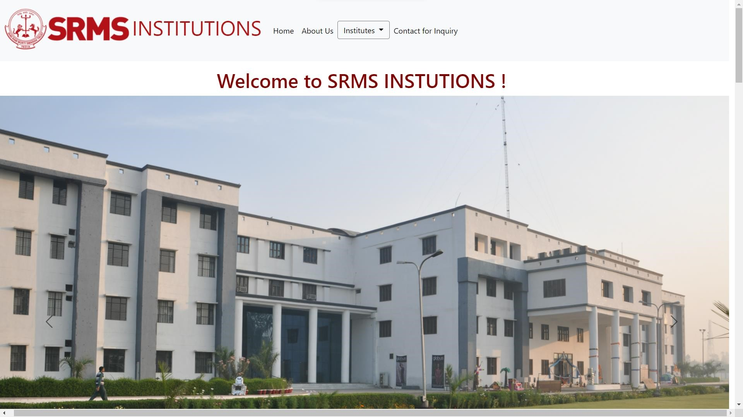❖ This is the first look of the website

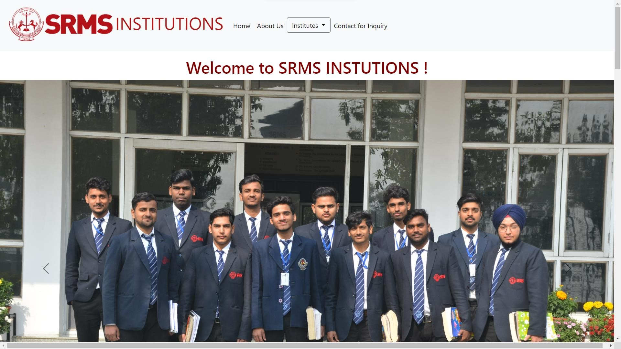

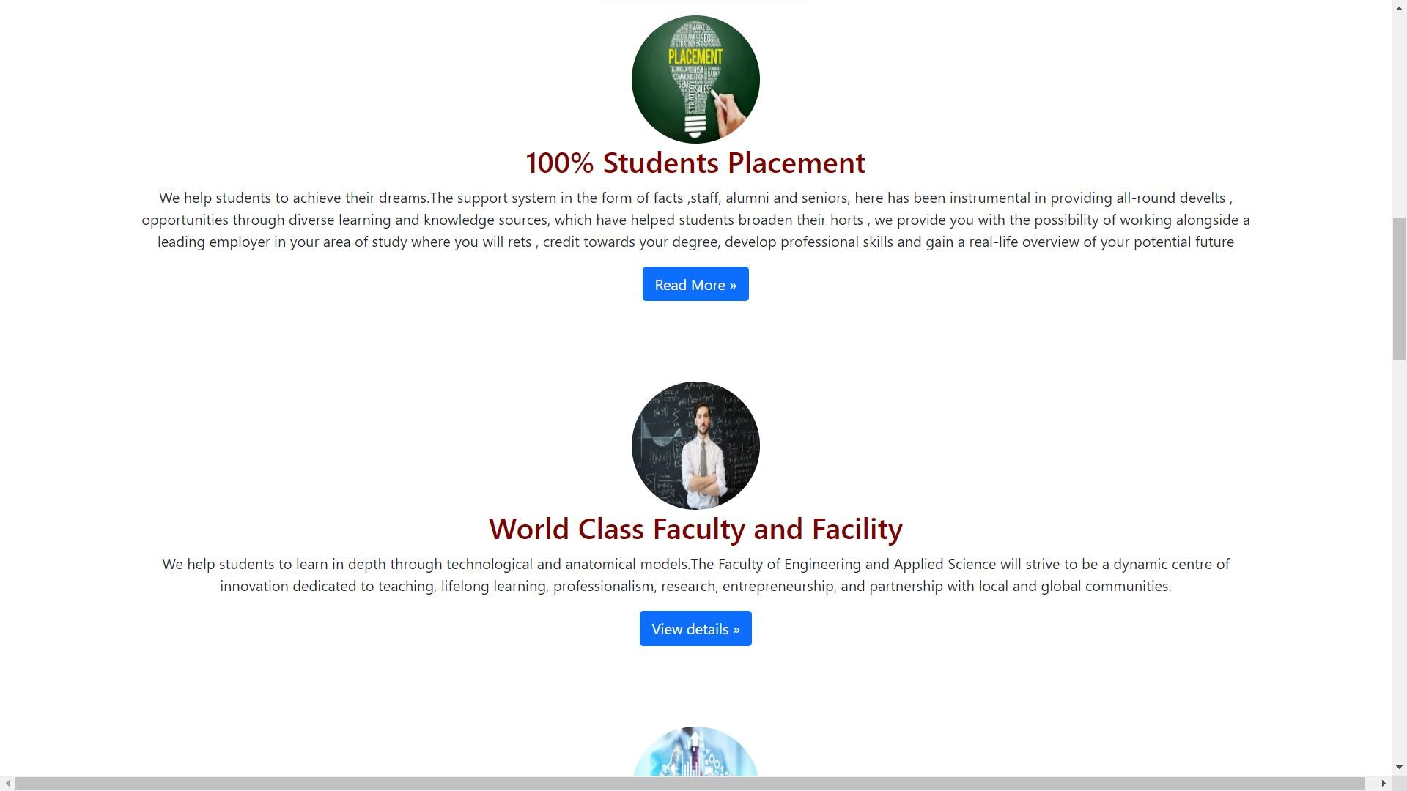

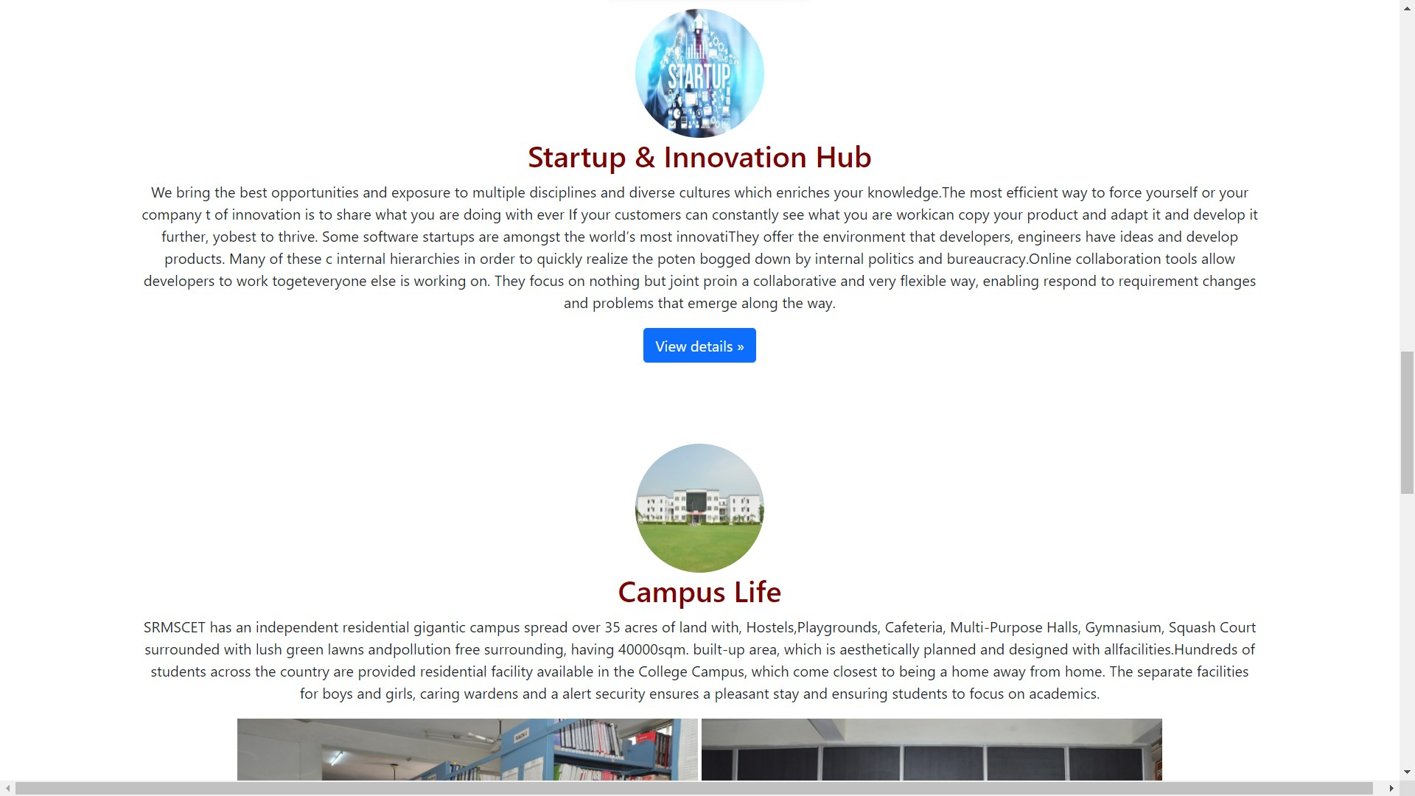

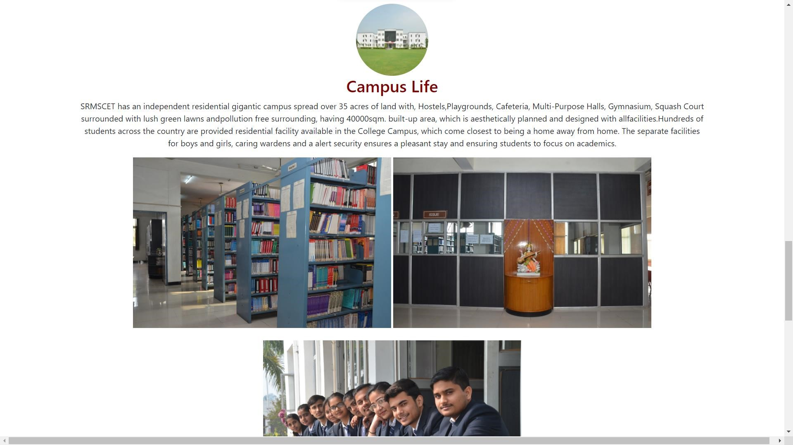

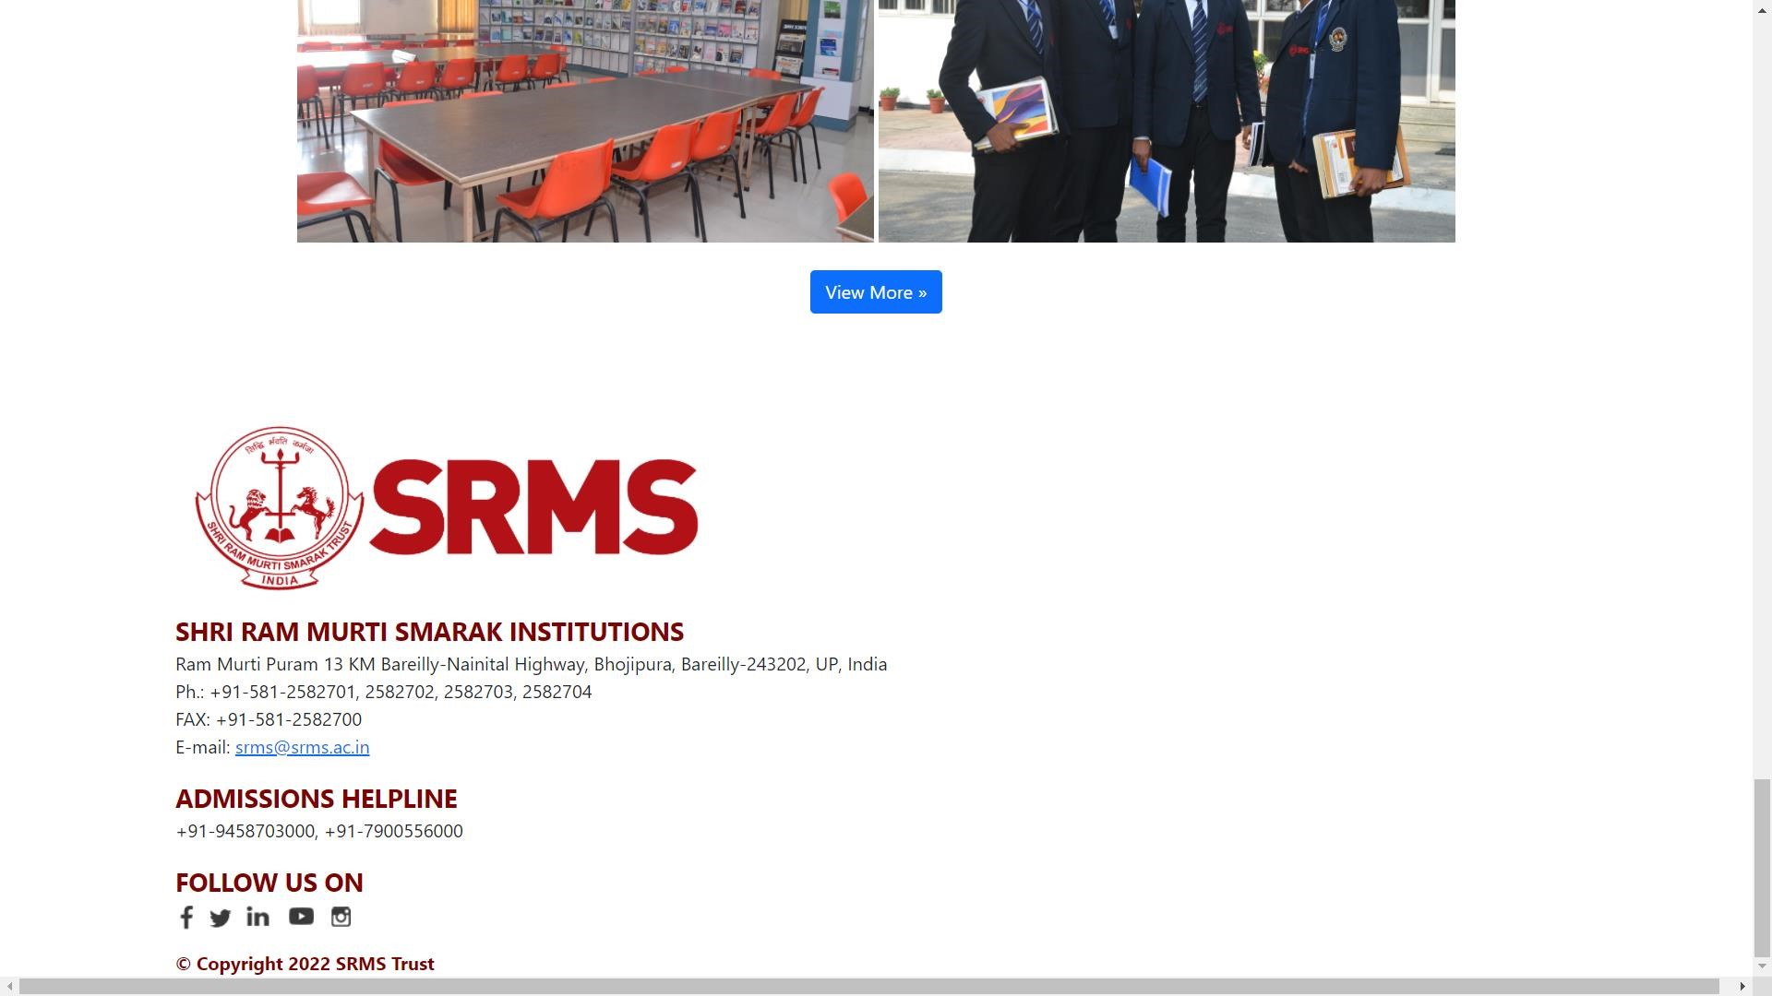

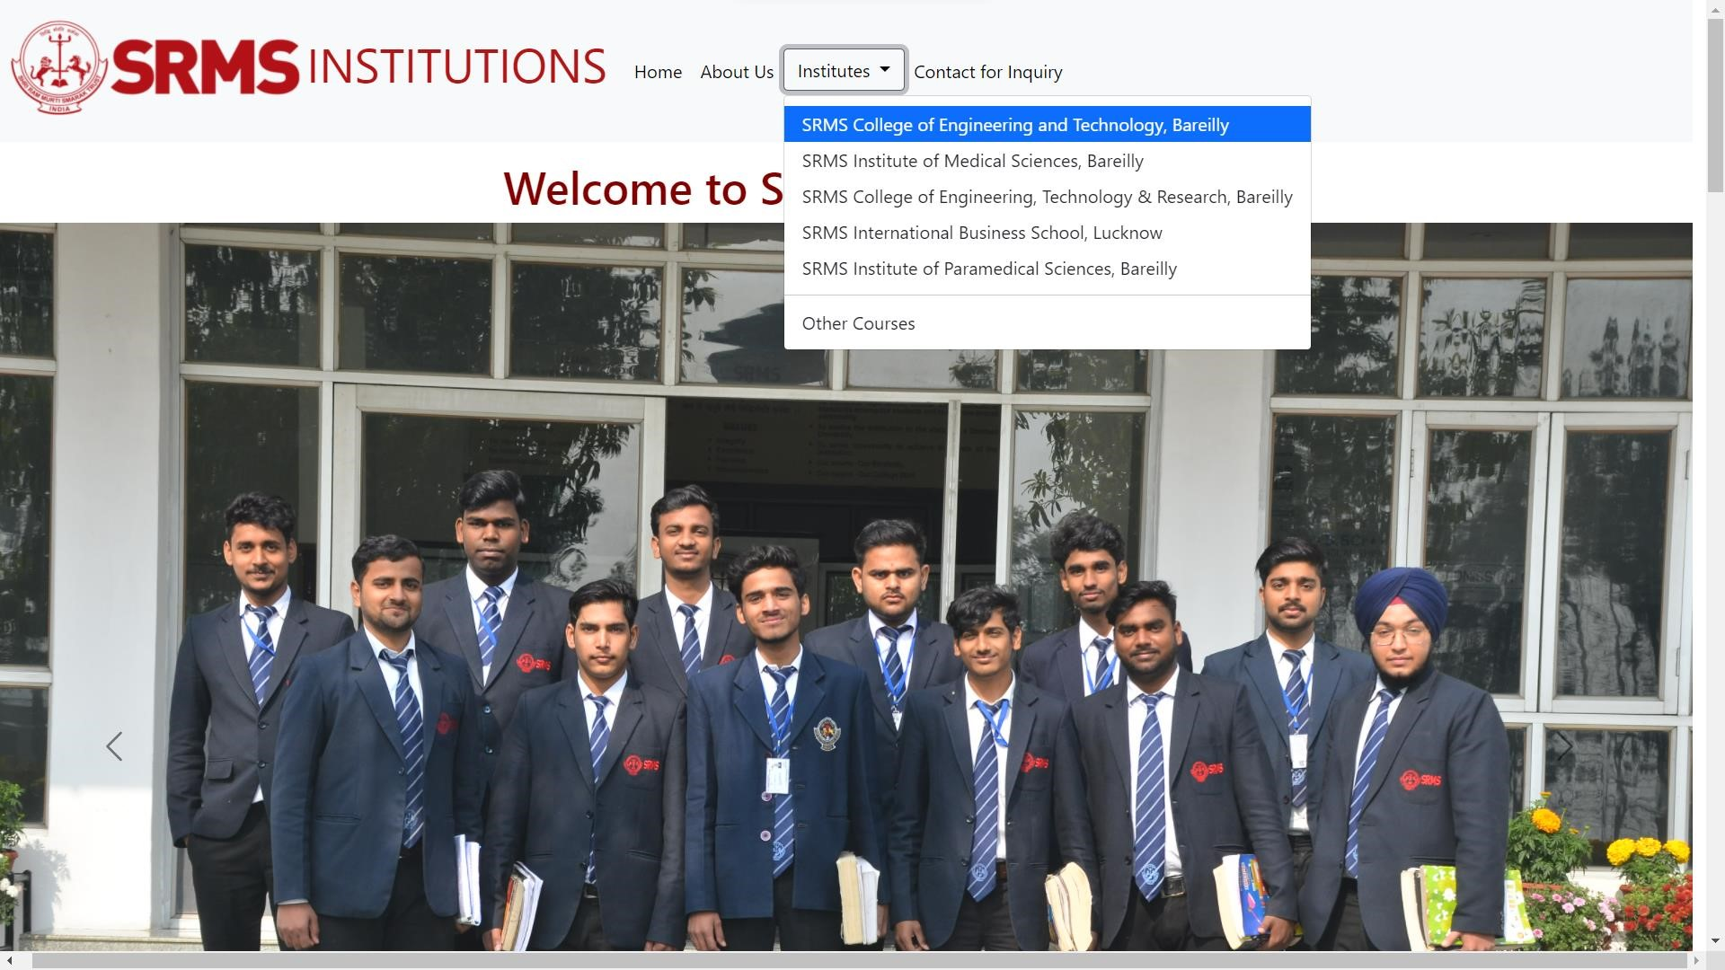

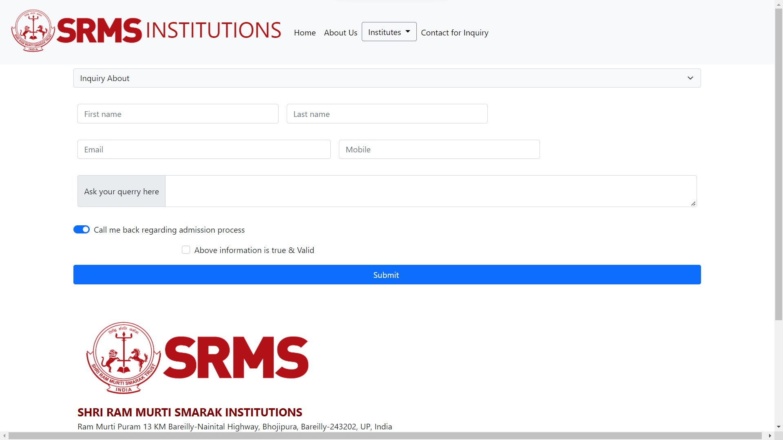

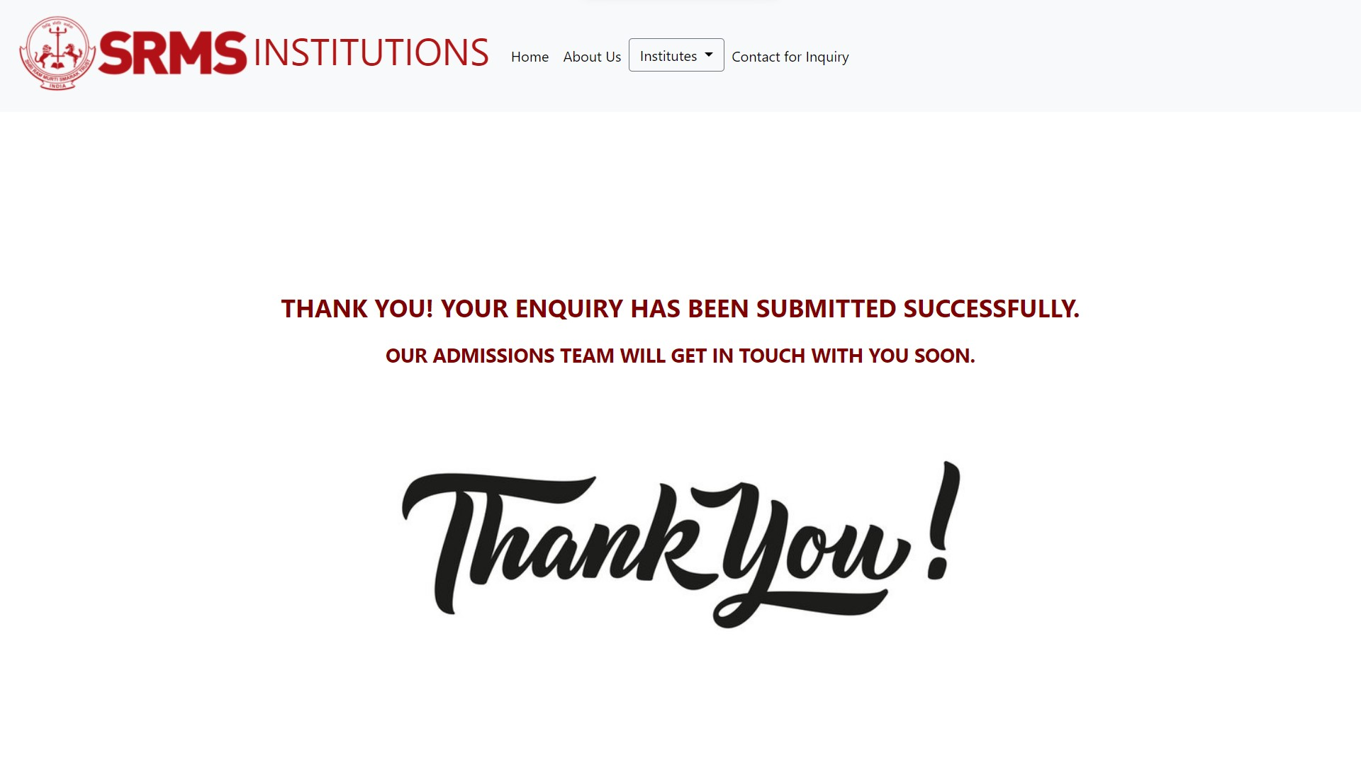

The computer program **“College Web Site”** has been designed basically for the students and Our institutions.

By entering the required data one can easily generate the information about any field as well as other services provided through the system. As provided in the introduction we can do many required works on it but it is not based on a particular online system as common idea is taken into consideration while preparing this project so to implement, it may require some modifications as per the requirements.

**“College Web Site**” is a good approach to easy search by just sitting at home.

**Books and other references:**

❑**HTML : www.w3schools.com,oreally**

❑**CSS :** [**www.w3.org**](http://www.w3.org/)



