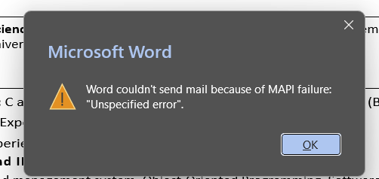Harsh Raj
+91 9835928274 | Mumbai, India | harshrajbih1234@gmail.com
LinkedIn | GitHub

EDUCATION
Bachelor of Computer Science and Engineering, Vishwaniketan's Institute of Management Entrepreneurship and Engineering Technology (University of Mumbai), 6.4 CGPA 2024- 2028
Currently in 3rd Year

SKILLS
Programming Languages: C and C++ (Proficient), JavaScript (Intermediate), Python (Beginner)
Database and Language: Experience in Mongo DB, MySQL, SQL (Intermediate)
Frameworks: working experience in React JS, Express JS, Node JS, Bootstrap
Version Control Tools and IDE: Git, Github, Visual Studio Code
Course Work: Database and management system, Object-Oriented Programming, Software Development
Computer Networks, Operation Systems, Data Structures, and Algorithms
Soft Skills: Collaboration, Communication, Planning, Teamwork, Time Management, Leadership

PROJECTS
AI Resume Shortlister - GitHub
- Developed an AI-powered application to analyze resumes and rank candidates based on job descriptions.
- Implemented resume parsing, candidate scoring, and automated shortlisting to simplify recruitment.
- Designed a responsive interface with efficient backend integration for faster resume processing.
- Tech stack used: Python, Flask, HTML, CSS, JavaScript, Machine Learning, NLP

Food Delivery System - GitHub
- Built a full-stack food ordering platform with restaurant listings, menu browsing, and order management.
- Implemented user authentication, cart functionality, and order tracking features.
- Integrated database operations for managing users, restaurants, and customer orders.
- Tech stack used: React.js, Node.js, Express.js, MongoDB, HTML, CSS, JavaScript
Player Management App - GitHub
- Built a player management application to add, update, delete, and search player records.
- Designed responsive UI components and integrated backend APIs for real-time data management.
- Improved application usability with efficient CRUD functionality and organized data display.
- Tech stack used: React.js, Spring Boot, Java, MySQL, REST API, HTML, CSS

ACHIEVEMENTS &EXTRA-CURRICULAR ACTIVITIES
- 🏆 Won 1st Place in the Python Programming Competition (2024).
- 📜 Completed certifications in Python and Web Development.

