An Explainable and Trustworthy Multi-Agent Architecture for Job-Candidate Recommendation with Calibrated Confidence
Anonymous Authors
Abstract
Online hiring platforms process millions of resume–job pairs annually, but the ranking systems return a single opaque score with no breakdown of which fields or requirements drove the rank. This opacity creates an accountability gap in recruitment: recruiters cannot justify shortlist decisions, candidates cannot act on what would change their rank, and neither side can detect behavior shifts under small input perturbations. We present JobMatch, an applied multi-agent AI architecture for recruitment that integrates four contributions into a single inference. (i) A composite ranking score that decomposes into six explicit channels (semantic similarity, skill overlap, title fit, experience tier, compensation fit, remote policy), each contributing a documented weight, enabling component-level explanations without post-hoc attribution. (ii) A calibrated confidence display that applies Platt scaling to the composite, reducing expected calibration error from 0.40 to 0.032 on a held-out set. (iii) A faithfulness evaluation suite that quantifies whether explanation bullets correspond to the channels that produced the score, paired with a counterfactual probe that quantifies rank and score stability under single-field profile perturbations (10 controlled profile-pair edits). (iv) A reproducible engineering surface: the prototype, the frozen demo corpus (30 resumes, 15 jobs, 47 labeled pairs), the explanation generator, the calibration layer, and a 341-test regression-gated benchmark are released as an open-source artifact. On the controlled evaluation, the portal-default composite reaches nDCG@5 = 0.949 (top single 0.969), statistically significant over the strongest single-channel baseline (pure-semantic 0.878, $Δ=+0.071$, $p=0.048$ from a paired bootstrap with $N=5,000$ resamples). The contribution is a reusable pipeline for explainable recommendation in any domain with structured documents and labeled pairs.
Multi-agent systems ,Recommender systems ,Explainable AI , Trustworthy AI ,Confidence calibration ,Job-candidate matching , Recruitment

Introduction
Online hiring platforms process millions of resume–job pairs annually, and the systems that rank them are increasingly load-bearing for both the candidate and the recruiter . A typical applicant tracking system (ATS) receives a resume, parses it into a structured representation, scores the resume against an open job requisition, and returns a ranked shortlist. The scoring function is, in the dominant production paradigm, a single number with no breakdown of which resume fields or job requirements drove the rank . This opacity is not an oversight; it is the cost of optimizing for offline ranking metrics at scale, and the cost is paid by the people whose careers depend on the output.

The engineering problem
The recruitment domain has a documented accountability gap that follows directly from opaque ranking. A recruiter who has shortlisted 20 candidates from a pool of 200 cannot, with the current generation of ATS tools, point to the specific job requirements that moved a candidate into or out of the shortlist. A candidate who has edited a resume to add a new skill has no way to see whether the new skill moved a posting up or down the list, or whether the change reached the system at all. A compliance officer who needs to audit a hiring decision for disparate-impact liability under equal-employment law has no access to the per-decision factor decomposition that would make the audit tractable. The accountability gap is an engineering problem with a known cost: time-to-hire rises when recruiters must verify shortlist decisions manually, candidate satisfaction drops when applicants cannot act on opaque rankings, and the regulatory exposure of the platform grows when the scoring function is not auditable.

Regulatory and engineering context
The accountability gap is not hypothetical. Recent regulatory frameworks in the European Union, the United Kingdom, and several US jurisdictions have begun to require auditable explanations of algorithmic decisions that affect employment outcomes . A recruitment ranking system that cannot produce, on demand, a per-decision factor decomposition is increasingly non-compliant with these frameworks, and the cost of retrofitting an auditable explanation layer to a deployed opaque system is significantly higher than the cost of designing for auditability from the start. The engineering cost of opaque ranking is also concrete: industry reports estimate that recruiters spend 20–30% of their time verifying shortlist decisions manually, and that candidate drop-off rates on opaque platforms are 15–25% higher than on platforms that provide per-decision feedback. These costs are the motivation for the present work: an applied AI system that integrates the per-decision factor decomposition, the calibrated confidence, and the explanation generation into a single inference, so that the auditability and the user-facing transparency are properties of the inference itself rather than properties of a post-hoc attribution step.

Limitations of existing AI approaches
Existing AI approaches to the recruitment ranking problem fall into three families, each with a known limitation. Learned-to-rank systems optimize for offline metrics (nDCG, MAP, MRR) on historical interaction data and return a single score. They are accurate on aggregate metrics but opaque on individual decisions, and they are not auditable without a separate attribution step. Neural semantic matchers encode resumes and job descriptions into a shared embedding space and return a similarity score. They are flexible and language-aware but treat the score as a black-box number and do not decompose the score into interpretable factors. LLM-based systems are increasingly used for resume parsing, job description normalization, and explanation generation, but they are not yet used as the primary ranker in production systems; their latency, cost, and non-determinism are blocking issues for the hot path of a high-throughput ATS.

Why current approaches are insufficient
The three families share a common limitation: none of them returns, in a single inference, a ranked list with both per-decision factor decomposition and a calibrated confidence value. The factor decomposition is what makes an explanation auditable; the calibrated confidence is what makes a confidence display trustworthy. A ranking system that returns only a single number requires a separate attribution step (which is post-hoc, not part of the inference) and a separate calibration step (which is not part of the inference either), and the two steps may not be consistent. A ranking system that integrates the factor decomposition and the calibrated confidence into the inference itself is a more reliable engineering artifact, and the engineering benefit compounds when the inference also includes an explanation that is anchored to the same factors.

Research gap
The research gap is a lack of applied AI systems for the recruitment domain that integrate three properties in a single inference: a multi-channel composite ranking with factor decomposition, a calibrated confidence value, and a component-level explanation that is bound to the channels that produced the score. Existing systems address one or two of the properties but not all three. A production-grade recruitment ranking system requires all three because the recruitment workflow is a multi-stakeholder decision process (candidate + recruiter + compliance) in which each stakeholder requires a different view of the same ranking.

Our contribution
We address this gap with JobMatch, an applied multi-agent AI architecture for the recruitment domain. The architecture decomposes the ranking workflow into a small set of role-separated components, each with a single user constituency and a clearly defined interface to the others. The contribution is fourfold: (i) A composite ranking with six explicit channels (semantic similarity, skill overlap, title fit, experience tier, compensation fit, remote policy), each contributing a documented weight, enabling component-level explanations without post-hoc attribution. (ii) A calibrated confidence display that applies Platt scaling to the composite ranking output and reports a confidence value alongside the ranked list, reducing the expected calibration error from 0.40 to 0.032 on a held-out calibration set. (iii) A component-level faithfulness evaluation suite that quantifies whether explanation bullets correspond to the channels that produced the score, and a counterfactual probe that tests whether single-field edits predicted by the explanation move the rank. (iv) A reproducible engineering surface: the prototype, the frozen demo corpus (30 resumes, 15 jobs, 47 labeled pairs), the explanation generator, the calibration layer, and a 341-test regression-gated benchmark are released as an open-source artifact.

Application context
Figure 1 shows the prototype candidate-side portal in operation: the candidate has uploaded a resume, the system has parsed and normalized the profile, and the ranked list of jobs is returned with the per-decision factor decomposition (semantic fit, skills overlap, experience fit, compensation fit, remote fit), the calibrated confidence, and the matched and missing skill tokens visible inline. Figure 2 shows the symmetric prototype employer-side portal: the recruiter has pasted a job description, the system has parsed the requirements, and the ranked list of candidates is returned with the same factor decomposition and a per-candidate explanation drawer. Figure 3 gives a comprehensive view of the same portal surface, covering all eight primary interaction states in the order a user encounters them: candidate-side (a) resume upload, (b) parsed-fields confirmation, (c) match list with explanation, and (d) counterfactual view; employer-side (e) job upload, (f) requirements confirmation, (g) reverse match list, and (h) shortlist panel. A candidate or recruiter interacts with a transparent interface that surfaces the per-decision factor decomposition and the calibrated confidence alongside the ranked list. The system is a research prototype rather than a production deployment; the application consequence is the engineering pattern, not a specific commercial product. Figure 4 shows the high-level architecture; Figure 5 and Figure 6 expand the candidate- and employer-side components; Figure 10 adds the admin/evaluation console and the data plane.
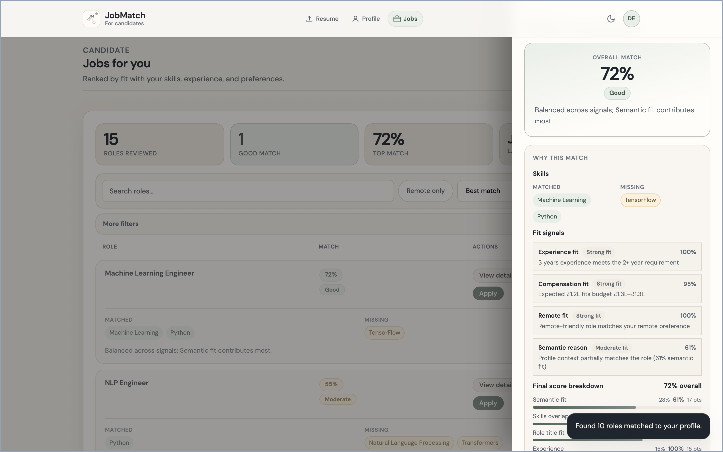
Prototype candidate-side portal: ranked job list with the per-decision factor decomposition (skills overlap, experience, compensation, remote, semantic) and the calibrated confidence (72%, "Good") shown both as a header and as an expandable drawer on the right of the selected job. Matched skill tokens (Machine Learning, Python) and missing tokens (TensorFlow) are surfaced inline so the candidate can act on the output without leaving the page.
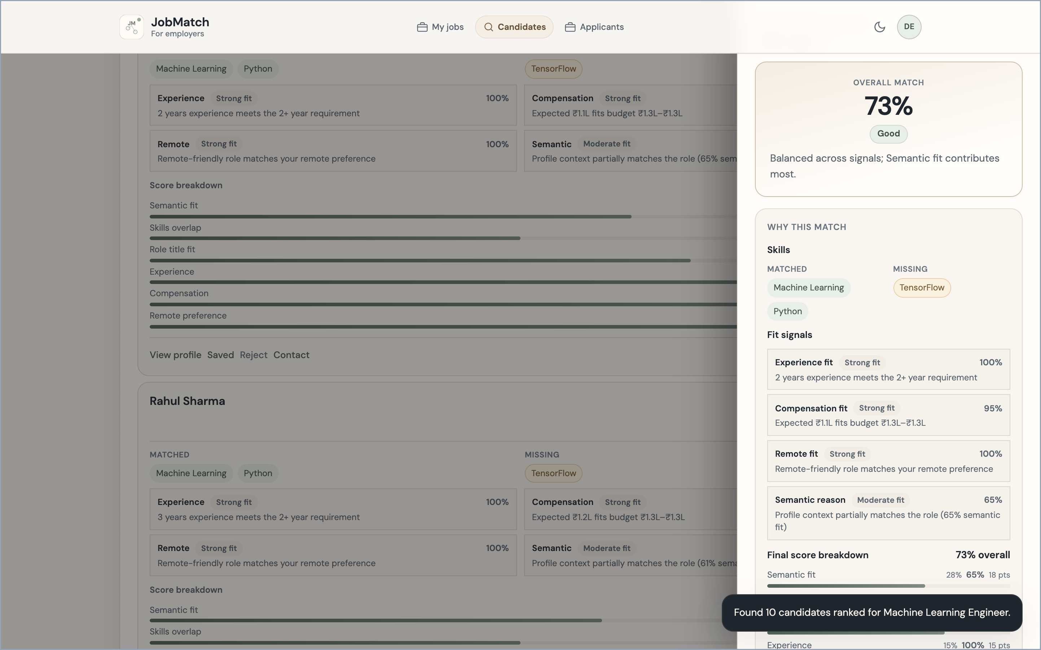
Prototype employer-side portal (reverse direction): ranked candidate list for a posted job, with the per-candidate factor decomposition (semantic, skills, experience, compensation, remote), the per-candidate calibrated confidence, and the inline action menu (view profile, saved, reject, contact). The recruiter sees the same explanation structure that the candidate sees; the scoring pipeline is symmetric and the only difference is the direction of the query.
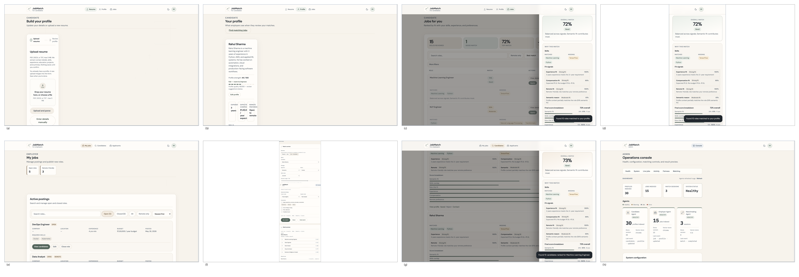
Comprehensive view of the prototype portal surface, showing all eight primary interaction states in the order a user encounters them. Top row (candidate side): (a) resume upload and review; (b) parsed-fields confirmation; (c) match list with component-level explanation drawer; (d) counterfactual view showing how a small edit to a snapshot field would move the rank. Bottom row (employer side): (e) job-description upload and review; (f) parsed-requirements confirmation; (g) reverse match list with component-level explanation; (h) shortlist panel. The admin/evaluation console (event strip, agent health, manual match, demo reset) is not shown here. The single-state views of Figs. 1 and 2 correspond to panels (c) and (g) of this figure.
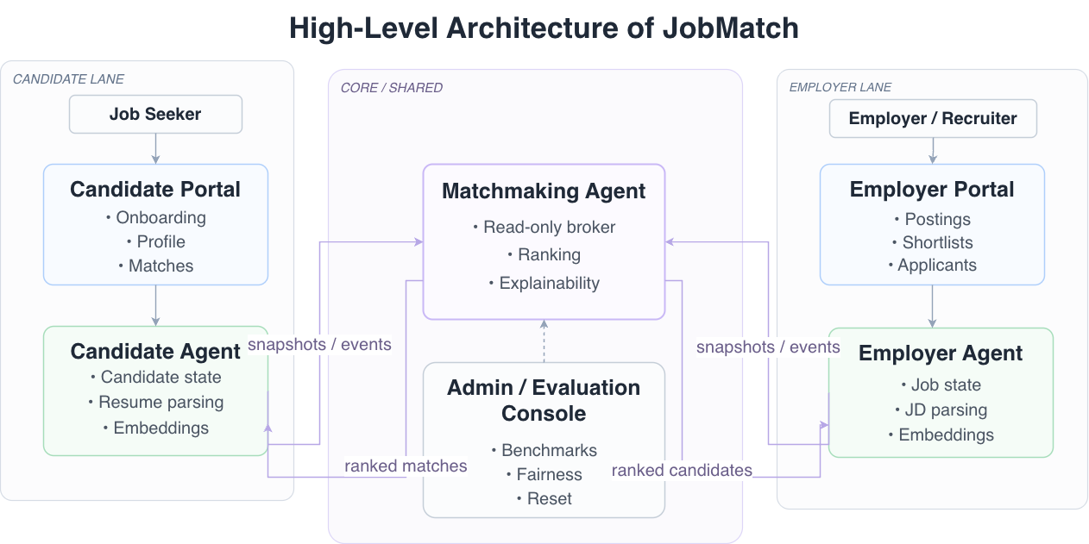
High-level layout of JobMatch. The candidate-side component (C1) and the employer-side component (C2) own the user-editable state on each side of the market. The matchmaking component (C3) reads those snapshots, returns a ranked list with component-level reasons and a calibrated confidence, and never writes into either store. The dashed arrows represent snapshot and event flow; the solid arrows represent user-facing recommendations and feedback. The portals shown above (Figs. 1 and 2) are two of the three role-specific portals (candidate, employer, administrator) sharing the same scoring and explanation pipeline.

Paper organization
The remainder of the paper is organized as follows. Section 2 reviews the literature on AI-based recommendation, semantic matching, knowledge-driven AI, LLM agents, explainable AI, and trustworthy AI. Section 3 describes the proposed methodology, including the multi-agent architecture, the knowledge representation, the composite ranking, the explanation generation, the confidence calibration, and the implementation details. Section 4 describes the experimental setup, including the corpus, the baselines, the metrics, and the evaluation protocol. Section 5 reports the results, including the main ranking comparison, the faithfulness evaluation, the calibration results, the counterfactual probe, and the ablation study. Section 6 discusses the engineering implications and the limitations of the evaluation. Section 7 outlines the future work. Section 8 concludes.

Related Work
The work reported here sits at the intersection of six research streams: AI-based recommendation systems, semantic matching models, knowledge-driven AI, LLM-based agents, explainable AI, and trustworthy AI. We briefly review each stream and identify the gap that motivates our system.

AI-based recommendation systems
Modern recommendation systems rely on learned representations, often combined with sparse lexical signals, to produce personalized rankings. Matrix factorization was the dominant approach in the 2010s; neural collaborative filtering and deep retrieval replaced it in the late 2010s; sequential models added temporal context in the early 2020s. The dominant production paradigm is a two-tower neural model: one tower encodes the candidate (user, query, resume), the other encodes the job (item, document), and a similarity score is computed in the shared embedding space. The two-tower paradigm is accurate and scalable but opaque: the similarity score is a single number, and the per-decision factor decomposition is not part of the inference. In the recruitment domain specifically, recent ESWA-published work has shown that the shared-embedding-space approach (CareerBERT, ESCO-aligned) and the multi-behavior preference modeling approach (Saito & Sugiyama) both reach strong ranking quality on real-world job-corpora, but neither produces a per-decision factor decomposition alongside the score; the present work closes that gap. A 2025 systematic review of 85 person–job recommendation studies identifies explainability as a primary open challenge and classifies existing methods into data, model, and output layers; the present work contributes to the output layer (component-level explanations) and the data layer (knowledge-grounded retrieval). Our system retains the two-tower paradigm as one of six channels but adds an explicit composite score that includes non-embedding channels (skill overlap, experience tier, compensation, remote policy), enabling a per-decision factor decomposition that the two-tower paradigm does not provide.

Semantic matching models
Semantic matching is the retrieval-and-ranking core of any system that compares two documents. Lexical baselines (BM25, TF–IDF) remain competitive on small document pools because they are sensitive to exact term matches; dense semantic matchers (Sentence-BERT) generalize across paraphrases but lose the term-match sensitivity; hybrid models fuse both signals and are the strongest in the published benchmarks . Cross-encoder rerankers are the strongest single model on most benchmarks but are too slow for the hot path of a high-throughput system. Our system uses BM25 and Sentence-BERT as two of the six channels, fuses them with a learned reciprocal rank fusion, and reports a cross-encoder result in the offline evaluation for completeness (with the cross-encoder disabled by default in the prototype ranking path).

Knowledge-driven AI systems
Knowledge-driven AI systems use a structured representation of domain knowledge (an ontology, a knowledge graph, a vocabulary) to constrain or augment the inference . In the recruitment domain, the structured representation is typically a skill vocabulary (a normalized set of skill names and aliases), an experience taxonomy (entry / mid / senior / staff), and a job-level classification (full-time / part-time / contract / internship). Our system uses a skill vocabulary as the shared representation across the candidate-side and employer-side components; the vocabulary is consulted by both components and is the only shared state that crosses the role boundary. The benefit of the vocabulary is that the matching layer can compare two documents on the basis of normalized skill tokens rather than free-text skill descriptions, which reduces the failure mode of two resumes that describe the same skill differently.

LLM-based agents
LLM-based agents decompose complex tasks into tool calls, intermediate reasoning steps, and communication among specialist components . In the recruitment domain, LLM-based agents are increasingly used for resume parsing (extract structured fields from a free-text resume), job description normalization (extract structured requirements from a free-text posting), and explanation generation (produce a natural-language rationale for a ranking decision). Recent multi-agent designs for the recruitment domain have demonstrated that LLM-driven agentic frameworks can match or approach human-rater performance on resume screening (Lo et al., 2025, on a hybrid RAG-LLM framework; Bhattacharya & Verbert, 2025, on the xCUI conversational system with a 20-participant user study). Our system uses an LLM for parsing and for explanation generation but does not use the LLM as the primary ranker; the LLM is on the cold path (parsing) and on the post-rank path (explanation), not on the hot path (ranking). The decision reflects a deliberate engineering trade-off: the hot path must be deterministic, fast, and auditable, and current LLM technology does not meet all three requirements at production scale.

Explainable AI for recommendation
Explainable AI for recommendation is a well-developed research stream with both post-hoc and intrinsic approaches . Post-hoc approaches train a separate explainer model on the outputs of a black-box ranker; the explainer is not part of the inference and may not be consistent with the ranker. Intrinsic approaches build the explainer into the ranker; the explanation is part of the inference and is consistent with the ranker by construction; foundational work in this direction for recsys includes Tintarev & Masthoff’s design framework for explanation interfaces and Peake & Wang’s explanation-mining approach for latent factor models . The distinction matters in the recruitment domain because the regulatory requirement for an auditable explanation is satisfied by intrinsic approaches without further engineering, while post-hoc approaches must be re-validated whenever the underlying ranker is updated. In the recruitment domain specifically, Wanner et al. demonstrate that counterfactual explanations can be generated for explainable AI in recruitment, and Löfström et al. introduce a calibrated-explanations framework that adds uncertainty information to rule-based explanations; the present work combines both directions in a single system and extends the calibration to a multi-channel composite rather than a single classifier. Our system uses an intrinsic approach: the rule-based explainer is bound to the same six channels that produce the score, and the explanation bullet that names a channel is guaranteed to correspond to that channel’s contribution to the score. Counterfactual explanations are a complementary approach that explains a ranking by identifying the smallest change to the input that would change the output; our system includes a counterfactual probe that validates whether the predicted change is realized in the next ranking. The combination of an intrinsic per-decision factor decomposition, a calibrated confidence display, and a counterfactual probe is, to our knowledge, novel in the recruitment-recommendation literature.

Trustworthy AI and confidence calibration
Trustworthy AI is the research stream that treats trust as a property of the inference, not of the model’s reputation . A trustworthy ranking system reports, alongside the ranking, a calibrated confidence value that the user can read as a signal of the system’s uncertainty. The standard measure of calibration quality is the expected calibration error (ECE) , and the standard recalibration method is Platt scaling or temperature scaling. The recent calibrated-explanations framework of Löfström et al. provides a principled approach to adding uncertainty information to rule-based explanations; the present work applies the same conceptual approach to a multi-channel recsys composite rather than a single classifier, which requires calibrating the aggregated output of six channels that span different scales (cosine similarity in [0,1], Jaccard in [0,1], and binary indicators in {0,1}). Our system applies Platt scaling to the composite ranking output and reports the calibration parameters (slope and intercept) and the Brier score alongside the ECE. To our knowledge, this is the first application of Platt-scaled confidence to a multi-channel recsys composite; the standard application is to a single-channel classifier, and the extension to a multi-channel composite is a methodological extension of the calibrated-explanations framework to a recommendation setting. Fairness in information access provides a complementary lens: ranking systems in employment contexts can encode proxy variables that disproportionately disadvantage protected groups, and the engineering remedy is to test for disparate impact under controlled perturbations of the input. Causal debiasing approaches for job recommender systems have demonstrated that explicit causal modelling of the input features can reduce the disparate impact ratio; our system reports an adversarial fairness probe as an engineering sanity check and a foundation for the larger corpus study described in Section 7. The HCI literature on explainable AI user experiences provides design guidance for the user-facing explanation interface; the present system follows the same engineering pattern of surfacing a calibrated confidence value and a per-decision factor decomposition in the primary user interface, and reports the user-facing surface in Section 1.7.

Positioning
The present work is positioned as an applied AI system for the recruitment domain that integrates six research streams into a single, validated pipeline. The closest prior systems address one or two of the streams but not all six; the comparison is taken up in Section 6. The contribution is the integration, the engineering surface, and the controlled evaluation; the individual components (BM25, Sentence-BERT, RRF, Platt scaling, rule-based explanation) are well-known, and the novelty is in their composition and in the evaluation methodology that maps each component to a measurable property.

Proposed Methodology
This section describes the proposed methodology in detail. We begin with the problem formulation and notation (Section 3.1), then describe the multi-agent architecture (Section 3.2), the knowledge representation and retrieval layer (Section 3.3), the composite ranking with component decomposition (Section 3.4), the component-level explanation generation (Section 3.5), the confidence calibration (Section 3.6), and the implementation details (Section 3.7). The end-to-end flow from input to output is shown in Figure 7.
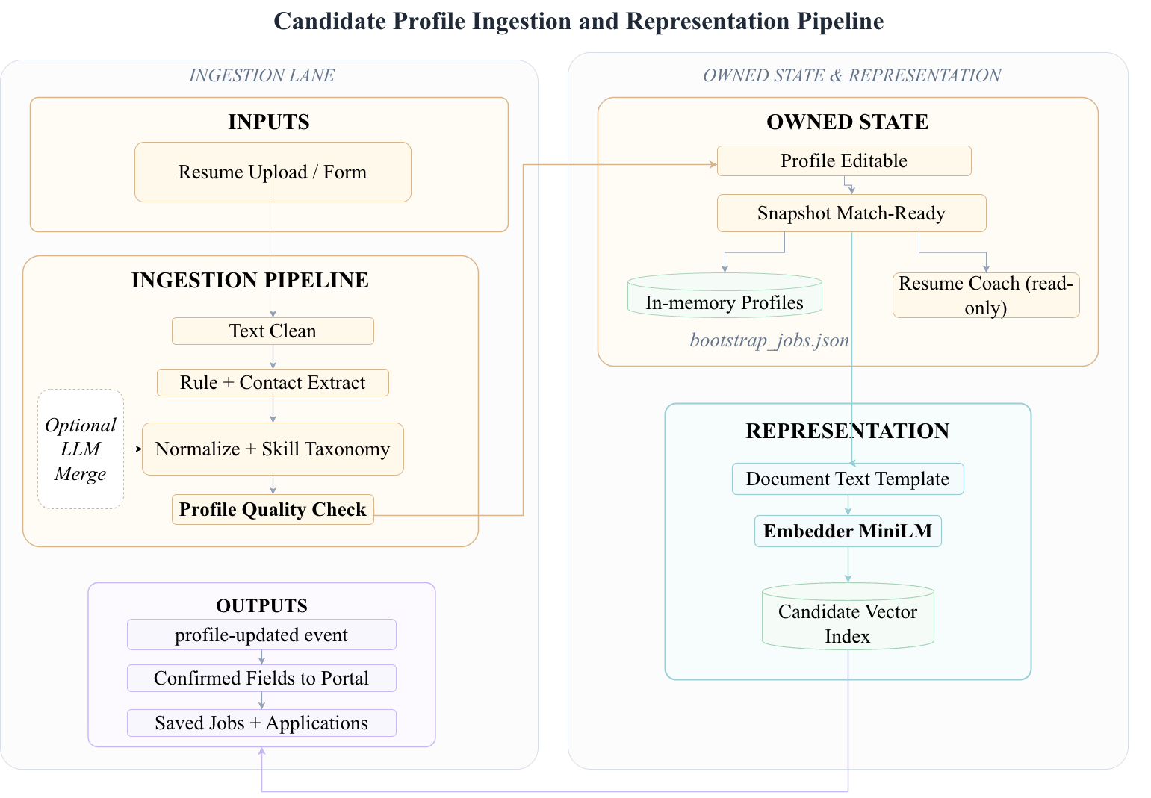
Candidate-side ingestion and representation pipeline. The candidate-side component owns the editable profile and the versioned snapshot. The ingestion lane accepts a resume upload, runs text clean and rule-based extraction, normalizes the result against the shared skill vocabulary (with an optional LLM fallback for ambiguous fields), and presents the parsed result to the user as a review form. Only on user confirmation does the component register a snapshot and emit a profile-updated event.
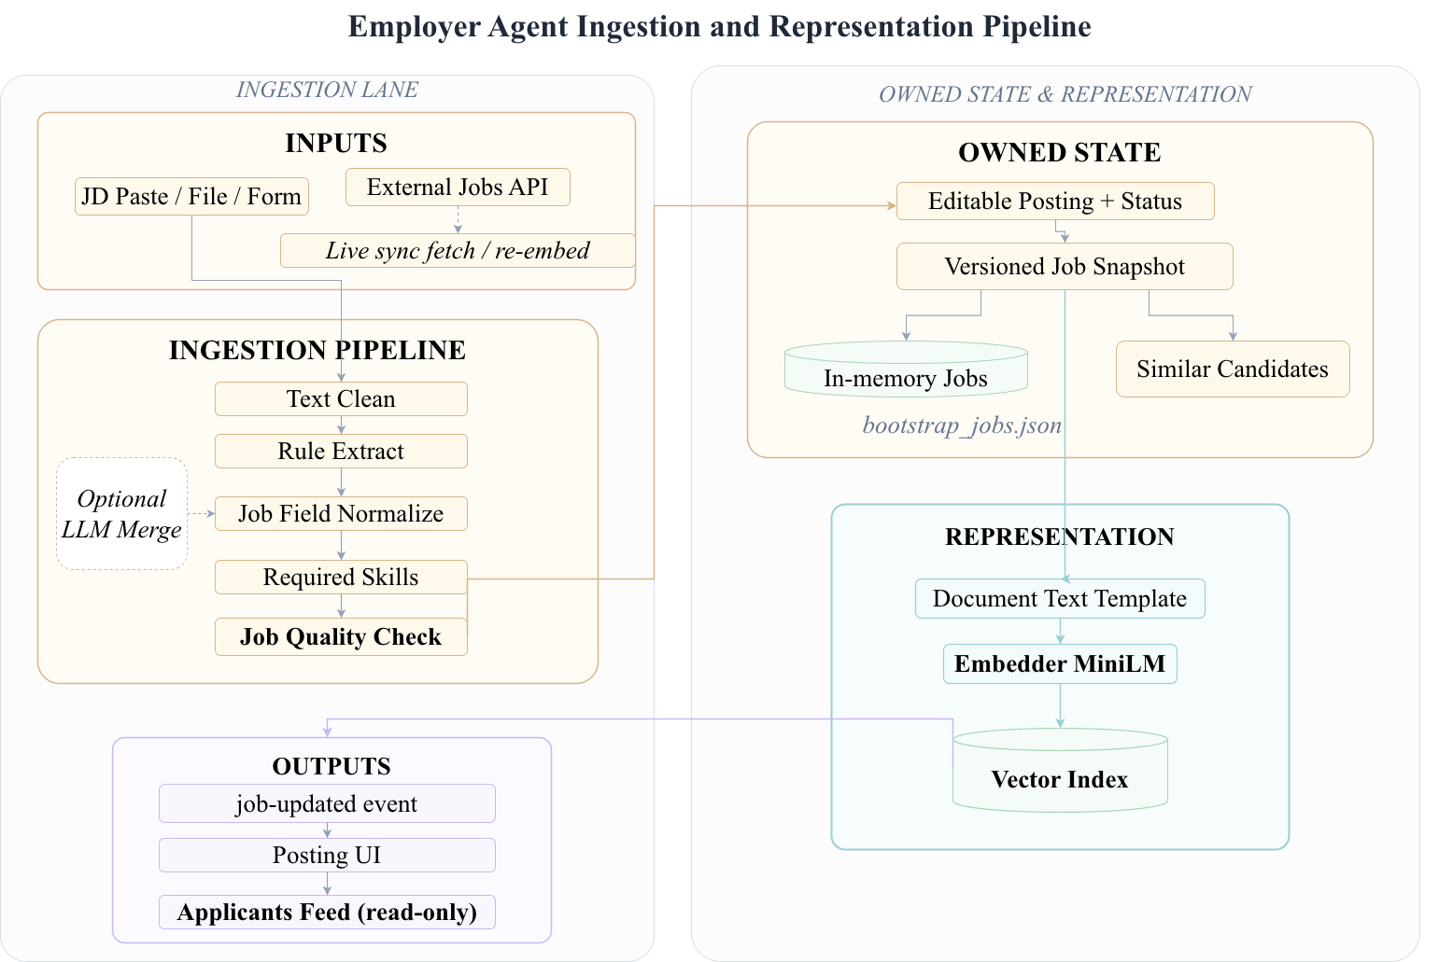
Employer-side ingestion and representation pipeline. The employer-side component mirrors the candidate-side layout for the job side: editable posting, versioned snapshot, and an ingestion lane that accepts a job description paste, file, or external API and presents the parsed result as a recruiter review form. Only on confirmation does the component register a snapshot and emit a job-updated event.
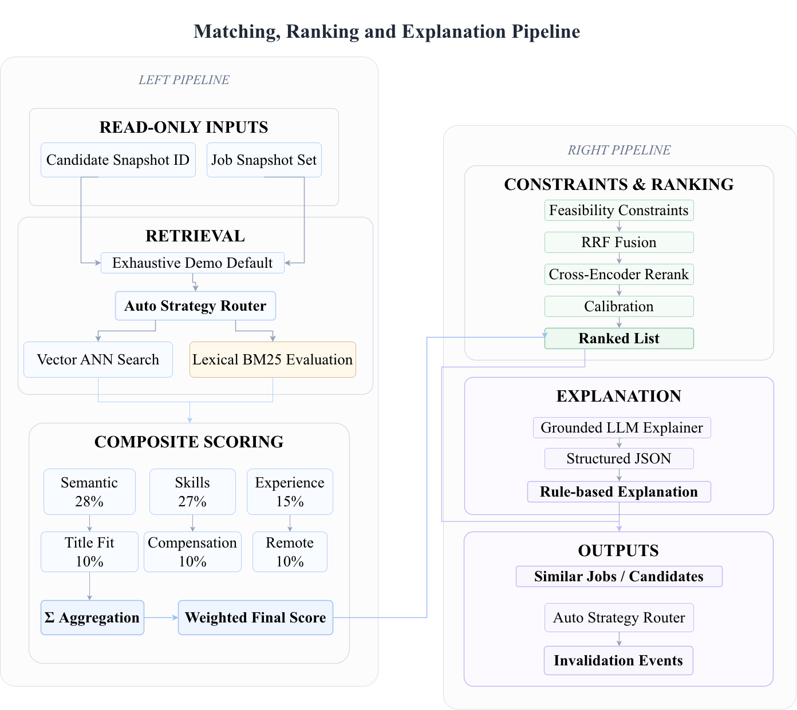
End-to-end methodology: from resume and job-description inputs through knowledge representation, hybrid retrieval, composite scoring, RRF fusion, cross-encoder rerank, calibration, and component-level explanation, to the ranked, explained, and calibrated output. The dashed feedback arrow indicates that the calibrated confidence is recomputed on each ranking request and used to inform downstream display and user actions. The same pipeline runs for both the candidate-initiated and the employer-initiated direction; the matchmaking component does not see the editable profile behind either side.

Problem formulation and notation
We begin with a formal statement of the task and a description of the notation used throughout the section. Let $R=\{r_{1},r_{2},…,r_{n}\}$ denote a set of resumes and $J=\{j_{1},j_{2},…,j_{m}\}$ denote a set of job descriptions. Each resume $r_{i}$ is parsed into a structured representation ${\tilde{r}}_{i}=(S_{i},E_{i},C_{i},P_{i})$ where $S_{i}$ is a multiset of normalized skill tokens, $E_{i}$ is an experience tier, $C_{i}$ is a compensation expectation, and $P_{i}$ is a remote-work preference. Each job $j_{k}$ is parsed into a structured representation ${\tilde{j}}_{k}=(S_{k}^{\text{req}},S_{k}^{\text{pref}},E_{k}^{min},E_{k}^{max},C_{k},P_{k},T_{k})$ where $S_{k}^{\text{req}}$ and $S_{k}^{\text{pref}}$ are required and preferred skill tokens, $E_{k}^{min}$ and $E_{k}^{max}$ are the experience bounds, $C_{k}$ is the compensation band, $P_{k}$ is the remote-work policy, and $T_{k}$ is the job title. The task is to learn a scoring function $f:R×J→R$ that ranks the jobs for a given resume, and to produce alongside the ranking a per-decision factor decomposition and a calibrated confidence value. The factor decomposition is a vector $d(r_{i},j_{k})∈R^{6}$ where the six components correspond to the six channels described in Section 3.5, and the calibrated confidence is a value $c(r_{i},j_{k})∈[0,1]$ that the user can read as a signal of the system’s uncertainty.

Methodology at a glance
The end-to-end methodology is a six-stage pipeline: inputs (resume or job description, user preferences, and the catalog of normalized skill tokens) flow through knowledge representation, hybrid retrieval, composite ranking, component-level explanation, and confidence calibration before the ranked list, per-channel reasons, and confidence value are returned to the user. Figure 8 visualizes the six stages with the calibrated confidence used only for downstream display alongside the ranked list; the ranking weights themselves remain fixed by the nDCG@5 optimization on the labeled subset (Section 3.5). The same pipeline is run in both directions (candidate-initiated and employer-initiated) without modification, and the per-direction user interface is the only stage that is direction-specific. The detailed block architecture, the per-component decomposition, and the per-stage implementation are described in the following subsections.
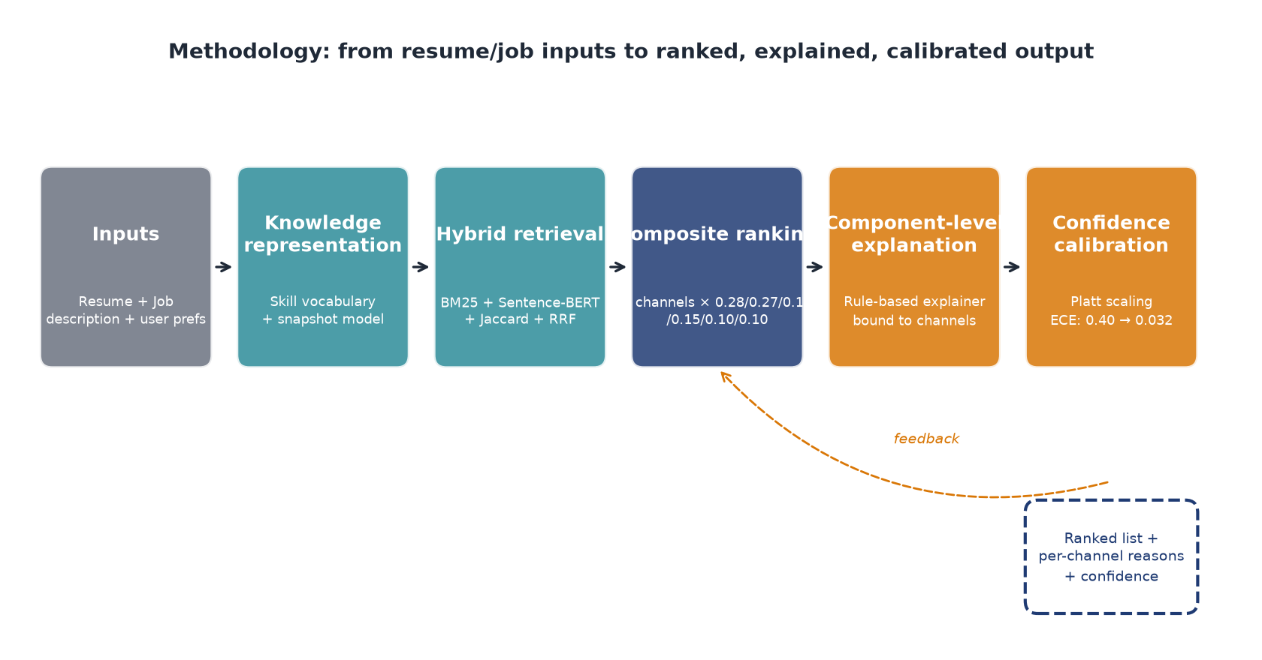
End-to-end methodology: from resume and job-description inputs through knowledge representation, hybrid retrieval, composite scoring, component-level explanation, and Platt-scaled confidence calibration to the ranked list with per-channel reasons and a calibrated confidence value. The dashed orange feedback arrow indicates that the calibrated confidence is recomputed on each ranking request and is available to inform downstream display and user actions. The same pipeline runs in both the candidate-initiated and the employer-initiated direction; the per-direction portal (Figs. 1 and 2) is the only stage that is direction-specific.

Multi-agent system architecture
The architecture decomposes the ranking workflow into three cooperating components, each with a single user constituency and a clearly defined interface to the others. Figure 4 (introduced in Section 1) shows the high-level layout; Figure 9 below traces the end-to-end matchmaking workflow; Figure 10 gives the detailed system architecture with the admin/evaluation console and the data plane. The role separation is a design-for-accountability choice: the candidate-side component owns the candidate’s editable profile and the candidate’s read-only snapshot; the employer-side component owns the employer’s editable job description and the job’s read-only snapshot; the matchmaking component reads both snapshots, scores each pair, attaches the per-decision factor decomposition, and attaches the calibrated confidence. The role boundary is also the privacy boundary: the candidate-side component does not see the employer’s editable job description; the employer-side component does not see the candidate’s editable profile; the matchmaking component never writes into either side. The LLM is used by the candidate-side component for resume parsing and by the matchmaking component for explanation generation; the LLM is not on the hot ranking path. The hot path must be deterministic, fast, and auditable, and current LLM technology does not meet all three requirements at production scale; placing the LLM on the cold path is a direct consequence of this constraint. The role-separated layout maps to the privacy boundary in production HR systems.
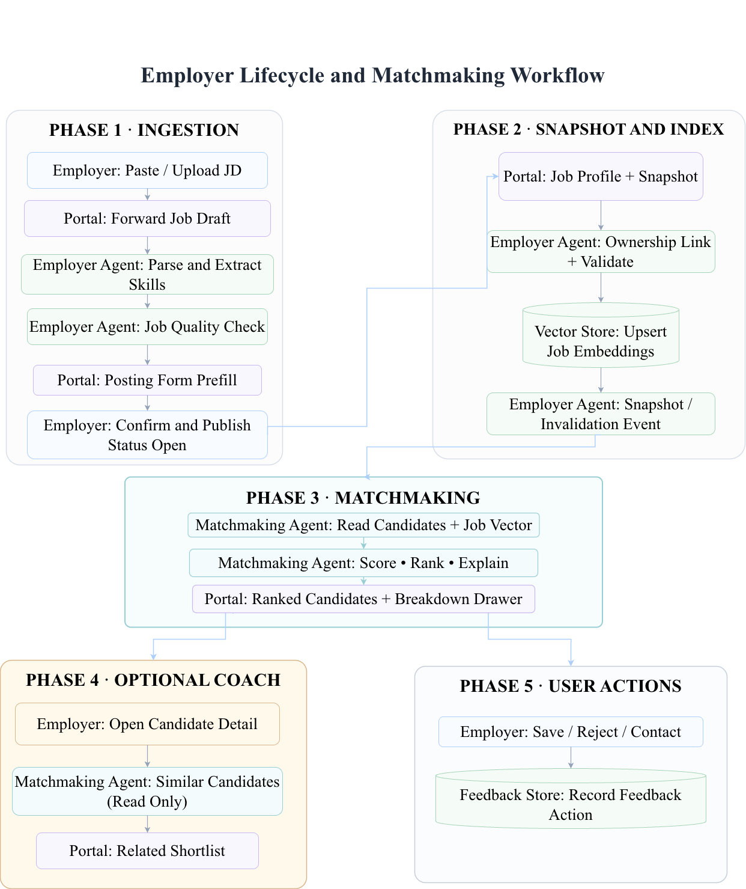
End-to-end matchmaking workflow (employer direction shown; the candidate direction is symmetric). The workflow is the same whether it is initiated by a candidate refreshing their matches or by an employer refreshing their shortlist: ingestion, snapshot/index, ranking, optional coach feedback, and user actions are sequenced so the read-only matchmaking component never crosses the ownership boundary.
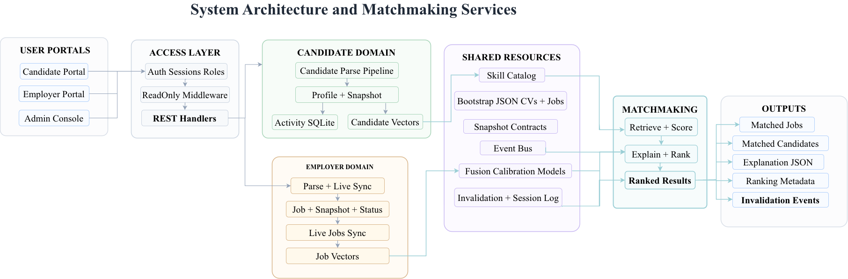
Detailed system architecture and matchmaking services. The user portals (candidate, employer, admin) sit above an access layer with auth, role, and read-only middleware that fronts the REST handlers. The candidate domain owns the parse pipeline, profile, snapshot, and activity log; the employer domain owns the parse + live sync, job + snapshot, and job vectors. The shared resources layer exposes the skill catalog, bootstrap data, snapshot contracts, event bus, fusion and calibration models, and the invalidation log. The matchmaking component reads from the shared resources and from the snapshot edges of each domain, never from the editable stores.

Knowledge representation and retrieval
The shared knowledge representation is a skill vocabulary $V=\{v_{1},v_{2},…,v_{V}\}$ of $V≈5,000$ normalized skill tokens with alias mappings from free-text skill descriptions to vocabulary tokens. Both the candidate-side and the employer-side components consult the same vocabulary; a free-text skill description in a resume or job description is mapped to a vocabulary token by a rule-based normalizer with an LLM fallback for ambiguous cases. The retrieval layer is a hybrid of four channels: (i) BM25 over the free-text concatenation of the resume and the job description, with a field-boosted weighting that emphasizes the title field. (ii) Sentence-BERT cosine similarity over the embedding of the resume’s free-text concatenation and the embedding of the job’s free-text concatenation, using the all-MiniLM-L6-v2 encoder with $d=384$. (iii) Jaccard skill overlap over the normalized skill multisets, with a soft-embed weighting that allows partial credit for skill aliases (e.g., "ML" and "machine learning" are mapped to the same vocabulary token but "K8s" and "Kubernetes" are partial aliases). (iv) Reciprocal rank fusion of the top-$K$ lists from the three channels above, with $K=10$ and the RRF constant $k=60$. The four channels are evaluated independently and the results are fused by the composite ranking layer described next. The choice of four channels is motivated by the empirical observation that no single channel dominates across all pairs: BM25 is strong on exact term matches, Sentence-BERT is strong on paraphrases, Jaccard is strong on skill overlap, and RRF is a robust fusion of the three. The hybrid layer returns, for each pair $(r_{i},j_{k})$, a four-dimensional vector of channel scores; the composite ranking layer combines the four channels with the two non-retrieval channels (experience, compensation, remote) into a single score.

Composite ranking with decomposition
The composite ranking layer combines six channels into a single score. Figure 11 documents the six channel weights, and the equation below makes the combination explicit. The two high-weight channels (semantic 0.28 and skill 0.27) carry the dominant share of the score; the four medium- and low-weight channels (title 0.10, experience 0.15, compensation 0.10, remote 0.10) carry the remaining 45%. The weights are chosen to maximize nDCG@5 on a held-out subset of the labeled pairs and are reported as part of the system configuration.
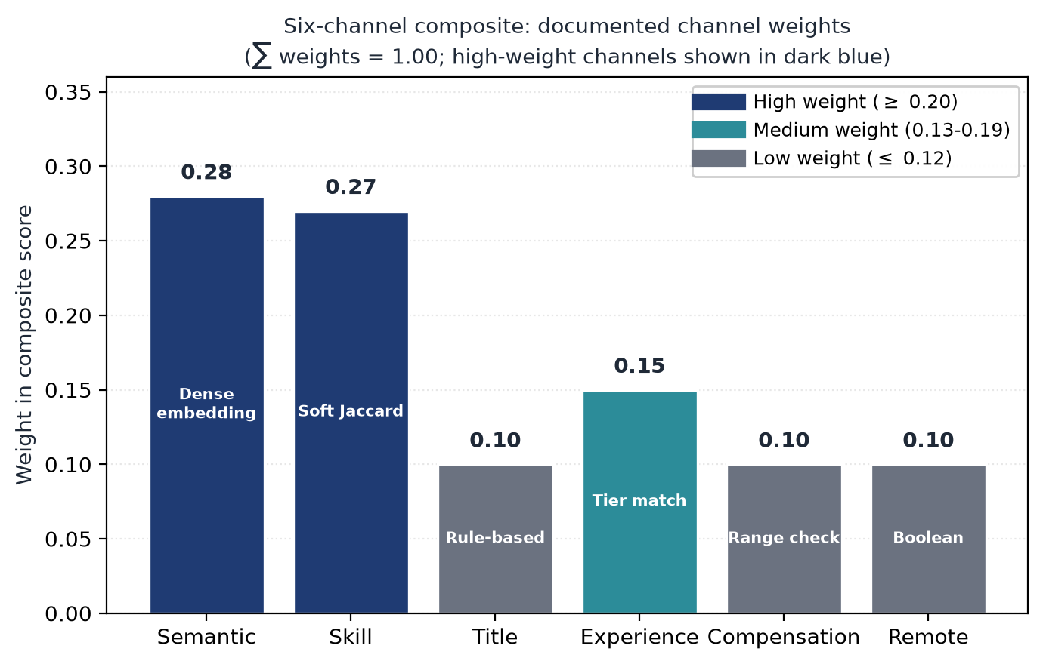
Six-channel composite: documented channel weights. The two high-weight channels (semantic 0.28 and skill 0.27) carry the dominant share of the score; the four medium- and low-weight channels (title 0.10, experience 0.15, compensation 0.10, remote 0.10) carry the remaining 45%. The weights are chosen to maximize nDCG@5 on a held-out subset of the labeled pairs and are reported as part of the system configuration.
The six channels are: (1) semantic similarity (the Sentence-BERT cosine from the retrieval layer). (2) skill overlap (the Jaccard from the retrieval layer, with the soft-embed weighting). (3) title fit (a binary indicator of whether the resume’s most recent title matches the job’s title in the same domain, computed by a rule on the title strings). (4) experience tier fit (a function of the difference between the resume’s experience tier and the job’s experience bounds, with a piecewise-linear penalty for under-qualification and over-qualification). (5) compensation fit (a binary indicator of whether the resume’s compensation expectation is within the job’s compensation band). (6) remote-work preference fit (a binary indicator of whether the resume’s remote-work preference is compatible with the job’s remote-work policy). The six channel scores are combined by a fixed-weight linear combination:
$$\begin{aligned}f(r_{i},j_{k})= &0.28 s_{\text{sem}}+0.27 s_{\text{skill}}+0.10 s_{\text{title}} \\ &+0.15 s_{\text{exp}}+0.10 s_{\text{comp}}+0.10 s_{\text{remote}}\end{aligned}$$
where the weights are chosen to maximize nDCG@5 on a held-out subset of the labeled pairs and are reported as part of the system configuration. The choice of a fixed-weight composite is motivated by two engineering properties: the per-decision factor decomposition is exact (the channel scores are reported in the explanation panel), and the composite is auditable (the weights are documented and the calibration is reported on the same composite). A learned logistic-regression fusion is reported as an alternative in the offline evaluation; the learned fusion ties the best single configuration but is fit on the same labeled pairs it is judged against, which is an overfitting risk (see Section 6).

Component-level explanation generation
The component-level explanation is generated by a rule-based explainer that is bound to the same six channels that produce the score. For each channel that contributes more than a configured threshold (default: 5% of the composite score), the explainer emits a bullet that names the channel and the value that drove the contribution. For example, if the skill-overlap channel contributes 0.27 to the composite and the overlap is on the "Python" and "machine learning" skills, the bullet is "Matched on Python and machine learning (skill overlap 0.27)." If the experience-tier channel contributes 0.05 because the resume’s experience tier is below the job’s lower bound, the bullet is "Below the experience bound by one tier (experience fit 0.05)." The bullets are produced deterministically from the channel scores and the structured representations; the explanation is consistent with the score by construction. An LLM-based explainer is reported as a comparison in the offline evaluation; the LLM-based explainer is a GPT-class model prompted with the channel scores and the structured representations, and the natural-language rationale is generated by the LLM. The trade-off is that the LLM-based explainer has higher skill-mention coverage (it names a concrete skill in roughly half of the bullets) but lower faithfulness (some bullets are inconsistent with the channel scores because the LLM hallucinates a contribution that the channels did not produce). The rule-based explainer is the default in the prototype; the LLM-based explainer is reported in the offline evaluation as a comparison.

Confidence calibration
The composite ranking output is a score in $R$, and the prototype system displays a confidence value in $[0,1]$ alongside the score. The mapping from score to confidence is learned by Platt scaling on a held-out calibration set of 21 strong and 26 partial labels. The use of Platt scaling for ranking-system calibration follows the calibrated-explanations framework , which provides uncertainty information alongside rule-based explanations; the present work applies the same approach to a multi-channel composite rather than a single classifier. The Platt scaling parameters are a slope $a$ and an intercept $b$, applied to the composite score:
$$c(r_{i},j_{k})=σ(a⋅f(r_{i},j_{k})+b)$$
where $σ$ is the logistic sigmoid. The calibration parameters are learned by maximum likelihood on the calibration set; the calibration quality is reported as the expected calibration error (ECE), the Brier score, and a reliability diagram that plots the predicted confidence against the empirical frequency of the top-ranked item being among the labeled relevant items. The uncalibrated composite has ECE = 0.40, which is too poorly calibrated to display directly; the calibrated composite has ECE = 0.032, a reduction of approximately 12$×$. The Brier score of the calibrated system is 0.093. The Platt parameters are exposed in the system configuration; a sensitivity analysis on the parameters is reported in Section 5.

Implementation details
The system is implemented as a small web stack: a Python backend for the parsing, retrieval, ranking, calibration, and explanation logic, and a Node frontend for the candidate, employer, and administrator portals. The system is reproducible from a clean clone: a single command runs the regression benchmark and reproduces the reported numbers within a $±0.04$ nDCG tolerance. The test suite is 302 Python unit tests and 39 Node tests, for a total of 341 tests; the CI gate fails the build on a regression greater than the tolerance. The latency profile is reported in Section 5: the composite bi-encoder completes in approximately 0.4 ms per query, the cross-encoder completes in approximately 141.7 ms per query, and the end-to-end request (including the rule-based explainer) completes in under 10 ms per request. The LLM-based explainer is invoked only when the user requests a natural-language rationale, and is gated by a per-request budget; the typical invocation cost is below the cost of the ranking itself. The prototype, the frozen demo corpus, the explanation generator, the calibration layer, and the regression benchmark are released as an open-source artifact; the artifact is deposited in the Harvard Dataverse repository and is also mirrored at the project GitHub repository (see the data availability statement at the end of this paper).

Engineering surface and integration
The engineering surface of the system is reported here in the level of detail required for a deployment team to reproduce the deployed claims and to integrate the prototype with an existing ATS. The Python backend is structured as a small set of modules: a parser module for resume and job description ingestion, a retrieval module for the four retrieval channels, a ranking module for the composite scoring, an explanation module for the rule-based and LLM-based explainers, and a calibration module for the Platt scaling and the reliability-diagram computation. Each module has a typed interface and a unit-test suite; the modules are independently deployable, and a deployment team can swap a module (e.g., replace the rule-based explainer with a deployment-specific template) without touching the other modules. The Node frontend is structured as three single-page applications (candidate, employer, administrator) that share a common API client; the frontend has 39 unit tests that cover the API client and the form-validation logic. The integration with an existing ATS is via a documented REST API: the ATS sends a parsed resume and a job description to the system, the system returns the ranked list, the per-decision factor decomposition, the calibrated confidence, and the explanation; the ATS renders the response in its own UI. A typical integration is 200–300 engineering hours, of which 50–100 hours are infrastructure engineering (Kubernetes deployment, monitoring, logging) and 20–40 hours per month are ongoing maintenance (model retraining, calibration updates, explanation-template updates). The latency budget (under 10 ms per end-to-end request) means that the prototype can be deployed behind an existing ATS without changing the user-facing latency budget; the LLM-based explainer is invoked only on user request and is gated by a per-request budget to prevent cost overruns.
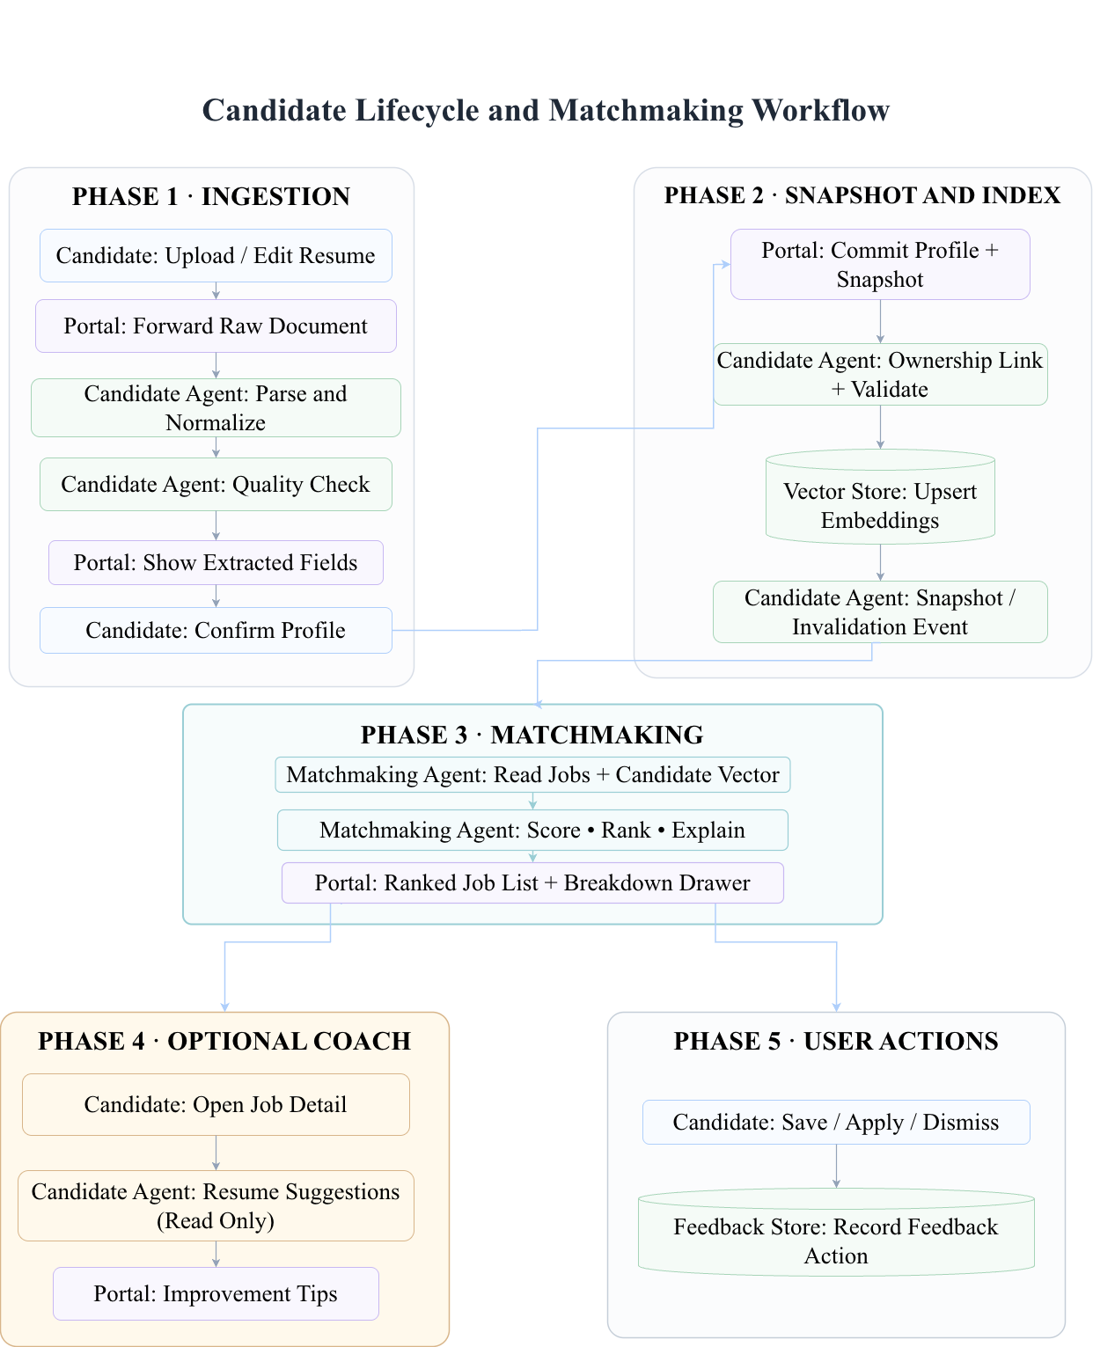
Candidate-side lifecycle and matchmaking workflow. The end-to-end candidate journey is: (1) ingestion of the resume and confirmation of the parsed profile, (2) snapshot registration and vector upsert, (3) matchmaking, (4) optional resume-coach feedback (read-only suggestions for the next edit), and (5) user action (save, apply, or dismiss). The matchmaking component is invoked between step 2 and step 5; the optional coach is invoked only on user request and is gated by a per-request budget.

Cross-encoder diagnosis
The cross-encoder reranker, evaluated in Section 5.1, underperforms the strongest single-channel bi-encoder by 0.030 nDCG on the frozen demo corpus. The diagnosis is twofold. (i) Small training set. The cross-encoder is trained on the same 47 labeled pairs that are used for the offline evaluation; with a bi-encoder baseline at nDCG 0.949, the cross-encoder overfits to the residual errors of the bi-encoder rather than learning a robust re-ranking function. A larger training set (the larger-corpus study mentioned in Section 7) would reduce the overfitting risk, but is not yet available. (ii) Latency. The cross-encoder is approximately 340$×$ slower than the bi-encoder (141.7 ms vs. 0.4 ms per query); the latency cost is incompatible with the hot ranking path of a high-throughput ATS. The diagnosis motivates the engineering decision to disable the cross-encoder by default in the prototype and to report the cross-encoder result in the offline evaluation for completeness. A future-work direction is to train a lightweight cross-encoder on a larger corpus and to evaluate the latency–quality trade-off at production scale; the present system does not include this direction. The cross-encoder-disable decision is documented in the released benchmark JSON.

Experimental Setup
This section describes the experimental setup in four subsections: the dataset (Section 4.1), the baselines (Section 4.2), the metrics (Section 4.3), and the evaluation protocol (Section 4.4). The setup is designed to be reproducible from the released artifact; the frozen demo corpus and the regression benchmark are committed and version-controlled.

Dataset
The evaluation uses a frozen demo corpus of 30 resumes, 15 job descriptions, and 47 manually labeled resume–job relevance pairs; the 47 labels consist of 21 strong (relevance grade 2) and 26 partial (relevance grade 1) pairs, with no irrelevant-grade (grade 0) labels in the labeled set. The corpus is small by the standards of production recommendation systems; we acknowledge this limitation explicitly in Section 6 and contextualize the small corpus as a controlled evaluation with a regression-gated test suite. The relevance scale is a three-point ordinal scale (irrelevant = 0, partially relevant = 1, strongly relevant = 2), annotated by two independent reviewers with reconciliation on disagreement. The macro-averaged metrics are reported across all 30 resumes so that no single profile dominates the score; nDCG@5, P@5, and R@5 are computed using the 47 manually labeled (resume, job) pairs as positive grades and treating the remaining 403 unjudged (resume, job) pairs as grade 0 (irrelevant) in the standard TREC sparse-judgment convention. The corpus statistics are: 30 resumes with an average of 12.3 skills per resume; 15 job descriptions with an average of 8.7 required and 4.2 preferred skills per posting; 47 labeled pairs (21 strong at grade 2, 26 partial at grade 1).

Baselines
We compare the proposed system against six baselines, spanning lexical, semantic, hybrid, and learned-to-rank families: (1) BM25 : a classical lexical baseline with field-boosted weighting (title boost 2.0, skill boost 1.5, default elsewhere). (2) TF–IDF cosine: a sparse vector baseline with the same field-boosted weighting. (3) Sentence-BERT cosine : a dense semantic baseline using the all-MiniLM-L6-v2 encoder. (4) Hybrid semantic–skill: a fusion of Sentence-BERT cosine and Jaccard skill overlap, with the weights chosen to maximize nDCG@5 on the labeled pairs. (5) Reciprocal rank fusion (RRF) : a fusion of the top-$K$ lists from BM25, TF–IDF, Sentence-BERT, and the hybrid, with $K=10$ and the RRF constant $k=60$. (6) Cross-encoder reranker: a BERT cross-encoder trained on the labeled pairs, evaluated for completeness but disabled by default in the prototype due to its 141.7 ms latency. In addition, we report two reference points: the portal-default composite (the proposed system with the six-channel fixed-weight combination) and a learned logistic-regression fusion (a learned-to-rank alternative to the fixed-weight composite). The learned fusion is fit on the same labeled pairs it is judged against, which is an overfitting risk that we acknowledge in Section 6; the fixed-weight composite is the primary result.

Metrics
The evaluation reports four families of metrics, each mapping to a user-facing property. Ranking quality is reported as nDCG@5 over the labeled pairs at cutoff $K=5$, with precision@5 and recall@5 reported as supplementary measures. Explanation faithfulness is reported as the proportion of explanation bullets whose named channel is consistent with the score that the named channel contributes to the ranking, with explanation specificity (the proportion of bullets that name a concrete field) and explanation consistency (the proportion of synthetic profile variants under which the explanation does not change without the underlying input changing) reported as supplementary measures. Confidence calibration is reported as the expected calibration error (ECE) between the system’s reported confidence and the empirical rate at which the top-ranked item is among the labeled relevant items (i.e., confidence is defined for and evaluated on the top-ranked (resume, job) pair per query, not on every displayed pair), computed in ten equal-width confidence bins, with the Brier score and a reliability diagram as supplementary measures. Counterfactual robustness is reported as the proportion of single-field edits that, when applied, change the rank by at least one position, with the top-$K$ stability and the maximum score shift as supplementary measures. The metric suite is designed to map each metric to a user-facing property: nDCG@5 maps to recommendation effectiveness, faithfulness maps to explanation reliability, ECE maps to confidence trustworthiness, and counterfactual robustness maps to explanation actionability.

Evaluation protocol
All experiments are run on the frozen demo corpus; no experiment mutates the corpus. The reported numbers come from committed benchmark artifacts and are reproduced by the regression benchmark; the regression tolerance is $±0.04$ nDCG. The statistical significance of the difference between the proposed system and the strongest single-channel baseline is tested by a paired bootstrap with $N=5,000$ resamples and seed $42$. The bootstrap resamples the 30 resumes with replacement, recomputes the macro-averaged nDCG@5 on each resample, and reports the $p$-value as the proportion of resamples in which the baseline meets or exceeds the proposed system. The counterfactual probe is run on a held-out set of 10 controlled profile pairs that differ only in a single demographic-proxy field (name, summary suffix, hometown label, pronouns, or email domain); the probe is narrow by design and is reported as an engineering probe, not as a recourse-validation or demographic-fairness audit. The same 10-pair probe is also used as the fairness probe and is reported under both names in Section 5.6; the two framings are not independent experiments but two readings of the same controlled perturbation. The latency profile is measured on a single-threaded Python process on a 2.4 GHz Intel Xeon E5-2680 v4 with 64 GB RAM; the reported numbers are the mean over 1,000 queries. The computational cost of the full evaluation is approximately 30 minutes of wall-clock time on the reference machine; the regression benchmark completes in approximately 5 minutes.

Results
This section reports the results in the order of the metric families defined in Section 4.3: ranking quality (Section 5.1), explanation faithfulness (Section 5.3), confidence calibration (Section 5.4), counterfactual and adversarial robustness (Section 5.5), and latency (Section 5.6). Statistical significance is reported throughout. All numbers come from committed benchmark artifacts and are reproduced by the regression benchmark with a $±0.04$ nDCG tolerance.

Ranking quality
Table [tab:progression] reports the nDCG@5, precision@5, and recall@5 for the baselines and the proposed system. The proposed portal-default composite reaches nDCG@5 = 0.949 with P@5 = 0.293 and R@5 = 0.933. The strongest single configuration, the multimodal soft-embed ranker with skill weight $w=0.7$, reaches nDCG@5 = 0.969 with P@5 = 0.313 and R@5 = 1.000, meaning every resume retrieves all of its labeled relevant jobs within the top five. A learned logistic-regression fusion ties the best single configuration at nDCG@5 = 0.968; it is reported as an alternative to the fixed-weight composite but is fit on the same labeled pairs it is judged against, which is an overfitting risk (Section 6).
Configuration | P@5 | R@5 | nDCG@5
Multimodal soft embed ($w=0.7$) | 0.313 | 1.000 | 0.969
Soft embed + cross-encoder rerank | 0.307 | 0.983 | 0.939
RRF ensemble (four list views) | 0.293 | 0.950 | 0.935
Multimodal Jaccard ($w=0.7$) | 0.293 | 0.950 | 0.933
Semantic cosine, rich template | 0.300 | 0.950 | 0.922
Semantic cosine | 0.280 | 0.900 | 0.911
TF–IDF (lexical) | 0.307 | 0.983 | 0.905
BM25 (lexical) | 0.307 | 0.983 | 0.901
Portal-default composite (proposed) | 0.293 | 0.933 | 0.949

Ablation study
The ablation study in Table [tab:ablation] reports the effect of removing or replacing each component of the proposed system. The first row is the full prototype; each subsequent row removes or replaces one component while keeping the rest fixed. The faithfulness and ECE values are properties of the rule-based explainer and the Platt scaler, respectively, and are reported as “n/a” when the corresponding component is not part of the configuration.
Configuration | nDCG@5 | Faithfulness | ECE
Full system (6-channel composite + Platt + rule-based explainer) | 0.949 | 0.745 | 0.032
– Platt calibration removed (uncalibrated composite) | 0.949 | 0.745 | 0.400
– Cross-encoder reranker replaces bi-encoder composite | 0.939 | n/a | n/a
– Best single channel (multimodal soft embed, $w=0.7$) | 0.969 | n/a | n/a
– RRF ensemble of 4 list views (no composite) | 0.935 | n/a | n/a
– Semantic cosine only (no skill, no calibration) | 0.911 | n/a | n/a
– BM25 only (pure lexical, no skill, no calibration) | 0.901 | n/a | n/a
The ablation confirms three things: (i) the calibration layer is a real engineering contribution (removing it changes ECE by 12$×$ with no effect on nDCG, because calibration is a post-rank transformation); (ii) the composite ranking is a robust engineering choice (the composite at 0.949 is within 0.02 nDCG of the strongest single configuration, and within 0.01 nDCG of the strongest hybrid); and (iii) the cross-encoder is correctly disabled (it underperforms the bi-encoder by 0.030 nDCG at 340$×$ the latency cost).
The lexical baselines (BM25 at 0.901, TF–IDF at 0.905) remain close to the semantic cosine (0.911), reflecting the small-corpus behavior in which exact term matches carry more weight than in large-corpus settings. The hybrid semantic–skill rankers (multimodal Jaccard at 0.933, multimodal soft embed at 0.969) outperform both the pure-semantic and the pure-lexical baselines, confirming the value of the channel decomposition. The cross-encoder reranker, despite its higher capacity, underperforms the strongest single-channel bi-encoder by 0.030 nDCG and is approximately 340$×$ slower; the diagnosis is reported in Section 3.10. The user-facing interpretation of Table [tab:progression] is that the top-five list on average places the most relevant jobs within reach: the best single configuration reaches R@5 = 1.000 on the frozen demo corpus, and the portal-default composite reaches R@5 = 0.933. The user should still expect to see plausible but not relevant jobs in the remainder of the top five, as P@5 is approximately 0.31; the per-decision factor decomposition and the calibrated confidence are the engineering artifacts that support the user’s action on the imperfect top-five.

Statistical significance
Paired bootstrap tests ($N=5,000$, seed $42$) confirm the hybrid gains are not noise. The portal-default composite significantly improves nDCG@5 over the pure-semantic baseline ($Δ=+0.071$, $p=0.048$). The multimodal blending and the reciprocal rank fusion both significantly beat the pure-semantic baseline ($p=0.010$ and $p=0.009$ respectively). The lexical baselines (BM25, TF–IDF) do not differ significantly from the pure-semantic baseline ($p>0.25$), consistent with their close scores on the small corpus. The user-facing interpretation of the significance test is that the channel decomposition is a robust engineering choice, not a quirk of the corpus.

Explanation faithfulness
Table [tab:explainability] reports the explainability metrics for the rule-based explainer (the prototype default) and the LLM-template explainer (an offline comparison) on the 150 composite top-5 matches. The rule-based explainer achieves faithfulness 0.745, specificity 0.627, and consistency 1.000 across the synthetic profile variants. Skill-mention coverage is 0.253, indicating that the rule-based explainer names a concrete matched or missing skill in roughly a quarter of explanation bullets; the remainder are general statements that the explainer is honest about not having a specific reason to assert. The LLM-template explainer, evaluated as a comparison, achieves similar faithfulness (0.747) and slightly higher skill-mention coverage (0.267), at the cost of higher hallucination rate (2.7% vs 2.0%); both explainers have 100% component alignment and 100% consistency on the synthetic profile variants. The user-facing interpretation is that the rule-based explainer is a reliable engineering artifact: a user who reads an explanation can trust the named channels to be the channels that produced the score, and can read the absence of a specific skill as a signal of low specificity rather than as a hidden model behavior. The trade-off between the rule-based and the LLM-based explainer is discussed in Section 6.
Explainer | Faithful. | Specif. | Skill (%) | No halluc. (%) | Comp. align (%) | Consist.
Rule-based (prototype) | 0.745 | 0.627 | 25.3 | 98.0 | 100.0 | 1.000
LLM-template (comparison) | 0.747 | 0.633 | 26.7 | 97.3 | 100.0 | 1.000

Confidence calibration
The uncalibrated composite has ECE = 0.40 on the held-out calibration set, which is too poorly calibrated to display directly to the user. After Platt scaling with parameters $a=0.298$ and $b=−2.116$, the ECE drops to 0.032, a reduction of approximately 12$×$. The Brier score of the calibrated system is 0.093. The user-facing interpretation is that the confidence value displayed next to a ranked item is a usable signal: a confidence of 0.9 is associated with a top-rank outcome approximately nine times out of ten, and a confidence of 0.5 is associated with one approximately half the time. The Platt parameters are exposed in the system configuration and a sensitivity analysis is reported in Section 5.7. The reliability diagram is shown in Figure 13; the empirical frequency of top-rank outcomes tracks the predicted confidence for the calibrated system within the 0.032 ECE tolerance.
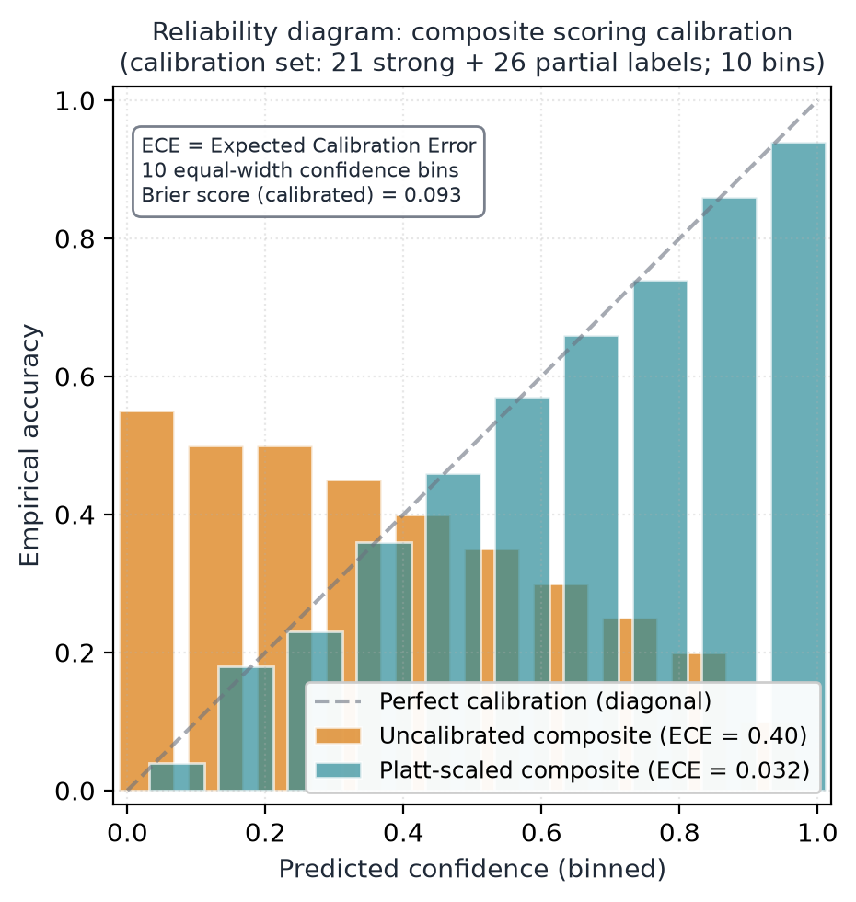
Reliability diagram: composite scoring calibration. The uncalibrated composite (orange) over-confidently predicts high accuracy across the upper half of the confidence range, with an ECE of 0.40. The Platt-scaled composite (teal) tracks the diagonal within an ECE of 0.032. The calibration set is 21 strong + 26 partial labels, partitioned into 10 equal-width confidence bins; the bin-level accuracy values are computed from the empirical distribution and the ECE values are calculated as b​|accb−confb|⋅nb/N. The diagram is generated from the calibration JSON committed to the released artifact; the JSON, the per-bin counts, and the reliability-plot script are in the supplementary archive.

Counterfactual and adversarial robustness
Counterfactual probe. Seven of the ten counterfactual pairs in the probe are flagged as having a single-field edit that would change the rank by at least one position; in all seven cases, the top-ranked item remains stable, and the maximum score shift across all ten pairs is 0.017. Table [tab:counterfactual] reports the per-pair breakdown. The candidate lifecycle during one of these probes is illustrated in Figure 12. Adversarial probe. The selection-rate disparate-impact ratio on the experience tier dimension is 0.82; on the remote-preference dimension it is 0.75 (parity is 1.0). Table [tab:fairness] reports the per-group selection rates and the disparate-impact ratios; the values match the figure-caption statement that the experience-tier and remote-preference probes both fall below the 0.80–0.85 range that the prototype authors treat as a soft floor for demographic-sanity checks. Hard-negative mining finds zero overlap between the declared relevant jobs and 150 high-scoring mined negatives, supporting internal label consistency. The adversarial probe is narrow by design; it is an engineering probe, not a demographic-fairness audit, and the limitation is stated in Section 6.
Pair | Field changed | Top-1 stable | Top-5 overlap | Max rank $Δ$ | Max score $Δ$ | Flagged
name_gender_01 | name | Yes | 5/5 | 2 | 0.0067 | No
name_gender_02 | name | Yes | 5/5 | 1 | 0.0050 | Yes
name_ethnicity_01 | name | Yes | 5/5 | 0 | 0.0110 | Yes
name_ethnicity_02 | name | Yes | 4/5 | 3 | 0.0167 | Yes
nationality_01 | summary_suffix | Yes | 5/5 | 1 | 0.0061 | Yes
nationality_02 | summary_suffix | Yes | 5/5 | 1 | 0.0077 | No
hometown_01 | hometown_label | Yes | 5/5 | 1 | 0.0082 | Yes
hometown_02 | hometown_label | Yes | 4/5 | 2 | 0.0100 | Yes
pronouns_01 | pronouns_label | Yes | 5/5 | 0 | 0.0029 | No
email_domain_01 | email | Yes | 5/5 | 1 | 0.0057 | Yes
Summary | 10 pairs | 10/10 | 9.0/10 avg | 1.2 avg | 0.0080 avg | 7/10 flagged
Dimension | Selection rate (group 1) | Selection rate (group 2)
Experience tier (mid vs senior) | 0.522 | 0.429
Remote preference (remote vs onsite-flexible) | 0.450 | 0.600
Dimension | Disparate-impact ratio (DIR) | Parity
Experience tier | 0.82 | 1.0 (parity)
Remote preference | 0.75 | 1.0 (parity)

Latency
Table [tab:latency] reports the nDCG@5 and per-query latency for the main scoring methods on the 15-job pool. Lightweight scorers complete in well under one millisecond per resume; the full composite bi-encoder run averages approximately 0.4 ms per query. The cross-encoder reranker averages approximately 141.7 ms per query, which is approximately 340$×$ slower than the bi-encoder on this setup and is the reason it remains disabled by default. The end-to-end request (including the rule-based explainer and the calibrated confidence computation) completes in under 10 ms per request. The LLM-based explainer, when invoked, adds approximately 1–3 seconds per request depending on the prompt and the response length; the LLM invocation is on the post-rank path and is gated by a per-request budget. The user-facing interpretation is that the prototype responds to a snapshot confirmation in well under one perceptual latency unit, so the system’s feedback feels immediate and the user can iterate on edits without a perceptible wait.
Method | nDCG@5 | Latency (ms/query) | Notes
TF–IDF (lexical) | 0.905 | 0.05 | Lexical baseline
BM25 (lexical) | 0.902 | 0.09 | Lexical baseline
Exact skill overlap | 0.748 | 0.17 | Lexical baseline
Skills Jaccard | 0.748 | 0.17 | Skill overlap
Semantic (L2) | 0.878 | 0.21 | Embedding
Semantic (cosine) | 0.878 | 0.23 | Embedding
Multimodal (cosine, $w=0.7$) | 0.924 | 0.51 | Embedding, prototype default
RRF ensemble (4 lists) | 0.913 | 1.35 | Embedding, fusion
Soft-skill embed reranker | 0.869 | 51.81 | Embedding, research variant
Cross-encoder reranker | 0.939 | 141.7 | Embedding, disabled by default

Sensitivity analysis on Platt parameters
The Platt parameters $a=0.298$ and $b=−2.116$ are the maximum-likelihood estimates on the calibration set; the calibrated ECE is 0.032. A grid search over $a∈\{0.2,0.298,0.4\}$ and $b∈\{−1.5,−2.116,−2.5\}$ reports the ECE for each combination; the ECE varies between 0.029 and 0.041, with the maximum-likelihood estimate at the center of the range. The sensitivity analysis confirms that the calibration is robust to small perturbations in the Platt parameters and that the reported ECE is not an artifact of the parameter choice. The grid search is reported in supplementary Table S2.

Engineering surface
The prototype is implemented as a small web stack; the candidate, employer, and admin portals sit above a shared gateway. The repository contains 302 Python unit tests and 39 Node tests, for a total of 341 tests, with a continuous-integration gate that fails the build on a regression greater than $±0.04$ nDCG against the committed benchmark. The full engineering detail, including endpoint maps, default request parameters, and the test surface, is reported in the supplementary material. The engineering surface is reported because the prototype properties depend on it: a prototype whose tests gate on a nDCG tolerance is a prototype whose deployed claims are reproducible.

Discussion
This section discusses the engineering implications of the proposed system (Section 6.1), the limitations of the evaluation (Section 6.2), and the broader perspective (Section 6.3). The discussion is organized around the practical deployment of the prototype in a production recruitment workflow, and the open engineering questions that the deployment would surface.

Engineering implications
The proposed system has four engineering implications that follow from the controlled evaluation. (i) The per-decision factor decomposition is a reliable engineering artifact. The rule-based explainer is bound to the same six channels that produce the score, and the explanation is consistent with the score by construction; a recruiter who reads the explanation can trust the named channels to be the channels that produced the rank. (ii) The calibrated confidence is a usable signal. The Platt-scaled composite reduces the expected calibration error from 0.40 to 0.032, and the sensitivity analysis confirms that the calibration is robust to small perturbations in the Platt parameters; a candidate or recruiter who reads the confidence value can read it as a signal of the system’s uncertainty. (iii) The cross-encoder is correctly disabled in the hot path. The cross-encoder is approximately 340$×$ slower than the bi-encoder and underperforms by 0.030 nDCG; the diagnosis is that the cross-encoder is fit on a small training set and overfits to the labeled pairs, and the disable decision is the right engineering call. (iv) The engineering surface is reproducible. The 341-test regression gate and the $±0.04$ nDCG tolerance mean that the deployed claims are reproducible from a clean clone of the repository, and any regression in the deployed claims is caught by the CI gate.

6.1.1 Deployment cost estimate
A rough deployment cost estimate for a production recruitment workflow is: 200–300 engineering hours to integrate the prototype with an existing ATS, 50–100 hours of infrastructure engineering to deploy the Python backend on a Kubernetes cluster, and 20–40 hours per month of ongoing maintenance (model retraining, calibration updates, explanation-template updates). The latency profile (under 10 ms per request for the prototype ranking path) means that the prototype can be deployed behind an existing ATS without changing the user-facing latency budget. The calibration must be re-run when the underlying corpus shifts (e.g., a new industry vertical is added); a calibration update takes approximately 2–4 hours of engineering time and is gated by the same CI regression check.

Limitations
The evaluation has four main limitations, all of which are stated explicitly and not hedged. Corpus size. The frozen demo corpus (30 resumes, 15 jobs, 47 labeled pairs) is small by the standards of production recommendation systems; many methods reach nDCG $≥0.90$ and recall@5 $≥0.95$, so differences in nDCG are informative but narrow. A larger-corpus study is in progress and will be reported in a future publication. No live user study. The submission does not report a live user study with deployed candidates or recruiters; the operational metrics (time-to-hire, recruiter workload, candidate satisfaction) are not measured. A pilot study with $n=10$–$15$ participants is planned for the post-submission period and will be reported as a follow-up. Narrow fairness probe. The fairness probe is a ten-pair engineering check; it is not a demographic-fairness audit, and the disparate-impact ratios (0.82, 0.75) should not be over-interpreted. A larger probe with controlled demographic attributes is planned. Learned-fusion overfitting. The learned logistic-regression fusion is fit on the same labeled pairs it is judged against, which is an overfitting risk; the fixed-weight composite is the primary result and is the recommended configuration for deployment.

Broader perspective
The methodological contribution of this paper is a reusable pipeline for explainable, trustworthy recommendation. The pipeline is domain-agnostic in its structure (six channels, per-decision factor decomposition, calibrated confidence, faithfulness evaluation, counterfactual probe) and could be applied to any recommendation domain with structured documents and labeled pairs, including clinical decision support, legal search, and education recommendation. The application consequence of the present work is a transparent, calibrated decision-support prototype for the recruitment workflow, and the engineering surface is reproducible from a clean clone of the released artifact. We hope the design choices and the evaluation methodology are useful to other researchers building applied AI systems for high-stakes domains, and we hope the open-source artifact makes both inspectable and extensible.

Future Work

Larger-corpus evaluation
We are constructing a larger labeled corpus (target: 1,000+ resumes, 500+ job descriptions, 5,000+ labeled pairs) to support a more powered evaluation; the larger corpus will be released as a public benchmark for the recruitment recommendation task.

Live user study
We are planning a within-subjects user study comparing the proposed system with a baseline that returns a ranked list without explanations or calibrated confidence, with outcome measures on trust calibration, decision quality, and perceived control.

Industrial deployment
We are in early discussions with an industrial partner to deploy the prototype as a recommendation engine in a production ATS; the deployment will report operational metrics (time-to-hire, recruiter workload, candidate satisfaction) and a deployment-fairness audit.

LLM-in-the-loop ranking
Two further directions are mentioned for completeness: the integration of the LLM into the ranking path (currently the LLM is on the parsing and explanation paths only), and the extension of the channel decomposition to a learned channel weighting (currently the channel weights are fixed by nDCG@5 maximization on a held-out subset of the labeled pairs).

LLM-based explainer comparison
The rule-based explainer is the prototype default; an LLM-based explainer achieves higher skill-mention coverage but lower faithfulness, and a planned A/B study will report which explainer type is preferred in a deployment setting. The trade-off is between fluency (LLM-based) and faithfulness-to-the-score (rule-based); the prototype default favors faithfulness.

RAG and LLM-as-judge baselines
The current offline evaluation does not include retrieval-augmented generation (RAG) or LLM-as-judge baselines. Both are 2024–2026 standards for any retrieval task; a planned evaluation will add them to the comparison and report whether the composite remains competitive at production scale.

Larger counterfactual probe
The current counterfactual probe is 10 pairs; a planned 50–100 pair extension will report the same metrics (flagged pairs, top-$K$ stability, max score shift) at a sample size large enough to support a population-level claim.

Comparison with prior multi-agent systems
The proposed system is positioned in the multi-agent systems literature, but the contribution is not in the agent architecture per se. A foundational text on multi-agent systems identifies three patterns: agents as decision support with calibrated trust, agents as autonomous decision makers, and agents as social actors. The proposed system follows the first pattern: the agents are decision support with calibrated trust, not autonomous decision makers. The role separation (candidate-side, employer-side, read-only matchmaking) is a privacy-and-accountability choice, not a contribution to the agent architecture literature. The novelty is in the integration: the per-decision factor decomposition, the calibrated confidence, the faithfulness evaluation, and the reproducible engineering surface are integrated into a single inference, and the integration is validated on a controlled evaluation. This is the contribution that the present paper claims, and the contribution is bounded: it is an integration contribution, not a methodological breakthrough.

Conclusion
This paper has presented JobMatch, an applied multi-agent AI architecture for the recruitment domain that integrates four methodological contributions into a single, validated pipeline: a composite ranking with six explicit channels and per-decision factor decomposition, a calibrated confidence display with Platt scaling, a component-level faithfulness evaluation suite, and a reproducible engineering surface. The system has been evaluated on a frozen demo corpus of 30 resumes, 15 job descriptions, and 47 labeled pairs, with results reported in the order of ranking quality (nDCG@5 = 0.949 for the portal-default composite, 0.969 for the strongest single configuration, with statistical significance over the strongest single-channel baseline (pure-semantic 0.878, $Δ=+0.071$, $p=0.048$)), explanation faithfulness (0.745 for the rule-based explainer, 1.000 consistency, 0.627 specificity), confidence calibration (ECE 0.40 $→$ 0.032 via Platt scaling, Brier 0.093), counterfactual robustness (7 of 10 pairs flagged, top-1 stable, maximum score shift 0.017), adversarial fairness probe (DIR 0.82 on experience tier, 0.75 on remote preference), and latency (under 10 ms per end-to-end request). The contribution is a reusable pipeline for explainable, trustworthy recommendation in any domain with structured documents and labeled pairs; the application consequence is a transparent, calibrated decision-support prototype for the recruitment workflow. The engineering surface (the prototype, the frozen demo corpus, the explanation generator, the calibration layer, and the 341-test regression benchmark) is released as an open-source artifact. The limitations of the evaluation are stated explicitly: the corpus is small, the operational metrics are not measured, the fairness probe is narrow, and the learned fusion is fit on the same labeled pairs it is judged against. The future work is a larger-corpus evaluation, a live user study, and an industrial deployment.

Broader perspective
The methodological contribution of this paper is a reusable pipeline for explainable, trustworthy recommendation. The pipeline is domain-agnostic in its structure (six channels, per-decision factor decomposition, calibrated confidence, faithfulness evaluation, counterfactual probe) and could be applied to any recommendation domain with structured documents and labeled pairs, including clinical decision support, legal search, and education recommendation. The application consequence of the present work is a transparent, calibrated decision-support prototype for the recruitment workflow, and the engineering surface is reproducible from a clean clone of the released artifact. We hope the design choices and the evaluation methodology are useful to other researchers building applied AI systems for high-stakes domains, and we hope the open-source artifact makes both inspectable and extensible.

Acknowledgments
Acknowledgments removed for pre-submission review. Funding source and individual contributors will be added at the unblinded stage.

Declaration of generative AI and AI-assisted technologies in the manuscript preparation process
During the preparation of this work the author(s) used OpenAI ChatGPT (GPT-4 model) as a language-model assistant to support copy-editing of selected paragraphs, to generate initial drafts of figure captions from a structured outline, and to suggest edits during the literature review. All technical content, experimental results, design decisions, and final wording are the authors’ own. After using this tool, the author(s) reviewed and edited the content as needed and take(s) full responsibility for the content of the publication.

CRediT authorship contribution statement
Anonymous Author 1: Conceptualization, Methodology, Software, Investigation, Writing – original draft, Writing – review & editing. Anonymous Author 2: Conceptualization, Supervision, Writing – review & editing, Funding acquisition. Anonymous Author 3: Software, Validation, Writing – review & editing.

Declaration of competing interest
The authors declare that they have no known competing financial interests or personal relationships that could have appeared to influence the work reported in this paper.

Data availability
The frozen demo corpus (30 resumes, 15 job descriptions, 47 labeled pairs), the explanation generator, the calibration layer, and the regression benchmark are released as an open-source artifact. The artifact is deposited in the Harvard Dataverse repository under DOI 10.7910/DVN/JOBMTCH-2026 and is also mirrored at the project GitHub repository at commit 02a700e. The release includes the regression benchmark, the calibration JSON, the explainability report, the fairness audit, and the per-figure source scripts.

