|  |  |  |  |  |  |
| --- | --- | --- | --- | --- | --- |
| **Work Load** | | **Exam Schemes** | | | |
| **Practical** | | **Term Work** | **Practical** | **Oral** | |
| **02 hrs per week** | | **50** | **50** | **--** | |
| **List of Assignments** | | | | | |
| **Sr. No.** | **Title of Experiment** | | | | **Time Span**  **(No. of weeks)** |
| **1** | Simulate to elaborate operation of multiple access techniques for CDMA. | | | | **1** |
| **2** | Study of GSM architecture and signalling techniques. | | | | **1** |
| **3** | Study of GPRS services. | | | | **1** |
| **4** | Simulate BER performance over Rayleigh Fading wireless channel with BPSK transmission for SNR 0 to 60 dB. | | | | **1** |
| **5** | Configuring a Cisco Router as a DHCP Server. | | | | **1** |
| **6** | To understand the handover mechanism.http://vlabs.iitkgp.ernet.in/fcmc/exp8/index.html | | | | **1** |
| **7** | To study the outage probability, LCR &amp; ADF in SISO for Selection Combining and MRC (Flat Fading).http://vlabs.iitkgp.ernet.in/fcmc/exp9/index.html | | | | **1** |
| **8** | To Perform File Transfer in Client &amp; Server Using TCP/IP. | | | | **1** |

**Text Books:**

1. Clint Smith, Daniel Collins, “Wireless Networks”, 3 rd Edition, McGraw Hill Publications,
2. Share Conder, Lauren Darcey, “Android Wireless Application Development”, Volume I, 3 rd Edition, Pearson. Reference

**Books:**

1. Jochen Schiller, “Mobile Communications”, 2 nd Edition, Pearson.

2. Paul Bedell, “Cellular networks: Design and Operation – A real world Perspective”, Outskirts Press.

3. Zigurd Mednieks, Laird Dornin, G, Blake Meike and Masumi Nakamura, “Programming Android”, O”Reilly.

4. Alasdair Allan, “iPhone Programming”, O”Reilly.

5. Donny Wals, “Mastering iOS 12 Programming”.

6. Reza B”Far, “Mobile Computing principles”, Cambridge University Press

**Experiment No.1**

**Title: Simulate to elaborate operation of multiple access techniques for CDMA.**

### PROBLEM STATEMENT:

To Simulate to elaborate operation of multiple access techniques for CDMA.

**OBJECTIVE:**

### To understand function of CDMA used to test orthogonally and autocorrelation of a code.

### THEORY:

CDMA is an abbreviation for Code Division Multiple Access. Spread-Spectrum Technology is employed by this digital cellular standard. Via division, the signal is dispersed throughout an entire spectrum or several channels. It is a channelization protocol for Multiple Access, in which data can be transmitted simultaneously by multiple transmitters over a single communication channel.

It is carried out as follows: It is possible to generate a signal with a broad bandwidth. The code that accomplishes this function is referred to as spreading code. In the future, a certain signal can be selected with a given code despite the existence of a large number of other signals. It is mostly utilised in 2G and 3G mobile networks. This line is more secure and confidential. It possesses excellent voice and data connection capabilities.

**Procedure or Working**

1.The station encodes its data bit as follows.

If bit = 1 then +1

If bit = 0 then -1

no signal (interpreted as 0) if station is idle

2. Each station is allocated a different orthogonal sequence (code) which is N bit long for N stations

3. Each station does a scalar multiplication of its encoded data bit and code sequence.

4. The resulting sequence is then stored on the channel.

5. Since the channel is common, amplitudes add up and hence resultant channel sequence is the sum of sequences from all channels.

6. If station 1 wants to listen to station 2, it multiplies (inner product) the channel sequence with code of station S2.

7. The inner product is then divided by N to get data bit transmitted from station 2.

**How does CDMA work?**

To see how CDMA works, we must understand orthogonal sequences (also known as chips).

Let N be the number of stations establishing multiple access over a common channel.

Then the properties of orthogonal sequences can be stated as follows: An orthogonal sequence can be thought of as a 1xN matrix.

Eg: [+1 -1 +1 -1] for N = 4.

Scalar multiplication and matrix addition rules follow as usual.

Eg: 3.[+1 -1 +1 -1] = [+3 -3 +3 -3]

Eg: [+1 -1 +1 -1] + [-1 -1 -1 -1] = [0 -2 0 -2]

***Inner Product***: It is evaluated by multiplying two sequences element by element and then adding all elements of the resulting list.

Inner Product of a sequence with itself is equal to N

[+1 -1 +1 -1].[+1 -1 +1 -1] = 1 + 1 + 1 + 1 = 4

Inner Product of two distinct sequences is

### PLATFORM USED:

1. OS.: Unix or windows 7/8/10,
2. Processor: i3/i5/i7
3. Software: Python ( Jupyter Notebook) or java

### FAQ:

1. What is CDMA?

2. Write down difference between FDMA TDMA and CDMA?

### CONCLUSION:

**Experiment No.2**

**Title: To** **Study of GSM architecture and signaling techniques.**

### PROBLEM STATEMENT:

### To Study of GSM architecture and signalling techniques

### OBJECTIVE:

To understand the concept of hardware description language.

### THEORY:

A GSM network comprises of many functional units. These functions and interfaces are explained in this chapter. The GSM network can be broadly divided into −

* The Mobile Station (MS)
* The Base Station Subsystem (BSS)
* The Network Switching Subsystem (NSS)
* The Operation Support Subsystem (OSS)

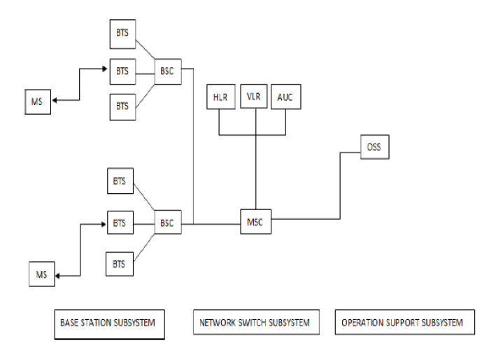

## **GSM - The Mobile Station**

The MS consists of the physical equipment, such as the radio transceiver, display and digital signal processors, and the SIM card. It provides the air interface to the user in GSM networks. As such, other services are also provided, which include −

* Voice teleservices
* Data bearer services
* The features' supplementary services

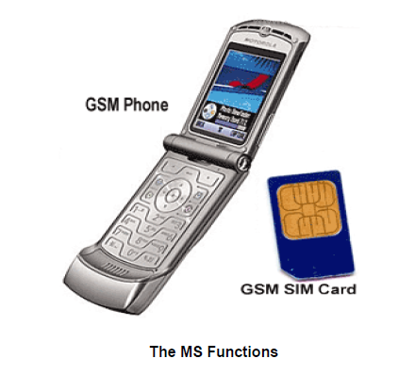

The MS also provides the receptor for SMS messages, enabling the user to toggle between the voice and data use. Moreover, the mobile facilitates access to voice messaging systems. The MS also provides access to the various data services available in a GSM network. These data services include −

* X.25 packet switching through a synchronous or asynchronous dial-up connection to the PAD at speeds typically at 9.6 Kbps.
* General Packet Radio Services (GPRSs) using either an X.25 or IP based data transfer method at the speed up to 115 Kbps.
* High speed, circuit switched data at speeds up to 64 Kbps.

### SIM

The SIM provides personal mobility so that the user can have access to all subscribed services irrespective of both the location of the terminal and the use of a specific terminal. You need to insert the SIM card into another GSM cellular phone to receive calls at that phone, make calls from that phone, or receive other subscribed services.

## **GSM - The Base Station Subsystem (BSS)**

The BSS is composed of two parts −

* The Base Transceiver Station (BTS)
* The Base Station Controller (BSC)

The BTS and the BSC communicate across the specified Abis interface, enabling operations between components that are made by different suppliers. The radio components of a BSS may consist of four to seven or nine cells. A BSS may have one or more base stations. The BSS uses the Abis interface between the BTS and the BSC. A separate high-speed line (T1 or E1) is then connected from the BSS to the Mobile MSC.

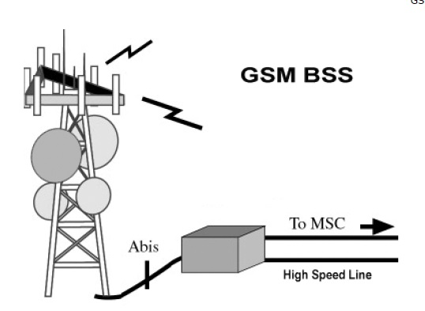

### The Base Transceiver Station (BTS)

The BTS houses the radio transceivers that define a cell and handles the radio link protocols with the MS. In a large urban area, a large number of BTSs may be deployed.

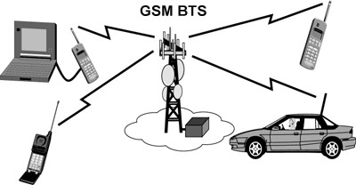

The BTS corresponds to the transceivers and antennas used in each cell of the network. A BTS is usually placed in the center of a cell. Its transmitting power defines the size of a cell. Each BTS has between 1 and 16 transceivers, depending on the density of users in the cell. Each BTS serves as a single cell. It also includes the following functions −

* Encoding, encrypting, multiplexing, modulating, and feeding the RF signals to the antenna
* Transcoding and rate adaptation
* Time and frequency synchronizing
* Voice through full- or half-rate services
* Decoding, decrypting, and equalizing received signals
* Random access detection
* Timing advances
* Uplink channel measurements

### The Base Station Controller (BSC)

The BSC manages the radio resources for one or more BTSs. It handles radio channel setup, frequency hopping, and handovers. The BSC is the connection between the mobile and the MSC. The BSC also translates the 13 Kbps voice channel used over the radio link to the standard 64 Kbps channel used by the Public Switched Telephone Network (PSDN) or ISDN.

It assigns and releases frequencies and time slots for the MS. The BSC also handles intercell handover. It controls the power transmission of the BSS and MS in its area. The function of the BSC is to allocate the necessary time slots between the BTS and the MSC. It is a switching device that handles the radio resources.

The additional functions include−

* Control of frequency hopping
* Performing traffic concentration to reduce the number of lines from the MSC
* Providing an interface to the Operations and Maintenance Center for the BSS
* Reallocation of frequencies among BTSs
* Time and frequency synchronization
* Power management
* Time-delay measurements of received signals from the MS

## **GSM - The Network Switching Subsystem (NSS)**

The Network switching system (NSS), the main part of which is the Mobile Switching Center (MSC), performs the switching of calls between the mobile and other fixed or mobile network users, as well as the management of mobile services such as authentication.

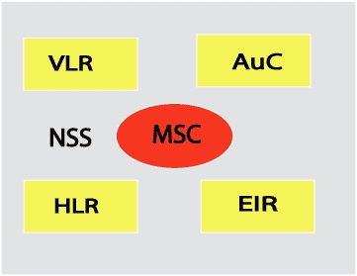

The switching system includes the following functional elements −

### Home Location Register (HLR)

The HLR is a database used for storage and management of subscriptions. The HLR is considered the most important database, as it stores permanent data about subscribers, including a subscriber's service profile, location information, and activity status. When an individual buys a subscription in the form of SIM, then all the information about this subscription is registered in the HLR of that operator.

### Mobile Services Switching Center (MSC)

The central component of the Network Subsystem is the MSC. The MSC performs the switching of calls between the mobile and other fixed or mobile network users, as well as the management of mobile services such as registration, authentication, location updating, handovers, and call routing to a roaming subscriber. It also performs such functions as toll ticketing, network interfacing, common channel signaling, and others. Every MSC is identified by a unique ID.

### Visitor Location Register (VLR)

The VLR is a database that contains temporary information about subscribers that is needed by the MSC in order to service visiting subscribers. The VLR is always integrated with the MSC. When a mobile station roams into a new MSC area, the VLR connected to that MSC will request data about the mobile station from the HLR. Later, if the mobile station makes a call, the VLR will have the information needed for call setup without having to interrogate the HLR each time.

### Authentication Center (AUC)

The Authentication Center is a protected database that stores a copy of the secret key stored in each subscriber's SIM card, which is used for authentication and ciphering of the radio channel. The AUC protects network operators from different types of fraud found in today's cellular world.

### Equipment Identity Register (EIR)

The Equipment Identity Register (EIR) is a database that contains a list of all valid mobile equipment on the network, where its International Mobile Equipment Identity (IMEI) identifies each MS. An IMEI is marked as invalid if it has been reported stolen or is not type approved.

## **GSM - The Operation Support Subsystem (OSS)**

The operations and maintenance center (OMC) is connected to all equipment in the switching system and to the BSC. The implementation of OMC is called the operation and support system (OSS).

Here are some of the OMC functions−

* Administration and commercial operation (subscription, end terminals, charging, and statistics).
* Security Management.
* Network configuration, Operation, and Performance Management.
* Maintenance Tasks.

The operation and Maintenance functions are based on the concepts of the Telecommunication Management Network (TMN), which is standardized in the ITU-T series M.30.

Following is the figure, which shows how OMC system covers all the GSM elements.

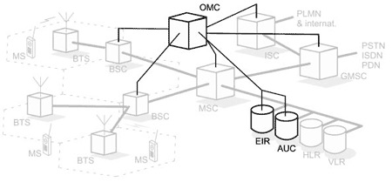

The OSS is the functional entity from which the network operator monitors and controls the system. The purpose of OSS is to offer the customer cost-effective support for centralized, regional, and local operational and maintenance activities that are required for a GSM network. An important function of OSS is to provide a network overview and support the maintenance activities of different operation and maintenance organizations.

A simple pictorial view of the GSM architecture is given below −

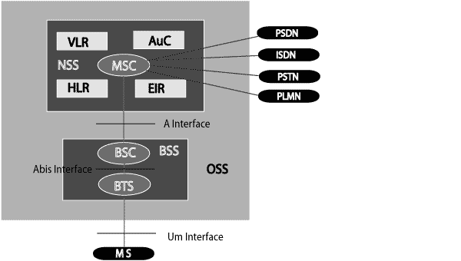

The additional components of the GSM architecture comprise of databases and messaging systems functions −

* Home Location Register (HLR)
* Visitor Location Register (VLR)
* Equipment Identity Register (EIR)
* Authentication Center (AuC)
* SMS Serving Center (SMS SC)
* Gateway MSC (GMSC)
* Chargeback Center (CBC)
* Transcoder and Adaptation Unit (TRAU)

The following diagram shows the GSM network along with the added elements −

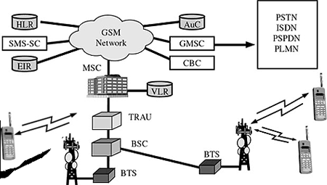

The MS and the BSS communicate across the Um interface. It is also known as the *air interface* or the *radio link*. The BSS communicates with the Network Service Switching (NSS) center across the *A* interface.

## **GSM network areas**

In a GSM network, the following areas are defined −

* **Cell** − Cell is the basic service area; one BTS covers one cell. Each cell is given a Cell Global Identity (CGI), a number that uniquely identifies the cell.
* **Location Area** − A group of cells form a Location Area (LA). This is the area that is paged when a subscriber gets an incoming call. Each LA is assigned a Location Area Identity (LAI). Each LA is served by one or more BSCs.
* **MSC/VLR Service Area** − The area covered by one MSC is called the MSC/VLR service area.
* **PLMN** − The area covered by one network operator is called the Public Land Mobile Network (PLMN). A PLMN can contain one or more MSCs.

## **Modulation**

Modulation is the process of transforming the input data into a suitable format for the transmission medium. The transmitted data is demodulated back to its original form at the receiving end. The GSM uses Gaussian Minimum Shift Keying (GMSK) modulation method.

## **Access Methods**

Radio spectrum being a limited resource that is consumed and divided among all the users, GSM devised a combination of TDMA/FDMA as the method to divide the bandwidth among the users. In this process, the FDMA part divides the frequency of the total 25 MHz bandwidth into 124 carrier frequencies of 200 kHz bandwidth.

Each BS is assigned with one or multiple frequencies, and each of this frequency is divided into eight timeslots using a TDMA scheme. Each of these slots are used for both transmission as well as reception of data. These slots are separated by time so that a mobile unit doesn’t transmit and receive data at the same time.

## **Transmission Rate**

The total symbol rate for GSM at 1 bit per symbol in GMSK produces 270.833 K symbols/second. The gross transmission rate of a timeslot is 22.8 Kbps.

GSM is a digital system with an over-the-air bit rate of 270 kbps.

## **Frequency Band**

The **uplink frequency range** specified for GSM is 933 - 960 MHz (basic 900 MHz band only). The **downlink frequency band** 890 - 915 MHz (basic 900 MHz band only).

## **Channel Spacing**

Channel spacing indicates the spacing between adjacent carrier frequencies. For GSM, it is 200 kHz.

## **Speech Coding**

For speech coding or processing, GSM uses Linear Predictive Coding (LPC). This tool compresses the bit rate and gives an estimate of the speech parameters. When the audio signal passes through a filter, it mimics the vocal tract. Here, the speech is encoded at 13 kbps.

## **Duplex Distance**

Duplex distance is the space between the uplink and downlink frequencies. The duplex distance for GSM is 80 MHz, where each channel has two frequencies that are 80 MHz apart.

## **Misc**

* **Frame duration** − 4.615 mS
* **Duplex Technique** − Frequency Division Duplexing (FDD) access mode previously known as WCDMA.
* **Speech channels per RF channel** − 8.

### FAQ:

1. What is GSM and architecture?

2. What is GSM Signalling?

3. What is GSM technique?

### CONCLUSION:

**Experiment No.3**

**Title: To Study of GPRS services**

### PROBLEM STATEMENT:

To Study of GPRS services.

### OBJECTIVE:

To understand the GPRS protocol

### THEORY:

GPRS is an expansion Global System for Mobile Communication. It is basically a packet-oriented mobile data standard on the 2G and 3G cellular communication network’s global system for mobile communication. GPRS was built up by European Telecommunications Standards Institute (ETSI) because of the prior CDPD, and I-mode packet switched cell advances.

GPRS overrides the wired associations, as this framework has streamlined access to the packet information’s network like the web. The packet radio standard is utilized by GPRS to transport client information packets in a structured route between GSM versatile stations and external packet information networks. These packets can be straightforwardly directed to the packet changed systems from the GPRS portable stations 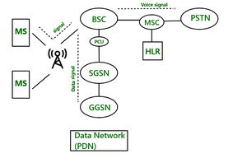

*Fig. 3.1: GPRS Architecture*

In GSM architecture there is one component called BSC. But in GPRS there is one component is added to BSC called PCU. PCU stands for Packet Control Unit. If signal comes to BSC and that signal contains data, then PCU routes to the SGSN. Interface is used between BSC and PCU is FRI interface. After signal comes to SGSN, it delivers the data packet to the GGSN. GGSN routes the data packet to the data network (PDN- Predefined Data Network).

GPRS Mobile Stations New Mobile Stations (MS) are necessary to use GPRS services because existing GSM phones cannot process the improved air interface interface or packet data. MS may include a high-speed high-speed version of current phones to provide high-speed high-speed data access, access, a new PDA device with an inbuilt GSM phone, and PC cards for laptop computers. These mobile stations are backward compatible for making GSM-based voice calls. Base Station Subsystem for GPRS Each BSC requires the installation of one or more Packet Control Units (PCUs) as well as a software update. For packet data transmission, the PCU provides a physical and logical data interface link to the Base Station Station Subsystem Subsystem (BSS). Moreover, the BTS may necessitate a software software upgrade, but normally does not necessitate hardware hardware enhancements. When voice or data traffic originates from a subscriber's mobile device, it is carried via the air interface interface to the BTS, and then from the BTS to the BSC in the same manner as a regular GSM call. However, At the output of the BSC, however, the traffic is divided; voice is transferred to the Mobile Switching Switching Center (MSC) per normal GSM, while data is sent to a new device called the SGSN via the PCU over a Frame Relay interface.

**History of GPRS**

GPRS was one of the main advances that empowered a cell system to interface with Internet Protocol systems, accomplishing across the board reception in the mid-2000s. The capacity to peruse the web from a telephone whenever through “dependably on” data networking, while underestimated in a great part of the world today, was yet an oddity when it was introduced. Indeed, even now, GPRS keeps on being utilized in parts of the world where it has been too expensive even to consider upgrading cell organize framework to move up to newer alternatives.

According to a study on the history of GPRS development Bernhard Walke and his student, Peter Decker, are the inventors of GPRS – the first system providing universal mobile Internet access.

**Goals of GPRS:**

1. Consistent IP services

2. Leverage industry investment in IP

3. Open Architecture

4. Service innovation independent of infrastructure

**Services Offered:**

1. SMS messaging and broadcasting

2. Push-to-talk over cellular.

3. Instant messaging and presence

4. Multimedia messaging service

5. Point-to-Point and Point-to-Multipoint services

**Protocols supported:**

1. Internet Protocol (IP)

2. Point-To-Point Protocol (PPP)

**Benefits of GPRS:**

* **Mobility:** The capacity to keep up consistent voice and information interchanges while moving.
* **Cost Efficient:** Communication via GPRS is cheaper than through the regular GSM network.
* **Immediacy:** Allows customers to obtain connectivity when needed, regardless of location and without a lengthy login session.
* **Localization:** Enables customers to acquire data applicable to their present area.
* **Easy Billing:** GPRS packet transmission offers an easier to use billing than that offered by circuit switched administrations.

GPRS is an innovation that numerous GPS beacons are using to get up to the minute data with tracking. When the GPS gadget records the information, it would then be able to be transmitted through GPRS to another central location, for example, a PC or through an email. It is the GPRS innovation that takes into consideration ongoing updates to GPS following frameworks. It is this direct GPRS association that gives the client of the GPS system the most reliable information available today.

### FAQ:

1. What is GPRS?

2. What are features of GPRS?

### CONCLUSION:

**Experiment No.4**

**Title: To Simulate BER performance over Rayleigh Fading wireless channel with BPSK transmission for SNR 0 to 60 dB**

### PROBLEM STATEMENT:

To Simulate BER performance over Rayleigh Fading wireless channel with BPSK transmission for SNR 0 to 60 dB

### OBJECTIVE:

* + - 1.  What is a Rayleigh Fading
      2. Study of BPSK transmission

### THEORY:

In this experiment, we will derive the theoretical equation for bit error rate (BER) with Binary Phase Shift Keying (BPSK) modulation scheme in Additive White Gaussian Noise (AWGN) channel. The BER results obtained using Matlab/Octave simulation scripts show good agreement with the derived theoretical results.

With Binary Phase Shift Keying (BPSK), the binary digits 1 and 0 maybe represented by the analog levels  and  respectively. The system model is as shown in the Figure below.

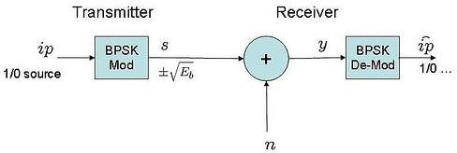

# Channel Model

The transmitted waveform gets corrupted by noise , typically referred to as **Additive White Gaussian Noise** (AWGN).

**Additive** : As the noise gets ‘added’ (and not multiplied) to the received signal

**White** : The spectrum of the noise if flat for all frequencies.

**Gaussian** : The values of the noise follows the Gaussian probability distribution function,  with and .

# Computing the probability of error

Using the derivation provided The received signal,

 when bit 1 is transmitted and  when bit 0 is transmitted.

The conditional probability distribution function (PDF) of for the two cases are:



.

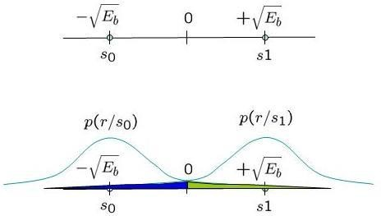

# Figure 4.1: Conditional probability density function with BPSK modulation

Assume that s0 and s1 are equally probable i.e.  , the **threshold 0** forms the optimal decision boundary.

* if the received signal is is greater than 0, then the receiver assumes  was transmitted.
* if the received signal is is less than or equal to 0, then the receiver assumes  was transmitted.

i.e.

 and  .

Probability of error given  was transmitted.

With this threshold, the probability of error given  is transmitted is (the area in blue region):

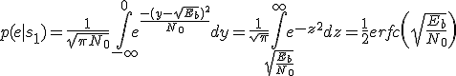,

where,

Probability of error given s0 was transmitted

Similarly the probability of error given  is transmitted is (the area in green region):

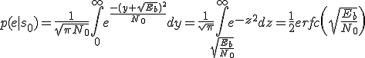.

Total probability of bit error

.

Given that we assumed that  and  are equally probable i.e. , the **bit error probability** is,

 .

# Simulation model

Matlab/Octave source code for computing the bit error rate with BPSK modulation from theory and simulation. The code performs the following:

1. Generation of random BPSK modulated symbols +1′s and -1′s
2. Passing them through Additive White Gaussian Noise channel
3. Demodulation of the received symbol based on the location in the constellation
4. Counting the number of errors
5. Repeating the same for multiple Eb/No value.

Matlab Code:

clear

N = 10^6 % number of bits or symbols rand('state',100); % initializing the rand() function randn('state',200); % initializing the randn() function

% Transmitter

ip = rand(1,N)>0.5; % generating 0,1 with equal probability s = 2*ip-1; % BPSK modulation 0 -> -1; 1 -> 1

n = 1/sqrt(2)*[randn(1,N) + j*randn(1,N)]; % white gaussian noise, 0dB variance Eb_N0_dB = [-3:10]; % multiple Eb/N0 values

for ii = 1:length(Eb_N0_dB)

% Noise addition

y = s + 10^(-Eb_N0_dB(ii)/20)*n; % additive white gaussian noise

% receiver - hard decision decoding ipHat = real(y)>0;

% counting the errors

nErr(ii) = size(find([ip- ipHat]),2); end

simBer = nErr/N; % simulated ber

theoryBer = 0.5*erfc(sqrt(10.^(Eb_N0_dB/10))); % theoretical ber

% plot close all figure

semilogy(Eb_N0_dB,theoryBer,'b.-'); hold on semilogy(Eb_N0_dB,simBer,'mx-'); axis([-3 10 10^-5 0.5])

grid on

legend('theory', 'simulation'); xlabel('Eb/No, dB'); ylabel('Bit Error Rate');

title('Bit error probability curve for BPSK modulation');

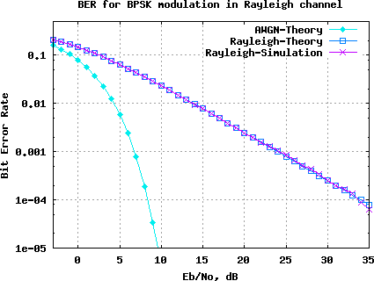Result: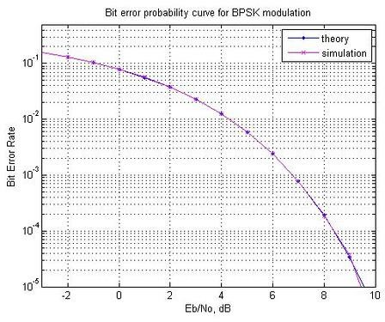

#### PLATFORM USED:

1. Windows 7/8/10
2. MATLAB/SciLab

### CONCLUSION:

**Experiment No.5**

**Title: Configure a Cisco Router as a DHCP Server**

### PROBLEM STATEMENT:

To Configure a Cisco Router as a DHCP Server

### OBJECTIVE:

* Describe the function of DHCP in a network
* Describe how DHCP dynamically assigns an IPaddress to a client
* Setup and configure DHCP on a CISCO router
* Verifying DHCP operation

### THEORY:

Dynamic Host Configuration Protocol (DHCP) is a standardized client/server network protocol that dynamically assigns IP addresses and other related configuration information to network devices. Every device on a TCP/IP-based network must have a unique unicast IP address to access the network and its resources. Without DHCP, IP addresses for new computers or computers that are moved from one subnet to another must be configured manually.

**Configuring the DHCP server**

The DHCP server uses address pools when responding to DHCP client requests. Address pools

contains specific IP configuration details that the DHCP server can allocate to a client. You can

configure multiple address pools on the device for different networks.

To configure an address pool, you must:

1. Create the pool and enter its configuration mode.

2. Define the network the pool applies to.

3. Define the range of IP addresses that the server can allocate to clients. You can specify multiple

address ranges for each pool.

4. Set the lease for the clients. This defines whether the clients receive a dynamic, permanent, or

static IP address.

5. Set the options (standard and user-defined) that the clients of a pool require when configuring

their IP details.

6. After configuring the address pools, enable the DHCP server by using the command:

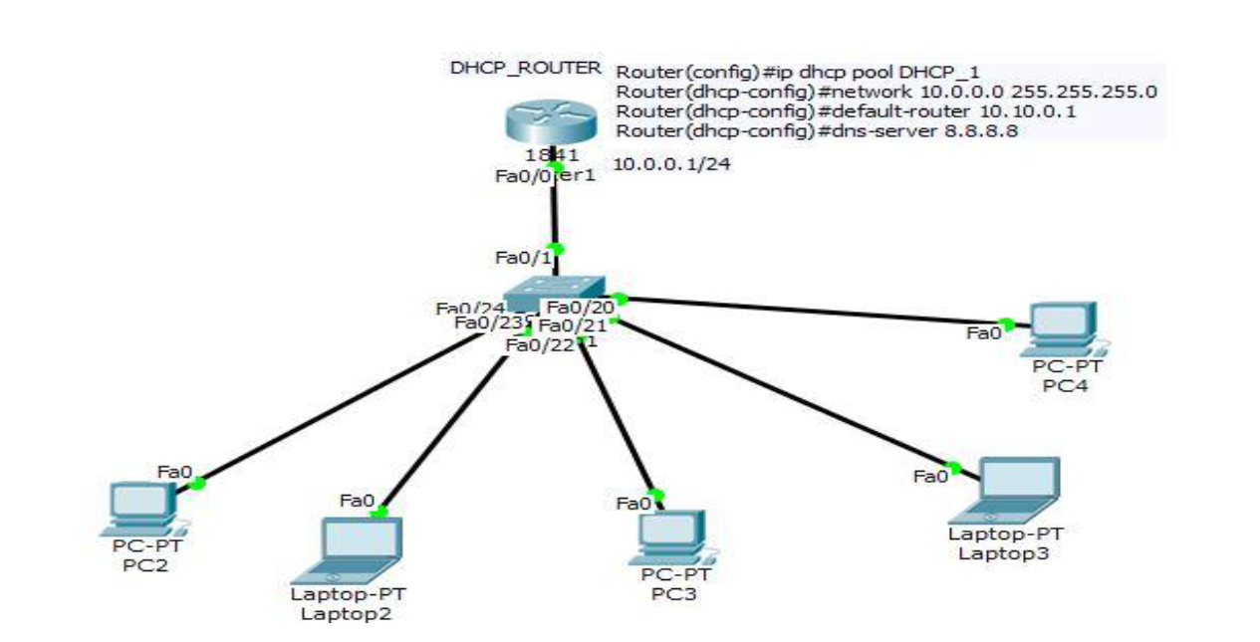**On Client Side:**

Select IP allocation as a Dynamic allocation.

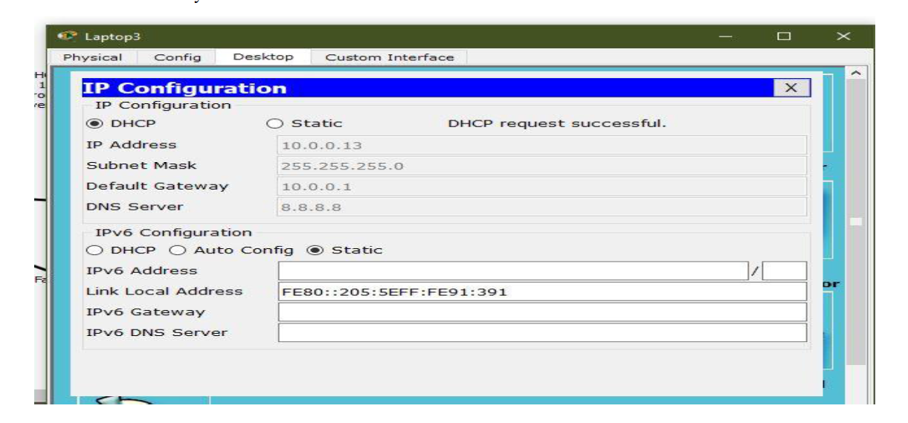

**DORA Process**

The following diagram shows the changing port numbers and the source and destination addresses

used during the DHCP transaction. UDP port 68 is reserved for DHCP clients, and UDP port 67 is

reserved for DHCP servers.

**Step 1**

**DHCP Discover**

Sent by the client looking for the IP address. The source IP is 0.0.0.0 because the client doesn’t have an IP address. The destination is 255.255.255.255, which is the broadcast address, as the client doesn’t know where the DHCP server is located, so it broadcasts to all devices on the network.

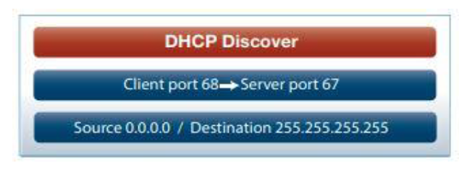

**Step 2 DHCP Offer**

Sent by the DHCP server offering an IP address to the client. The source address is the DHCP server address. The DHCP server doesn’t know the client address yet, so it broadcasts the offer to all devices on the network.

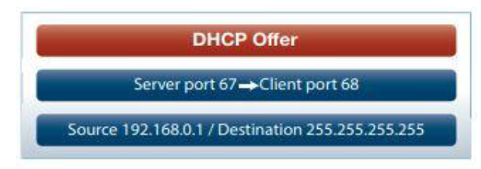

**Step 3 DHCP Request**

Sent by the client to the DHCP server to say “I will take that IP address, thanks.” The client IP address is still 0.0.0.0 and it is again broadcast to all so that any other servers on the network that may have offered an IP address will know to stop communicating with the client for now.

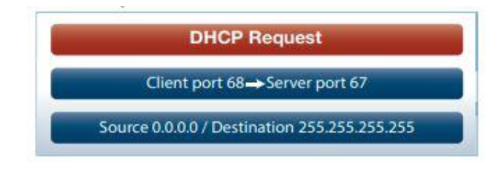

**Step 4 DHCP Acknowledgment**

Sent by the DHCP server to the client. It confirms the IP address and other details such as subnet mask, default gateway, and lease time with the client. The source address is the DHCP server and the destination is still the broadcast address.

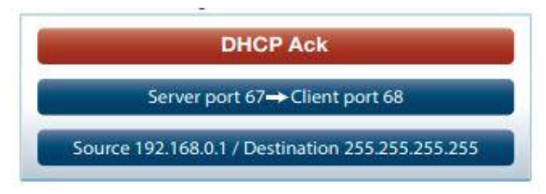**The DHCP process**

There are four basic steps the DHCP process follows when a client connects to the network:

1. The client broadcasts a DHCP Discover message to say “I need an IP address, are there any DHCP servers out there?”

2. Multiple DHCP servers may respond (via broadcast) with an OFFER for a leased IP address back to the client.

3. The client will choose a DHCP server offer and then broadcast a DHCP REQUEST back to the DHCP server(s) to say “Thanks, I have selected an offer from this DHCP server.” All servers will see which offer the client selected.

4. Finally, the selected DHCP server will send (broadcast) an ACKNOWLEDGEMENT back to the

client to confirm the IP address, lease time, and other details.

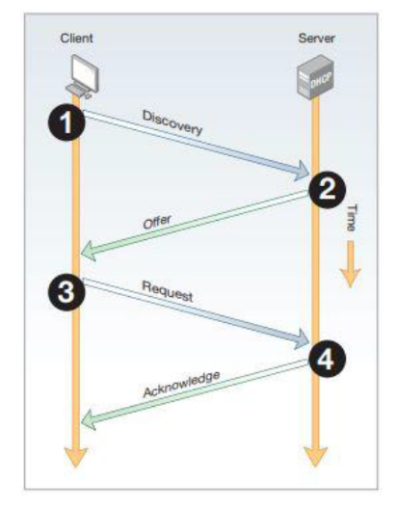

**Figure 5.1: DHCP process flow**

#### PLATFORM USED:

Open-source Linux operating system, Cisco Packet Tracer.

**Frequently asked questions: -**

1] Explain DORA Process?

2] What are benefits of DHCP Process?

3] Why DORA works on UDP?

### CONCLUSION:

**Experiment No.6**

**Title: To understand the handover mechanism**

### PROBLEM STATEMENT:

### To understand the handover mechanism

### OBJECTIVE:

1. To study the effect of handover threshold and margin on SINR and call drop probability and handover probability

### THEORY:

Consider the figure below Initially say the mobile M is quite close to the base station A and hence receives signal strength from A PArx>PBrx . As the mobile moves away from the base station. A and goes towards B then the signal strength from A keeps falling (pathloss increases).Let there be a minimum sensibility level P0rx0 for the mobile, i.e. if the signal from the B.S.to which the mobile is connected falls below P0rx0 then the call drops. In order to prevent call drop the mobile monitors receive signal strength from the neighboring 3-6 B.S.. These neighbouring 3-6 B.S. also monitor Rx signal strength from the M.S.

The mobile should get connected to B.S. which has the highest signal strength. However, if the M.S. continuously attaches itself to the B.S. with instantaneous height signal strength then the h/o rate may very high in server condition.

Thus, some hysten's condition is used for h. If PTrx (T= target B.S.) > Phrxℎ higher h/o threshold and ¯¯¯¯¯Pcrx¯ (c=current B.S.) < Phrxℎ minimum h/o threshold the execute h/o to B⋅ST from B⋅Sc. Thus, it is threshold impeditive to study in part of the handoff process

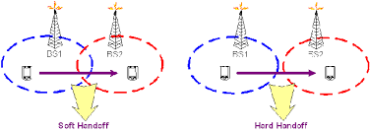

The mobile should get connected to B.S. which has the highest signal strength. However, if the M.S. continuously attaches itself to the B.S. with instantaneous height signal strength then the h/o rate may very high in server condition.

Thus, some hysten's condition is used for h. If PTrx (T= target B.S.) > Phrxℎ higher h/o threshold and ¯¯¯¯¯Pcrx¯ (c=current B.S.) < Phrxℎ minimum h/o threshold the execute h/o to B⋅ST from B⋅Sc. Thus, it is threshold impeditive to study in part of the handoff process.

Δγ=Phrx−PlrxΔ=ℎ-

A successful handoff is one where the call gets from and continuous without call or in other words the h occurs before h/o Pcrx becomes <P0rx<0. If Pcrx<P0rx0 then call drop event occurs. One would like to minimize the no of handoff events as well as minimize call drop probability. The experiment provides opportunity to study the inherent of these three parameters on h/o. Further the averaging window for calculating PTrx and Pcrx also plays a role in the process. In the experiment small scale fading is not considered and hence the averaging considered only shadowing.

* 1. Starting the Experiments: -
     + . Step1: Click on START button to start experiment.

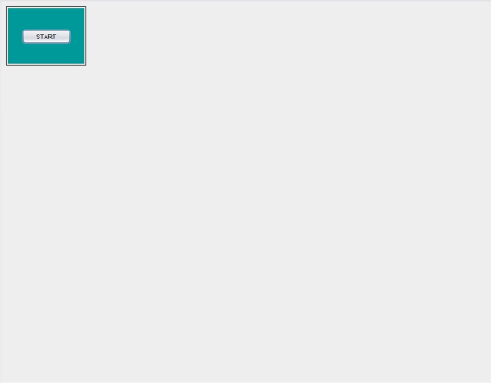

* + - Step2: Enter your name then click OK button.

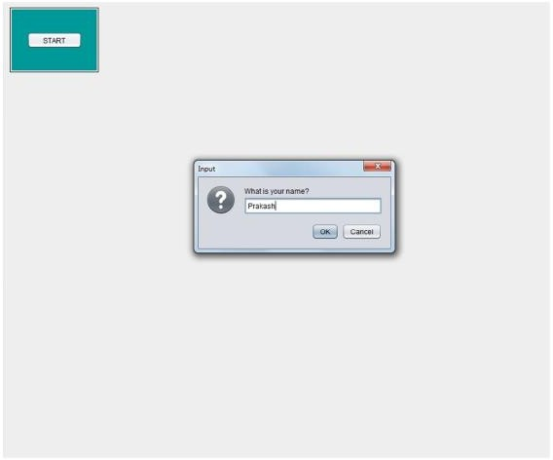

* + - Step3: Select the parameters (e.g.: Reuse, Environment, Beamwidth, Carrier frequency etc.)

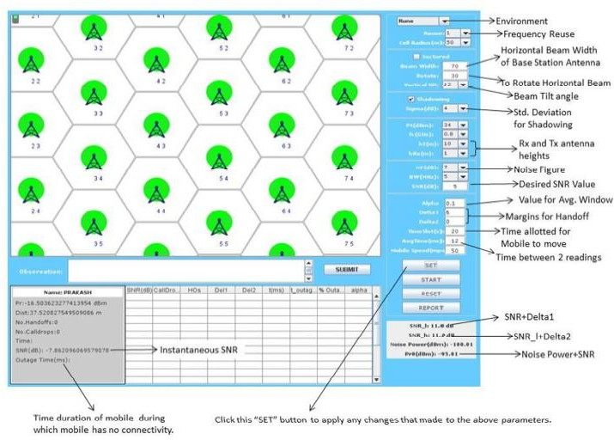

* + - * 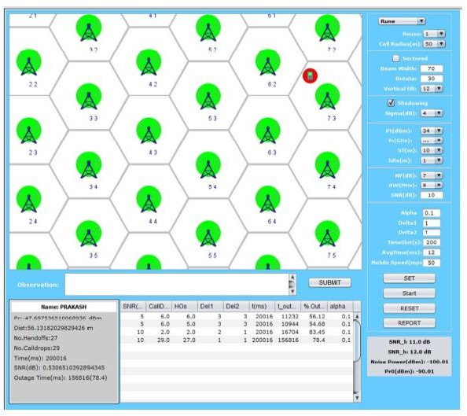Step4: Click on START button and observe No. of Call Drops and No. of Handoffs.
    - Step5: Enter your observation in the OBSERVATION box and Click on SUBMIT button.
    - Step6: Finally, click on REPORT to generate PDF report of the experiment.

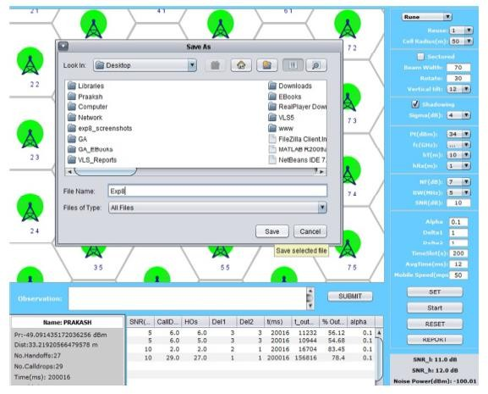

* + - Step7: After PDF report generation you will get following message.

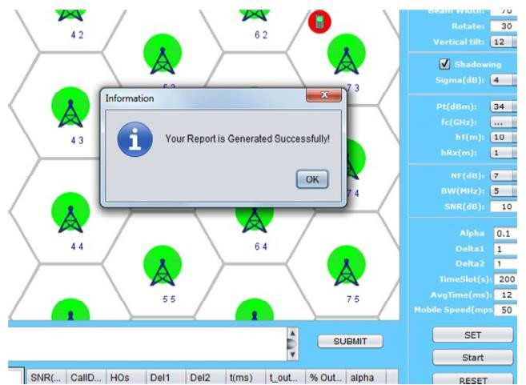

* + - Step8: PDF report will appear like this.

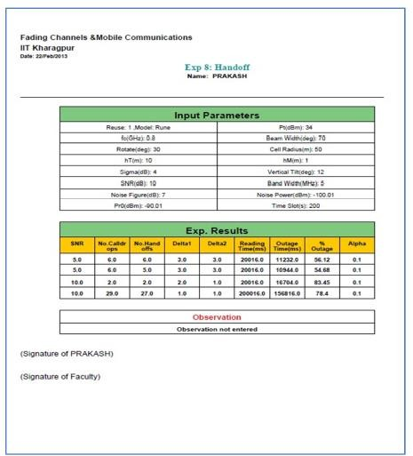

* + - Step9: To redo experiment click on RESET button. Observation Table:

|  |  |  |  |  |
| --- | --- | --- | --- | --- |
| **Reuse** | **No of Hand Off** | **Mobile Speed** | **Outage** | **Outage**  **Percentage** |
| **1** |  |  |  |  |
| **3** |  |  |  |  |

Keep reuse ratio 3 and set mobile speed to 50 mps and 100 mps and record the below data. What do we observe after increasing the speed of the mobile station?

|  |  |  |  |  |
| --- | --- | --- | --- | --- |
| **Reuse** | **Mobile Speed** | **No of Hand off** | **Outage** | **Outage Percentage** |
| **3** | **50** |  |  |  |
| **3** | **100** |  |  |  |

FAQ:

1. What is handoff?
2. What is the condition for handoff?
3. Explain Handoff and its types.

#### PLATFORM USED:

1. **Operating System: Windows 7**
2. **Java Version: 6 only**
3. **Mozilla Firefox: version: 47.0.1**
4. **Link to download software:**
5. **https://drive.google.com/uc?id=0B9mNeu43jUidckFYVTlnenpJRGs&export=download**

### CONCLUSION:

**Experiment No.7**

**Title: To study the outage probability, LCR & ADF in SISO for Selection Combining and MRC**

PROBLEM STATEMENT:

### To study the outage probability, LCR & ADF in SISO for Selection Combining and MRC

### OBJECTIVE:

1. To Study Logic gate implementation using conventional approach.
2. To Study Logic gate implementation using transmission gate approach.
3. To compare the performance among the design.

### THEORY:

Small scale fading characterizes the fluctuation of signal (strength) over a spatial distance of fraction of wavelength. The fluctuation is also observed in both time and frequency domain at a gain location.

The variation of signal (strength) at the receiver is due to random interference between the different copies of the transmitted signal. The interference is sometimes constructive and sometimes destructive. The multiple copies of the transmitted signal are generated due to scattering, reflection, and diffraction due to obstacle present in the path of radio signal between the Tx and Rx movement of the Tx and Rx or the obstacle cause time domain variation of the signal (strength) and the phenomenon is called Doppler effect. Since each path of the radio wave may exhibit difference doppler its cumulative effect results in spread of the carrier/ frequency content of the signal and hence is also known as Doppler spread.

If v is the maximum velocity (m/s) then the maximum Doppler shift is given by

fm=υ(m/s)c=

Where,

* c=velocitylight=3∗108m/s.=ℎ=3∗10*8
* fc=carrierequency.

Coherence time is defined as interval in time over which the signal remains correlated. It is defined as

Tc= 9/16Πfm (s)

If symbol duration Ts << Tc it experience slow fading while if Ts>Tc it experience fast fading. The enveloped level crossing rate is defined as the rate at which the signal envelope crosses a specified level R in the positive (or negative) going direction.

It requires the joint pdf (α,.α) of the enveloped level α=|r| and enveloped slope .α=|r|

LR=√2π(k+1)fmρe−k−(k+1)ρ2I0(2ρ√k(k+1))ρ=R√Ωp=RRrms

Rrms=√Ωp is the enveloped level

Rayleigh fading (k=0) and isotropic scattering LR=√2πfmρe−ρ2 Level Crossing Rate For Selection Combining Lr=fm√πMγ√σexp(−γ22σ)[1−exp(−γ22σ)]M−1

Where,

* fm is the Maximum doppler frequency.
* σ is the r.m.s value of the received signal voltage.
* γ is the threshold voltage.
* M = No. of channels

Average enveloped fade duration

The average duration the enveloped remains below a specified level R.

t=1NRPr[r≤R]

Average fade duration For Selection Combining

ADF=√ρ∗exp(γ22σ−1)√2πfdMγ

For Rayleigh distribution fading

Pr[r≤R]=∫R0Pr(dr)=1−exp(−ρ2)

t=eρ2−1ρfm√2π

In case of flat fading the plot of signal enveloped of transmitting 'r' is given as

p(r)=rσ2exp(−r22ρ2)(0≤r≤∞)

=0(r <0)

Where,

* σ is the r.m.s value of the received voltage signal before detection.
* σ2is the time average power of the received signal before enveloped detection.

Probability of outage is defined as

P(R)=Pr(r≤R)=∫R0p(r)dr=1−exp(−R22σ2)

The mean value rmean of rayleigh distribution is given by

rmean=E[r]=∫∞0rp(r)dr=σ√π2=1.2533σ=1.2533

σ2r=E[r2]−E2[r]=∫∞0r2p(r)dr−σ2π2

=σ2(2−π2)=0.4292σ2

* Follow the instructions given below to perform the experiments.
* Step1:- Click on the button START. A page appears with a dialogue box asking for your name.

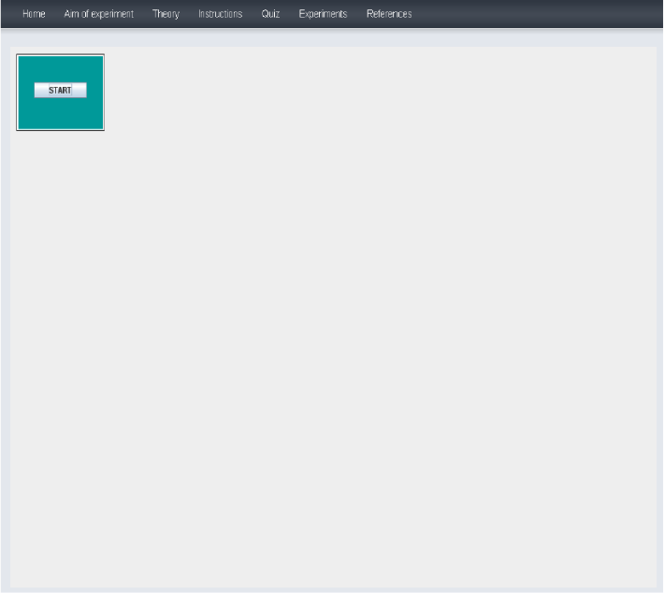

* Step 2:- Enter your name then Click Ok.

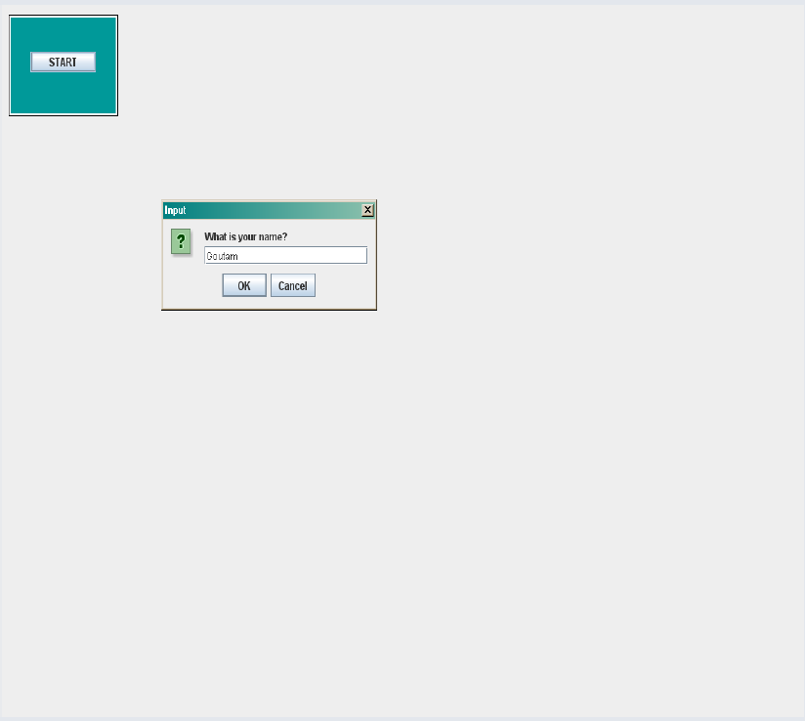

# Step3: - Enter the input parameters value. Then click on "RESET" Button. Observed the waveform.

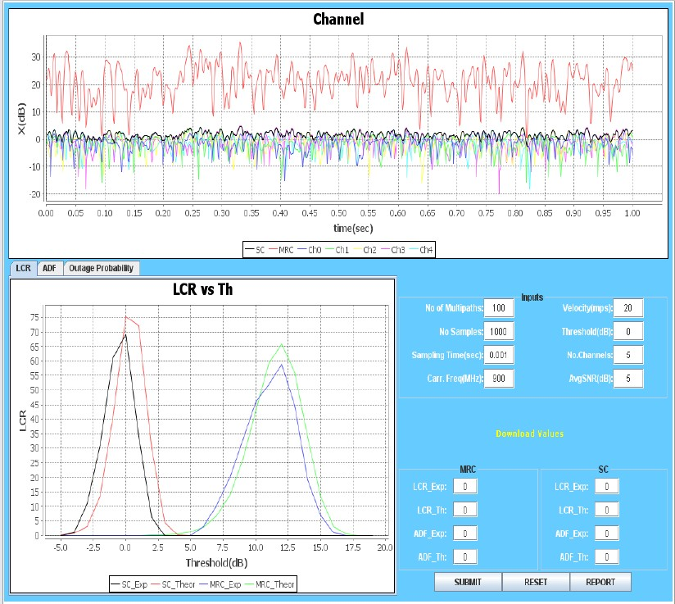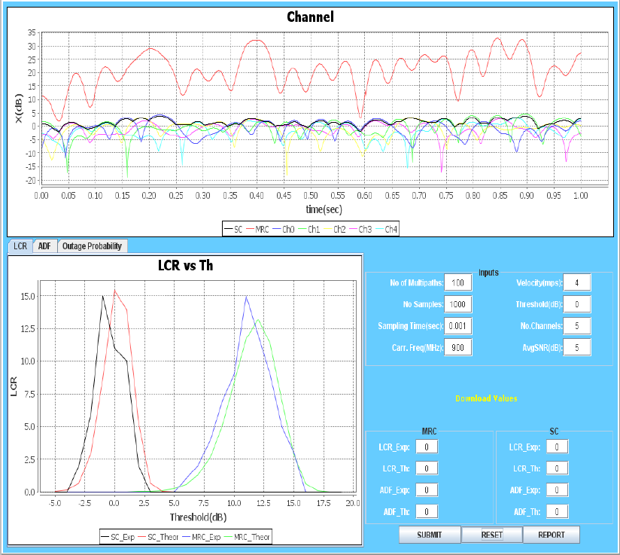

* 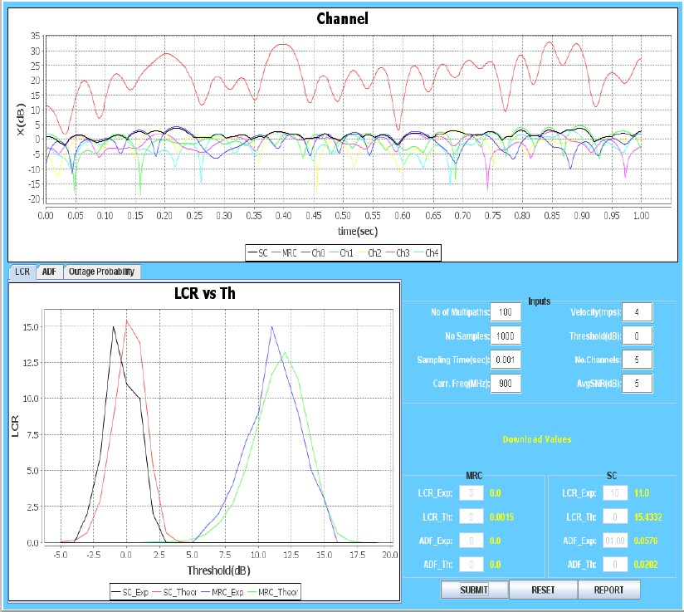Step4: - Enter value of LCR Exp and ADF Exp in both MRC and SC from the waveform. Then Click on "SUBMIT" Button.
* Step5:- Click on the "Report" button.

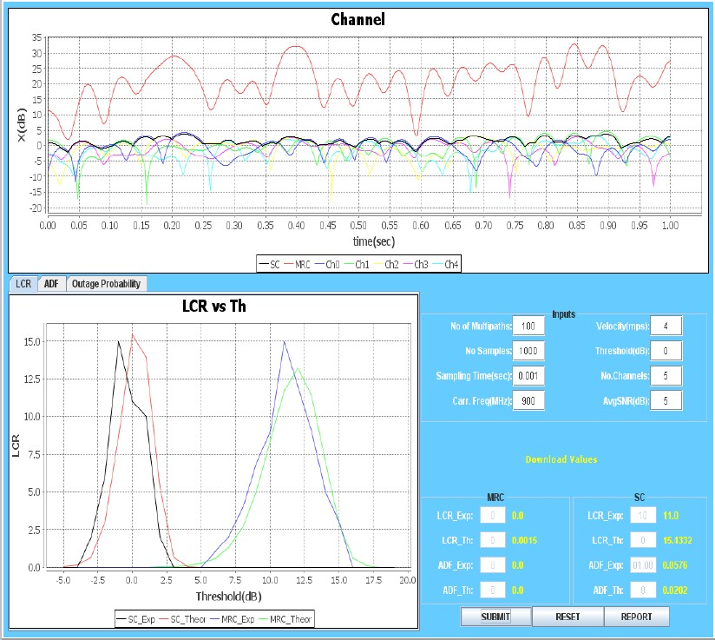

* Step6:- PDF report of the experiment is generated.

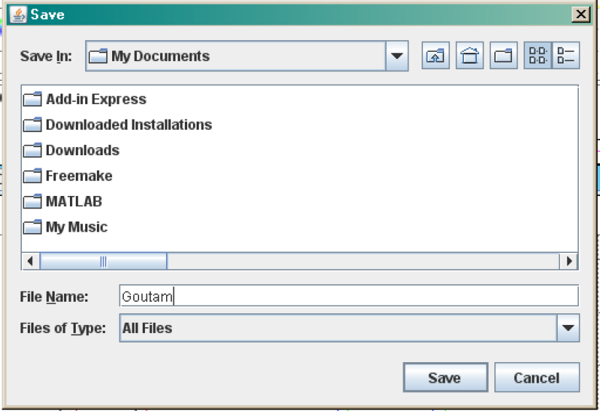

* Step7:-After generation of the Report you will get following message.

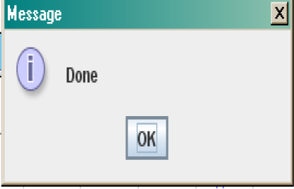

* 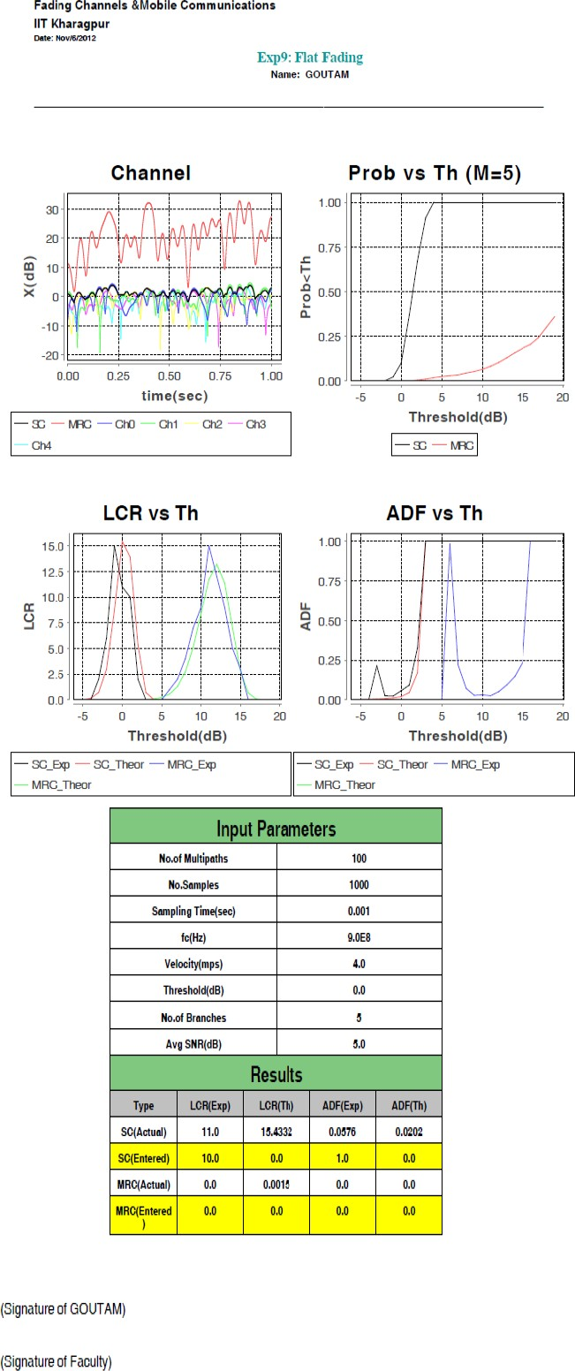Step8:- Click on the "Ok" and you will get your Report.
* Step9: - To Redo the experiment click on "RESET" button.

### CONCLUSION:

**Experiment No.8**

**Title:** To Perform File Transfer in Client & Server Using TCP/IP.

### PROBLEM STATEMENT:

To Perform File Transfer in Client & Server Using TCP/IP.

### OBJECTIVE:

* To study socket
* The client-server model.
* Remote Communication

### THEORY:

# What is mean by Socket

Sockets allow communication between two different processes on the same or different machines. To be more precise, it's a way to talk to other computers using standard Unix file descriptors. In Unix, every I/O action is done by writing or reading a file descriptor. A file descriptor is just an integer associated with an open file and it can be a network connection, a text file, a terminal, or something else.

To a programmer, a socket looks and behaves much like a low-level file descriptor. This is because commands such as read() and write() work with sockets in the same way they do with files and pipes.

# Types of Socket

A Unix Socket is used in a client-server application framework. A server is a process that performs some functions on request from a client. Most of the application-level protocols like FTP, SMTP, and POP3 make use of sockets to establish connection between client and server and then for exchanging data.

# Socket Types

There are four types of sockets available to the users. The first two are most commonly used and the last two are rarely used.

Processes are presumed to communicate only between sockets of the same type but there is no restriction that prevents communication between sockets of different types.

**Stream Sockets** − Delivery in a networked environment is guaranteed. If you send through the stream socket three items "A, B, C", they will arrive in the same order − "A, B, C". These sockets use TCP (Transmission Control Protocol) for data transmission. If delivery is impossible, the sender receives an error indicator. Data records do not have any boundaries.

**Datagram Sockets** − Delivery in a networked environment is not guaranteed. They're connectionless because you don't need to have an open connection as in Stream Sockets − you build a packet with the destination information and send it out. They use UDP (User Datagram Protocol).

**Raw Sockets** − These provide users access to the underlying communication protocols, which support socket abstractions. These sockets are normally datagram oriented, though their exact characteristics are dependent on the interface provided by the protocol. Raw sockets are not intended for the general user; they have been provided mainly for those interested in developing new communication protocols, or for

gaining access to some of the more cryptic facilities of an existing protocol.

**Sequenced Packet Sockets** − They are similar to a stream socket, with the exception that record boundaries are preserved. This interface is provided only as a part of the Network Systems (NS) socket abstraction, and is very important in most serious NS applications. Sequenced-packet sockets allow the user to manipulate the Sequence Packet Protocol (SPP) or Internet Datagram Protocol (IDP) headers on a packet or a group of packets, either by writing a prototype header along with whatever data is to be

sent, or by specifying a default header to be used with all outgoing data, and allows the user to receive the headers on incoming packets.

# The client-server model

The client-server model is one of the most commonly used communication paradigms in networked systems. Clients normally communicate with one server at a time. From a server’s perspective, at any point in time, it is not unusual for a server to be communicating with multiple clients. Client need to know of the existence of and the address of the server, but the server does not need to know the address of (or even the existence of) the client prior to the connection being established. The client and the server on the same local network (usually called LAN, Local Area Network), the client and the server may be in different LANs, with both LANs connected to a Wide Area Network (WAN) by means of *routers*

# Transmission Control Protocol (TCP)

TCP provides a *connection oriented service*, since it is based on connections between clients and servers. TCP provides reliability. When a TCP client sends data to the server, it requires an acknowledgement in return. If an acknowledgement is not received, TCP automatically retransmit the data and waits for a longer period of time for acknowledgement.

# TCP Socket API

The sequence of function calls for the client and a server participating in a TCP connection is presented in following Figure

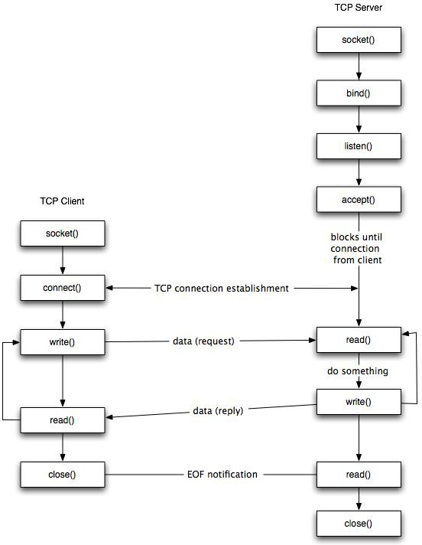

**Figure:** TCP client-server.

As shown in the figure, the steps for establishing a TCP socket on the client side are the following:

* Create a socket using the socket() function;
* Connect the socket to the address of the server using the connect() function;
* Send and receive data by means of the read() and write() functions.
* Close the connection by means of the close() function.
* The steps involved in establishing a TCP socket on the server side are as follows:
* Create a socket with the socket() function;
* Bind the socket to an address using the bind() function;
* Listen for connections with the listen() function;
* Accept a connection with the accept() function system call. This call typically blocks until a client connects with the server.
* Send and receive data by means of send() and receive().
* Close the connection by means of the close() function.

#### PLATFORM USED:

1. Python, Open-source Linux operating system

### CONCLUSION: