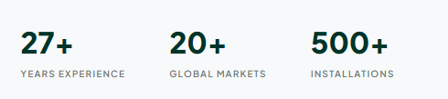
Remove this part

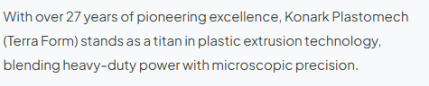
At BLOWN VISION MACHINERY, we represent the next generation of blown film extrusion technology. As an ambitious and fast-growing manufacturer, we bridge the gap between cutting-age engineering and customer-focused innovation—delivering high-performance machines built without compromise. We don't just manufacture equipment; we provide reliable, future-ready production solutions that ensure consistent output and maximum long-term value for modern manufacturers. (Replace)

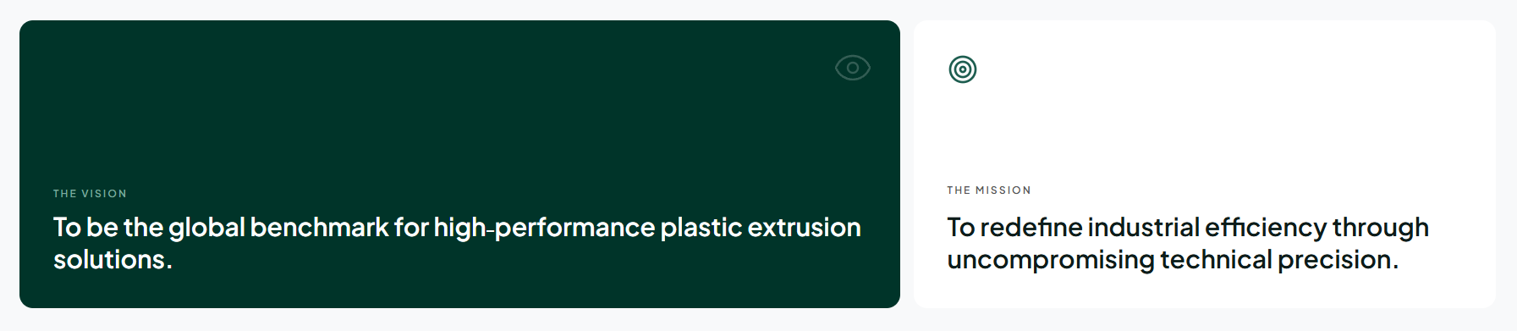
(Vision)
To be the primary benchmark for high-performance plastic extrusion solutions globally.
Our goal is to pioneer smart, state-of-the-art machinery that sets new benchmarks in accuracy and productivity. We aim to reshape the flexible packaging landscape by continuously integrating cutting-edge technology into every system we build.
(THE MISSION)
To redefine industrial efficiency through uncompromising technical precision.
We engineer robust, reliable, and energy-efficient blown film lines tailored to the evolving demands of modern manufacturing. Every component we craft is designed to deliver superior material consistency, maximum ROI, and long-lasting operational reliability.
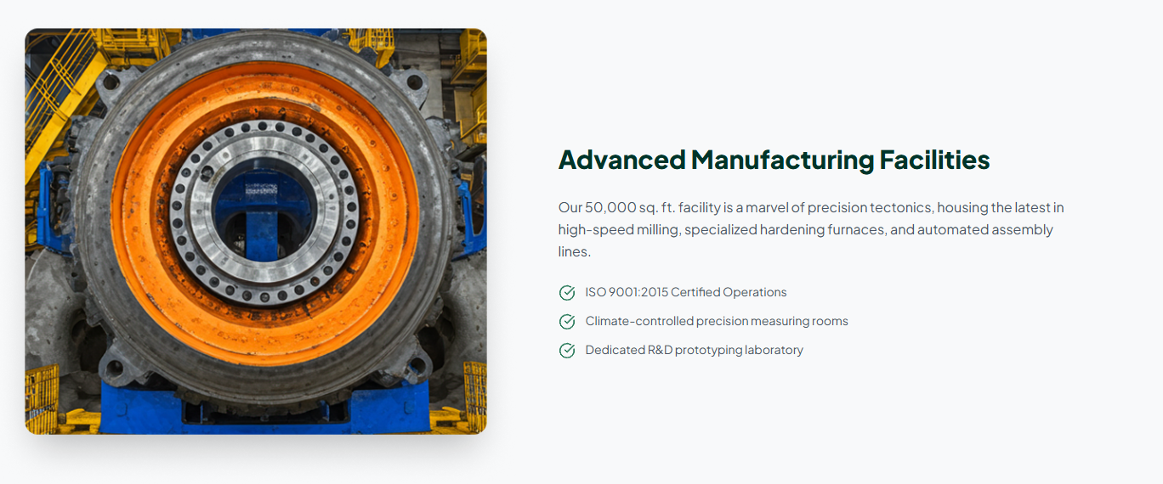
Replace
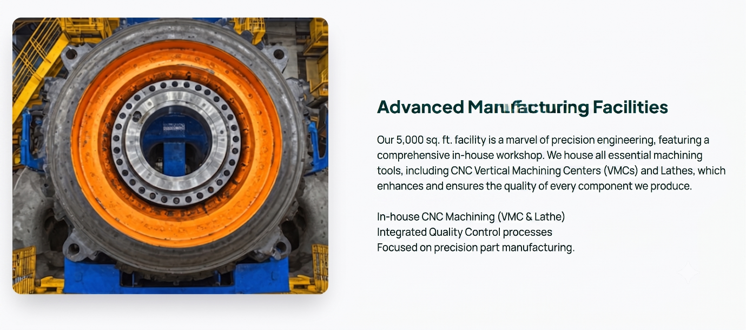

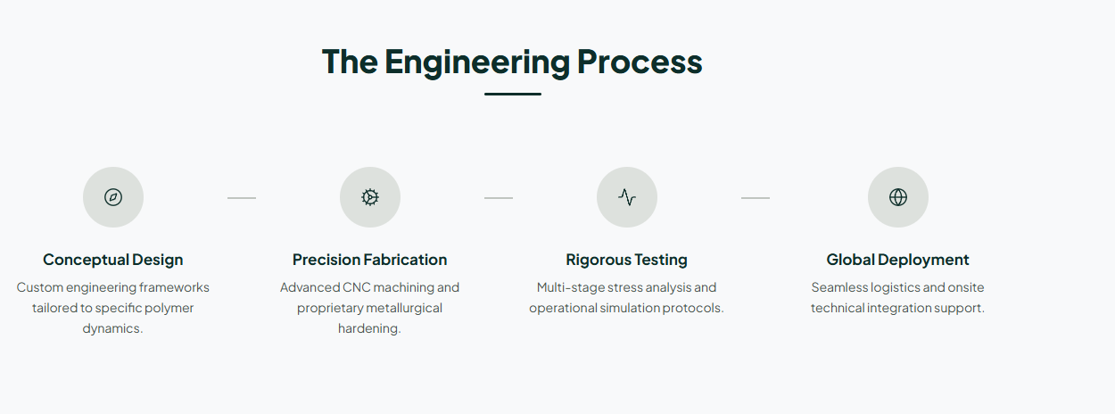

1. Conceptual Design
Custom engineering frameworks tailored to specific polymer dynamics.
2. Precision Fabrication
Advanced CNC machining and proprietary metallurgical hardening.
3. Rigorous Testing
Extensive multi-material trial runs and rigorous operational testing to ensure flawless performance.

4. Dedicated After-Sales Support
Prompt technical assistance, installation, and ongoing maintenance to guarantee maximum uptime.
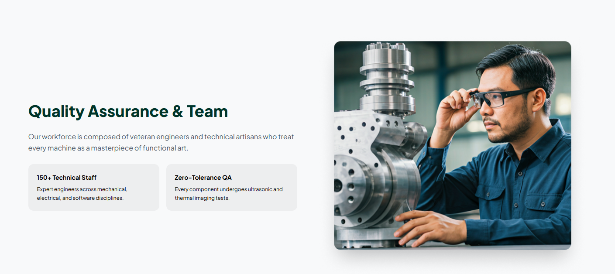
Remove
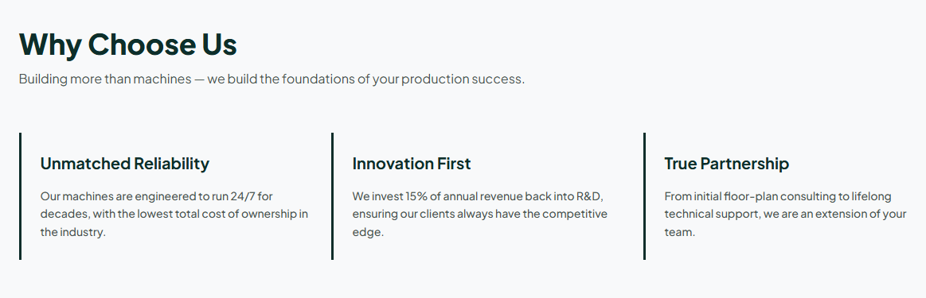

1. Modular & Upgradable Design
Upgrade key components like die heads, air rings, or automatic winders as your customer demand grows—no need to buy an entirely new line.

2. In-House Precision & Control
Powered by our fully equipped 5,000 sq. ft. workshop featuring CNC VMCs and Lathes, our skilled team of 25+ members maintains strict end-to-end quality control on every component.

3. Unmatched Reliability & Partnership
Our machines are engineered for long-term performance, backed by continuous technical support to ensure your operation stays profitable and ahead of the competition.
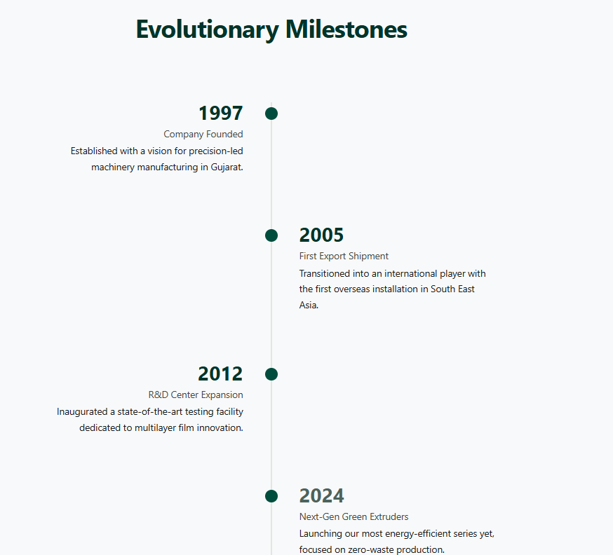
Remove

remove

Product 1 page
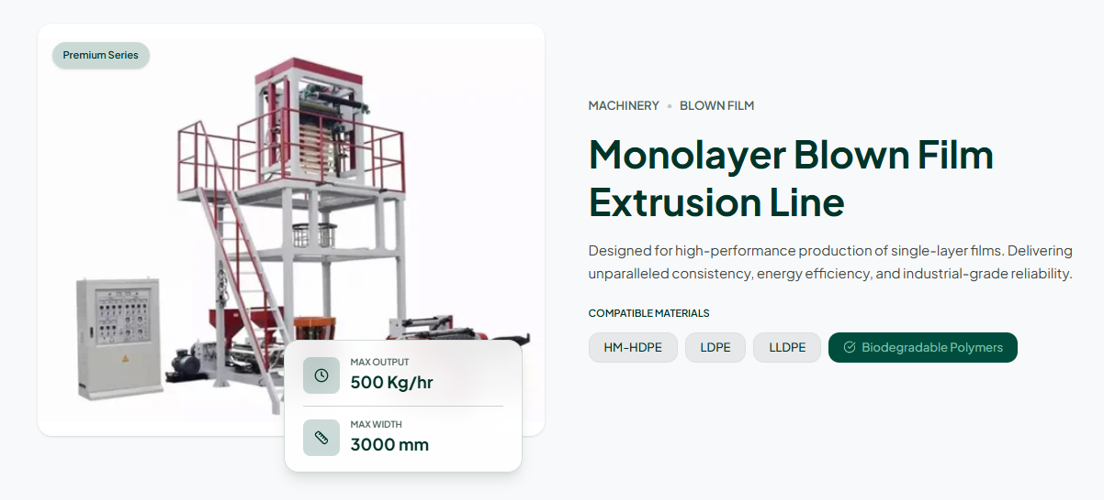
Name:- Alpha Series Blown Film Extrusion Plant
Text :- Engineered as a high-performance, space-saving extrusion line designed specifically for maximum productivity in compact footprints. The Alpha Series focuses solely on delivering exceptional output for small-to-medium film widths without sacrificing quality, energy efficiency, or reliability.
Max OUTPUT :- 30-60 KG/hr
MAX WIDTHG :-150-850 mm
MICRONS(ADD) :-20-100
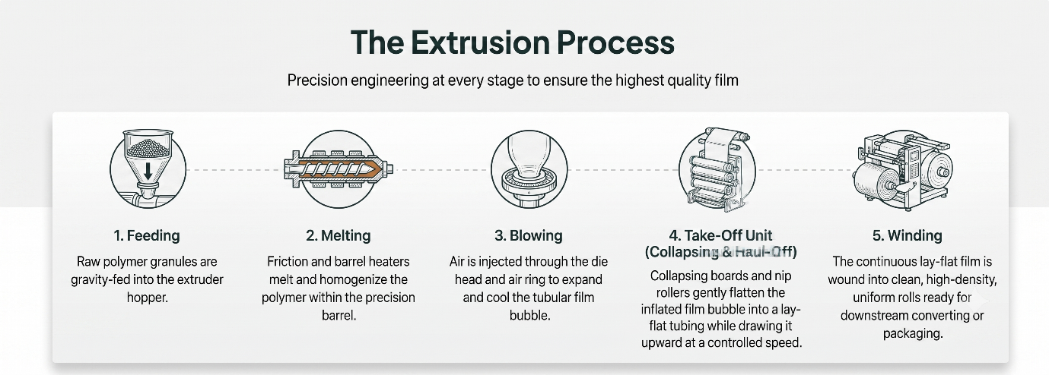
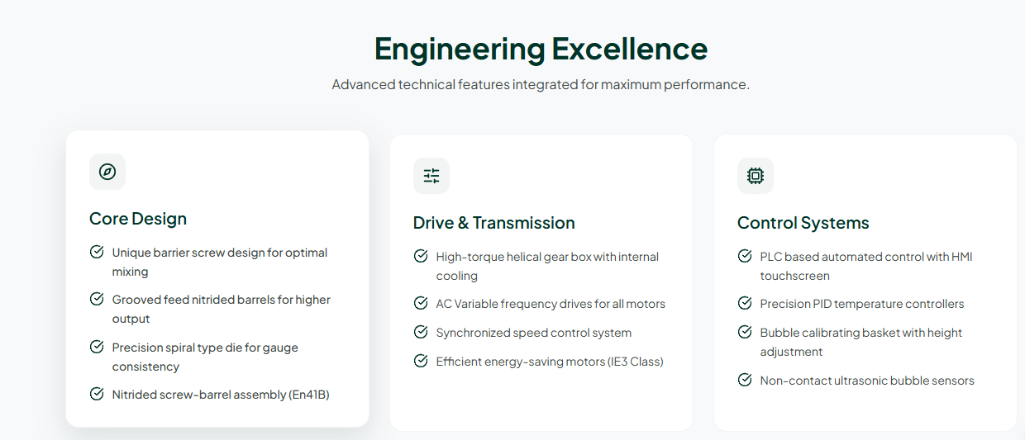
IE2 CLas motors(column 2)
Remove last line from control systems

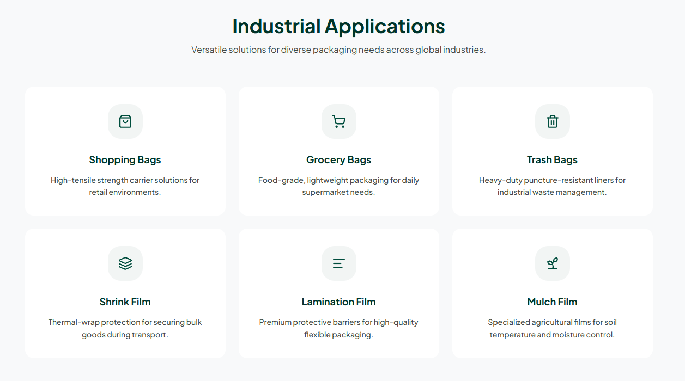
Add liner bags

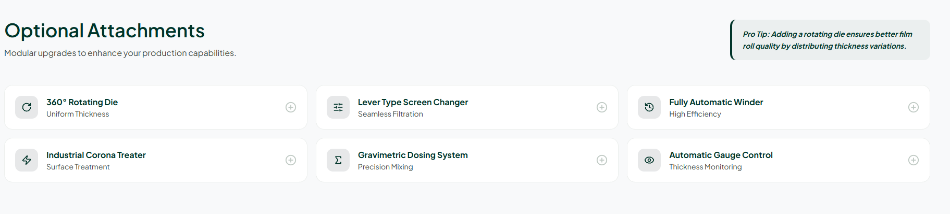

Here are the optional attachments along with a 3-word description for each:
- Hopper Loader: Feeds raw materials
- Hopper Loader with Dryer: Feeds dry granules
- Corona Treater: Enhances surface adhesion
- Lever Type Manual Screen Changer: Filters melt manually
- Web Aligner: Aligns moving film
- Air Shaft: Secures core rolls
- Auto Winder: Winds film automatically
- Trim Suction Blower: Removes edge trims
- Two Station Surface Winder: Winds dual rolls
- Water Chiller: Cools system water

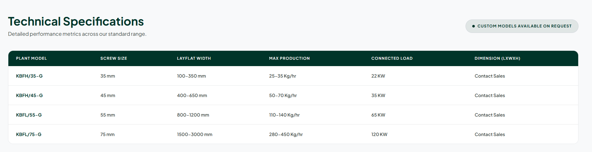
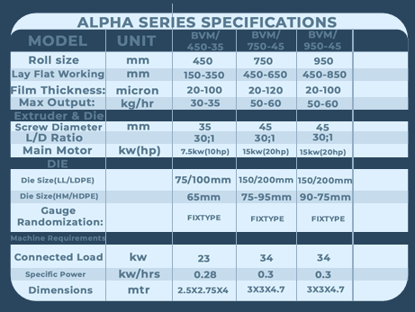

Product 2
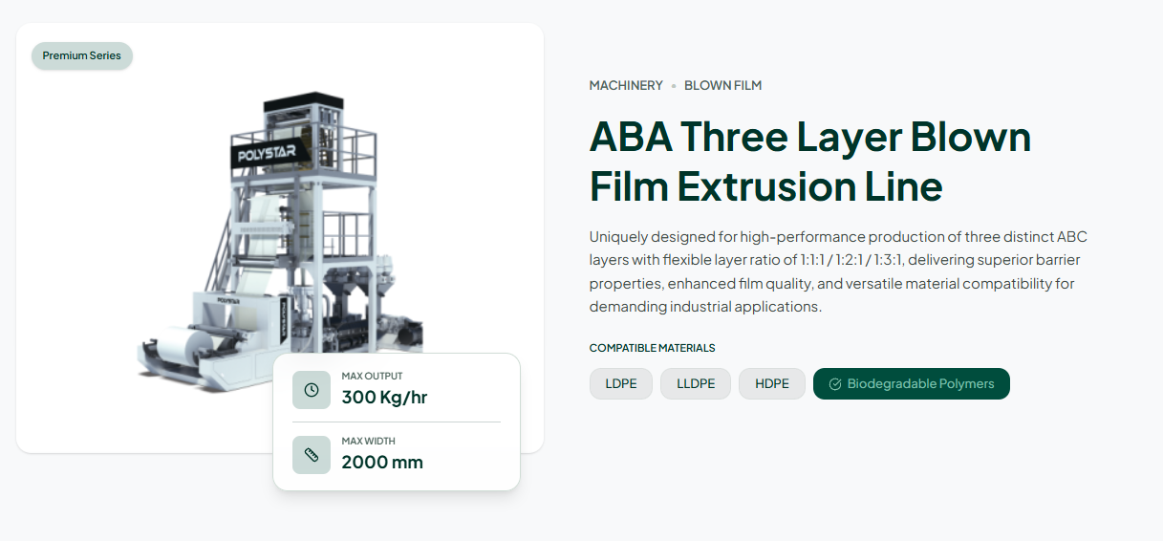
Name:- Beta Series Blown Film Extrusion Plant
Text :- Specifically engineered with enhanced film cooling technology to maximize production efficiency. Features an advanced high-capacity air ring to ensure rapid bubble stabilization at higher speeds. Integrated with an independent, detached winder configuration for ultimate layout flexibility. Delivers maximum output capacity while maintaining superior film strength and uniform quality.
Max OUTPUT :- 55-80 KG/hr
MAX WIDTHG :-300-850 mm
MICRONS(ADD) :-20-100
IE2 CLas motors(column 2)
Remove last line from control systems

Add liner bags

Here are the optional attachments along with a 3-word description for each:
- Hopper Loader: Feeds raw materials
- Hopper Loader with Dryer: Feeds dry granules
- Corona Treater: Enhances surface adhesion
- Lever Type Manual Screen Changer: Filters melt manually
- Web Aligner: Aligns moving film
- Air Shaft: Secures core rolls
- Auto Winder: Winds film automatically
- Trim Suction Blower: Removes edge trims
- Two Station Surface Winder: Winds dual rolls
- Water Chiller: Cools system water

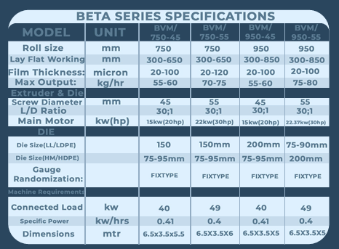

Product 3’

Name:- Gamma Series Blown Film Extrusion Plant
Text :- Engineered specifically for medium to high working widths. Delivers a reliable and versatile maximum output capacity. Equipped with a standard rotating die by default to guarantee superior gauge uniformity. Ensures consistent roll geometry and optimal film quality across diverse packaging applications.
Max OUTPUT :- 85-200 KG/hr
MAX WIDTHG :-550-1600 mm
MICRONS(ADD) :-20-150
IE2 CLas motors(column 2)
Remove last line from control systems

Add liner bags

Here are the optional attachments along with a 3-word description for each:
- Hopper Loader: Feeds raw materials
- Hopper Loader with Dryer: Feeds dry granules
- Corona Treater: Enhances surface adhesion
- Lever Type Manual Screen Changer: Filters melt manually
- Web Aligner: Aligns moving film
- Air Shaft: Secures core rolls
- Auto Winder: Winds film automatically
- Trim Suction Blower: Removes edge trims
- Two Station Surface Winder: Winds dual rolls
- Water Chiller: Cools system water

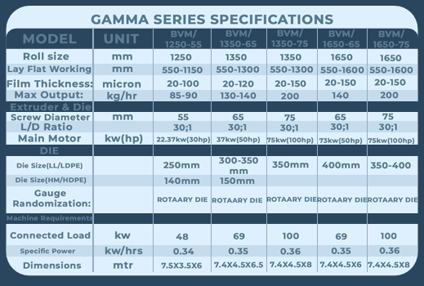

https://shubhamextrusion.com/consumer-application/ aa website par jaa applications che and ema machines jova made che aapde pan aavu banavu che if yes contact me.

ALSO make a Contact Us page jee inquirey direct mane send thay

ADD Youtube, Instagram, Whatsapp link

