CS204 Project Phase-1 Documentation

**Functional simulator for a subset of RISC-V instruction set**

This document describes the design aspect of a GUI-based functional simulator for a subset of RISC-V instruction set.

**Input/Output Mechanism**

Input to the simulator is a “input.mc” file that contains the encoded instructions and their corresponding addresses separated by a space along with data values and their corresponding addresses separated by a space. The instructions and data values are separated by a ‘$’ sign.

*Example:*

0x0 0xE3A0200A

0x4 0xE3A03002

0x8 0xE0821003

0xC $

0x10000000 0x2

0x10000004 0x8

The instructions are stored in the instruction memory and the data values are stored in the data memory.

The simulator then reads instructions from the instruction memory, decodes the instruction, reads from registers, execute the operation, and then writes back to the register file.

The GUI shows all the register values and updated memory values after each executed instruction and the type of each instruction (add, xor, bge, jal, etc.).

**Design Of Simulator**

**Data Structure**

Register, instruction memory, data memory, intermediate value and control signals (for each stage of instruction execution) are declared as global variables. Register values are stored in an integer array of size 32. The instruction and data memory are stored as C++ STL vectors of string and integer type respectively.

**Simulator Flow**

There are mainly two steps :-

1. Memory is loaded using a “input.mc” file.
2. Simulator executes each instruction one by one and updates & displays each register value and updated memory values using its GUI.

**Implementation of Fetch, Decode, Execute, Memory Access, Write Back**

1. **Fetch:** This is the first step in which the instruction is loaded from the memory.
2. **Decode:** Firstly, the instruction format is identified using the opcode, func3 & func7 values, then the operation is identified and then the operands.
3. **Execute:** This is carried out by the ALU by performing the desired operation on the register-stored values, and storing it in ALUresult.
4. **Memory Access:** This step is used for load/store instructions where the accessing/editing the memory i.e. read/write operation in the memory is done.
5. **Write Back:** If RF_Write signal is on and RD is not equal to 0, then RD is updated to the result of ALU or Memory Access.

**Graphical User Interface**

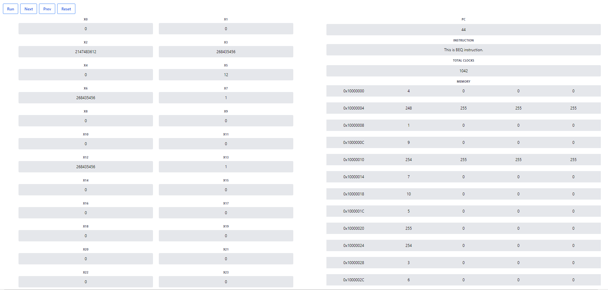

The registers are shown on the left side and the memory values are shown on the right side of the GUI. The machine code is written in the “input.mc” file and “main.cpp” file is executed and then the GUI is run to display the execution of the code all at once(run button) or step-by-step(step button). Step-by-step execution will show each register and memory value that is updated after each instruction.

**Testing Of Simulator**

We test the simulator using the following assembly programs :-

1. Fibonacci Number Program
2. Sum of the array of N elements. Initialize an array in first loop with each element equal to its index. In second loop find the sum of this array, and store the result at Arr[N].
3. Bubble Sort Program