DEEP LEARNING PROJECT REPORT
ADAR: Adaptive Deep Architecture Routing
A System-One decision head that learns which deep architecture to trust, and when to call the big model
Team: [Team member names and register numbers]
Course: [Course code] Deep Learning
Guide: [Faculty name]
Institution: [Department, College]
Date: [Submission date]
Code: github.com/Harsh4-Dev/System-One-DLE · Models: huggingface.co/DEV-HV/adar-head-ag-news

Contents

If the contents list is empty, right-click it in Word and choose Update Field.

Abstract
Picking the right deep-learning architecture for an application is usually done by hand: we train a CNN, an LSTM and a GRU, keep the best one and discard the rest. Large System-One models such as TypeSafe AI’s Jev and its open-source counterpart Laya answer typed questions in a single forward pass, but they are expensive, they are not always the most accurate, and their probabilities are not always honest.
We present ADAR (Adaptive Deep Architecture Routing), a 2.3M-parameter decision head trained on top of the frozen Laya encoder and four networks from our syllabus (TextCNN, Bi-RNN, Bi-LSTM, Bi-GRU). For every input, ADAR returns a calibrated answer, the probability that each expert is right, and the probability that its own answer is right. A cascade router lets the cheap experts answer first and calls Laya only when they are unsure.
On AG News (7,600 test articles), ADAR reaches 93.24% accuracy, above every baseline including Laya itself (92.53%), with 15% lower log-loss than the best baseline; the cascade keeps 93.1% accuracy at 2.6× lower CPU cost. On Emotion tweets, where Laya is weak (58.1%), ADAR ties the best syllabus network (92.0%) and the router learns to call Laya for only 1% of inputs. On the public typed-decisions benchmark, our calibration (ADAR-Cal) lowers Laya’s expected calibration error from 0.173 to 0.021. All numbers come from one full run of our notebook on Kaggle (GPU T4 ×2, 61 minutes).

1. Introduction

1.1 The problem
Three measurements from our own run motivate the project:
- The biggest model is not always right. Laya (421M parameters) answers Emotion tweets with 58.1% accuracy, while a 1.2M-parameter Bi-LSTM reaches 92.3%.
- Big models are slow. On a CPU, Laya needs 721 ms per input; a TextCNN needs 1.2 ms, about 622 times less.
- Confidence is not always honest. Laya’s fine-tuned checkpoint has an expected calibration error (ECE) of 0.214 on its own leaderboard: its probabilities are off by about 20 points.
Our course asks us to “analyse and identify the appropriate deep architecture for a given application.” ADAR turns that manual choice into a learned, per-input decision.

1.2 Contributions
- A System-One decision head that fuses a frozen System-One encoder with syllabus networks through attention, and outputs typed, calibrated decisions (choice, per-expert noul, act).
- A cascade router (threshold and REINFORCE policy gradient) that spends the expensive model only on hard inputs.
- A fair evaluation against 12 baselines on two datasets with temperature-scaled probabilities, three seeds and paired-bootstrap confidence intervals.
- ADAR-Cal, a train-split calibration of Laya evaluated on the public typed-decisions benchmark, with a scorer that reproduces the published leaderboard numbers.

2. Background

2.1 System-One models
A System-One model (named after Kahneman’s fast, intuitive System 1) reads a state (text or JSON) and a set of typed questions, and answers all of them in one forward pass without generating text. The three question types are choice (pick one option), score (a level on an ordered scale) and noul (a yes/no probability). TypeSafe AI introduced the first such model, Jev; Laya by Convai Innovations is the open-source alternative (Apache-2.0): a ModernBERT-large encoder (395M) plus a two-layer decision head, 421M parameters in total.
Laya places a mask marker before every option, encodes question, options and state together, and scores each option from the encoder’s hidden state at its marker. With a per-type temperature T:
$p(k | x,q) = \frac{exp(s_{k} / T)}{Σ_{j} exp(s_{j} / T)}$ (1)
Laya is trained with reinforcement learning against strictly proper scoring rules (RLCD), so that the reported probabilities are honest.

2.2 The syllabus experts
TextCNN (Unit I–II). Word embeddings $x_{1} … x_{n}$ are convolved with filters of width $h ∈ \{3, 4, 5\}$, batch-normalised and max-pooled over time:
$c_{i} = ReLU(BN(W ∗ x_{i:i+h−1} + b)), ĉ = max_{i} c_{i}$ (2)
Recurrent experts (Unit III). A vanilla RNN updates $h_{t} = tanh(W x_{t} + U h_{t−1} + b)$ and suffers from vanishing gradients on long sequences. The LSTM adds gates and a memory cell:
$f_{t} = σ(W_{f}[h_{t−1}, x_{t}] + b_{f}), i_{t} = σ(W_{i}[h_{t−1}, x_{t}] + b_{i}), o_{t} = σ(W_{o}[h_{t−1}, x_{t}] + b_{o})$ (3)
$c_{t} = f_{t} ⊙ c_{t−1} + i_{t} ⊙ tanh(W_{c}[h_{t−1}, x_{t}] + b_{c}), h_{t} = o_{t} ⊙ tanh(c_{t})$ (4)
The GRU merges the gates into an update gate $z_{t}$ and a reset gate $r_{t}$:
$h_{t} = (1 − z_{t}) ⊙ h_{t−1} + z_{t} ⊙ tanh(W[r_{t} ⊙ h_{t−1}, x_{t}])$ (5)
All three recurrent experts are bidirectional; their output is the concatenation of mean- and max-pooling over valid time steps.

2.3 Calibration and proper scoring rules
A classifier is calibrated if, among inputs where it reports confidence c, it is right a fraction c of the time. For N test examples with predicted distribution $p_{i}$ and one-hot label $y_{i}$ we report:
$NLL = −\frac{1}{N}Σ_{i} log p_{i,y_{i}}, Brier = \frac{1}{N}Σ_{i} Σ_{k} (p_{ik} − y_{ik})^{2}$ (6)
$ECE = \sum_{b=1}^{15}{\frac{|B_{b}|}{N} |acc(B_{b}) − conf(B_{b})|}$ (7)
where $B_{b}$ are 15 equal-width confidence bins. NLL (log score) and the Brier score are strictly proper scoring rules: their expected value is minimised only by reporting the true probabilities, so they reward honesty as well as accuracy. Temperature scaling fits one scalar T on validation data and replaces p = softmax(z) by softmax(z / T); it changes confidence but never the predicted class.

3. Method: ADAR

3.1 Overview
Figure 1 shows the pipeline. Four syllabus experts answer first (≈16 ms on a CPU in total). A router reads only the experts’ signals and predicts whether they are right. If so, the experts’ answer is returned; otherwise the input escalates: the frozen Laya encoder embeds the text and the ADAR head combines that embedding with the experts’ votes.
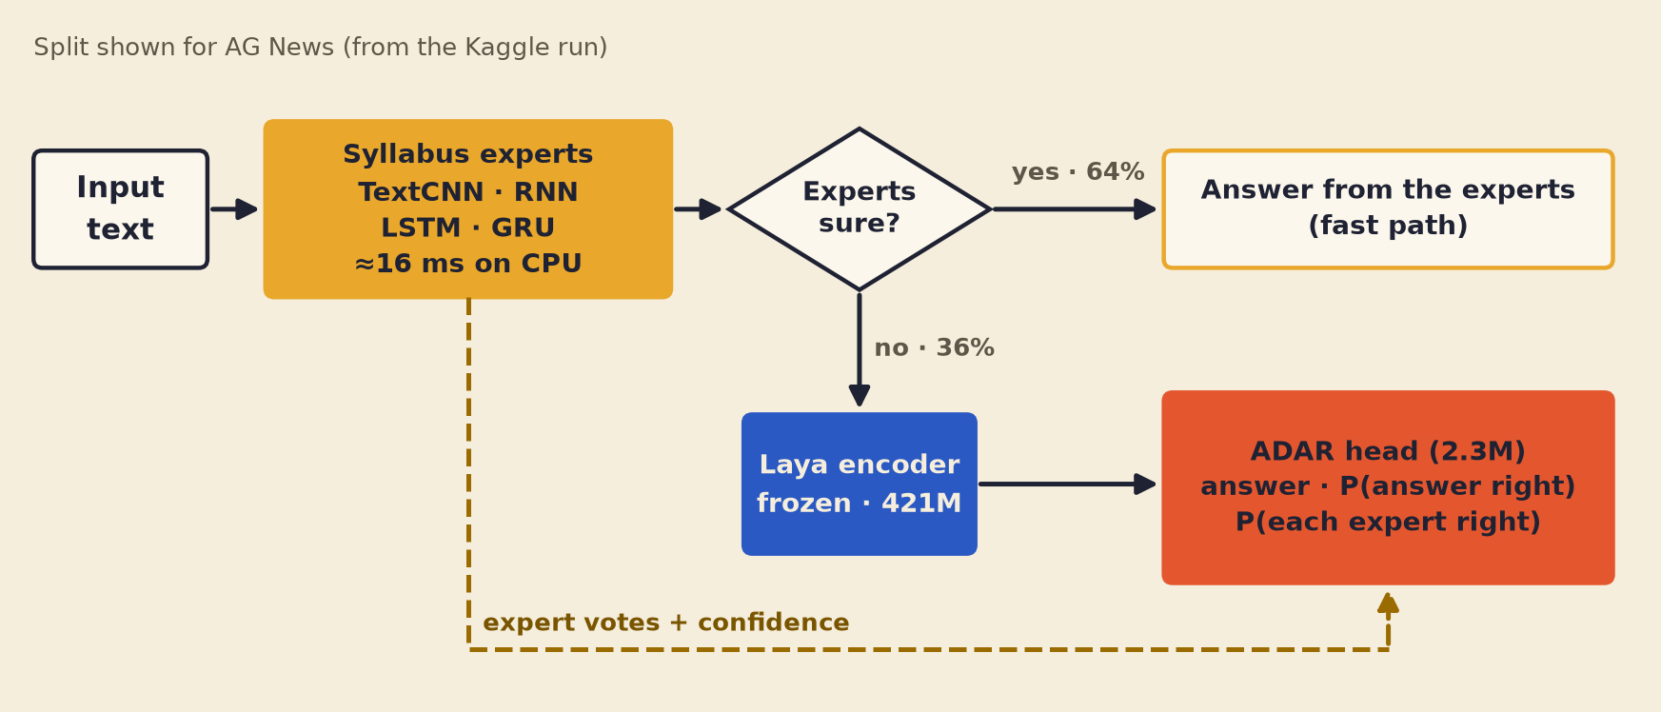
Figure 1. ADAR system architecture. Percentages are the AG News routing split from the Kaggle run.

3.2 Honest expert opinions (out-of-fold training)
If the head learned from an expert’s predictions on that expert’s own training data, it would learn to trust over-fitted experts. We therefore split the training pool into K = 3 stratified folds and train every expert three times. Example i in fold k(i) only receives predictions from the model that did not see it:
${p̂}_{e}(x_{i}) = f_{e}^{(−k(i))}(x_{i})$ (8)
At validation and test time the three fold models are averaged. This is stacked generalisation (Wolpert, 1992) applied to deep networks.

3.3 The ADAR head
Every input becomes a short sequence of 1 + K + E tokens (K answer options, E = 4 experts), projected to d = 256 dimensions. Let z(x) be Laya’s pooled embedding (mean of the last hidden layer concatenated with the first token, 2,048 values), $e_{k}$ Laya’s embedding of option k’s written description, and ${p̂}_{ek}$ expert e’s probability for option k:
$t_{state} = W_{s} z(x), t_{k} = W_{o} e_{k} + W_{v}[log {p̂}_{1k}, …, log {p̂}_{Ek}, {p̂}_{1k}, …, {p̂}_{Ek}]$ (9)
$t_{e} = W_{f} φ({p̂}_{e}) + u_{e}, φ({p̂}_{e}) = [max_{k} {p̂}_{ek}, margin, entropy, agreement]$ (10)
Type embeddings mark the three token kinds. A two-layer pre-norm transformer encoder (4 heads) mixes the tokens: $H = Transformer([t_{state}; t_{1} … t_{K}; t_{1} … t_{E}])$. The choice logits combine three paths: a scorer on each option token, a bilinear match between the input and the option, and a per-input weighted vote of the experts:
$ℓ_{k} = g(h_{k}) + \frac{(U t_{state})^{⊤}(V t_{k})}{\sqrt{d}} + \sum_{e=1}^{E}{α_{e}(x) log {p̂}_{ek}}, α(x) = softplus(W_{α} h_{state})$ (11)
The routing weights $α_{e}(x)$ are the “adaptive routing” in ADAR: the head decides, for each input, how much each architecture’s vote counts. Three typed outputs follow, in the style of a System-One model:
$p = softmax(ℓ / T), q_{e} = σ(w_{n}^{⊤} h_{e}), a = σ(MLP([h_{state}, top-1(p), margin(p), entropy(p)]))$ (12)
Here p is the choice answer, $q_{e}$ the noul probability that expert e is right on this input, and a the act probability that the head’s own answer is right. Figure 2 shows the structure. During training each expert’s evidence is dropped with probability 0.15 so the head stays robust when an expert is missing.
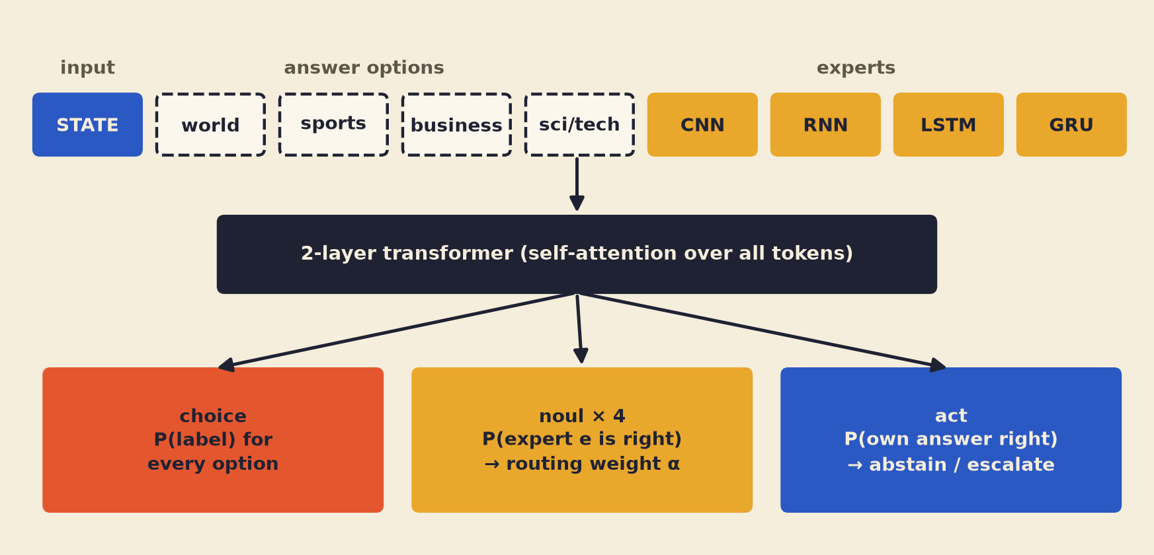
Figure 2. Inside the ADAR head: tokens, a two-layer transformer and three typed outputs.

3.4 Training objective
The head minimises two proper scoring rules for the answer plus binary cross-entropies for the auxiliary outputs, where $ŷ_{e}$ is expert e’s predicted class and ŷ the head’s:
$L = −log p_{y} + Σ_{k} (p_{k} − y_{k})^{2} + 0.2Σ_{e} BCE(q_{e}, 1[ŷ_{e} = y]) + 0.1 BCE(a, 1[ŷ = y])$ (13)
After early stopping on validation NLL, one temperature is fitted on the validation set:
$T^{*} = arg min_{T} NLL_{val}(softmax(ℓ / T))$ (14)

3.5 The cascade router
Tier 0 is the average of the four experts (temperature-scaled); tier 1 is Laya + ADAR. From the experts’ features f(x) (top probability, margin, entropy, agreement, each expert’s top probability) a logistic regression predicts r(x) = P(tier 0 is correct). The threshold router escalates when r(x) < τ, with τ the smallest threshold whose validation accuracy is within 0.2 points of always escalating.
The REINFORCE router (Unit IV) treats escalation as an action $a ∈ \{0, 1\}$ of a stochastic policy $π_{θ}(a | f)$ and maximises the expected reward, with c the cost share of the expensive path:
$R = 1[final answer correct] − λ c a, ∇_{θ} J ≈ (R − b) ∇_{θ} log π_{θ}(a | f(x))$ (15)
b is a moving-average baseline that reduces the gradient variance. Sweeping λ traces an accuracy–cost curve.

3.6 ADAR-Cal for the typed-decisions benchmark
For typed decisions we keep Laya’s answers and only recalibrate: one temperature per (question type t, number of options K), fitted on the benchmark’s train split. The soft objective matches the gold probability distribution $g_{d}$; the hard objective uses its top label. The variant is chosen on the train split only:
$T_{t,K}^{*} = arg min_{T} Σ_{d ∈ train(t,K)} −Σ_{k} g_{dk} log softmax(z_{d} / T)_{k}$ (16)

4. Experimental setup

4.1 Datasets
Dataset | Text | Train pool | Validation | Test | Classes
AG News | news headline + first sentence | 114,000 | 6,000 | 7,600 | 4
Emotion (dair-ai) | short English tweets | 16,000 | 2,000 | 2,000 | 6
typed-decisions | tickets, invoices, incidents | 1,200 cases | – | 400 cases (2,000 decisions) | mixed

AG News has no official validation split, so 6,000 articles are held out from its training set. The official test sets are used exactly once, for the final tables.

4.2 Baselines
- scikit-learn on TF-IDF (word 1–2-grams, 200k features): Multinomial Naive Bayes, Logistic Regression, Linear SVM (Platt-calibrated), Random Forest (200 trees, 30k rows), MLPClassifier (256 hidden, chi² top-20k features, 40k rows).
- Syllabus networks: TextCNN, Bi-RNN, Bi-LSTM, Bi-GRU, and their average.
- Laya-based: Laya zero-shot (a typed choice question with the label descriptions), logistic regression on Laya embeddings (probe), and stacking (logistic regression on Laya embeddings plus the experts’ out-of-fold log-probabilities).

4.3 Implementation details
Component | Setting
Experts | embedding 128, 128 filters (3/4/5) or 128 hidden units per direction; max length 64 (AG News) / 48 (Emotion); vocabulary 30k
Expert training | AdamW, lr 2e-3, weight decay 1e-4, batch 256, ≤10 epochs, early stopping (patience 2) on validation NLL, gradient clipping at 1.0
Laya encoder | convaiinnovations/laya, frozen, fp16 on GPU, max 128 (AG News) / 64 (Emotion) tokens, sharded cache on both GPUs
ADAR head | d = 256, 2 layers, 4 heads, feed-forward 512, dropout 0.1, 2.3M parameters
Head training | AdamW, lr 1e-3, weight decay 0.01, batch 512, ≤30 epochs, 5% warm-up + cosine, early stopping (patience 5), expert dropout 0.15, seeds 0/1/2
Hardware | Kaggle GPU T4 ×2; whole pipeline 61 minutes; CPU latencies are batch-1 medians on the Kaggle CPU

4.4 Evaluation protocol
Every model’s probabilities are temperature-scaled on the validation split and evaluated on the same test rows. We report accuracy, macro-F1, NLL, Brier, ECE (15 bins) and CPU latency. ADAR is trained with three seeds and reported as mean ± standard deviation. A claim “A beats B” counts only if the 95% confidence interval of the accuracy difference, from 2,000 paired bootstrap resamples of the test set, excludes zero:
$Δ = acc(A) − acc(B), CI_{95} = [Δ_{2.5\%}, Δ_{97.5\%}] over paired resamples$ (17)

5. Results

5.1 AG News
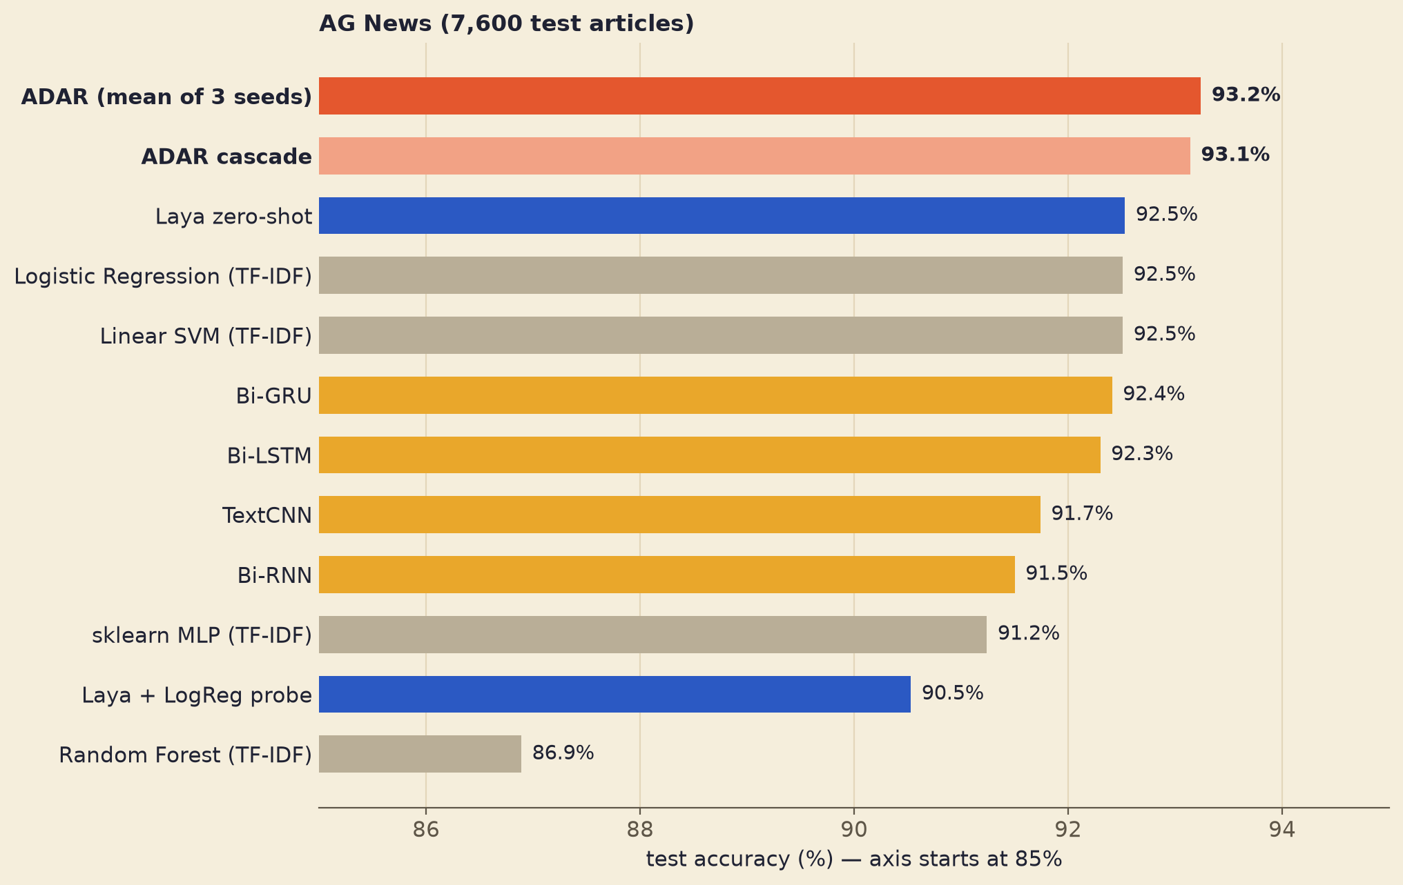
Figure 3. AG News test accuracy (7,600 articles). Axis starts at 85%.
Model | Accuracy | NLL ↓ | Brier ↓ | ECE ↓ | CPU ms
ADAR (ours, 3 seeds) | 93.24% ± 0.10 | 0.198 | 0.103 | 0.008 | 483.3
ADAR cascade (36% to Laya) | 93.14% | 0.209 | 0.106 | 0.011 | 185.7
Laya zero-shot | 92.53% | 0.237 | 0.120 | 0.021 | 721.2
Logistic Regression (TF-IDF) | 92.51% | 0.241 | 0.120 | 0.015 | 2.4
Linear SVM (TF-IDF) | 92.51% | 0.237 | 0.118 | 0.008 | 2.6
Bi-GRU | 92.41% | 0.236 | 0.122 | 0.018 | 5.7
Bi-LSTM | 92.30% | 0.232 | 0.121 | 0.014 | 6.1
Stacking (Laya + experts) | 92.12% | 0.232 | 0.120 | 0.010 | 480.6
TextCNN | 91.74% | 0.259 | 0.129 | 0.021 | 1.2
Random Forest (TF-IDF) | 86.89% | 0.384 | 0.198 | 0.014 | 57.0

ADAR is the most accurate model and passes all 14 of 14 quality checks. Selected confidence intervals (seed 0):
- ADAR accuracy > best Laya zero-shot (Laya zero-shot (typed choice)): delta=+0.76pp, 95% CI [+0.24, +1.28]
- ADAR accuracy > best scikit-learn model (Logistic Regression (TF-IDF)): delta=+0.78pp, 95% CI [+0.29, +1.26]
- ADAR accuracy > best syllabus deep model (Bi-GRU): delta=+0.88pp, 95% CI [+0.43, +1.34]

5.2 Honesty and cost
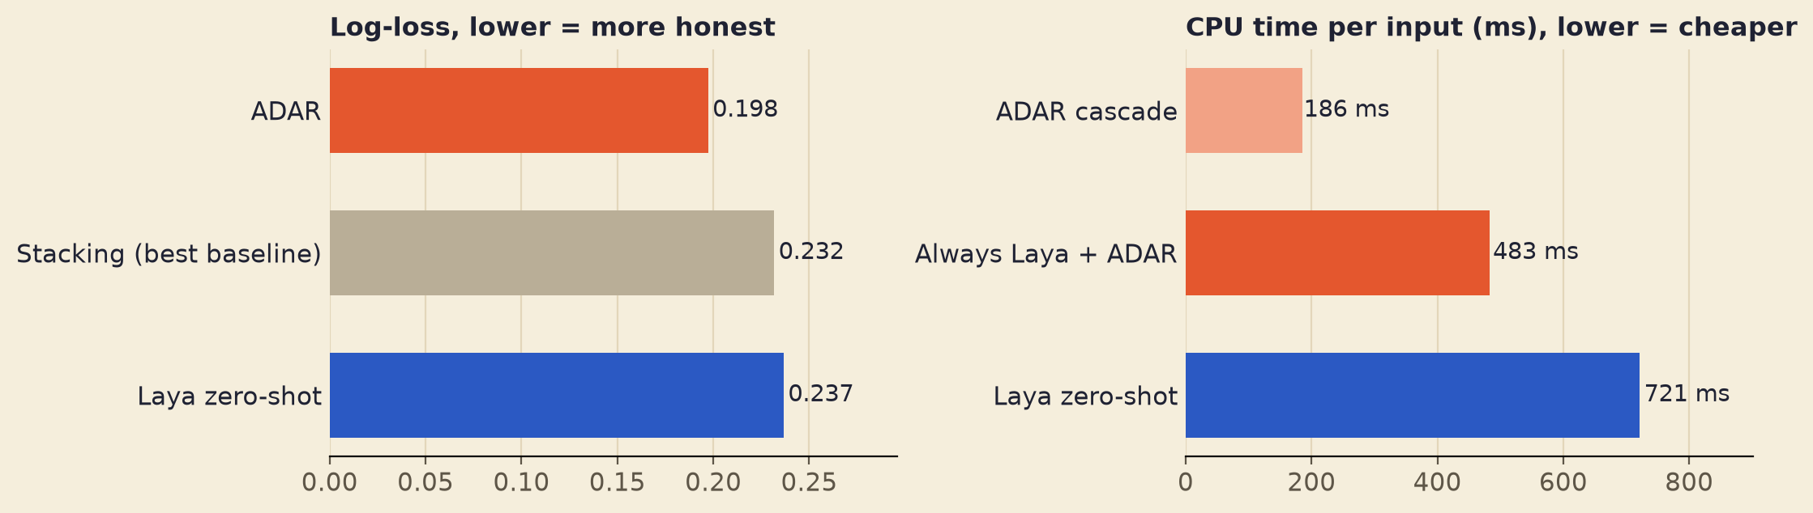
Figure 4. AG News: log-loss (left) and CPU time per input (right).
ADAR’s log-loss (0.198) is 15% lower than the best baseline’s, so its probabilities are the most honest of all models. The cascade calls Laya for 36% of inputs and averages 186 ms per input instead of 483 ms (2.6× cheaper) while keeping 93.1% accuracy.

5.3 Emotion
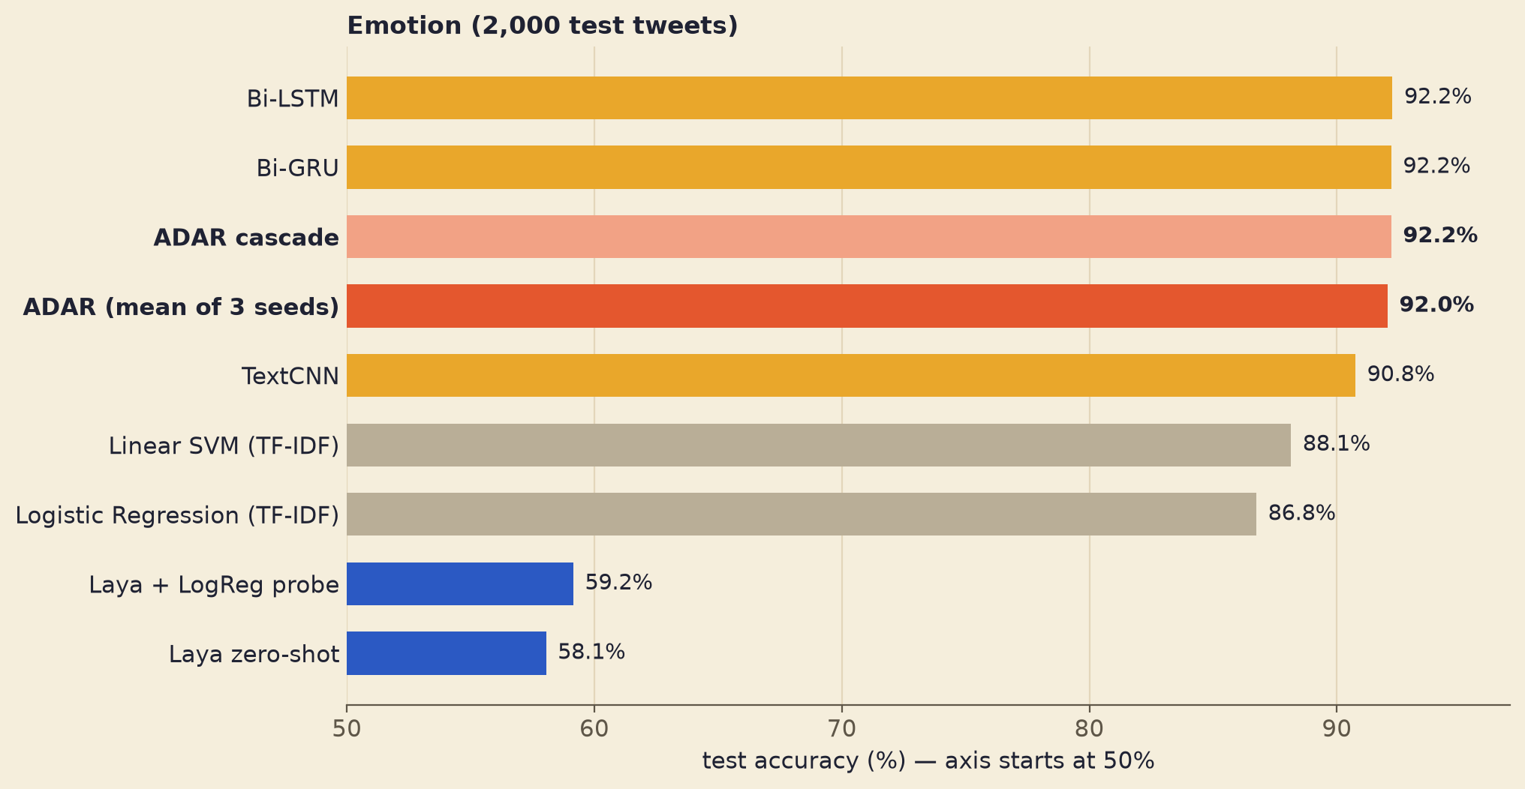
Figure 5. Emotion test accuracy (2,000 tweets). Axis starts at 50%.
Laya is weak on emotion tweets (58.1% zero-shot, 59.2% with a probe), consistent with the 57.3% reported on Laya’s own model card. ADAR (92.0% ± 0.12) beats every scikit-learn model (best: Linear SVM, 88.1%) and Laya by 34 points, but only ties the best syllabus network (Bi-LSTM, 92.3%); the difference is not significant, and 4 of 14 checks fail for that reason. The router learned that Laya does not help here: it escalates only 1% of tweets, giving 92.2% accuracy at 14.5 ms instead of 395 ms per input.

5.4 Ablations (AG News)
Variant | Accuracy | Change | Significant?
Full ADAR (mean of 3 seeds) | 93.24% | – | –
Without the experts (Laya only) | 91.82% | -1.4 pts | yes
Without Laya (experts only) | 92.51% | -0.7 pts | yes
Without attention (no transformer) | 93.18% | -0.1 pts | no

Both information sources are needed. Attention adds little accuracy but improves the probabilities (log-loss 0.205 without it, 0.198 with it).

5.5 typed-decisions benchmark
First we checked that our scorer matches the leaderboard by evaluating the published fine-tuned checkpoint:
laya-typed-decisions | Published | Our run
Accuracy | 0.766 | 0.7665
Brier (vs gold distribution) | 0.062 | 0.0615
ECE (10 bins) | 0.213 | 0.2137

Our entry, base Laya + ADAR-Cal (temperatures fitted on the train split):
Metric (2,000 test decisions) | Laya | Laya + ADAR-Cal | Change
ECE ↓ | 0.173 | 0.021 | -88%
Brier ↓ | 0.315 | 0.236 | -25%
KL ↓ | 0.569 | 0.433 | -24%
Accuracy ↑ | 0.363 | 0.363 | unchanged

Calibration never changes the chosen answer, so accuracy is unchanged while every probability metric improves. Applying the same procedure to the fine-tuned checkpoint lowered its ECE by 71% but more than doubled its Brier score, because that checkpoint was trained on the same train split; we therefore submit the base-model entry.

6. Discussion
- When does Laya help? On news topics Laya’s encoder carries information the experts miss (+0.7 points over the experts-only head). On tweets it does not; the router detects this and stops paying for it. The same head therefore adapts its cost to the dataset.
- Why attention adds little. With 9–11 tokens, the bilinear path and the expert vote already capture most interactions; attention mainly sharpens the probabilities. Larger option sets or more experts may change this.
- Calibration is not accuracy. On typed-decisions the gold answers are soft distributions. Making the top answer more confident lowers ECE but can move the probabilities away from the gold distribution (higher Brier). Reporting both metrics avoids over-claiming.
- Honest per-expert reliability. On AG News the noul output for TextCNN separates its right and wrong answers with an AUC of 0.902 (the per-expert table is in the run report); this per-input reliability is what makes routing possible.

7. Mapping to the Deep Learning syllabus
Unit | Topics used in ADAR
I | Neural network training, backpropagation, initialisation (gate initialised to equal expert weights), vanishing/exploding gradients (gradient clipping), gradient-descent strategies (AdamW, warm-up + cosine schedule), batch normalisation, CNN structure and training (TextCNN)
II | CNN classifiers; training a new head on a frozen pretrained network (fine-tuning)
III | RNN architecture and its challenges, LSTM, GRU, embeddings, attention, transformers, a BERT-family encoder (ModernBERT inside Laya)
IV | Deep reinforcement learning framework (state, action, reward), policy-gradient methods (REINFORCE with a baseline); routing as a one-step contextual decision

8. Limitations and future work
- Only text classification (AG News, Emotion) is covered; vision tasks (Unit II) are future work.
- Laya is frozen; only the 2.3M-parameter head is trained.
- On Emotion, ADAR ties rather than beats the best expert; attention’s accuracy gain is not significant.
- ADAR-Cal improves calibration on typed-decisions but not accuracy.
- Future work: RouterArena (routing between large language models with the same per-expert noul idea), an image task with CNN experts, an echo-state-network expert, and a short arXiv paper.

9. Reproducibility
- Import notebooks/adar_kaggle.ipynb into Kaggle; set Accelerator to GPU T4 ×2 and Internet on.
- Save Version → Save & Run All. Every stage checkpoints; a re-run skips finished work.
- Download adar_outputs.zip: results/ (tables, figures, quality checks), publish/ (trained heads), typed_decisions/ (benchmark files).
- Regenerate the leaderboard entry and model cards: python tools/make_submissions.py.
Using a published head:
from adar.inference import ADARClassifier
clf = ADARClassifier.from_pretrained("adar-head-ag-news")
clf.predict(["NASA's new telescope captured images of a distant galaxy cluster."])
# -> sci_tech 0.948, P(answer right) 0.973, escalate: False (real output from the run)

References
Brier, G. W. (1950). Verification of forecasts expressed in terms of probability. Monthly Weather Review, 78(1).
Cho, K. et al. (2014). Learning phrase representations using RNN encoder–decoder for statistical machine translation. EMNLP.
Convai Innovations (2026). Laya: open-source System-One decision model. huggingface.co/convaiinnovations/laya.
Devlin, J., Chang, M.-W., Lee, K., Toutanova, K. (2019). BERT: Pre-training of deep bidirectional transformers for language understanding. NAACL.
Efron, B., Tibshirani, R. J. (1993). An Introduction to the Bootstrap. Chapman & Hall.
Gneiting, T., Raftery, A. E. (2007). Strictly proper scoring rules, prediction, and estimation. Journal of the American Statistical Association, 102(477).
Guo, C., Pleiss, G., Sun, Y., Weinberger, K. Q. (2017). On calibration of modern neural networks. ICML.
Hochreiter, S., Schmidhuber, J. (1997). Long short-term memory. Neural Computation, 9(8).
Ioffe, S., Szegedy, C. (2015). Batch normalization: Accelerating deep network training by reducing internal covariate shift. ICML.
Kahneman, D. (2011). Thinking, Fast and Slow. Farrar, Straus and Giroux.
Kim, Y. (2014). Convolutional neural networks for sentence classification. EMNLP.
LocalLLaMA (2026). typed-decisions benchmark. huggingface.co/datasets/LocalLLaMA/typed-decisions.
Loshchilov, I., Hutter, F. (2019). Decoupled weight decay regularization. ICLR.
Saravia, E. et al. (2018). CARER: Contextualized affect representations for emotion recognition. EMNLP.
TypeSafe AI (2026). Introducing System One models and Jev. typesafe.ai/blog.
Vaswani, A. et al. (2017). Attention is all you need. NeurIPS.
Warner, B. et al. (2024). Smarter, better, faster, longer: A modern bidirectional encoder (ModernBERT). arXiv:2412.13663.
Williams, R. J. (1992). Simple statistical gradient-following algorithms for connectionist reinforcement learning. Machine Learning, 8.
Wolpert, D. H. (1992). Stacked generalization. Neural Networks, 5(2).
Zhang, X., Zhao, J., LeCun, Y. (2015). Character-level convolutional networks for text classification. NeurIPS.

Appendix A. Full result tables
All values from the full Kaggle run (results/kaggle_run/summary.json). Probabilities temperature-scaled on validation data; ECE after scaling.

A.1 AG News
Model | Acc. | Macro-F1 | NLL | Brier | ECE | CPU ms
Random Forest (TF-IDF) | 86.89% | 0.868 | 0.384 | 0.198 | 0.014 | 57.0
Laya encoder + Logistic Regression | 90.53% | 0.905 | 0.278 | 0.145 | 0.012 | 464.5
Naive Bayes (TF-IDF) | 90.76% | 0.907 | 0.301 | 0.147 | 0.026 | 2.6
sklearn MLPClassifier (TF-IDF) | 91.24% | 0.912 | 0.275 | 0.138 | 0.018 | 26.7
Bi-RNN | 91.50% | 0.915 | 0.263 | 0.133 | 0.019 | 3.1
TextCNN | 91.74% | 0.917 | 0.259 | 0.129 | 0.021 | 1.2
Stacking LogReg (Laya emb + experts) | 92.12% | 0.921 | 0.232 | 0.120 | 0.010 | 480.6
Bi-LSTM | 92.30% | 0.923 | 0.232 | 0.121 | 0.014 | 6.1
Bi-GRU | 92.41% | 0.924 | 0.236 | 0.122 | 0.018 | 5.7
Average of syllabus experts | 92.46% | 0.924 | 0.235 | 0.120 | 0.016 | 16.0
Logistic Regression (TF-IDF) | 92.51% | 0.925 | 0.241 | 0.120 | 0.015 | 2.4
Linear SVM (TF-IDF) | 92.51% | 0.925 | 0.237 | 0.118 | 0.008 | 2.6
Laya zero-shot (typed choice) | 92.53% | 0.925 | 0.237 | 0.120 | 0.021 | 721.2
ADAR ablation: laya only | 91.82% | 0.918 | 0.238 | 0.126 | 0.008 | 466.4
ADAR ablation: experts only | 92.51% | 0.925 | 0.227 | 0.118 | 0.011 | 18.5
ADAR cascade (escalates 36%) | 93.14% | 0.931 | 0.209 | 0.106 | 0.011 | 185.7
ADAR ablation: no attention | 93.18% | 0.932 | 0.205 | 0.106 | 0.010 | 482.3
ADAR (ours, mean of 3 seeds) | 93.24% | 0.932 | 0.198 | 0.103 | 0.008 | 483.3

A.2 Emotion
Model | Acc. | Macro-F1 | NLL | Brier | ECE | CPU ms
Laya zero-shot (typed choice) | 58.05% | 0.470 | 1.211 | 0.590 | 0.088 | 652.3
Laya encoder + Logistic Regression | 59.15% | 0.506 | 1.085 | 0.544 | 0.032 | 382.8
Naive Bayes (TF-IDF) | 76.05% | 0.630 | 0.677 | 0.337 | 0.025 | 1.2
sklearn MLPClassifier (TF-IDF) | 84.60% | 0.775 | 0.425 | 0.222 | 0.027 | 5.5
Random Forest (TF-IDF) | 86.50% | 0.800 | 0.360 | 0.193 | 0.014 | 56.0
Logistic Regression (TF-IDF) | 86.75% | 0.804 | 0.356 | 0.195 | 0.031 | 1.5
Stacking LogReg (Laya emb + experts) | 87.75% | 0.812 | 0.343 | 0.179 | 0.011 | 391.9
Linear SVM (TF-IDF) | 88.15% | 0.822 | 0.288 | 0.161 | 0.023 | 3.5
TextCNN | 90.75% | 0.857 | 0.212 | 0.121 | 0.013 | 1.1
Bi-RNN | 90.80% | 0.862 | 0.212 | 0.119 | 0.019 | 1.8
Average of syllabus experts | 92.05% | 0.877 | 0.177 | 0.105 | 0.020 | 9.1
Bi-GRU | 92.20% | 0.882 | 0.174 | 0.103 | 0.018 | 3.1
Bi-LSTM | 92.25% | 0.882 | 0.192 | 0.110 | 0.016 | 3.2
ADAR ablation: laya only | 64.95% | 0.477 | 0.975 | 0.486 | 0.027 | 384.7
ADAR (ours, mean of 3 seeds) | 92.05% | 0.880 | 0.170 | 0.101 | 0.015 | 394.9
ADAR cascade (escalates 1%) | 92.20% | 0.879 | 0.176 | 0.104 | 0.019 | 14.5
ADAR ablation: experts only | 92.25% | 0.883 | 0.164 | 0.097 | 0.014 | 11.9
ADAR ablation: no attention | 92.45% | 0.883 | 0.170 | 0.100 | 0.016 | 393.6

A.3 Quality checks
- AG News: PASS — ADAR accuracy > best scikit-learn model (Logistic Regression (TF-IDF)): delta=+0.78pp, 95% CI [+0.29, +1.26]
- AG News: PASS — ADAR accuracy > best syllabus deep model (Bi-GRU): delta=+0.88pp, 95% CI [+0.43, +1.34]
- AG News: PASS — ADAR accuracy > best expert ensemble (Average of syllabus experts): delta=+0.83pp, 95% CI [+0.38, +1.26]
- AG News: PASS — ADAR accuracy > best Laya zero-shot (Laya zero-shot (typed choice)): delta=+0.76pp, 95% CI [+0.24, +1.28]
- AG News: PASS — ADAR accuracy > best Laya linear probe (Laya encoder + Logistic Regression): delta=+2.76pp, 95% CI [+2.26, +3.25]
- AG News: PASS — ADAR accuracy > best stacking baseline (Stacking LogReg (Laya emb + experts)): delta=+1.17pp, 95% CI [+0.75, +1.57]
- AG News: PASS — ADAR NLL lower than every baseline (best: Stacking LogReg (Laya emb + experts)): ADAR 0.1968 vs 0.2317
- AG News: PASS — ADAR BRIER lower than every baseline (best: Linear SVM (TF-IDF)): ADAR 0.1032 vs 0.1179
- AG News: PASS — ADAR ECE (after TS) <= best baseline ECE + 0.005 (best: Linear SVM (TF-IDF)): ADAR 0.0086 vs 0.0076
- AG News: PASS — full ADAR >= ADAR ablation: laya only (accuracy; NLL lower): delta=+1.47pp CI [+1.01, +1.93], NLL 0.1968 vs 0.2380
- AG News: PASS — full ADAR >= ADAR ablation: experts only (accuracy; NLL lower): delta=+0.78pp CI [+0.34, +1.20], NLL 0.1968 vs 0.2270
- AG News: PASS — full ADAR >= ADAR ablation: no attention (accuracy; NLL lower): delta=+0.11pp CI [-0.13, +0.36], NLL 0.1968 vs 0.2047
- AG News: PASS — ADAR stable across seeds (accuracy std < 0.5pp): std=0.10pp over 3 seeds
- AG News: PASS — Cascade keeps accuracy within 0.5pp of always-Laya while skipping Laya calls: acc 0.9314 vs 0.9329; Laya called on 36% of inputs; mean cost 185.6 vs 483.3 ms
- Emotion: PASS — ADAR accuracy > best scikit-learn model (Linear SVM (TF-IDF)): delta=+4.05pp, 95% CI [+2.80, +5.35]
- Emotion: FAIL — ADAR accuracy > best syllabus deep model (Bi-LSTM): delta=-0.05pp, 95% CI [-0.85, +0.75]
- Emotion: FAIL — ADAR accuracy > best expert ensemble (Average of syllabus experts): delta=+0.15pp, 95% CI [-0.75, +1.05]
- Emotion: PASS — ADAR accuracy > best Laya zero-shot (Laya zero-shot (typed choice)): delta=+34.15pp, 95% CI [+31.75, +36.60]
- Emotion: PASS — ADAR accuracy > best Laya linear probe (Laya encoder + Logistic Regression): delta=+33.05pp, 95% CI [+30.70, +35.35]
- Emotion: PASS — ADAR accuracy > best stacking baseline (Stacking LogReg (Laya emb + experts)): delta=+4.45pp, 95% CI [+3.10, +5.80]
- Emotion: PASS — ADAR NLL lower than every baseline (best: Bi-GRU): ADAR 0.1714 vs 0.1740
- Emotion: PASS — ADAR BRIER lower than every baseline (best: Bi-GRU): ADAR 0.1017 vs 0.1028
- Emotion: PASS — ADAR ECE (after TS) <= best baseline ECE + 0.005 (best: Stacking LogReg (Laya emb + experts)): ADAR 0.0140 vs 0.0105
- Emotion: PASS — full ADAR >= ADAR ablation: laya only (accuracy; NLL lower): delta=+27.25pp CI [+25.00, +29.60], NLL 0.1714 vs 0.9751
- Emotion: FAIL — full ADAR >= ADAR ablation: experts only (accuracy; NLL lower): delta=-0.05pp CI [-0.90, +0.85], NLL 0.1714 vs 0.1640
- Emotion: FAIL — full ADAR >= ADAR ablation: no attention (accuracy; NLL lower): delta=-0.25pp CI [-1.20, +0.70], NLL 0.1714 vs 0.1700
- Emotion: PASS — ADAR stable across seeds (accuracy std < 0.5pp): std=0.12pp over 3 seeds
- Emotion: PASS — Cascade keeps accuracy within 0.5pp of always-Laya while skipping Laya calls: acc 0.9220 vs 0.9220; Laya called on 1% of inputs; mean cost 14.5 vs 394.9 ms

