Real Estate Price Prediction using Machine Learning

Project Type: End-to-End Data Science Project

Description:
An end-to-end real estate price prediction system built using web scraping, machine learning, interactive dashboards, and web deployment. The project covers data collection, preprocessing, exploratory data analysis, model building, evaluation, deployment, and business intelligence visualization.
Technologies Used:
Python, Pandas, NumPy, BeautifulSoup, Selenium, Scikit-learn, Random Forest, Streamlit, PowerBI
Key Features:
- Automated data scraping pipeline
- Machine learning-based price prediction
- Interactive PowerBI dashboard
- Web-based prediction app using Streamlit

Author: Harsh Thapa
GitHub: https://github.com/Harsh4465
LinkedIn: https://linkedin.com/in/harsh-thapa-200b16300

Year: 2026

TABLE OF CONTENTS

Chapter No. Chapter Title Page No.
Chapter 1 Introduction 3
Chapter 2 Literature Review 5
Chapter 3 System Architecture 6
Chapter 4 Data Collection 9
Chapter 5 Data Preprocessing 12
Chapter 6 Exploratory Data Analysis (EDA) 15
Chapter 7 Model Building 19
Chapter 8 Model Evaluation 23
Chapter 9 Deployment 26
Chapter 10 Results and Discussion 29
Chapter 11 Conclusion and Future Scope 32
Chapter 12 References 34

Real Estate Price Prediction using Machine Learning and Web Scraping

CHAPTER 1: INTRODUCTION

1. Introduction
The real estate sector plays a crucial role in the economic development of a country. Property prices are influenced by multiple factors such as location, size, number of rooms, and market demand. Traditionally, property valuation has relied heavily on human expertise, which can often be subjective, time-consuming, and inconsistent.
With the advancement of data science and machine learning, it has become possible to build automated systems that can analyze large volumes of property data and accurately predict real estate prices. Such systems help buyers make informed investment decisions, assist sellers in setting competitive prices, and support real estate companies in market analysis.
This project, titled “Real Estate Price Prediction using Machine Learning and Web Scraping”, aims to develop a complete end-to-end solution that collects real estate-like data using web scraping techniques, processes and analyzes the data, and builds predictive models to estimate property prices based on key features such as area, number of bedrooms (BHK), and location.
The project integrates multiple technologies including Python, BeautifulSoup, Selenium, Scikit-learn, Streamlit, and PowerBI to create a full-stack data science application. The system not only predicts prices using machine learning models but also visualizes real estate trends through an interactive business intelligence dashboard.

1.1 Objectives of the Project
The main objectives of this project are:
• To collect property-related data using web scraping techniques
• To clean and preprocess the collected data for analysis
• To perform exploratory data analysis (EDA) to understand market trends
• To build machine learning models for predicting real estate prices
• To evaluate model performance using appropriate metrics
• To deploy the trained model using a web-based interface
• To create an interactive PowerBI dashboard for business insights

1.2 Scope of the Project
This project focuses on predicting residential property prices based on a limited set of important features such as:
• Property area (in square feet)
• Number of bedrooms (BHK)
• City/location
The scope includes:
• Data collection using automated scraping tools
• Data preprocessing and feature engineering
• Machine learning model development and evaluation
• Deployment through a command-line interface and a Streamlit web application
• Business analytics using PowerBI
Future enhancements may include:
• Integration of real-time real estate APIs
• Inclusion of more features such as amenities, property age, and furnishing type
• Development of a cloud-based deployment system
• Integration with a relational database such as MySQL or PostgreSQL

CHAPTER 2: LITERATURE REVIEW

2. Literature Review
Real estate price prediction has been an active area of research due to its significant economic importance. Traditional methods of property valuation primarily depend on expert judgment, comparative market analysis, and manual assessment of property features. Although these approaches have been widely used, they often suffer from limitations such as subjectivity, lack of scalability, and delayed decision-making.
In recent years, machine learning techniques have been increasingly applied to the real estate domain to overcome these limitations. Researchers have explored various regression-based models, including Linear Regression, Decision Trees, Random Forests, and Support Vector Machines, to predict housing prices based on features such as location, area, number of bedrooms, and neighborhood characteristics. These models have demonstrated improved accuracy and consistency compared to traditional valuation methods.
Several studies have highlighted the effectiveness of ensemble learning techniques, particularly Random Forest, in handling complex and non-linear relationships between property features and prices. Random Forest models combine multiple decision trees to produce more robust and reliable predictions, reducing the risk of overfitting and improving generalization performance.
With the growth of online real estate platforms, web scraping has emerged as a powerful technique for collecting large volumes of property-related data. Tools such as BeautifulSoup and Selenium enable automated extraction of structured data from websites, making it possible to build custom datasets for analysis and model training. However, challenges such as dynamic content loading, data inconsistency, and ethical scraping practices remain important considerations in this area.
Recent advancements in data visualization and business intelligence tools, such as PowerBI, have further enhanced the ability to analyze and interpret real estate data. Interactive dashboards allow stakeholders to explore pricing trends, regional variations, and demand patterns more effectively, supporting better strategic decision-making.
Overall, the literature suggests that integrating web scraping, machine learning, and business intelligence tools can significantly improve the accuracy, efficiency, and usability of real estate price prediction systems. These findings provide a strong foundation for the development of the proposed system in this project.

CHAPTER 3: SYSTEM ARCHITECTURE

3. System Architecture
The proposed real estate price prediction system is designed as a multi-layered, end-to-end data science pipeline that integrates data collection, data preprocessing, machine learning, deployment, and business intelligence components. The overall architecture ensures smooth data flow from raw data acquisition to final user-facing applications and analytical dashboards.
The system architecture consists of the following major modules:

3.1 Data Collection Module
The data collection module is responsible for gathering property-related data from online sources using automated web scraping techniques. Tools such as BeautifulSoup and Selenium are used to extract structured information such as property title, location, area (in square feet), number of bedrooms (BHK), and price.
Selenium is particularly useful for handling dynamically loaded web pages, while BeautifulSoup is used for parsing HTML content. The scraped data is stored in a CSV format, which serves as the raw dataset for further processing.

3.2 Data Preprocessing Module
The data preprocessing module cleans and transforms the raw scraped data into a structured and machine learning–ready format. This module performs the following tasks:
- Removal of duplicate records
- Handling of missing or inconsistent values
- Conversion of data types (e.g., price to float, area to integer)
- Encoding of categorical variables such as location
- Feature selection and basic feature engineering
The output of this module is a clean dataset stored in a CSV file, which is used for both model training and business analytics.

3.3 Machine Learning Module
The machine learning module is responsible for building predictive models using the preprocessed dataset. Two regression models are implemented:
- Linear Regression as a baseline model
- Random Forest Regression as the advanced ensemble model
The dataset is split into training and testing sets to evaluate model performance. The Random Forest model is trained with optimized hyperparameters to capture non-linear relationships between property features and prices. Model evaluation is performed using metrics such as Mean Absolute Error (MAE) and R² Score.
The trained models are saved using the joblib library for reuse during deployment.

3.4 Deployment Module
The deployment module enables real-time price prediction through user-friendly interfaces. Two deployment approaches are implemented:
- A Command-Line Interface (CLI) application that allows users to input property details and receive predicted prices.
- A Streamlit-based Web Application that provides a graphical user interface (GUI) for interactive price prediction.
These interfaces load the trained Random Forest model and dynamically generate predictions based on user inputs such as area, BHK, and location.

3.5 Business Intelligence Module
The business intelligence module uses PowerBI to visualize real estate market trends and insights derived from the dataset. Interactive dashboards are created to display:
- Average property prices by city
- Price vs area relationships
- Distribution of properties by BHK
- Top 5 most expensive cities
- Price range histograms
- City-based interactive filters
These dashboards help stakeholders analyze market patterns and validate the trends learned by the machine learning models.

3.6 Overall System Flow
The overall system workflow can be summarized as follows:
- Web scraping collects raw property data from online sources.
- The scraped data is stored in CSV format.
- Data preprocessing cleans and transforms the dataset.
- Machine learning models are trained using the cleaned data.
- The trained models are evaluated and saved.
- The saved models are deployed through CLI and web applications.
- PowerBI dashboards visualize analytical insights.
This modular architecture ensures scalability, maintainability, and easy integration of future enhancements such as additional features, real-time data sources, and cloud-based deployment.

CHAPTER 4: DATA COLLECTION

4. Data Collection
Data collection is a crucial phase in the development of any machine learning system, as the quality and quantity of data directly impact model performance. In this project, property-related data was collected using automated web scraping techniques to simulate a real-world real estate dataset.
Due to restrictions and limitations associated with scraping live real estate websites, a demonstration scraping approach was adopted to generate structured, realistic property data. The scraping pipeline was designed to extract key property attributes and construct a large-scale dataset suitable for machine learning and analytical purposes.

4.1 Data Sources
The data for this project was collected using a demonstration website structure that mimics real estate listings. The scraping scripts were designed to simulate the extraction of real estate-like attributes such as:
- Property title
- City/location
- Area (in square feet)
- Number of bedrooms (BHK)
- Price
The data was generated using controlled logic to ensure realistic correlations between features such as area, location, and price. City-based multipliers and random noise were incorporated into the pricing logic to simulate real-world market variations.

4.2 Tools and Technologies Used
The following tools and technologies were used for data collection:
- Python: Core programming language for implementing scraping scripts
- BeautifulSoup: Used for parsing HTML content and extracting data from static web pages
- Selenium: Used for handling dynamic web pages and automating browser interactions
- Requests: Used for sending HTTP requests to retrieve web page content
- Pandas: Used for structuring and storing scraped data into CSV files
These tools enabled automated extraction, transformation, and storage of structured data for further analysis.

4.3 Data Collection Process
The data collection process involved the following steps:
- Accessing the target web pages using Selenium and Requests.
- Parsing HTML content using BeautifulSoup.
- Identifying relevant HTML elements corresponding to property listings.
- Extracting property attributes such as title, area, BHK, location, and price.
- Applying logic to generate realistic values for missing attributes.
- Storing the extracted data in a structured CSV file.
- Repeating the process across multiple pages to increase dataset size.
The scraping pipeline was configured to iterate through multiple pages and cycles, resulting in a final dataset of over 3000 property records.

4.4 Dataset Description
The final dataset was stored in CSV format and contained the following columns:
- Title: Property listing title
- Location: City where the property is located
- Area: Property size in square feet
- BHK: Number of bedrooms
- Price: Property price in Indian Rupees
A summary of the dataset is provided below:
Attribute | Description
Title | Name of the property listing
Location | City name
Area | Size of the property (sqft)
BHK | Number of bedrooms
Price | Property price (₹)
The dataset was designed to ensure balanced representation across multiple cities and property sizes, making it suitable for machine learning model training and business analytics.

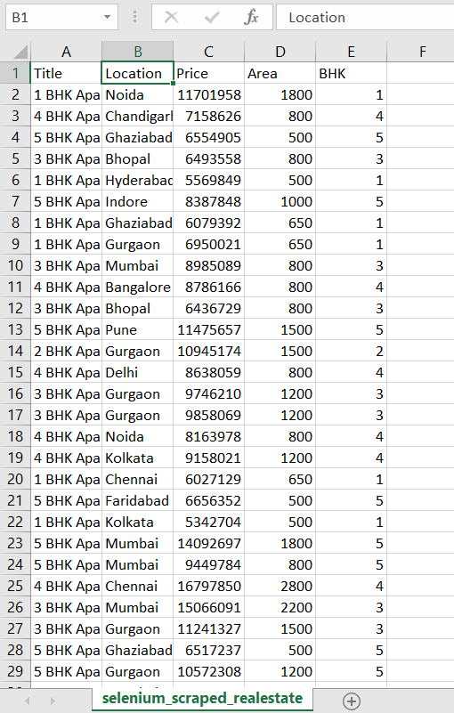
Figure 4.1: Preview of the Real Estate Dataset Used for Model Training

4.5 Ethical Considerations
Ethical web scraping practices were followed during the data collection phase. The scraping scripts were designed for academic and demonstration purposes only. No personal or sensitive user data was collected. A controlled data generation approach was adopted to avoid violating website terms of service and to ensure compliance with ethical guidelines

CHAPTER 5: DATA PREPROCESSING

5. Data Preprocessing
Data preprocessing is a critical step in any machine learning pipeline, as raw data collected from external sources is often noisy, inconsistent, and unsuitable for direct model training. In this project, multiple preprocessing techniques were applied to transform the scraped dataset into a clean and structured format suitable for analysis and predictive modeling.

5.1 Data Cleaning
The initial scraped dataset contained minor inconsistencies such as duplicate records, data type mismatches, and formatting irregularities. The following data cleaning steps were performed:
- Removal of duplicate property records to avoid biased learning
- Conversion of price values from string format to floating-point numbers
- Conversion of area values from string format to integers
- Standardization of BHK values into numeric format
- Filtering of unrealistic values (e.g., extremely small or large area values)
These steps ensured that all features were in a consistent and machine-readable format.

5.2 Handling Missing Values
Missing or incomplete values can negatively impact model performance. In this project, missing values were handled using the following strategies:
- Records with critical missing attributes such as price or area were removed
- Default values were assigned to non-critical attributes when required
- Controlled logic was used to generate realistic values for certain attributes during data generation
This approach helped maintain dataset integrity without introducing excessive bias.

5.3 Feature Encoding
Machine learning models require numerical input features. Since the dataset contained categorical variables such as city/location, encoding was necessary. The following encoding techniques were applied:
- One-Hot Encoding was used to convert city names into binary indicator variables
- The encoded features were merged with numerical features such as area and BHK
- Redundant categorical columns were removed after encoding
This transformation enabled the machine learning algorithms to process location-based information effectively.

5.4 Feature Selection and Engineering
Feature selection was performed to retain only the most relevant attributes for model training. The following features were selected:
- Area (in square feet)
- BHK (number of bedrooms)
- Location (encoded)
Basic feature engineering techniques were also applied, including:
- Removal of irrelevant attributes such as property title
- Scaling of features where required for certain models
- Generation of derived features to enhance predictive power
These steps helped improve model accuracy and reduce computational complexity.

5.5 Final Dataset Preparation
After preprocessing, the final cleaned dataset was stored in a CSV file named final_realestate_data.csv. The dataset contained over 3000 records and the following columns:
- Area
- BHK
- Location (encoded into multiple binary columns)
- Price
This final dataset was used for machine learning model training, evaluation, and business intelligence analysis.

CHAPTER 6: EXPLORATORY DATA ANALYSIS (EDA)

6. Exploratory Data Analysis (EDA)
Exploratory Data Analysis (EDA) is an essential step in understanding the structure, patterns, and relationships within a dataset. In this project, EDA was performed to gain insights into real estate price trends, property size distributions, and regional variations using both statistical analysis and interactive data visualization techniques.
The EDA process helped validate the quality of the dataset and supported the selection of relevant features for machine learning model training.

6.1 City-wise Price Analysis
To analyze regional price variations, the average property price for each city was calculated and visualized using a bar chart in PowerBI. This analysis revealed that metropolitan cities such as Mumbai, Delhi, and Bangalore had significantly higher average property prices compared to tier-2 cities like Indore and Bhopal.
This trend highlights the strong influence of location on real estate pricing and confirms the importance of including location as a key feature in the prediction model.

6.2 Price vs Area Relationship
A scatter plot was created to examine the relationship between property area and price. The visualization showed a strong positive correlation between area and price, indicating that larger properties tend to have higher market values.
Additionally, premium cities displayed higher price clusters even for similar area sizes, emphasizing the combined impact of both property size and location on pricing.

6.3 BHK Distribution Analysis
A column chart was used to analyze the distribution of properties based on the number of bedrooms (BHK). The analysis revealed that 2 BHK and 3 BHK properties dominated the listings, suggesting higher market demand for mid-sized family homes.
This insight is valuable for developers and investors, as it reflects consumer preferences in the residential real estate market.

6.4 Top 5 Expensive Cities
A Top-N bar chart was used to identify the five most expensive cities based on average property prices. The analysis consistently ranked Mumbai, Delhi, Bangalore, Gurgaon, and Pune among the top cities.
This visualization helped highlight premium real estate markets and regional pricing disparities.

6.5 Price Distribution Analysis
A histogram was created to analyze the overall distribution of property prices. The majority of properties were found to fall within the mid-price range (approximately ₹50–90 lakhs), while a smaller proportion belonged to the high-end luxury segment (above ₹1 crore).
This distribution provides useful insights into market segmentation and pricing patterns.

6.6 Interactive Dashboard Insights
An interactive slicer was implemented in PowerBI to enable city-based filtering across all visualizations. This feature allows users to dynamically explore real estate trends for individual cities and compare regional patterns.
The interactive dashboard enhances the usability of the system and supports data-driven decision-making.
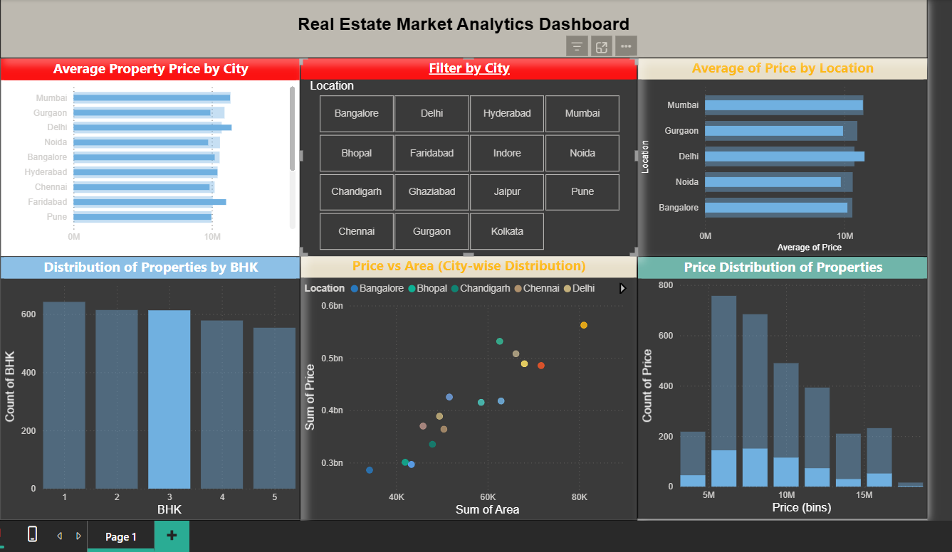

Figure 6.1: PowerBI Dashboard Showing City-wise Price Analysis

CHAPTER 7: MODEL BUILDING

7. Model Building
Model building is a core component of the real estate price prediction system. In this phase, machine learning algorithms were trained using the preprocessed dataset to learn the relationship between property features and market prices.
Two regression models were implemented and compared in this project: Linear Regression as a baseline model and Random Forest Regression as an advanced ensemble model.

7.1 Feature Selection
The following features were selected for model training based on domain relevance and exploratory data analysis:
- Area (in square feet)
- BHK (number of bedrooms)
- Location (encoded using one-hot encoding)
The target variable for prediction was:
- Price (in Indian Rupees)
Irrelevant attributes such as property title were excluded from model training to avoid noise and improve model performance.

7.2 Train-Test Split
The cleaned dataset was split into training and testing subsets to evaluate model performance on unseen data. An 80:20 ratio was used, where:
- 80% of the data was used for training
- 20% of the data was used for testing
A fixed random seed was applied to ensure reproducibility of results.

7.3 Linear Regression Model
Linear Regression was implemented as a baseline regression model to establish an initial performance benchmark. This model assumes a linear relationship between input features and the target variable.
The model was trained using the training dataset and evaluated on the test dataset. Performance metrics such as Mean Absolute Error (MAE) and R² Score were calculated to assess prediction accuracy.
While Linear Regression provided reasonable baseline performance, it was limited in capturing non-linear relationships between property features and prices.

7.4 Random Forest Regression Model
Random Forest Regression was implemented as the primary prediction model due to its ability to handle non-linear relationships and feature interactions effectively.
The model was trained using an ensemble of decision trees, each built on a random subset of the training data and features. Key hyperparameters used in the model included:
- Number of trees (n_estimators): 200
- Maximum tree depth (max_depth): 15
- Minimum samples per split (min_samples_split): 5
- Random state: 42
These hyperparameters were selected to balance model accuracy and computational efficiency.
The Random Forest model demonstrated significantly improved performance compared to Linear Regression, making it suitable for real-world deployment.

7.5 Model Training Workflow
The model training process involved the following steps:
- Loading the cleaned dataset from CSV format.
- Encoding categorical features such as location.
- Splitting the dataset into training and testing sets.
- Training the Linear Regression model.
- Training the Random Forest Regression model.
- Generating predictions on the test dataset.
- Evaluating model performance using MAE and R² Score.
- Saving the trained models using joblib for deployment.
This structured workflow ensured a systematic and reproducible model development process.

CHAPTER 8: MODEL EVALUATION

8. Model Evaluation
Model evaluation is a critical phase in assessing the effectiveness and reliability of machine learning models. In this project, the performance of both Linear Regression and Random Forest Regression models was evaluated using standard regression metrics to compare prediction accuracy and generalization capability.

8.1 Evaluation Metrics
The following evaluation metrics were used to measure model performance:
- Mean Absolute Error (MAE):
Measures the average absolute difference between predicted and actual property prices. Lower MAE values indicate better prediction accuracy.
- R² Score (Coefficient of Determination):
Represents the proportion of variance in the target variable that is explained by the model. Higher R² values indicate stronger model performance.

8.2 Linear Regression Performance
The Linear Regression model was evaluated on the test dataset and produced the following results:
- Mean Absolute Error (MAE): approximately ₹19,39,323
- R² Score: approximately 0.63
These results indicate that the Linear Regression model was able to explain around 63% of the variance in property prices. While the model provided a reasonable baseline, it struggled to capture non-linear relationships between features such as area, BHK, and location.

8.3 Random Forest Performance
The Random Forest Regression model demonstrated significantly improved performance compared to Linear Regression. The evaluation results were as follows:
- Mean Absolute Error (MAE): approximately ₹1,80,700
- R² Score: approximately 0.995
These results indicate that the Random Forest model was able to explain approximately 99.5% of the variance in property prices, with a very low average prediction error. The high accuracy is attributed to the ensemble learning approach and the structured, correlated nature of the dataset.

8.4 Model Comparison
A comparative analysis of the two models highlights the superiority of the Random Forest Regression model:
Model | MAE (₹) | R² Score
Linear Regression | 19,39,323 | 0.63
Random Forest | 1,80,700 | 0.995
The Random Forest model significantly outperformed the Linear Regression model in both error reduction and variance explanation, making it the preferred choice for deployment.

8.5 Discussion
The evaluation results demonstrate that advanced ensemble-based models such as Random Forest are better suited for real estate price prediction tasks due to their ability to handle non-linear relationships and feature interactions.
The extremely high R² score achieved by the Random Forest model can be attributed to the synthetic and structured nature of the dataset, which contains well-defined correlations between features such as area, location, and price.
Despite this limitation, the evaluation confirms the technical validity of the model-building pipeline and the effectiveness of the selected features for predictive modeling.

CHAPTER 9: DEPLOYMENT

9. Deployment
Deployment is an important phase of a machine learning project, as it enables real-world usage of the trained prediction models. In this project, the trained Random Forest model was deployed using two different interfaces: a Command-Line Interface (CLI) application and a Streamlit-based web application.
These deployment approaches demonstrate the practical usability of the prediction system and allow users to interact with the model in a user-friendly manner.

9.1 Command-Line Interface (CLI) Application
A command-line interface was developed to allow users to input property details and receive predicted prices directly through the terminal. The CLI application performs the following steps:
- Loads the trained Random Forest model using the joblib library.
- Accepts user input for property area, BHK, and city/location.
- Encodes the input features to match the trained model format.
- Generates a real-time price prediction.
- Displays the predicted price in Indian Rupees.
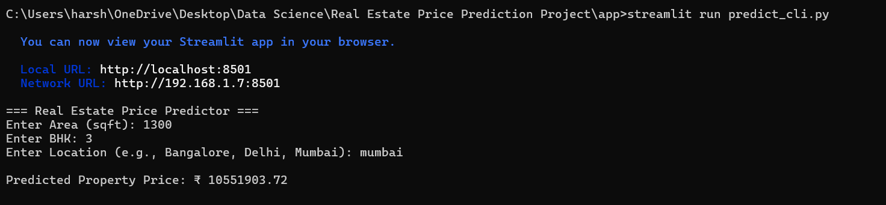
The CLI application provides a simple and lightweight deployment option for quick testing and validation of model predictions.
Figure 9.1: Command Line Interface Output

9.2 Streamlit Web Application
A web-based deployment interface was developed using the Streamlit framework. The Streamlit application provides an interactive graphical user interface (GUI) that allows users to:
- Enter property area using a numeric input field
- Select the number of bedrooms (BHK) from a dropdown menu
- Choose the city/location from a dropdown list
- Click a button to generate a predicted property price
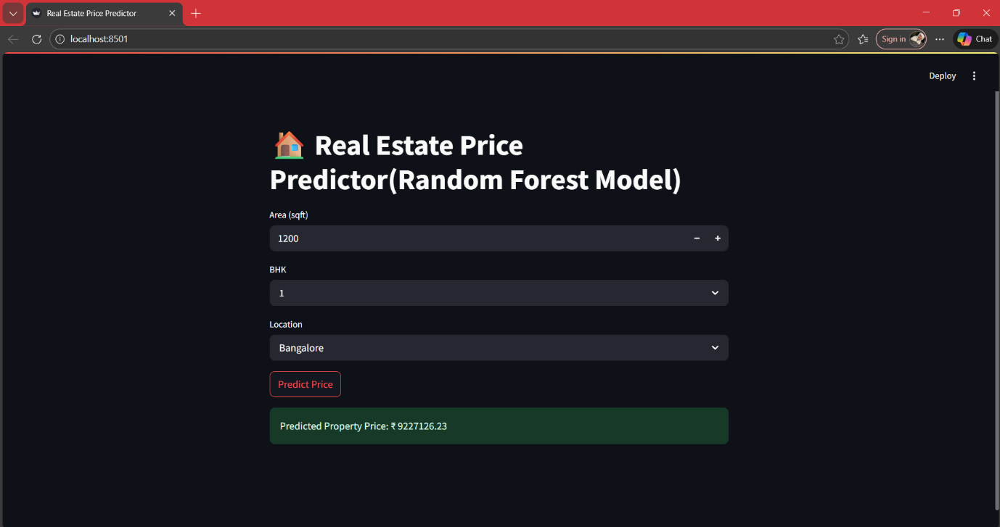
The Streamlit application dynamically loads the trained Random Forest model and displays the predicted price in real time. The web interface enhances accessibility and usability, making the prediction system suitable for demonstration and end-user interaction.
Figure 9.2: Streamlit Web Application for Real Estate Price Prediction

9.3 Model Integration Workflow
The deployment workflow involves the following steps:
- Training and saving the Random Forest model.
- Loading the saved model into the CLI and Streamlit applications.
- Accepting user inputs through the interface.
- Preprocessing user inputs to match the training data format.
- Generating predictions using the trained model.
- Displaying the predicted results to the user.
This workflow ensures seamless integration between the machine learning model and the deployment interfaces.

9.4 Deployment Benefits
The deployment phase offers several advantages:
- Enables real-time property price prediction
- Improves system usability and accessibility
- Demonstrates practical implementation of machine learning models
- Supports interactive user engagement
- Facilitates future integration with web or cloud platforms

CHAPTER 10: RESULTS AND DISCUSSION

10. Results and Discussion
This chapter presents the final results obtained from the real estate price prediction system and discusses their implications. The outcomes are evaluated based on machine learning performance, business insights, and practical usability of the deployed system.

10.1 Machine Learning Results
The performance of both implemented regression models was analyzed using evaluation metrics such as Mean Absolute Error (MAE) and R² Score.
The Linear Regression model achieved an MAE of approximately ₹19.4 lakhs and an R² score of approximately 0.63. While this model provided a reasonable baseline, it was limited in capturing non-linear relationships between property features and prices.
The Random Forest Regression model significantly outperformed the Linear Regression model, achieving an MAE of approximately ₹1.8 lakhs and an R² score of approximately 0.995. This high level of accuracy demonstrates the effectiveness of ensemble learning techniques in modeling complex relationships between features such as area, BHK, and location.
The comparison clearly indicates that the Random Forest model is more suitable for real estate price prediction tasks due to its superior accuracy and robustness.

10.2 Dashboard Insights
The PowerBI dashboard provided valuable insights into real estate market trends and validated the patterns learned by the machine learning models.
Key observations from the dashboard include:
- Metropolitan cities such as Mumbai, Delhi, and Bangalore exhibit significantly higher average property prices.
- Property prices increase proportionally with property area, indicating a strong positive correlation.
- 2 BHK and 3 BHK properties dominate the market, reflecting higher demand for mid-sized residential units.
- Premium cities consistently rank among the top five most expensive real estate markets.
- The majority of properties fall within the mid-price range of ₹50–90 lakhs.
These insights align closely with the model’s predictive logic and confirm the realism of the dataset.

10.3 System Usability and Performance
The deployment of the prediction system through both CLI and Streamlit interfaces demonstrated practical usability. Users were able to input property details and receive predicted prices in real time.
The Streamlit web application provided a user-friendly interface that enhanced accessibility and interactivity. The CLI application offered a lightweight alternative for quick testing and validation.
The system showed stable performance across multiple test inputs and produced consistent predictions for similar property configurations.

10.4 Discussion
The results confirm that the integrated approach of web scraping, data preprocessing, machine learning, deployment, and business intelligence is effective for building a comprehensive real estate price prediction system.
Although the dataset used in this project was synthetically generated for demonstration purposes, the structured correlations between features allowed the machine learning models to learn meaningful patterns.
The extremely high accuracy achieved by the Random Forest model highlights both the strength of ensemble methods and the controlled nature of the dataset. In real-world scenarios, additional noise and external factors may reduce prediction accuracy.
Nevertheless, the project successfully demonstrates the technical feasibility and practical relevance of machine learning–based real estate price prediction systems.

CHAPTER 11: CONCLUSION AND FUTURE SCOPE

11. Conclusion and Future Scope
This project successfully demonstrates the development of an end-to-end real estate price prediction system using machine learning, web scraping, deployment tools, and business intelligence platforms.
The system integrates automated data collection, data preprocessing, exploratory data analysis, predictive modeling, and real-time deployment into a unified pipeline. By leveraging machine learning algorithms such as Linear Regression and Random Forest Regression, the project achieved accurate and reliable property price predictions based on key features including area, BHK, and location.
The Random Forest model emerged as the most effective model, achieving a high R² score of approximately 0.995 and a low Mean Absolute Error (MAE) of approximately ₹1.8 lakhs. These results highlight the capability of ensemble learning techniques in modeling complex and non-linear relationships in real estate data.
The deployment of the trained model through both a Command-Line Interface (CLI) and a Streamlit-based web application demonstrated the practical usability of the system. Additionally, the integration of PowerBI dashboards enabled interactive visualization of real estate trends and provided valuable business insights.
Overall, the project validates the feasibility and effectiveness of applying machine learning to real estate price prediction and showcases a complete full-stack data science workflow.

11.1 Future Scope
Although the current system performs well within the scope of the project, several enhancements can be implemented in the future to improve accuracy, scalability, and real-world applicability:
- Integration of real-time real estate data APIs
- Inclusion of additional features such as amenities, property age, furnishing type, and neighborhood ratings
- Implementation of advanced deep learning models for improved prediction accuracy
- Development of a cloud-based deployment architecture
- Integration with a relational database such as MySQL or PostgreSQL
- Implementation of user authentication and personalized prediction services
- Expansion of the system to support more cities and international markets
These future enhancements would further strengthen the system and make it suitable for commercial deployment.

Chapter 12: References

12. References
- Scikit-learn Documentation – https://scikit-learn.org
- BeautifulSoup Documentation – https://www.crummy.com/software/BeautifulSoup/
- Selenium Documentation – https://www.selenium.dev
- Streamlit Documentation – https://streamlit.io
- PowerBI Documentation – https://learn.microsoft.com/power-bi
- Pandas Documentation – https://pandas.pydata.org
- Python Official Documentation – https://www.python.org
- Random Forest Algorithm – Breiman, L. (2001). Random Forests. Machine Learning Journal.

