**#basic calculator**

**n1=float(input("enter number 1:"))**

**n2=float(input("enter number 2:"))**

**choice=input("enter your choice:")**

**if(choice=="sum"):**

**print(n1+n2)**

**elif(choice=="subtract"):**

**print(n1-n2)**

**elif(choice=="quotient"):**

**print(n1/n2)**

**elif(choice=="reminder"):**

**print(n1%n2)**

**elif(choice=="multiply"):**

**print(n1*n2)**

**else:**

**print("invalid choice")**

**output**

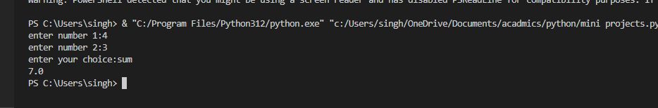

#NUMBER SYSTEM

n=int(input("enter value till u want to print"))

print("1 for forward and 0 for reverse")

c=int(input("enter c:"))

if(c==1):

    print("2 for vertical and 3 for horizontal")

    d=int(input("enter d:"))

    if(d==2):

        for i in range(1,n+1,1):

            print(i)

    elif(d==3):

        for i in range(1,n+1,1):

            print(i,end=',')

    else:

        print("invalid choice")

elif(c==0):

    print("2 for vertical and 3 for horizontal")

    d=int(input("enter d:"))

    if(d==2):

        for i in range(n,0,-1):

            print(i)

    elif(d==3):

        for i in range(n,0,-1):

            print(i,end=',')

    else:

        print("invalid choice")

else:

    print("invalid choice")

**output**

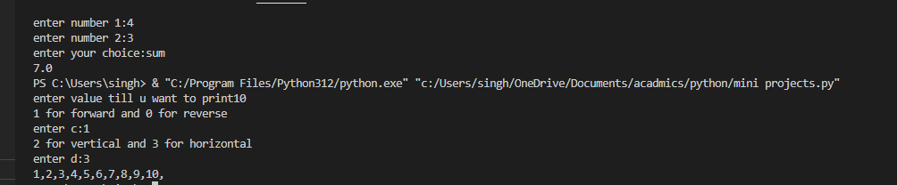

#voting system

b=0;c=0;a=0;s=0;r=0

while True:

    name=input("enter your name:")

    n=int(input("enter your age:"))

    if(n>=18):

        print("eligble to vote")

        print("bjp==1;INC==2;AAP==3;BSP==4;RLD==5")

        p=int(input("enter the party u want to vote"))

        if(p==1):

            b+=1

            print("BJP total votes:",b)

        elif(p==2):

            c+=1

            print("INC total votes:",c)

        elif(p==3):

            a+=1

            print("AAP total votes:",a)

        elif(p==4):

            s+=1

            print("BSP total votes:",s)

        elif(p==5):

            r+=1

            print("RLD total votes:",r)

        else:

            print("invalid")

        ch=int(input("you want to continue:"))

        if(ch==10):

            continue;

        else:

            break;

    else:

        print("no eligble to vote")

    print("voting is ended")

**output**

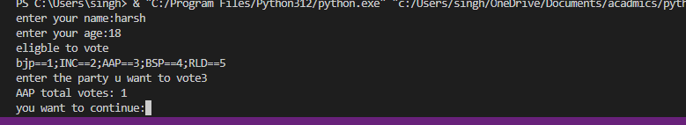

#stone paper and scissor

import random

def play_game():

    print("Let's play Rock, Paper, Scissors!")

    choices = ["rock", "paper", "scissors"]

    user_choice = input("Enter your choice (rock, paper, or scissors): ").lower()

    if user_choice not in choices:

        print("Invalid choice. Please enter rock, paper, or scissors.")

        play_game()

    computer_choice = random.choice(choices)

    print("You chose:", user_choice)

    print("Computer chose:", computer_choice)

    if user_choice == computer_choice:

        print("It's a tie!")

    elif (

        (user_choice == "rock" and computer_choice == "scissors") or

        (user_choice == "paper" and computer_choice == "rock") or

        (user_choice == "scissors" and computer_choice == "paper")

    ):

        print("You win!")

    else:

        print("Computer wins!")

play_game()

**output**



#roll the dice

import random

user=0;comp=0

while True:

    c=random.randint(1,7)

    n=c

    comp+=1

    i=int(input("enter the value:"))

    if(1<=i<=6):

        user+=i

    else:

        print("value out of range")

    k=int(input("enter to continue"))

    if(k==9):

        continue;

    else:

        break;

print("user total",user)

print("computer total",comp)

if(user>comp):

    print("win",user)

elif(comp>user):

    print("loss",comp)

else:

    print("its a tie")

**output**

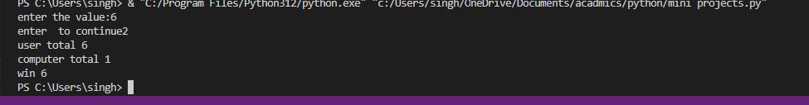

#grading system

f=open('record file','w')

while True:

    name=input("enter the student name:")

    marks=int(input("enter student total marks:"))

    k=500

    p=(marks/k)*100

    if(95<=p<=100):

        print("student got A+ grade",p)

    elif(90<=p<95):

         print("student got A grade",p)

    elif(80<=p<90):

         print("student got B grade",p)

    elif(70<=p<80):

         print("student got C grade",p)

    elif(60<=p<70):

         print("student got D grade",p)

    elif(0<=p<60):

         print("student got F grade",p)

    else:

        print("H")

    f.write("name:-(name)percentage:-(p)")

    choice=int(input("1 to continue "))

    if(choice==1):

        continue;

    else:

        break;

**output**

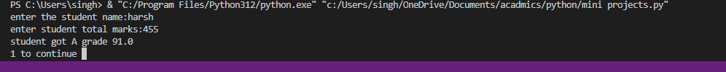

#guessing number

import random

x=int(input("range till u want"))

while True:

    c=random.randint(1,x)

    n=c

    user=int(input("entr the number user want"))

    if(user==n):

        print("right guess")

        break;

    else:

        print("better luck next time")

    choice=int(input("1 to continue"))

    if(choice==1):

        continue;

    else:

        break;

**output**

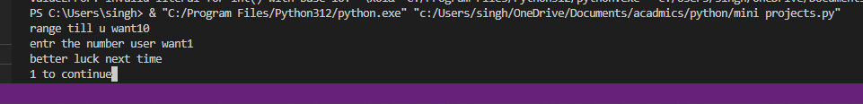

#inventory management

l={"apple":80,"banana":60}

totalamount=0

print(l)

name=input("enter customer name:")

cardamount=int(input("enter card balance:"))

while True:

    cart=input("items purchased:")

    quantity=int(input("enter the quantity:"))

    s=l[cart]

    a=quantity*s

    print(a)

    choice=int(input("1 to continue:"))

    totalamount+=a

    if(choice==1):

        continue;

    else:

        break;

#totalamount+=a

if(cardamount<totalamount):

    print("insufficient balance")

    r=int(input("0 to recharge"))

    if(r==0):

        k=int(input("enter recharge amount"))

        cardamount+=k

        amountleft=cardamount-totalamount

        print("card balance",amountleft)

    else:

        print("no rechgarge")

elif(cardamount>totalamount):

    amountleft=cardamount-totalamount

    print("card balance",amountleft)

else:

    print()

**output**

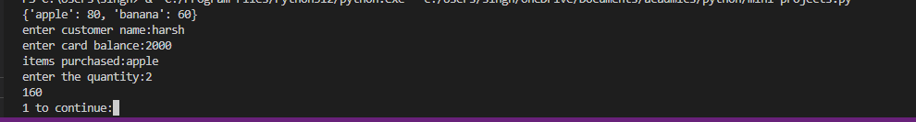

with open('user_input.txt', 'w') as file:

name = input("Enter your name: ")

uni_roll= input("Enter your university roll no.: ")

marks=int(input("Enter total marks of 5 Subject"))

res=(marks*100)/500

file.write(f"Name: {name}\n")

file.write(f"University roll no.: {uni_roll}\n")

if res<=40:

file.write(f"Result:{"Fail"}\n")

else:

file.write(f"Result:{"Pass"}\n")

with open ('user_input.txt','r') as file:

print(file.read())

