PROJECT

CALCULATOR Using ARDUINO UNO

**I build my own calculator with Arduino**. The values can be sent in through a **keypad (4×4 keypad)** and result can be viewed on a **LCD screen** (16×2 Dot-matrix). This calculator could perform simple operations like Addition, Subtraction, Multiplication and Division with whole numbers

Circuit and Working

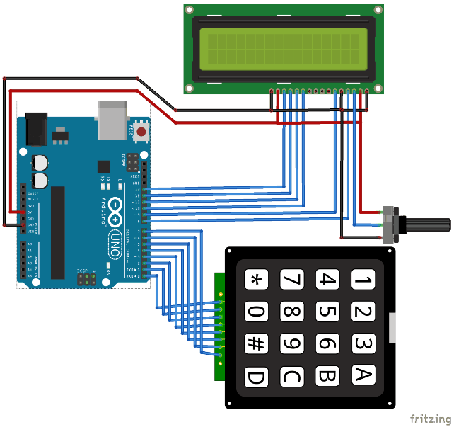

PIN CONNECTIONS

|  |  |
| --- | --- |
| Arduino Pin Name: | Connected to: |
| D0 | 1st pin of the keyboard |
| D1 | 2nd pin of the keyboard |
| D2 | 3rd pin of the keyboard |
| D3 | 4th pin of the keyboard |
| D4 | 5th pin of the keyboard |
| D5 | 6th pin of the keyboard |
| D6 | 7th pin of the keyboard |
| D7 | 8th pin of the keyboard |
| D8 | Register select pin of LCD (pin 4) |
| D10 | Data pin 4 (pin 11) |
| D11 | Data pin 4 (pin 11) |
| D12 | Data pin 4 (pin 11) |
| D13 | Data pin 4 (pin 11) |
| +5V | Connected to Vdd pin of LCD (pin 2) |
| Ground | Connected to Vss,Vee and RW pin of LCD (pin 1,3 and 5) |

WORKING

Make the connections as per circuit diagram and upload the code below. If it shows error make sure you have added the library as per the instruction given above. You can also try the simulation to check if the problem is with your hardware. If everything is done as it’s supposed to be, then your hardware will look something like this below with the LCD displaying this

|  |  |
| --- | --- |
| **Character on Keypad** | **Assumed to be** |
| “A” | Addition (+) |
| “B” | Subtraction (-) |
| “C” | Multiplication (*) |
| “D” | Division (/) |
| “*” | Clear (C) |
| “#” | Equals (=) |

CODE

#include <LiquidCrystal.h>

#include <Keypad.h>

const byte ROWS = 4; // Four rows

const byte COLS = 4; // Three columns

// Define the Keymap

char keys[ROWS][COLS] = {

{'7','8','9','D'},

{'4','5','6','C'},

{'1','2','3','B'},

{'*','0','#','A'}

};

byte rowPins[ROWS] = { 0, 1, 2, 3 };// Connect keypad ROW0, ROW1, ROW2 and ROW3 to these Arduino pins.

byte colPins[COLS] = { 4, 5, 6, 7 }; // Connect keypad COL0, COL1 and COL2 to these Arduino pins.

Keypad kpd = Keypad( makeKeymap(keys), rowPins, colPins, ROWS, COLS ); // Create the Keypad

const int rs = 8, en = 9, d4 = 10, d5 = 11, d6 = 12, d7 = 13; //Pins to which LCD is connected

LiquidCrystal lcd(rs, en, d4, d5, d6, d7);

long Num1,Num2,Number;

char key,action;

boolean result = false;

void setup() {

lcd.begin(16, 2); //We are using a 16*2 LCD display

lcd.print("DIY Calculator"); //Display a intro message

lcd.setCursor(0, 1); // set the cursor to column 0, line 1

lcd.print("-CircuitDigest"); //Display a intro message

delay(2000); //Wait for display to show info

lcd.clear(); //Then clean it

}

void loop() {

key = kpd.getKey(); //storing pressed key value in a char

if (key!=NO_KEY)

DetectButtons();

if (result==true)

CalculateResult();

DisplayResult();

}

void DetectButtons()

{

lcd.clear(); //Then clean it

if (key=='*') //If cancel Button is pressed

{Serial.println ("Button Cancel"); Number=Num1=Num2=0; result=false;}

if (key == '1') //If Button 1 is pressed

{Serial.println ("Button 1");

if (Number==0)

Number=1;

else

Number = (Number*10) + 1; //Pressed twice

}

if (key == '4') //If Button 4 is pressed

{Serial.println ("Button 4");

if (Number==0)

Number=4;

else

Number = (Number*10) + 4; //Pressed twice

}

if (key == '7') //If Button 7 is pressed

{Serial.println ("Button 7");

if (Number==0)

Number=7;

else

Number = (Number*10) + 7; //Pressed twice

}

if (key == '0')

{Serial.println ("Button 0"); //Button 0 is Pressed

if (Number==0)

Number=0;

else

Number = (Number*10) + 0; //Pressed twice

}

if (key == '2') //Button 2 is Pressed

{Serial.println ("Button 2");

if (Number==0)

Number=2;

else

Number = (Number*10) + 2; //Pressed twice

}

if (key == '5')

{Serial.println ("Button 5");

if (Number==0)

Number=5;

else

Number = (Number*10) + 5; //Pressed twice

}

if (key == '8')

{Serial.println ("Button 8");

if (Number==0)

Number=8;

else

Number = (Number*10) + 8; //Pressed twice

}

if (key == '#')

{Serial.println ("Button Equal");

Num2=Number;

result = true;

}

if (key == '3')

{Serial.println ("Button 3");

if (Number==0)

Number=3;

else

Number = (Number*10) + 3; //Pressed twice

}

if (key == '6')

{Serial.println ("Button 6");

if (Number==0)

Number=6;

else

Number = (Number*10) + 6; //Pressed twice

}

if (key == '9')

{Serial.println ("Button 9");

if (Number==0)

Number=9;

else

Number = (Number*10) + 9; //Pressed twice

}

if (key == 'A' || key == 'B' || key == 'C' || key == 'D') //Detecting Buttons on Column 4

{

Num1 = Number;

Number =0;

if (key == 'A')

{Serial.println ("Addition"); action = '+';}

if (key == 'B')

{Serial.println ("Subtraction"); action = '-'; }

if (key == 'C')

{Serial.println ("Multiplication"); action = '*';}

if (key == 'D')

{Serial.println ("Devesion"); action = '/';}

delay(100);

}

}

void CalculateResult()

{

if (action=='+')

Number = Num1+Num2;

if (action=='-')

Number = Num1-Num2;

if (action=='*')

Number = Num1*Num2;

if (action=='/')

Number = Num1/Num2;

}

void DisplayResult()

{

lcd.setCursor(0, 0); // set the cursor to column 0, line 1

lcd.print(Num1); lcd.print(action); lcd.print(Num2);

if (result==true)

{lcd.print(" ="); lcd.print(Number);} //Display the result

lcd.setCursor(0, 1); // set the cursor to column 0, line 1

lcd.print(Number); //Display the result

}

