PROJECT

Radar (Radio Detection and Ranging) Using ARDUINO UNO

Radar is a device which transmit radio signals which are being travel and get returned from obstacles and received at the receiver.

It helps in finding the distance and location of the target or obstacle.

Circuit and Working

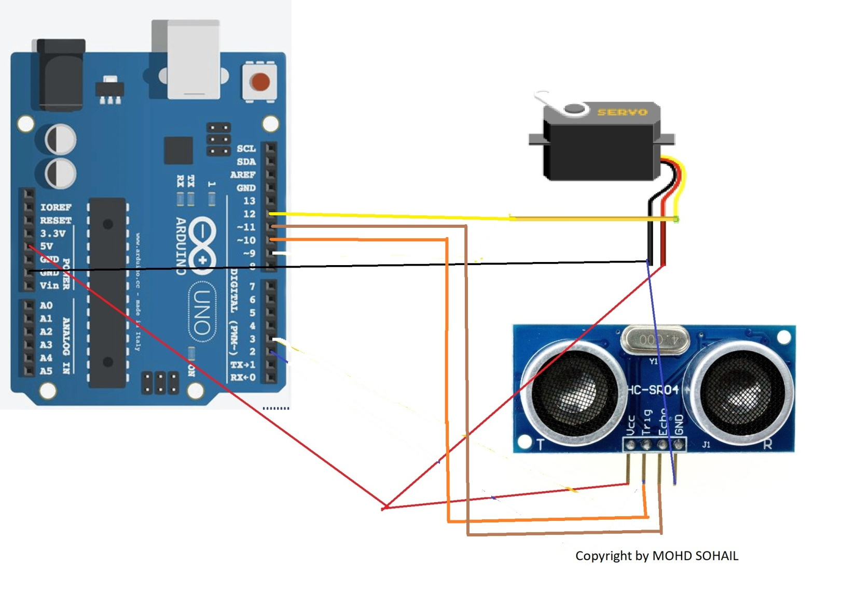

PIN CONNECTIONS

Connect the ultrasonic TRIG pin to arduino pin 10.

Connect the ultrasonic ECHO pin to arduino pin 11.

Take servo motor and connect signal pin to arduino pin 12.

Connect both ultrasonic sensor and servo Vcc pin to Arduino +5V pin.

Connect both ultrasonic sensor and servo GND pin to Arduino GND pin.

Upload the arduino code.

we use PROCESSING software to upload code to arduino

WORKING

Radar is a long-range object detection system that uses radio waves to establish certain parameters of an object like its range, speed and position. Radar technology is used in aircrafts, missiles, marine, weather predictions and automobiles.

Even though the title says Arduino Radar Project, technically the project is based on Sonar technology as I will be using an Ultrasonic Sensor to determine the presence of any object in a particular range.

CODE

#include <Servo.h>.

// Defines Tirg and Echo pins of the Ultrasonic Sensor

const int trigPin = 10;

const int echoPin = 11;

// Variables for the duration and the distance

long duration;

int distance;

void setup() {

pinMode(trigPin, OUTPUT); // Sets the trigPin as an Output

pinMode(echoPin, INPUT); // Sets the echoPin as an Input

Serial.begin(9600);

myServo.attach(12); // Defines on which pin is the servo motor attached

}

void loop() {

// rotates the servo motor from 15 to 165 degrees

for(int i=15;i<=165;i++){

myServo.write(i);

delay(30);

distance = calculateDistance();// Calls a function for calculating the distance measured by the Ultrasonic sensor for each degree

Serial.print(i); // Sends the current degree into the Serial Port

Serial.print(","); // Sends addition character right next to the previous value needed later in the Processing IDE for indexing

Serial.print(distance); // Sends the distance value into the Serial Port

Serial.print("."); // Sends addition character right next to the previous value needed later in the Processing IDE for indexing

}

// Repeats the previous lines from 165 to 15 degrees

for(int i=165;i>15;i--){

myServo.write(i);

delay(30);

distance = calculateDistance();

Serial.print(i);

Serial.print(",");

Serial.print(distance);

Serial.print(".");

}

}

// Function for calculating the distance measured by the Ultrasonic sensor

int calculateDistance(){

digitalWrite(trigPin, LOW);

delayMicroseconds(2);

// Sets the trigPin on HIGH state for 10 micro seconds

digitalWrite(trigPin, HIGH);

delayMicroseconds(10);

digitalWrite(trigPin, LOW);

duration = pulseIn(echoPin, HIGH); // Reads the echoPin, returns the sound wave travel time in microseconds

distance= duration\*0.034/2;

return distance;

}

