PROJECT

Working of an RGB led Using ARDUINO UNO

The RGB LED can emit different colors by mixing the 3 basic colors red, green and blue. So it actually consists of 3 separate LEDs red, green and blue packed in a single case. That’s why it has 4 leads, one lead for each of the 3 colors and one Common Cathode or Anode depending of the RGB LED type. The RGB LED used in this lab report is a Common Cathode RGB LED.

Circuit and Working

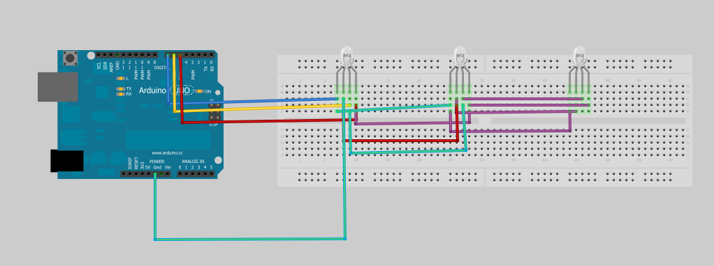

PIN CONNECTIONS

connect red Pin to 7,

connect green Pin = 6,

connect blue Pin = 5,

negative to ground

WORKING

The cathode will be connected to the ground and the 3 anodes will be connected through to 3 digital pins on the Arduino Board that can provide PWM (Pulse Width Modulator) signal. We will use PWM, Pulse Width Modulation for simulating analog output which will provide different voltage levels to the LEDs so we can get the desired colors.

CODE

int redPin= 7;

int greenPin = 6;

int bluePin = 5;

void setup()

{

pinMode(redPin, OUTPUT);

pinMode(greenPin, OUTPUT);

pinMode(bluePin, OUTPUT);

}

void loop()

{

setColor(255, 0, 0); // Red Color

delay(1000);

setColor(0, 255, 0); // Green Color

delay(1000);

setColor(0, 0, 255); // Blue Color

delay(1000);

setColor(255, 255, 255); // White Color

delay(1000);

setColor(170, 0, 255); // Purple Color

delay(1000);

}

