VISUALIZATION
Visualization means showing data in the form of pictures, like charts and graphs. When data is only numbers in a table, it is hard to understand. When the same data is shown as a graph, we can see the pattern very quickly.
In Python, there are many libraries for data visualization. Two of the most popular ones are Matplotlib and Seaborn.
In this document, I have used small and simple examples to learn both libraries. The examples are monthly sales, product sales, study hours and exam marks, and monthly expenses. For every chart, the code, the output and a short description are given.
This document has these parts:
- Matplotlib: line chart, bar graph, scatter plot, histogram and pie chart.
- Seaborn: line plot, bar plot, scatter plot, histogram and heatmap.
- Comparison of Matplotlib and Seaborn.
- Conclusion and references.

MATPLOTLIB
Matplotlib is the basic and most used plotting library in Python. It was introduced in 2002 by John Hunter. It is used to make 2D charts like line charts, bar graphs and pie charts. Many other libraries, including Seaborn, are built on top of it.

PYPLOT
Pyplot is a part of Matplotlib that has all the simple functions for making charts. We import it like this:
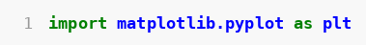
Some of the plots in Matplotlib:

LINE CHART
A line chart joins the points one after another with a line. It is used to see how something changes over time. Here we use it to see the sales of each month.
plot() is used for line charts.
Code snippet:
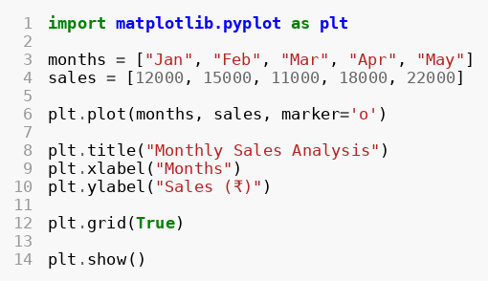
Output:
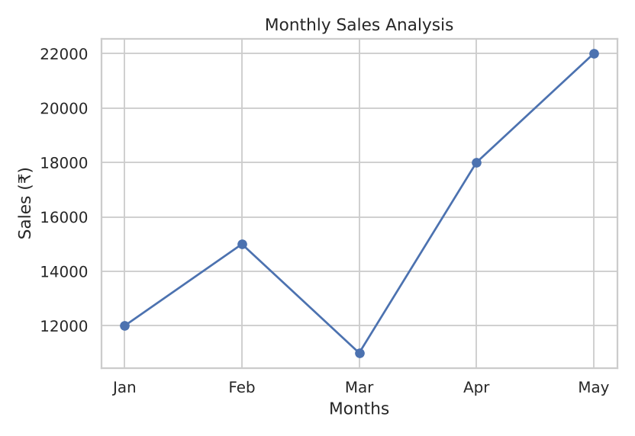
Description:
months and sales are two lists. The months go on the x axis and the sales go on the y axis.
plot() draws the line. marker='o' puts a small circle on every point.
title() gives the title. xlabel() and ylabel() give names to the x axis and y axis.
grid(True) shows the grid lines in the background.
show() displays the graph.
From the graph, we can see that sales went up from Jan to Feb, came down in Mar, and then went up again till May. May has the highest sales.

BAR GRAPH
A bar graph uses rectangular bars to compare different things. The height of the bar shows the value. bar() is used for bar graphs.
bar(x, y)
Code snippet:
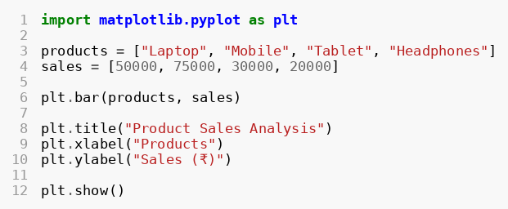
Output:
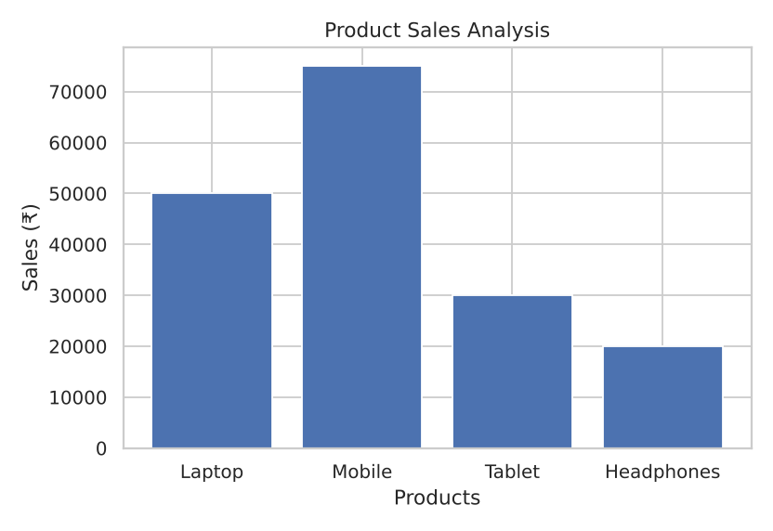
Description:
products and sales are the lists for the names and the values.
bar() draws one bar for each product.
Mobile has the tallest bar, so Mobile has the highest sales. Headphones has the lowest sales.

SCATTER PLOT
A scatter plot uses dots to show the relationship between two things. scatter() is used for scatter plots.
Code snippet:
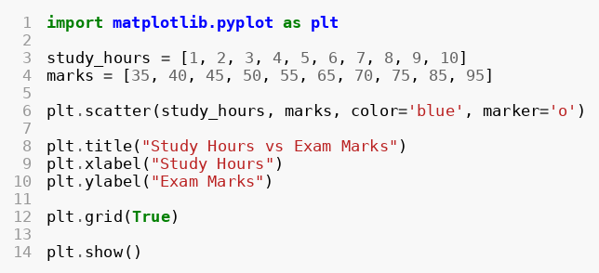
Output:
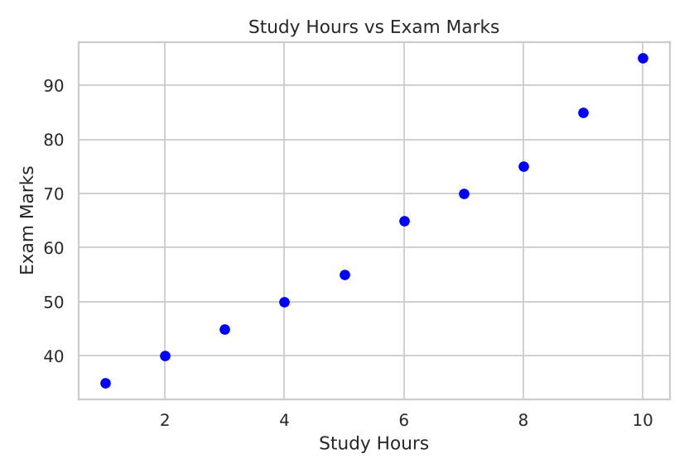
Description:
study_hours is on the x axis and marks is on the y axis. Each dot is one student.
color='blue' sets the colour of the dots and marker='o' sets the shape of the dots.
The dots go upward from left to right. This means that when study hours increase, marks also increase.

HISTOGRAM
A histogram is like a bar graph, but it groups the numbers into ranges. It shows how the data is spread. hist() is used for histograms.
Code snippet:
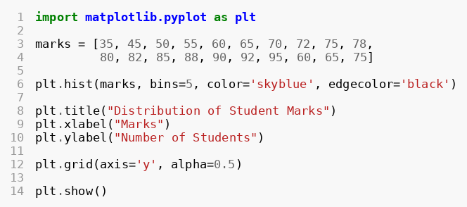
Output:
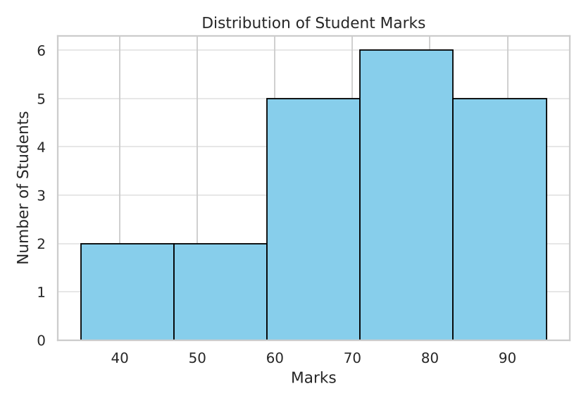
Description:
marks is a list of the marks of 20 students.
bins=5 means the marks are divided into 5 groups.
color='skyblue' is the colour of the bars and edgecolor='black' puts a black border on the bars.
grid(axis='y', alpha=0.5) shows light grid lines only on the y axis.
The tallest bars are on the right side, so most of the students got high marks.

PIE CHART
A pie chart is a circle that is divided into parts. Each part shows how much of the total it takes. pie() is used for pie charts.
Code snippet:
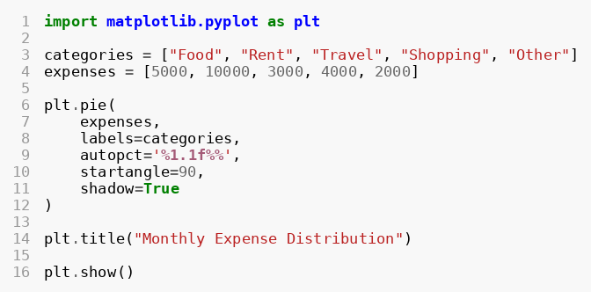
Output:
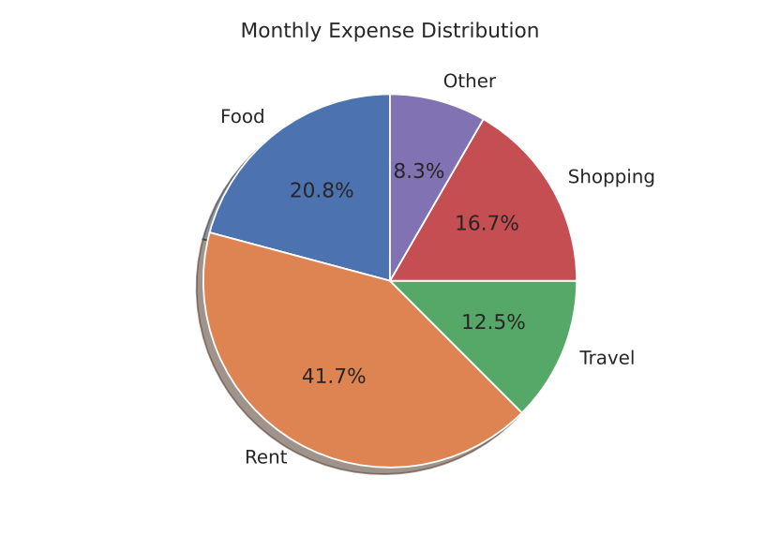
Description:
expenses has the amounts and labels=categories writes the name of each part.
autopct='%1.1f%%' shows the percentage on each part with one number after the decimal.
startangle=90 decides where the first part starts, and shadow=True adds a small shadow.
Rent takes the biggest part (41.7%) and Other takes the smallest part (8.3%).

SEABORN
Seaborn is a visualization library of Python which is built on top of Matplotlib. It makes charts that look good with very little code. It has its own style and colours, and it works very well with Pandas DataFrames.
We import the libraries and set the style as following:
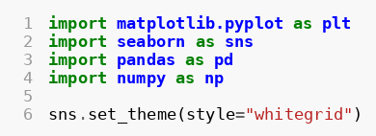
sns.set_theme(style="whitegrid") gives all the charts a white background with light grid lines. We still use plt.title(), plt.xlabel(), plt.ylabel() and plt.show() from Matplotlib, because Seaborn works on top of it.
In Seaborn, we first keep our data in a DataFrame, and then we give the column names to x and y.
Some of the plots in Seaborn:

LINE PLOT
lineplot() is used to draw a line chart. It shows how the values change.
Code snippet:
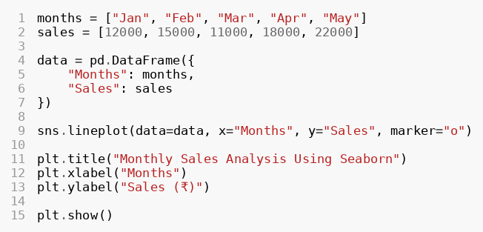
Output:
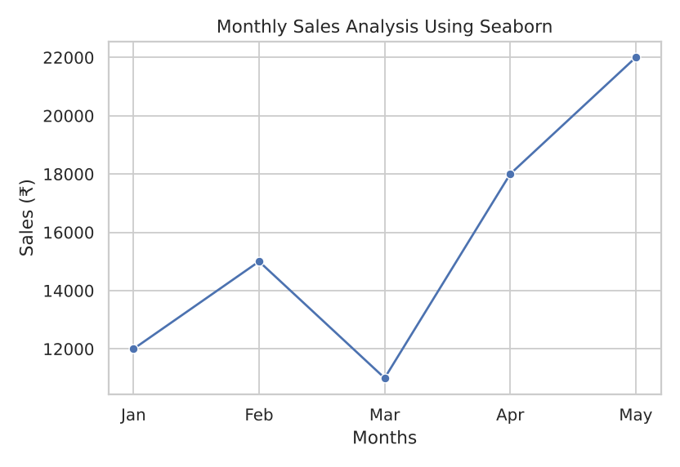
Description:
pd.DataFrame() makes a table with two columns, Months and Sales.
data=data tells Seaborn which table to use. x="Months" and y="Sales" tell which columns to use.
marker="o" puts a circle on every point.
The graph is the same as the Matplotlib line chart, but here the grid and the style come by default from the theme.

BAR PLOT
barplot() is used to draw a bar graph for comparing different things.
Code snippet:
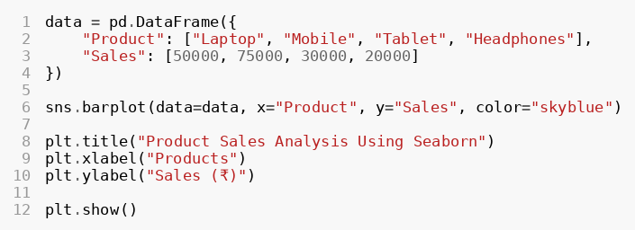
Output:
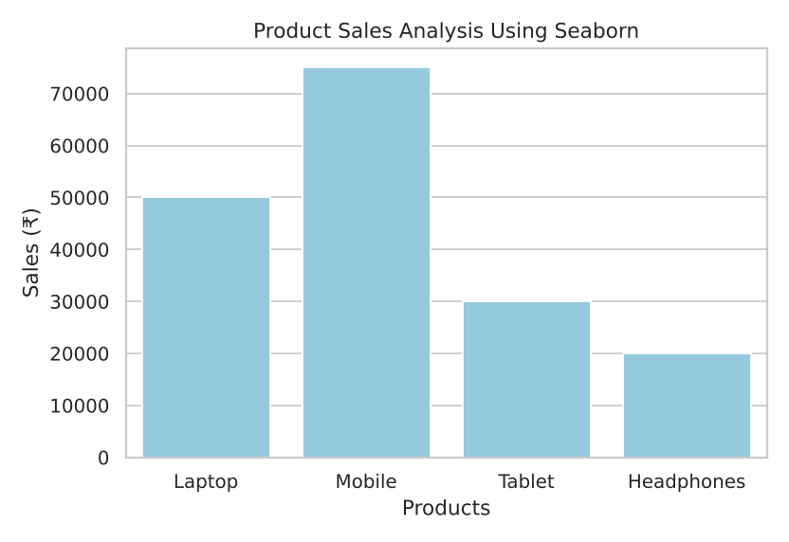
Description:
The DataFrame has two columns, Product and Sales.
color="skyblue" makes all the bars the same colour. If we do not give a colour, Seaborn gives its own colour.
Mobile has the highest sales and Headphones has the lowest sales.

SCATTER PLOT
scatterplot() is used to show the relationship between two columns using dots.
Code snippet:
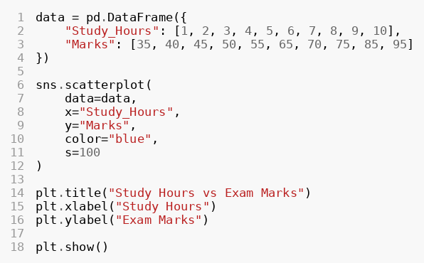
Output:
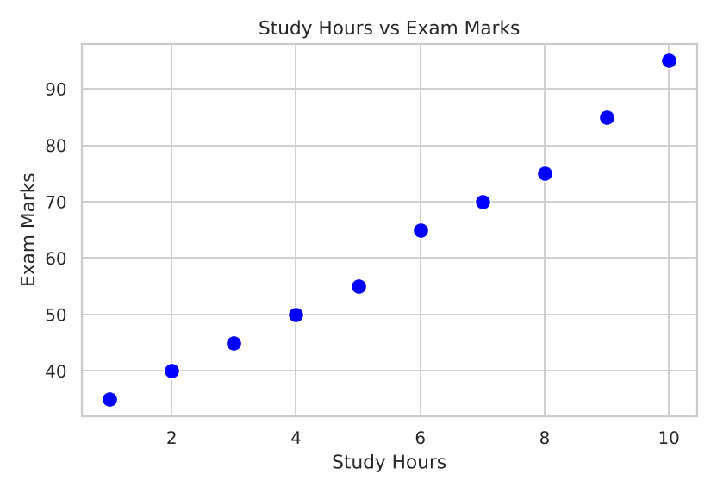
Description:
x="Study_Hours" and y="Marks" are the two columns of the DataFrame.
s=100 is the size of the dots and color="blue" is the colour of the dots.
The dots go upward, so more study hours give more marks.

HISTOGRAM
histplot() is used to draw a histogram. It shows how many values fall in each group.
Code snippet:
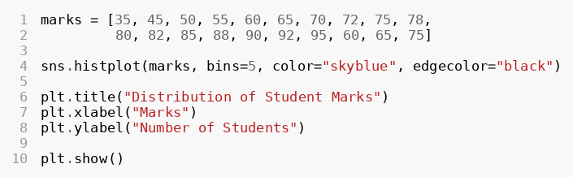
Output:
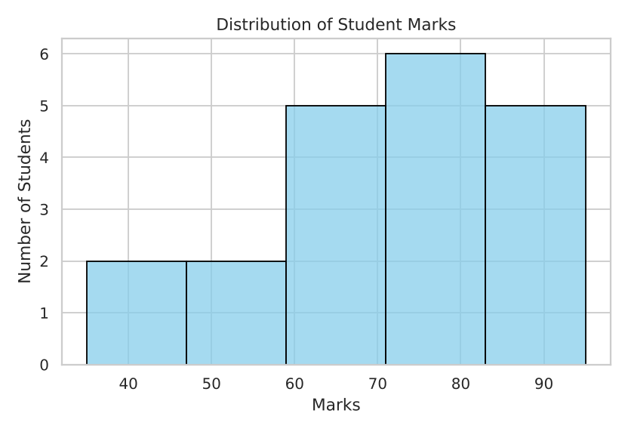
Description:
Here we gave a simple list of marks directly, so a DataFrame is not needed.
bins=5 makes 5 groups. color and edgecolor set the colour and the border of the bars.
Most of the students have marks between 70 and 95.

HEATMAP
A heatmap shows numbers using colours. Here it is used to show the correlation between columns. Correlation tells how strongly two things are connected. heatmap() is used for heatmaps.
Code snippet:
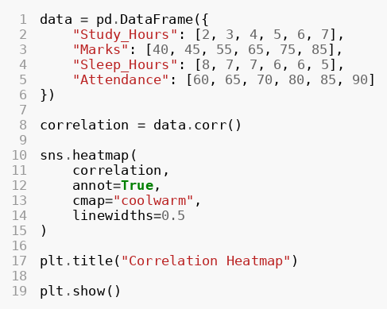
Output:
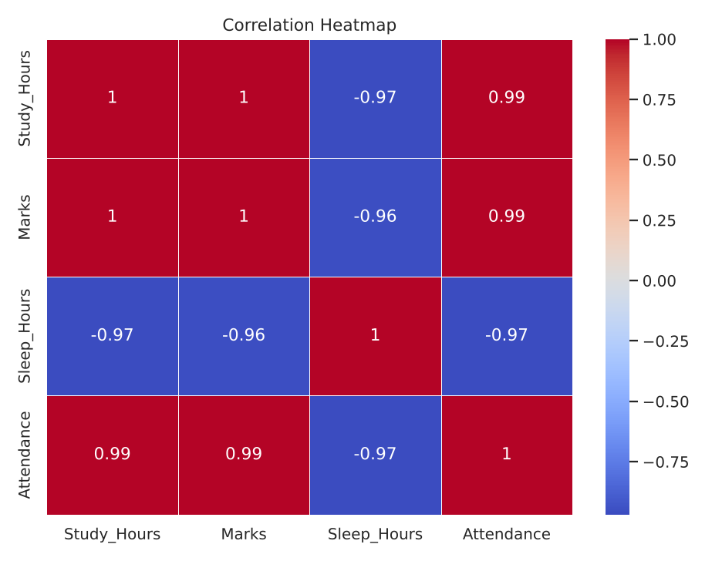
Description:
data.corr() finds the correlation between all the columns.
annot=True writes the number inside each box. cmap="coolwarm" sets the colours (red for high values and blue for low values). linewidths=0.5 puts thin lines between the boxes.
A value near 1 means that when one goes up, the other also goes up. A value near -1 means that when one goes up, the other goes down.
Here Study_Hours and Marks are very strongly connected (about 1). Sleep_Hours is connected in the opposite way (about -0.97).

COMPARISON OF MATPLOTLIB AND SEABORN
Both libraries are used to make charts, and we have made the same four charts in both (line, bar, scatter and histogram). The table below shows the main differences.
Point | Matplotlib | Seaborn
What it is | The basic plotting library of Python. | A library built on top of Matplotlib.
Ease of use | Needs more lines of code for a good-looking chart. | Needs fewer lines of code and looks good by default.
Default look | Plain and simple. We set grid, colours and labels ourselves. | Nice theme and colours (we used whitegrid) without extra work.
Data input | Works with simple lists and arrays. | Works best with a Pandas DataFrame (columns like x="Months").
Chart types we used | Line, bar, scatter, histogram and pie chart. | Line, bar, scatter, histogram and heatmap.
Pie chart | Available using plt.pie(). | Not available.
Heatmap / correlation | Possible, but needs extra work. | Very easy with sns.heatmap() and annot=True.
Control over the chart | Full control over every small part. | Less control, but it saves time.
Best for | Learning the basics and custom charts. | Quick data analysis and statistical charts.

Same chart, different code
- In Matplotlib, we write plt.plot(months, sales) and we give the lists directly.
- In Seaborn, we write sns.lineplot(data=data, x="Months", y="Sales") and we give a DataFrame with column names.
- The final graphs look almost the same. Seaborn needs less work for the style, and Matplotlib gives more freedom.

My choice
For a beginner, I think we should learn Matplotlib first, because it teaches the basic parts of a chart like the title, labels, grid and colours. After that, Seaborn is the better choice for daily data work, because it makes good-looking charts quickly and works easily with Pandas. Also, Matplotlib is needed for the pie chart and Seaborn is better for the heatmap. So, the best way is to use both together.

CONCLUSION
In this document, I made charts using both Matplotlib and Seaborn. In Matplotlib, I made a line chart, a bar graph, a scatter plot, a histogram and a pie chart. In Seaborn, I made a line plot, a bar plot, a scatter plot, a histogram and a heatmap.
From the examples, I learned that Matplotlib is simple and gives full control over the chart, but it needs a little more code. Seaborn is built on Matplotlib, so it is easier and its charts look better by default.
Both libraries are useful. Matplotlib is good for learning the basics and Seaborn is good for quick data analysis. Using both together is the best way to show data clearly.

REFERENCES
- Matplotlib documentation: https://matplotlib.org/stable/
- Seaborn documentation: https://seaborn.pydata.org/
- Pandas documentation: https://pandas.pydata.org/docs/
- Hunter, J. D. (2007). Matplotlib: A 2D Graphics Environment. Computing in Science & Engineering, 9(3), 90-95.
- Waskom, M. L. (2021). seaborn: statistical data visualization. Journal of Open Source Software, 6(60), 3021.

