DELHI AQI ANALYSIS
Air pollution is a big problem in many cities of India. Delhi is one of the cities where the air quality is very bad in many months of the year. To understand this problem, we need to look at the data.
AQI stands for Air Quality Index. It is a single number that tells how clean or how dirty the air is. A low AQI means clean air and a high AQI means polluted air. In this data, the AQI is divided into six categories: Good, Satisfactory, Moderate, Poor, Very Poor and Severe.
In this document, I have analysed the daily air quality data of Delhi using Python. The dataset is city_day.csv from Kaggle. It has 29531 rows and 16 columns, and it has the daily data of many cities. I have taken only the Delhi data, which has 2009 rows.
The main aims of this project are:
- To clean the Delhi data and find the average, highest and lowest AQI.
- To see the AQI categories and the monthly trend of AQI.
- To compare the PM2.5 and PM10 pollution levels.
- To find which pollutants are connected with the AQI.

LIBRARIES USED
Four Python libraries are used in this project:
- Pandas: to load, clean and analyse the data in table form.
- NumPy: to work with numbers and arrays.
- Matplotlib: to draw the basic graphs.
- Seaborn: to draw good looking statistical graphs.
We import them as following:
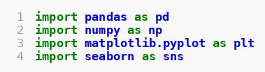
pd, np, plt and sns are the short names of the libraries, so that we can write less code.

DATA LOADING AND EXPLORATION

LOADING THE DATASET
First, the CSV file is loaded into a Pandas DataFrame. A DataFrame is like a table with rows and columns.
Code snippet:
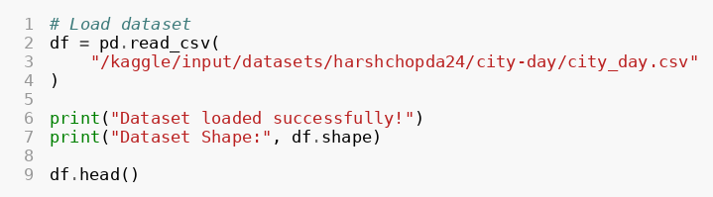
Output:
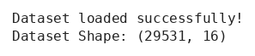
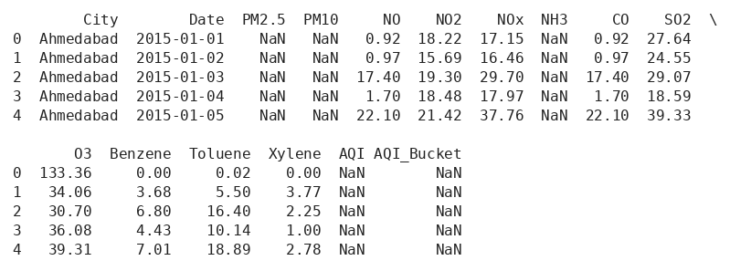
Description:
read_csv() reads the CSV file and keeps the data in the variable df.
df.shape gives the number of rows and columns. Here the data has 29531 rows and 16 columns.
head() shows the first 5 rows of the data.
NaN means that the value is missing. In the first rows, PM2.5, PM10 and AQI are NaN for Ahmedabad.

DATASET INFORMATION
Next, we look at the columns, the data types, the missing values and the basic statistics of the whole dataset.
Code snippet:
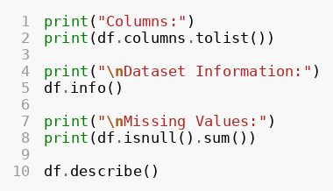
Output:
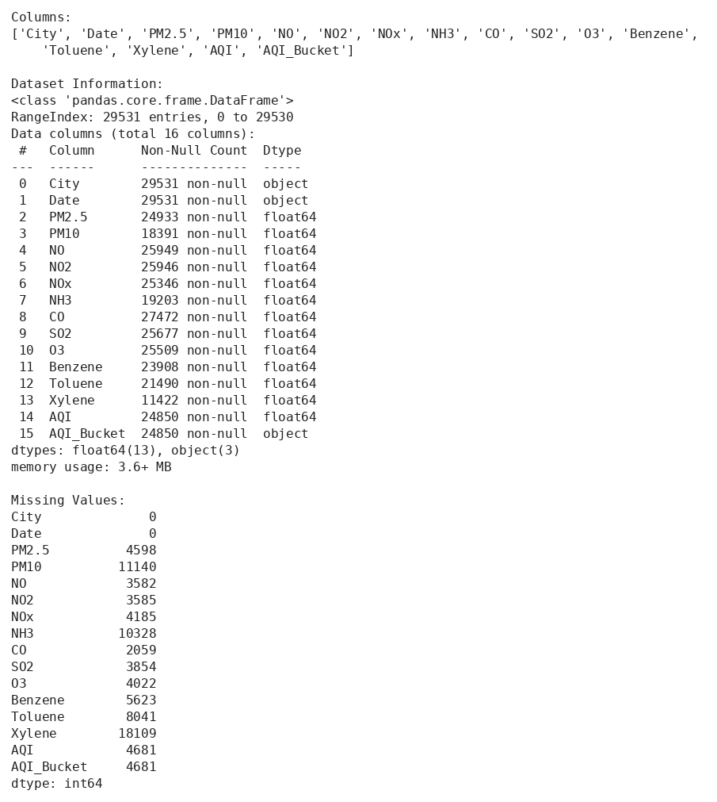
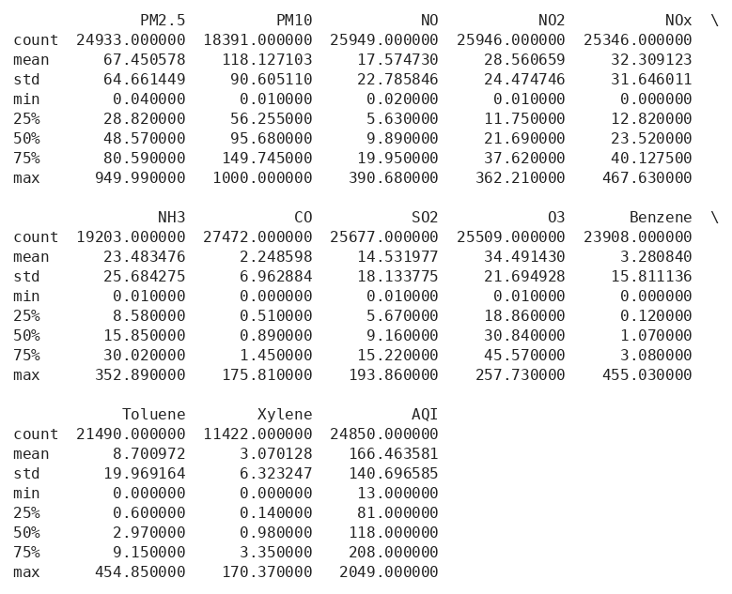
Description:
df.columns.tolist() gives the names of all the columns.
df.info() shows the number of non-null values and the data type of each column.
df.isnull().sum() gives the number of missing values in each column.
df.describe() gives count, mean, standard deviation, minimum, maximum and the quartiles of each number column.
We can see that PM10 has many missing values (only 18391 values are present out of 29531).

SELECTING THE DELHI DATA
The dataset has many cities. Here we take only the rows of Delhi.
Code snippet:
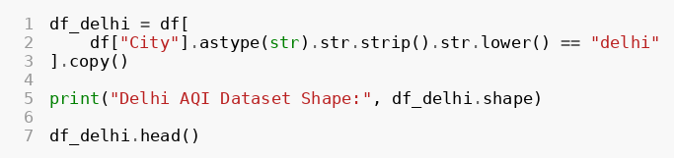
Output:
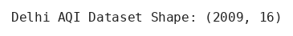
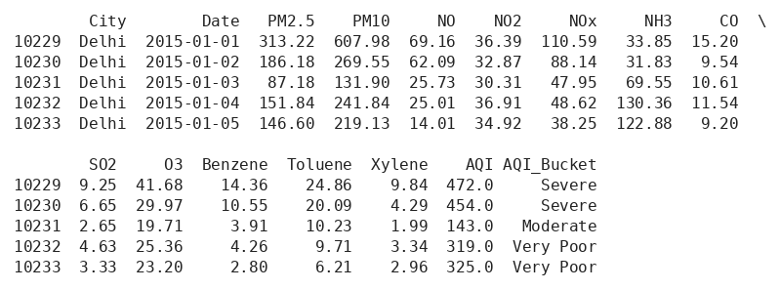
Description:
str.strip() removes extra spaces and str.lower() changes the text to small letters. This is done so that the city name matches in any case.
copy() makes a separate copy, so the main data is not changed.
The Delhi data has 2009 rows and 16 columns.

CHECKING THE DELHI DATA
Now we check the Delhi data in more detail.
Code snippet:
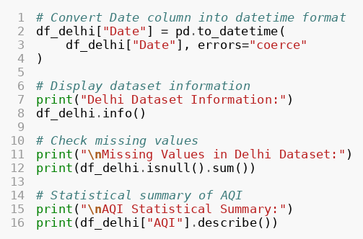
Output:
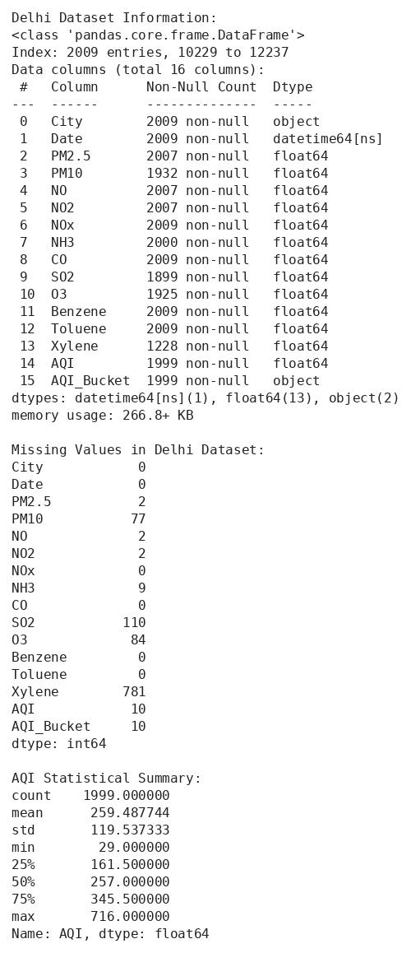
Description:
to_datetime() changes the Date column from text (object) to the date format. errors="coerce" makes the value NaT if a date is wrong.
df_delhi.info() shows that the Date column is now datetime64.
The AQI column has 1999 values out of 2009, so 10 values are missing.
Xylene has the most missing values (781), and SO2, PM10 and O3 also have some missing values.
describe() on the AQI column gives its statistics.

AQI CATEGORIES
Here we count how many days fall in each AQI category.
Code snippet:
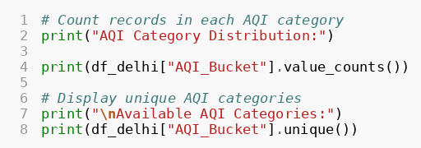
Output:
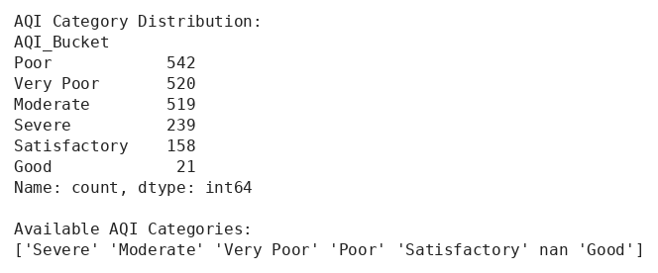
Description:
value_counts() counts the records of each category.
unique() shows the different categories. nan means that some records have no category.
Poor is the most common category (542 records), then Very Poor (520) and Moderate (519). Good is very rare (only 21 records).

DATA CLEANING
Data cleaning is the process of finding and handling missing values, wrong data types and duplicate records. It makes the data better and the results more reliable.

CLEANING THE DELHI DATA
Code snippet:
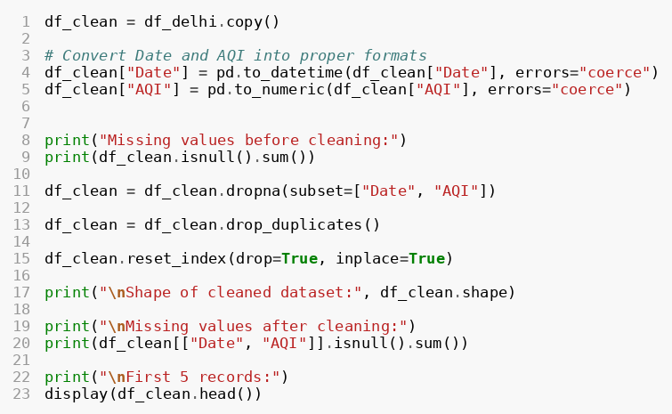
Output:
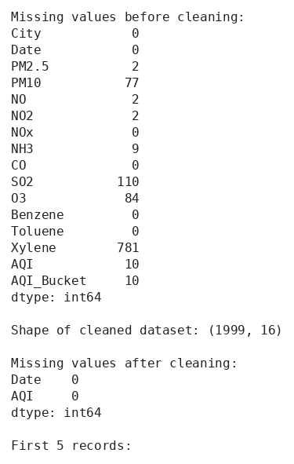
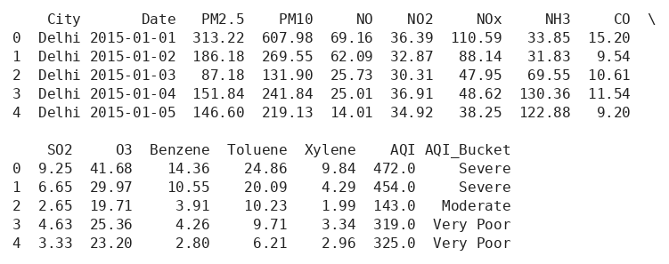
Description:
pd.to_numeric() changes the AQI column into numbers. The Date column is also changed into the date format.
dropna(subset=["Date", "AQI"]) removes the rows where Date or AQI is missing.
drop_duplicates() removes the repeated rows.
reset_index() makes the row numbers start again from 0.
After cleaning, the data has 1999 rows. So 10 rows were removed, and now Date and AQI have no missing values.

AQI STATISTICS
After cleaning, the main AQI values are calculated.
Code snippet:
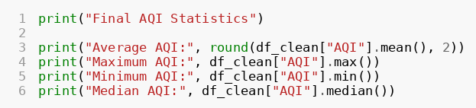
Output:
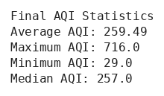
Description:
mean() gives the average, max() gives the highest value, min() gives the lowest value and median() gives the middle value.
The average AQI of Delhi is 259.49 and the median is 257. Both are almost the same.
The highest AQI is 716 and the lowest AQI is 29.

DATA VISUALIZATION
Now we draw graphs to understand the data in a better way.

AQI DISTRIBUTION (HISTOGRAM)
A histogram shows how the values are spread. Here it shows how often each AQI value comes.
Code snippet:
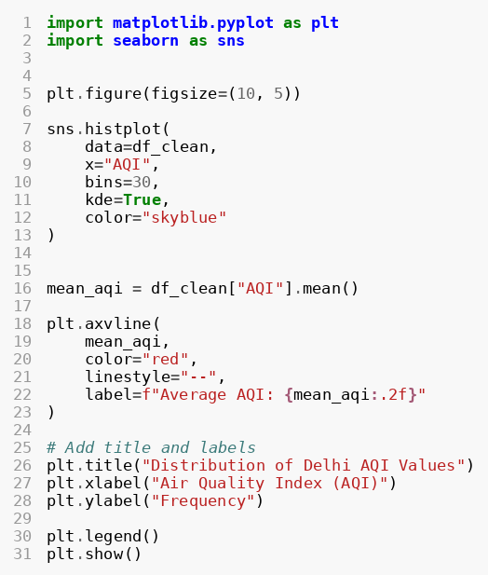
Output:
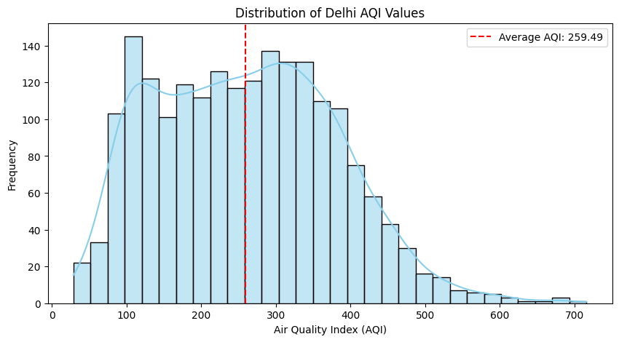
Description:
histplot() draws the histogram. bins=30 divides the AQI values into 30 groups.
kde=True adds a smooth curve over the bars.
axvline() draws a red dashed line at the average AQI (259.49).
title(), xlabel() and ylabel() give the title and the names of the axes, and legend() shows the label of the red line.
Most of the AQI values are between 100 and 400. Only a few days have AQI above 600.

AQI CATEGORY COUNT (COUNT PLOT)
A count plot shows the number of records in each category.
Code snippet:
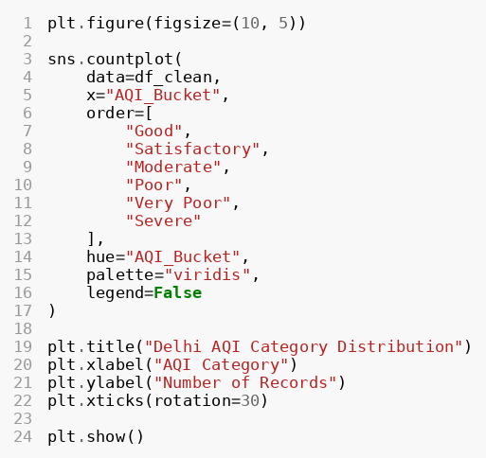
Output:
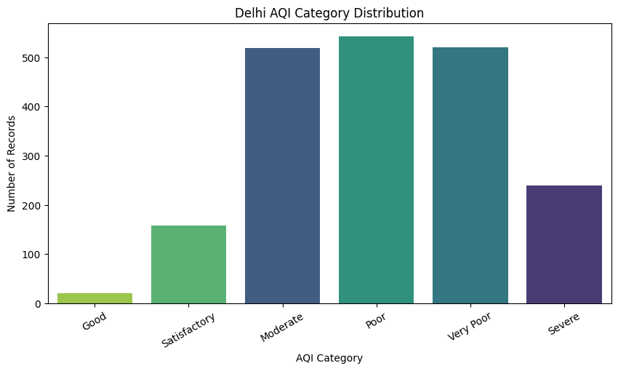
Description:
countplot() counts the records of each AQI_Bucket by itself.
order=[...] arranges the categories from Good to Severe.
palette="viridis" sets the colours and legend=False hides the extra legend.
xticks(rotation=30) tilts the names on the x axis so that they are easy to read.
Poor, Very Poor and Moderate have the highest bars. Good has the smallest bar. This shows that Delhi's air is bad on most of the days.

MONTHLY AQI TREND (LINE CHART)
A line chart shows how the AQI changes with time. Here we use the monthly average.
Code snippet:
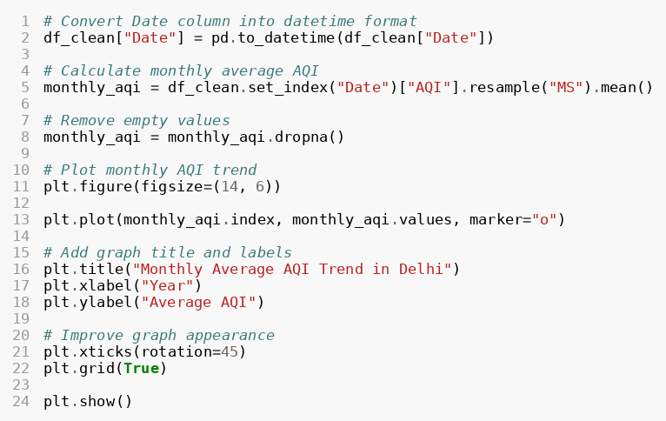
Output:
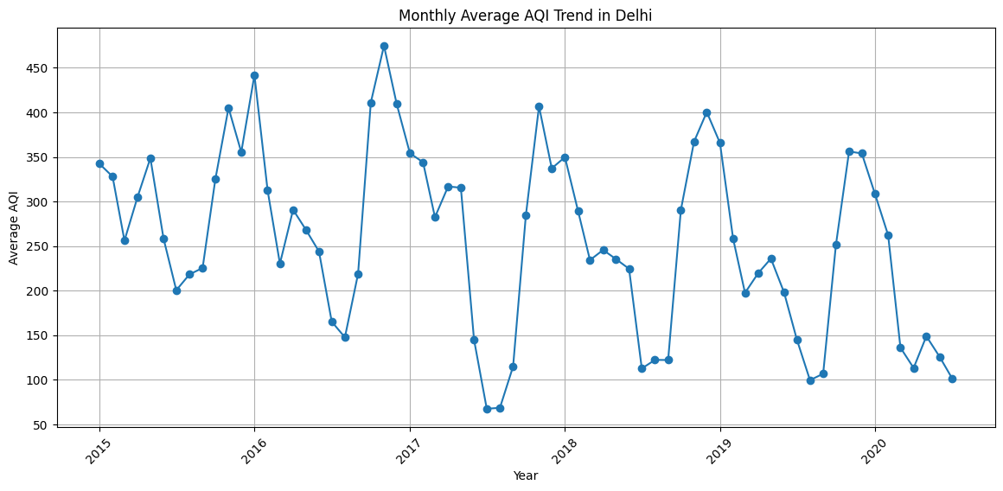
Description:
set_index("Date") makes Date the index, and resample("MS").mean() finds the average AQI of every month.
dropna() removes the months which have no value.
plot() draws the line and marker="o" puts a circle on every month.
grid(True) shows the grid lines.
The AQI goes up and down every year. The high values come near the end and the start of each year, and the low values come in the middle of the year.

PM2.5 AND PM10 ANALYSIS
PM2.5 and PM10 are the main air pollutants. They affect the air quality and the health of people.
- PM2.5: Fine particles with a diameter of 2.5 micrometers or smaller.
- PM10: Particles with a diameter of 10 micrometers or smaller.

Objectives of this part:
- To study the PM2.5 and PM10 pollution levels.
- To compare their average values.
- To find the monthly pollution pattern.
- To see how the particle pollution changes with time.

PM2.5 AND PM10 STATISTICS
Code snippet:
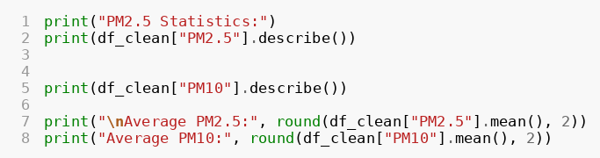
Output:
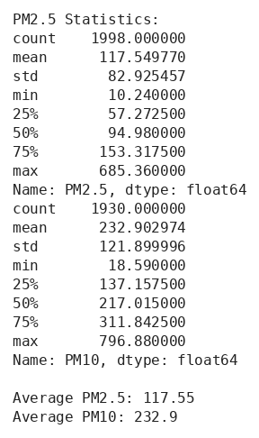
Description:
describe() gives the count, mean, minimum, maximum and the quartiles for both columns.
The average PM2.5 is 117.55 and the average PM10 is 232.9. So PM10 is almost double of PM2.5.
The highest PM2.5 is 685.36 and the highest PM10 is 796.88.

PM2.5 VS PM10 DISTRIBUTION
Here both pollutants are drawn on the same histogram, so that we can compare them.
Code snippet:
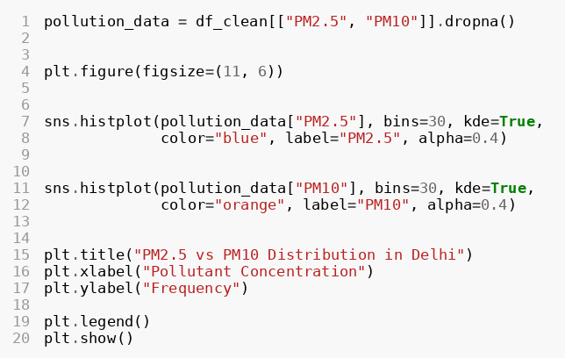
Output:
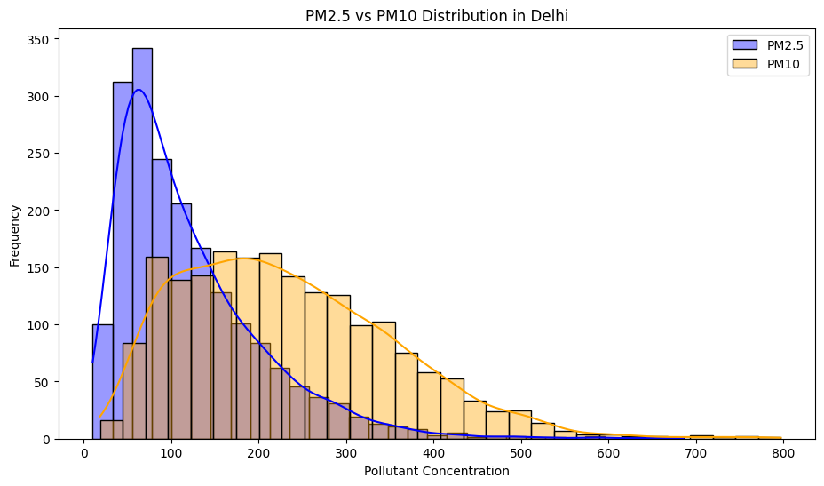
Description:
dropna() is used so that only the rows having both values are taken.
Two histplot() are drawn in one graph. blue is for PM2.5 and orange is for PM10.
alpha=0.4 makes the colours light, so that we can see both graphs even when they overlap.
PM2.5 has most of the values at the low side (about 50 to 100). PM10 is spread more and goes up to about 800.

MONTHLY PM2.5 AND PM10 LEVELS
This line chart shows the monthly average of both pollutants.
Code snippet:
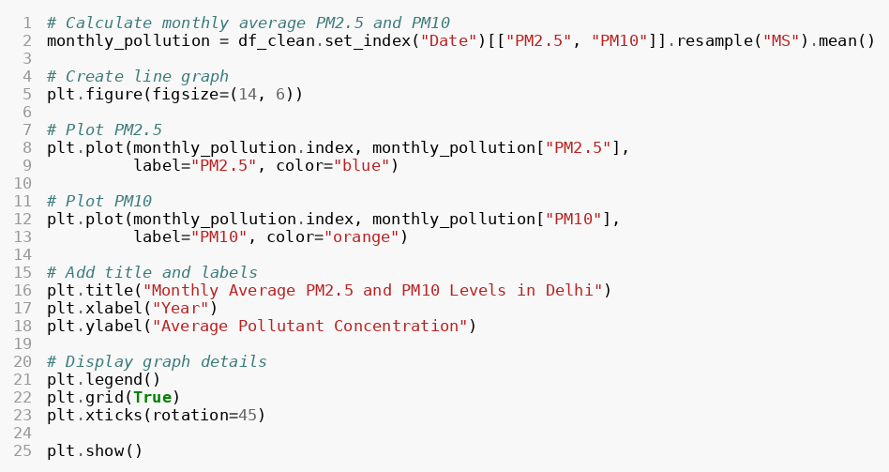
Output:
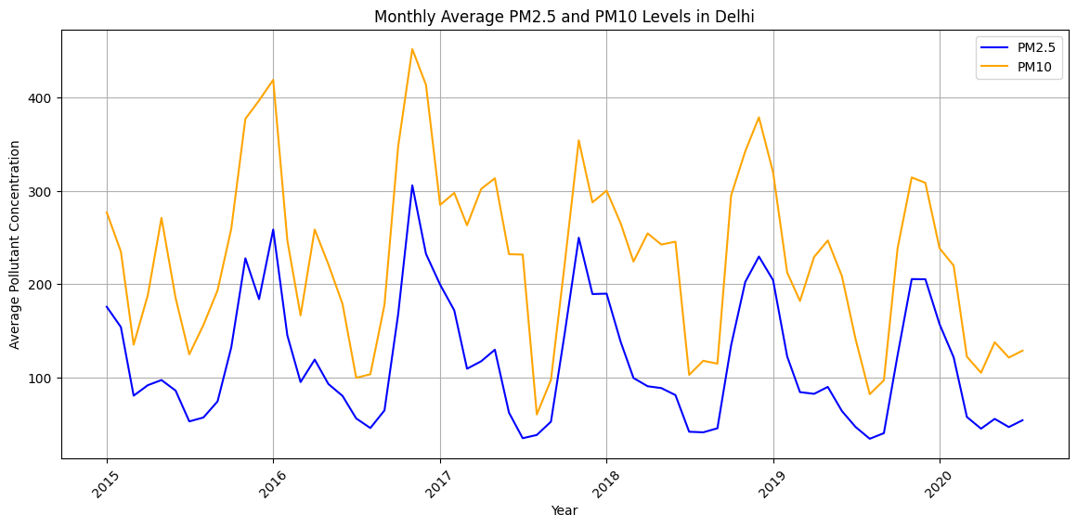
Description:
The monthly average of both columns is found using resample("MS").mean().
plot() is used two times, once for PM2.5 and once for PM10. label gives the name of each line.
The PM10 line is always above the PM2.5 line.
Both lines go up and down together, with the highest values near the end and the start of the year.

CORRELATION HEATMAP
Correlation tells how strongly two things are connected. A heatmap shows it using colours.
Code snippet:
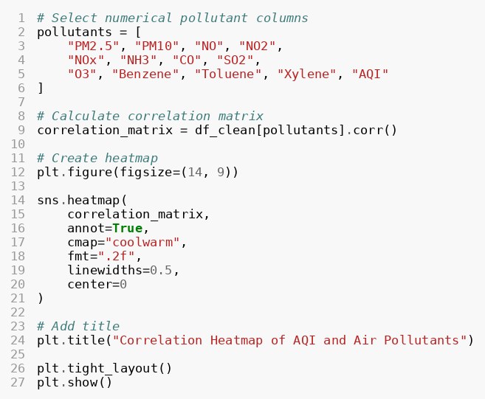
Output:
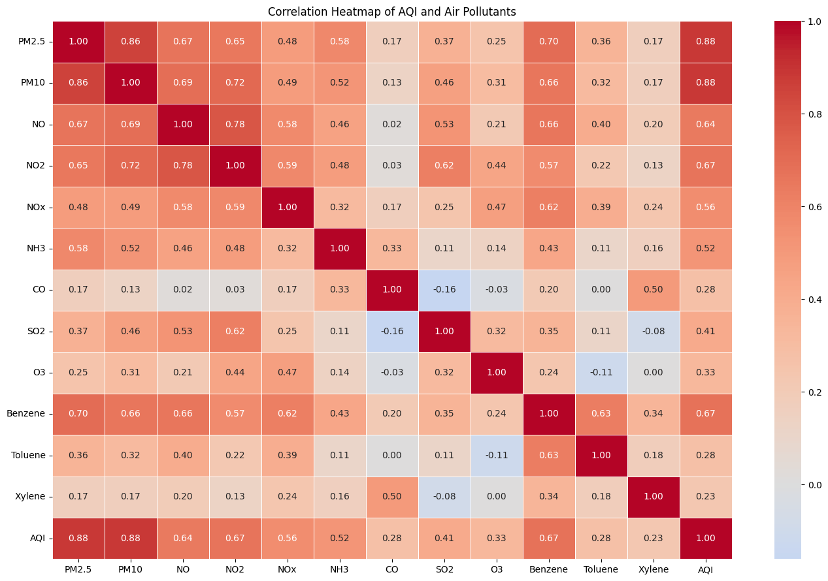
Description:
pollutants is the list of the columns that are used. corr() finds the correlation between all of them.
annot=True writes the numbers in the boxes and fmt=".2f" shows two digits after the decimal point.
cmap="coolwarm" sets the colours and center=0 keeps the middle colour at zero. linewidths=0.5 adds thin lines between the boxes.
tight_layout() fits the graph properly in the figure.
PM2.5 and PM10 have the strongest connection with AQI (0.88 for both). PM2.5 and PM10 are also strongly connected with each other (0.86).
NO2 and Benzene (0.67 each) and NO (0.64) are also connected with the AQI. CO has a weak connection (0.28).

FINAL SUMMARY

SUMMARY OF THE ANALYSIS
In the end, all the important results are printed together.
Code snippet:
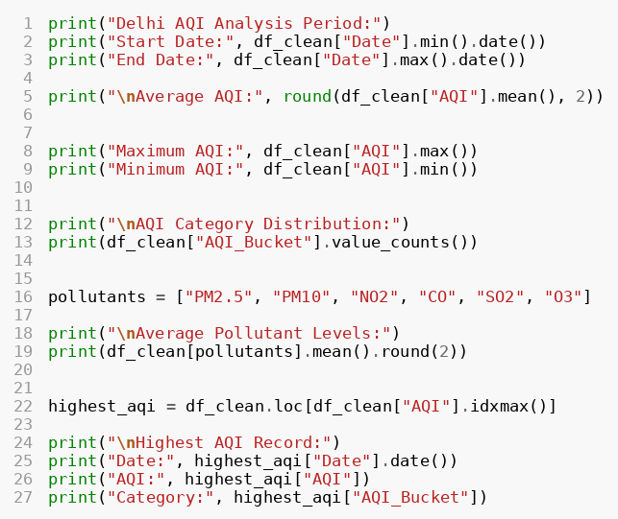
Output:
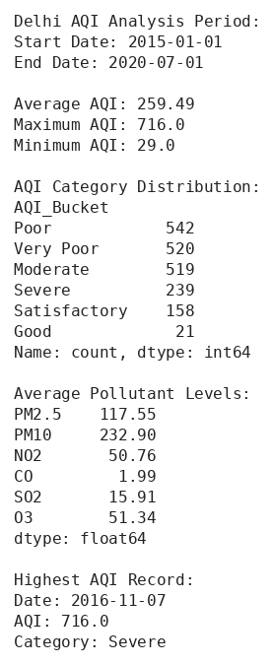
Description:
The data is from 2015-01-01 to 2020-07-01.
The average AQI is 259.49, the highest is 716 and the lowest is 29.
The average levels are PM2.5 117.55, PM10 232.9, NO2 50.76, CO 1.99, SO2 15.91 and O3 51.34.
idxmax() finds the row of the highest AQI. It was on 2016-11-07, with AQI 716, in the Severe category.

SAVING THE CLEANED DATA
The cleaned data is saved in a new CSV file, so that it can be used again.
Code snippet:
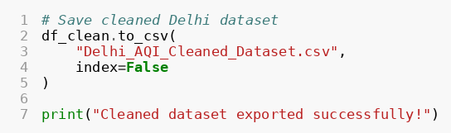
Output:
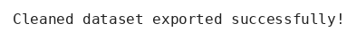
Description:
to_csv() saves the DataFrame in a file. index=False means that the row numbers are not saved in the file.

KEY FINDINGS
- The average AQI of Delhi from 2015 to 2020 was 259.49, which is a high value.
- Poor was the most common AQI category (542 records), and Good was the least common (21 records).
- The highest AQI was 716 (on 2016-11-07) and the lowest AQI was 29.
- PM10 (average 232.9) was much higher than PM2.5 (average 117.55), but both moved in the same pattern.
- The correlation heatmap showed that PM2.5 and PM10 are the pollutants most connected with the AQI.
- The monthly analysis showed that the pollution is high near the end and the start of each year and low in the middle of the year.

RECOMMENDATIONS TO REDUCE AIR POLLUTION
- Promote public transport and carpooling.
- Encourage the use of electric vehicles.
- Control the smoke from industries.
- Reduce the dust from construction and roads.
- Plant more trees and make more green spaces.
- Check the air quality regularly.
- Spread awareness about air pollution and its effect on health.

CONCLUSION
The Delhi AQI Analysis project shows how Python can be used to study air pollution data and understand the condition of the environment.
Using Pandas, NumPy, Matplotlib and Seaborn, the data was explored, cleaned and shown in different graphs. The analysis covered the AQI distribution, the AQI categories, the monthly trend, the PM2.5 and PM10 levels and the connection between different pollutants.
This project helped to find the important patterns of air quality in Delhi and showed how data analysis is useful in watching the environment.

REFERENCES
- Kaggle dataset: city_day.csv (city-day, by harshchopda24), daily air quality data of Indian cities.
- Pandas documentation: https://pandas.pydata.org/docs/
- NumPy documentation: https://numpy.org/doc/
- Matplotlib documentation: https://matplotlib.org/stable/
- Seaborn documentation: https://seaborn.pydata.org/
- Central Pollution Control Board (CPCB), National Air Quality Index: https://cpcb.nic.in/

