Vyaya Expense Tracker

Frontend State Management Decision

STATUS  Proposed |  | OWNER  Frontend architecture |  | LAST UPDATED  July 16, 2026

Authors | Repository architecture review
Reviewers | Unassigned
Related docs | FRONTEND.md; AGENTS.md; packages/shared schemas
Scope | State ownership and data-flow design for the Vyaya Next.js frontend.

1. Abstract
Vyaya should keep server data, URL state, ephemeral UI state, and durable offline work separate as the expense tracker grows. The current Next.js shell is a sound starting point, but it has no feature-owned data layer yet. This design keeps server components as the first read path, introduces a typed API boundary and, only when client-side cache is needed, Redux Toolkit with RTK Query. This avoids adopting Redux, TanStack Query, and Zustand together.
The design covers authenticated web flows backed by the existing Nest REST API. It does not add a global client store today, offline list synchronization, or a new backend state service. Money remains integer paise; ledger writes remain API-owned, transactional, and idempotent.

2. Goals and Non-Goals
Goals | Non-goals
One owner per state class: URL, server/RSC, RTK Query, local form/UI, or offline outbox. | No client-side ledger source of truth or three-library state stack.
Keep first reads server-rendered; add RTK Query only to client interactions that need caching/refetching. | No offline synchronization for transaction lists or balances.
Make mutations idempotent, observable, and RTK-tag invalidation-complete. | No server actions for business writes.
Permit Redux slices only for globally shared, mutable client workflows that cannot be URL/local state. | No Zustand by default; no dependency without a demonstrated need.

3. Background and Problem Statement
Today, apps/web has App Router route groups, server session access, Better Auth, shared UI primitives, and placeholder ledger routes. It has no generated business API client, query-cache provider, feature data hooks, or ownership rules for filters, mutations, and invalidation. Adding endpoint calls directly to pages would couple rendering to transport details and make future transactions, transfers, assets, and reports hard to evolve.
The frontend boundary is: routes compose features; features own domain queries and mutations; the API client owns transport and problem parsing; shared schemas own data shapes. The guiding invariant is one authoritative owner for each state class: URL for shareable filters, server/query cache for remote data, component state for ephemera, form state for drafts, RTK Query for client-cached API data, and IndexedDB only for explicitly offline-capable writes.

4. Proposed Architecture

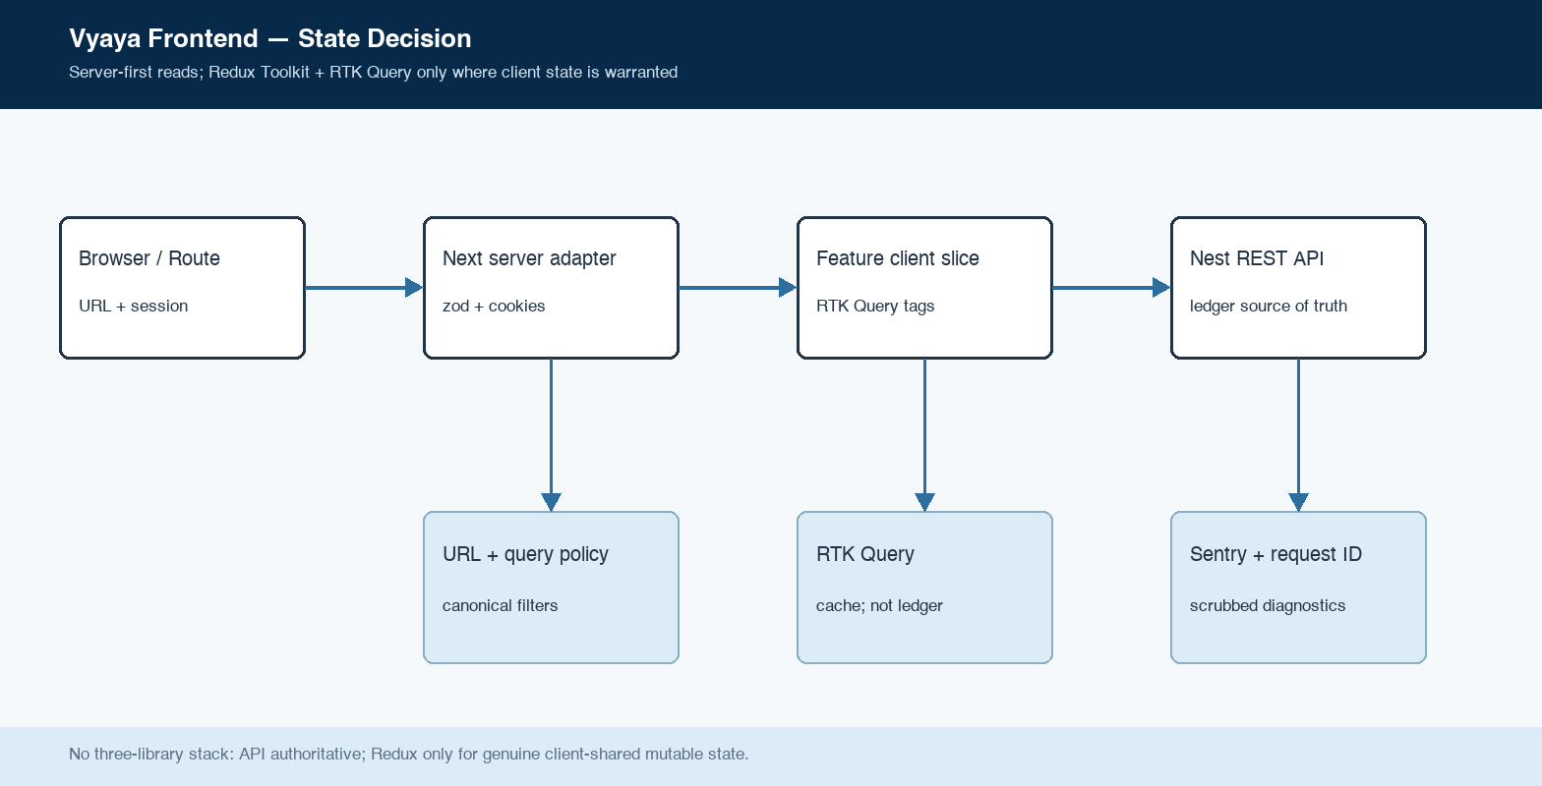
Figure 1. Server-first reads with an optional Redux Toolkit + RTK Query client boundary.

Core components

Component | Responsibility | Primary storage | Failure behavior
App routes | Compose layouts and feature public APIs; server-render first reads. | Route params + searchParams | Render an error boundary; never fabricate business data.
Feature slice | Owns a domain's server loader, RTK endpoints, components, and tag rules. | RTK tags + local UI state | Falls back to feature error/empty states; no cross-feature deep imports.
Typed API adapters | Forward session/request ID, parse zod responses, map problem+json errors. | HTTP only | Fail closed with typed network/auth/domain errors.
Redux Toolkit + RTK Query | Caches client API data; Redux slices exist only for proven shared mutable workflows. | In-memory Redux store | Rollback optimistic rows; invalidate tags and refetch after uncertainty.
Offline outbox (Phase 5) | Stores only quick-add payload plus idempotency key; drains foreground-first. | IndexedDB | Keeps entries on 401/422; reports repair state, never silently drops money.

5. Request Lifecycle
- A route receives params and searchParams. It renders the first authenticated read on the server through the typed server API adapter.
- Better Auth session verification remains at the API. The proxy performs only the cookie-presence redirect; zod parses API data at the frontend boundary.
- The feature loader derives filters from the URL and creates a canonical query key. It does not read business state from a global store.
- The server returns the first read. A client feature uses RTK Query only for interactive pagination, refetching, or mutation coordination; it does not duplicate server-rendered data by default.
- A mutation creates an idempotency UUID when its form mounts, validates with the shared schema, and sends the request through the typed client.
- RTK Query invalidation is feature-owned through tags: transaction writes invalidate affected transaction lists, account balances, and rollups. Retries are visible policy, not hidden behavior.
- The UI resolves optimistic state or rolls it back. Request IDs, problem types, and scrubbed breadcrumbs support diagnosis; no ledger payload is sent to client telemetry.

6. API and Data Contracts

Primary data contract

Field | Type | Required | Description
URL filters | search params | Yes | Shareable account, category, date, text, cursor, and page-size state.
RTK endpoint + tags | typed endpoint | Yes | Feature-local cache identity and invalidation derived from validated filters.
API response | shared zod type | Yes | Parsed remote data; RTK Query cache is a view, not source of truth.
Mutation input | shared zod type | Yes | Form values; amountMinor stays positive integer paise.
Idempotency key | UUID header | Writes | Generated on form mount; reused until confirmed success.
Form draft | react-hook-form state | No | Ephemeral input state; never used as a ledger record.
Offline entry | IndexedDB record | Quick add | Future scope: payload, key, createdAt, attempts, last error.

Contract guarantees

- Every remote response is parsed at the client boundary; zod schemas in packages/shared are the single contract source.
- Query keys are deterministic and include only canonical filters. Mutation idempotency keys are generated once per form mount and reused for retries.
- URL filters, query key, request ID, and idempotency key are retained only for their operational purpose; ledger values remain in the API audit trail.
- RTK Query is a cached view of API data, never the ledger source of truth. Redux slices are permitted only for durable, cross-feature mutable client workflows; component and form state stay local.
The contract source is
Research basis (16 Jul 2026): Next.js App Router docs; Redux Toolkit Next.js guide; RTK Query overview; Zustand Next.js guide; TanStack Query SSR guide. Sources: nextjs.org/docs/app, redux-toolkit.js.org/usage/nextjs, zustand.docs.pmnd.rs/learn/guides/nextjs, tanstack.com/query/latest/docs/framework/react/guides/ssr.

7. Consistency, Idempotency, and Replay

Reads may be stale for the configured query-cache window; writes are never inferred locally as ledger truth. A successful mutation returns the API result and invalidates dependent keys. An optimistic row is explicitly marked pending and rolls back on error. Duplicate submissions reuse the same idempotency key, so the API returns the original result without another effect.
Scenario | Expected behavior | Reasoning
Double submit / replay | Reuse idempotency key; API returns original result; RTK invalidates the same tags. | One monetary effect; UI converges on API result.
API write fails | Rollback optimistic RTK cache; retain form and show typed error. | No client cache entry is treated as posted.
Timeout / offline | Do not retry blindly in fetch; reuse the same key on explicit retry. Future quick-add queues only offline capture. | Prevents duplicate effects while preserving a repair path.
Filter changes | URL changes derive RTK endpoint arguments; in-flight old result cannot overwrite the current view. | State remains explainable and back-button safe.

8. Security and Privacy Considerations

- Session identity comes from Better Auth only. Routes do not accept userId in client payloads; the API scopes every repository query by the authenticated user.
- Query cache and browser diagnostics contain no raw ledger contents beyond what is required to render. Sentry scrubbers remove amountMinor, descriptions, passwords, and form-like payloads.
- Browser code uses relative /api paths. Internal API URLs and observability DSNs come from validated deployment configuration, not client code literals.
- Server Actions remain limited to Next-local concerns such as the theme cookie. Business mutations use the Nest API, shared schema validation, and idempotency headers.
- The frontend does not own deletion or audit retention. Offline queue entries, when introduced, must survive logout without storing credentials and must surface invalid entries for repair.

9. Operational Readiness
Signal | SLO or alert | Owner | Launch gate
Transaction mutation success | No duplicate money effect; investigate unexpected rollback | Frontend + API | Required
First read / query latency | Measure by route and connection type before setting an alert | Frontend | Recommended
Network / mutation error | Breadcrumb + typed error; no console-only diagnosis | Frontend | Required
Contract drift | Generated client/schema diff blocks adoption | Frontend + API | Required
Balance / offline integrity | API invariants pass; queued quick-adds resolve or remain visible | API + Frontend | Required
Rollout constraint: ship state infrastructure behind feature adoption; each mutation needs idempotency, invalidation, unit coverage, and browser coverage before use.

10. Alternatives Considered

Alternative | Why it was considered | Why it was not selected
TanStack Query + Zustand | Remote cache plus UI store. | A second client boundary.
Redux Toolkit + RTK Query | Typed store, tags, DevTools. | Use only after need proof.
Zustand alone | Small hooks-first store. | SSR overhead; little added value.
No client cache | Lowest dependency surface. | Current baseline.

11. Open Questions
- Which Phase 1 interaction proves the RTK Query need?
- Does future reconciliation need Redux DevTools auditability?
- Can M2 be measured without adding a client state library?
- Who approves the written adoption record?

12. Decision and Next Steps
Remain server-first and URL-first. If interactive client caching is proven necessary, use Redux Toolkit + RTK Query alone; Redux slices need written justification.
Milestone | Deliverable | Exit criteria
M1 | API adapter and URL filters. | Adapter tests; no client store.
M2 | Prove cache need in transactions. | Written record; one-effect flow.
M3 | RTK base API and endpoints. | Tags/hydration tests; no extra store.
M4 | Quick-add outbox. | One resolution or repair path.

Use footnotes for definitions, assumptions, or terms that need precision without interrupting the main narrative.

