Air quality index and environment monitoring

Harsh Mukesh Jain^{[i]}
Department of Computer Engineering, Sardar Patel Institute of Technology, Mumbai, India
[i] harsh.jain2@spit.ac.in

Abstract – Considering the importance of air to human existence, air pollution are critical issues that require collective effort for prevention and control. Different types of anthropogenic activities have resulted in environmental dilapidation and ruin. One of the tools that can be used for such a campaign is Air Quality Index (AQI). The AQI is based on the concentrations of different pollutants such as PM10, PM2.5, CO, NO, NO_{2,} SO₂. There is a need for constant and continuous environment monitoring of air quality for the development of AQI, which in turn will enable clear communication of how clean or unhealthy the air in the study area is. A possible solution, that caters for above mentioned needs, is implementation of AQI forecasting enabling authorized personnel to issue timely alerts.
Keywords – AQI, Pollutants, Forecasting, Clean, Unhealthy air

Introduction
Air pollution is a pressing global concern, posing significant threats to human health and environmental well-being. Anthropogenic activities have contributed to the degradation of air quality, leading to detrimental effects on ecosystems and public health. In response to this challenge, the Air Quality Index (AQI) has emerged as a crucial tool for assessing and communicating air quality levels.

The AQI is a comprehensive measure based on the concentrations of various pollutants such as PM10, PM2.5, CO, NO, NO2, and SO2. It provides a standardized way to evaluate the quality of the air in a given area, enabling policymakers, environmental agencies, and the public to understand the extent of air pollution and its potential impacts.

Continuous monitoring of air quality is essential for the development and maintenance of AQI standards. By monitoring key pollutants on an ongoing basis, authorities can assess trends, identify pollution hotspots, and take proactive measures to mitigate air pollution.

Forecasting AQI levels plays a crucial role in environmental management and public health protection. By predicting future air quality conditions, authorized personnel can issue timely alerts, implement pollution control measures, and educate the public about potential health risks associated with poor air quality.

In this context, this paper proposes a solution for forecasting AQI levels, utilizing data collected from reliable sources such as the Central Pollution Control Board. Through data preprocessing, exploratory data analysis, and the application of forecasting models, this study aims to provide accurate predictions of AQI levels, facilitating informed decision-making and proactive interventions to safeguard air quality and public health.

Methodology
Auto Correlation Function (ACF) measures correlation between a time series and its lagged values at different lags. The ACF provides insights into the strength and direction of autocorrelation, revealing patterns of dependence that may exist within the time series.

Partial Auto Correlation Function (PACF) captures the unique correlation between the current observation and past observations at a specific lag, after removing the influence of intervening lags.
The Augmented Dickey-Fuller (ADF) test assesses whether a time series is stationary or non-stationary. Stationarity means the statistical properties remain constant over time, while non-stationarity indicates changing properties like trends or seasonal patterns. The test compares a calculated statistic to critical values: if it falls below, the series is stationary; if it exceeds, it's non-stationary.
- ADF statistic: Measures significance of the test. A more negative (i.e., lower) value indicates stronger evidence against the null hypothesis of non-stationarity..
- P-value: Indicates likelihood of observing the statistic if the series were non-stationary.
- Number of lags and observations: Used in the test.
- Critical values: Thresholds for comparison.
ADF test determines if series is stationary based on the p-value (reject null hypothesis if p ≤ 0.05).

Differencing is a commonly used technique in time series analysis to make data stationary. Stationarity is a crucial assumption for many time series models, as it ensures that the statistical properties of the data remain constant over time. Differencing helps achieve stationarity by removing trends and other systematic patterns from the data.

Mathematically, the first order difference of a time series yt is defined as:
Δy_{t} = y_{t} – y_{t-1}

It can be applied at different orders and in combination with seasonal adjustments to achieve the desired level of stationarity for modeling and analysis.

An Autoregressive (AR) model is a type of time series model that predicts future values of a variable based on its own past values. In an AR model, the future value of the variable is modeled as a linear combination of its past values, with the coefficients of these past values determined through estimation. The term "autoregressive" refers to the fact that the model uses the variable's own past values to make predictions.

y_{t} = c + β₁ * y_{t – 1} + β₂ * y_{t – 2} + ….. + β_{p} * y_{t – p} + ε_{t}
​
Where,
y_{t} is the value variable at time t,
c is the constant term (intercept)
β₁, β_{2,}…, β_{p} are regressive coefficients,
y_{t – 1,} y_{t – 2,} …, y_{t – p} are lagged values at t – 1, t – 2, … ,t – p,
ε_{t} is the error term

Unlike autoregressive models that rely on the relationship between current observations and lagged values of the series itself, the MA model focuses on the relationship between current observations and lagged error terms.

y_{t} = μ + ε_{t} + ε_{t – 1} * θ₁ + ε_{t – 2} * θ₂ + ….. + ε_{t – q} * θ_{q}

Where,
y_{t} is the value variable at time t,
μ is the mean of the time series,
ε_{t} denotes white noise term.
θ₁, θ₂, …., θ_{q} are the coefficients of the MA model.

AR model forecast a series based on solely on the past values in the series – called lags.

MA model forecast a series based on the past errors in the series – called error lags.

The Autoregressive Integrated Moving Average (ARIMA) model combines three key components - autoregression (AR), differencing (I), and moving average (MA) - to capture complex patterns and trends in time series data.
The autoregressive component (AR) accounts for the dependency of the current value on its past values, assuming a linear relationship. The order of autoregression (p) determines how many lagged observations are included in the model.
The integrated component (I) involves differencing the time series data to make it stationary, removing trends or seasonal patterns. The order of differencing (d) indicates the number of differencing operations required to achieve stationarity.

The moving average component (MA) considers the relationship between the current value and past forecast errors. It helps model the random fluctuations or noise in the data. The order of the moving average (q) specifies the number of lagged forecast errors included in the model.

The ARIMA model is denoted as ARIMA (p,d,q). It can be expressed mathematically as:

y_{t} = c + β₁ * y_{t – 1} + β₂ * y_{t – 2} + ….. + β_{p} * y_{t – p} + ε_{t} + μ + ε_{t} + ε_{t – 1} * θ₁ + ε_{t – 2} * θ₂ + ….. + ε_{t – q} * θ_{q}

The ARIMA model, while powerful in many respects, has several limitations to consider. Firstly, it assumes linear relationships between variables, potentially overlooking more complex nonlinear dynamics present in real-world data. Secondly, selecting appropriate model parameters such as the orders of autoregression, differencing, and moving average terms can be challenging and may impact model performance. Additionally, ARIMA models may struggle to effectively capture seasonal patterns in data, often requiring more specialized approaches like Seasonal ARIMA.

Seasonal ARIMA, often abbreviated as SARIMA, is an extension of the classic ARIMA model that incorporates seasonality into the forecasting process. While ARIMA models are effective for capturing trends and short-term dependencies in time series data, they may struggle to adequately model seasonal patterns that occur at regular intervals, such as weekly, monthly, or yearly cycles. SARIMA addresses this limitation by introducing additional seasonal components into the model.

The SARIMA model is specified by three sets of parameters:
(p,d,q) for the non-seasonal part, and (P,D,Q,s) for the seasonal part, where:
- p, d, and q are the same as in the non-seasonal ARIMA model, representing the autoregressive, differencing, and moving average orders, respectively.
- P, D, and Q represent the seasonal autoregressive, differencing, and moving average orders, respectively.
- s is the length of the seasonal cycle, indicating how many time periods separate each seasonal observation.

PrOPOSED SYSTEM
Below is the detail information of dataset used and algorithm used to forecast Air Quality Index (AQI):
1. Data Collection: Data is collected from the Central Pollution Control Board under the Ministry of Environment, Forest, and Climate Change, Government of India. [1] The website contains dataset
2. Data Preprocessing: Data collected is preprocess by formating excel file values into time series data & finding out missing values in each yearly data. Missing values are handled using ffill() and bfill() method. At last, all yearly data are merged into one dataframe for EDA and model training.
3. Exploratory Data Analysis (EDA): On performing EDA on time series data, various techniques are used to gain insights into underlying pattern, trends, and charateristics of the data. Time series data is converted into monthly and weekly data to perform EDA.
A. Time Series Plot: A line plot with timestamp on x-axis and AQI on y-axis helps in to visualize its trend, seasonality, and any irregular patterns.
B. Auto correlation & Partial Correlation analysis: Autocorrelation and partial autocorrelation analyses provide information about the temporal dependence structure of the time series, helping identify significant lags and autocorrelation patterns. Using pacf and acf plots, order of ARIMA and SARIMA is determined.
C. Rolling Statistics: Rolling statistics, such as moving averages and standard deviations, are calculated to smooth the time series and identify trends or cycles.

4. Model Training: Yearly data obtained after preprocessing step is converted into monthly data and weekly data for forecasting purpose. For monthly dataframe, data is split into train (80%) and test data (20%). The training data is fit into AR, MA, ARIMA and SARIMA model. Similar to monthly data, weekly data is trained on each model.

5. Model Testing: Testing data & predictions obtained after fitting training data into model is used for testing the accuracy of model by plotting line plot.

6. Model Evaluation: Mean Absolute Error (MAE), Mean Absolute Percentage Error (MAPE), Mean Squared Error (MSE) are used for model evaluation.
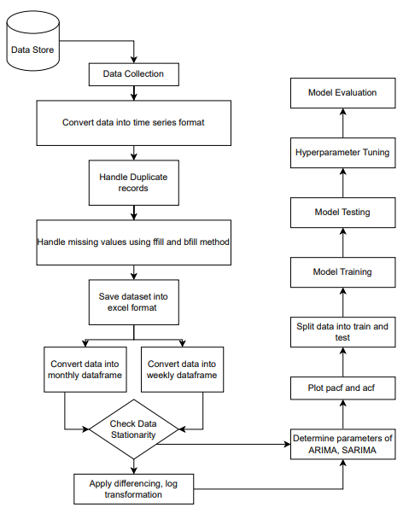
Fig – 1 Flowchart of ML model

Results

For Montly Forecasting
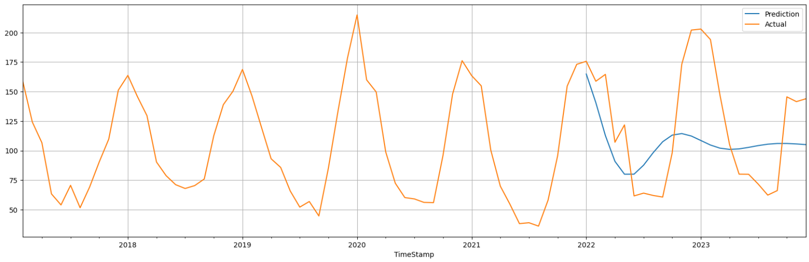
Fig – 1 Auto Regressive Model with p = 2

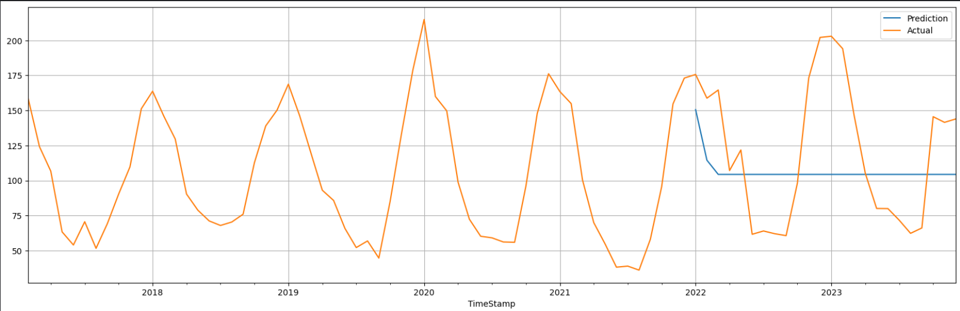
Fig – 2 Moving Average Model with q = 2

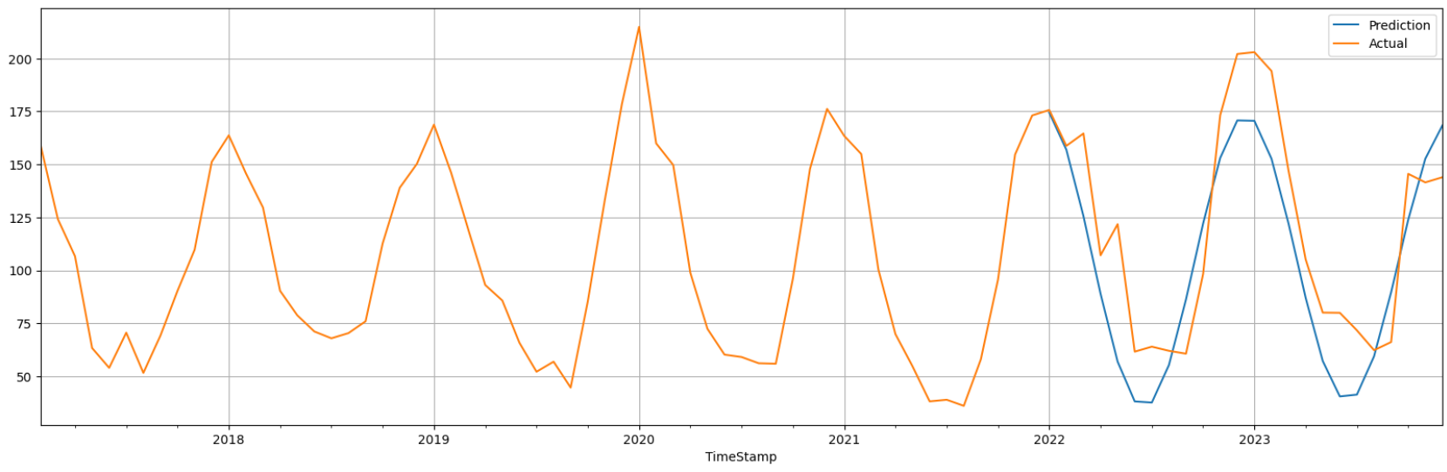
Fig – 3 ARIMA model with p = 2, d = 1, q = 2

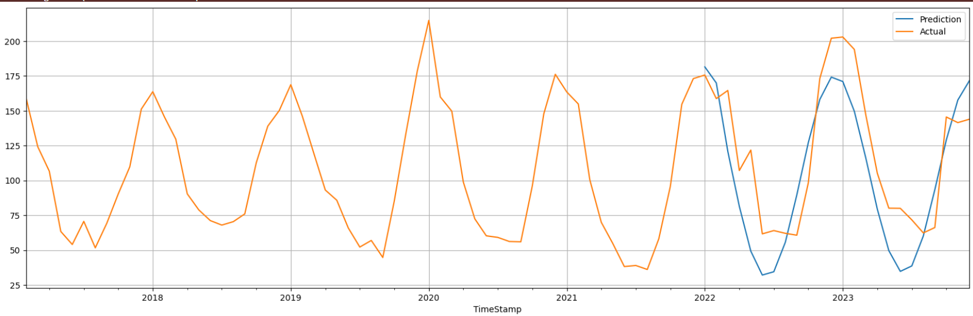
Fig – 4 ARIMA model with p = 2, d = 1, q = 6

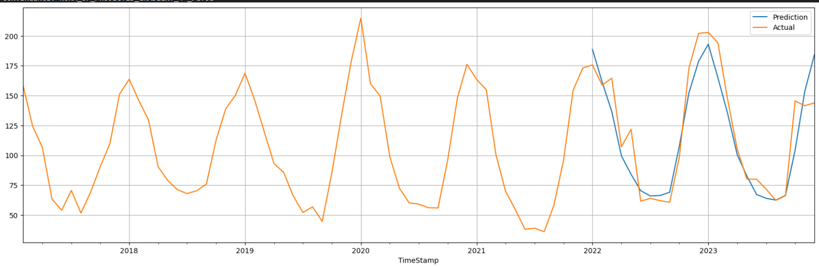
Fig – 5 SARIMA model with p = 0, d = 1, q = 0, P = 4, D = 1, Q = 6, S = 12

Model Performance Metrics:
Model | MAE | MSE | MAPE | RMSE
AR model (p = 2) | 38.92 | 2084.7 | 34.63 | 45.66
MA model (q = 2) | 41.72 | 2405 | 37.53 | 49.04
ARIMA model (p = 2, d = 1, q = 2) | 23.99 | 768.33 | 22.97 | 27.71
SARIMA model (p = 0, d = 1, q = 0, P = 4, D = 1, Q = 6, S = 12) | 14.09 | 352.86 | 10.95 | 18.78

For Weekly Forecasting:
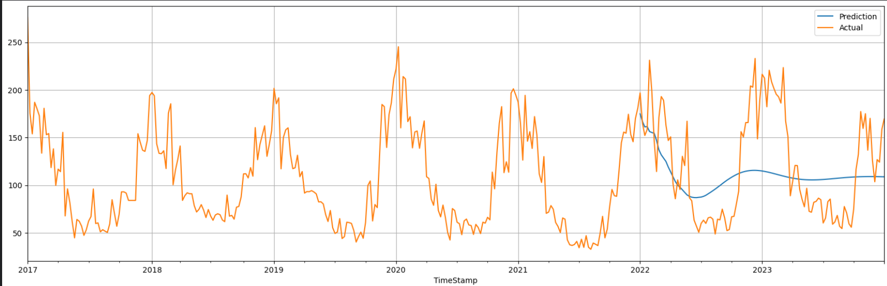
Fig – 1 Auto Regressive Model with p = 9

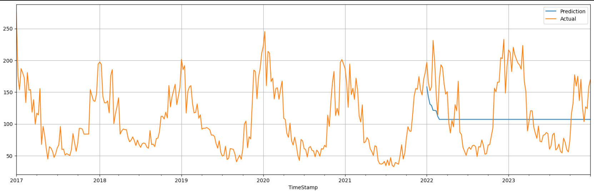
Fig – 2 Moving Average Model with q = 8

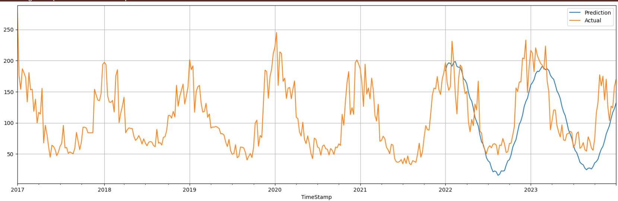
Fig – 3 ARIMA model with p = 9, d = 0, q = 8

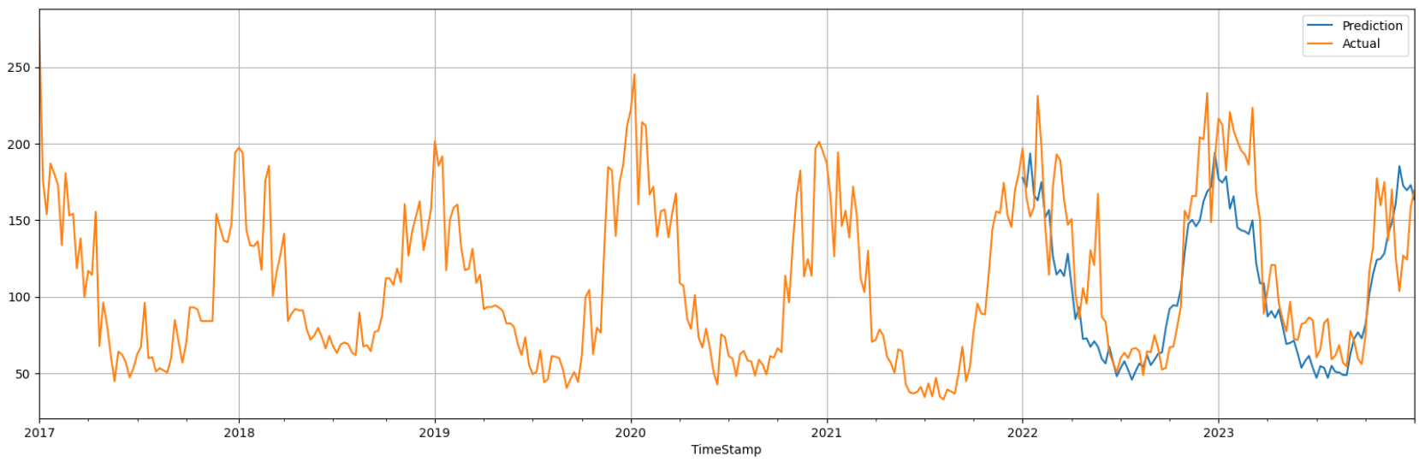
Fig – 4 SARIMA model with p = 0, d = 0, q = 0, P = 6, D = 1, Q = 9, S = 7

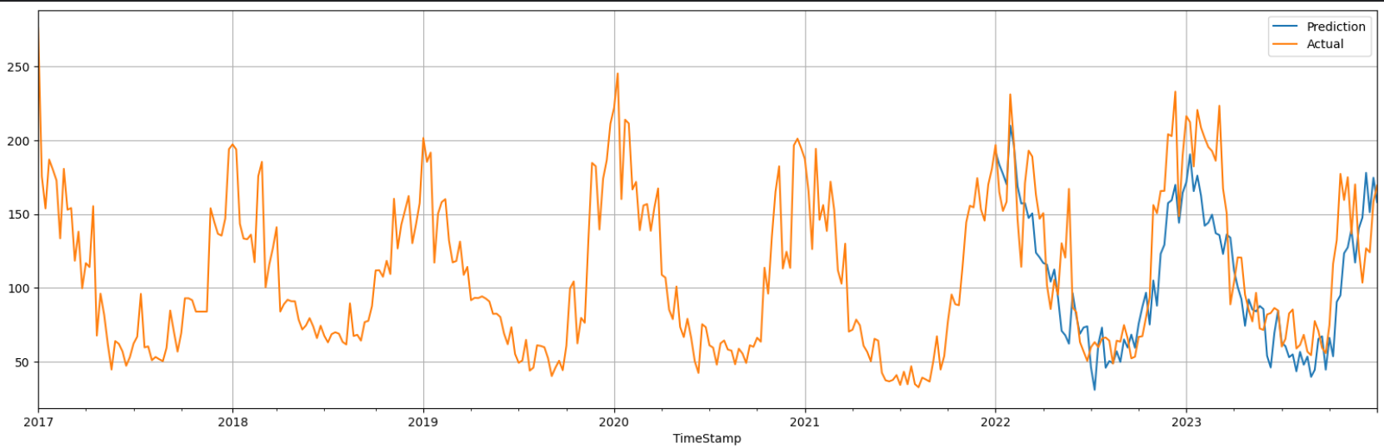
Fig – 4 SARIMA model with p = 0, d = 0, q = 0, P = 6, D = 1, Q = 9, S = 12

Model Performance Metrics:
Model | MAE | MSE | MAPE | RMSE
AR model (p = 9) | 40.18 | 2325.02 | 36.69 | 48.21
MA model (q = 8) | 45.76 | 2893.61 | 41.98 | 53.79
ARIMA model (p = 9, d = 0, q = 8) | 37.39 | 2120.41 | 34.97 | 46.05
SARIMA model (p = 0, d = 0, q = 0, P = 6, D = 1, Q = 7, S = 7) | 25.86 | 1092.79 | 21.12 | 33.05

Conclusion
In conclusion, the proposed system provides a comprehensive approach to forecast the Air Quality Index using time series analysis techniques and various forecasting models. By employing rigorous data preprocessing, exploratory data analysis, model training, testing, and evaluation, the system ensures the reliability and accuracy of the AQI forecasts, which are crucial for environmental management and public health interventions.

References
[1] Central Pollution Control Board under the Ministry of Environment, Forest, and Climate Change, Government of India. https://cpcb.nic.in/index.php (accessed April 15, 2024)/
[2] Statistics By Jim. https://statisticsbyjim.com/time-series/autocorrelation-partial-autocorrelation/ (accessed April 19, 2024)
[3] Wikipedia. https://en.wikipedia.org/wiki/Autocorrelation (accessed April 19, 2024)
[4] Pandas. https://pandas.pydata.org/docs/reference/api/pandas.plotting.autocorrelation_plot.html (accessed April 19, 2024)
[5] Coursera. https://www.coursera.org/articles/autoregressive-models (accessed April 21, 2024)
[6] OTexts. https://otexts.com/fpp2/AR.html (accessed April 21, 2024)
[7] Analytics Vidhya. https://www.analyticsvidhya.com/blog/2020/10/how-to-create-an-arima-model-for-time-series-forecasting-in-python/ (accessed April 21, 2024)
[8] Science Direct. https://www.sciencedirect.com/topics/mathematics/autoregressive-integrated-moving-average (accessed April 22, 2024)
[9] Youtube. https://www.youtube.com/watch?v=IK67f3IItfw (accessed April 23, 2024)
[10] Towards Data Science. https://towardsdatascience.com/timeseries-forecasting-with-arima-sarima-and-sarimax-ee61099e78f6
(accessed April 24, 2024)

