// Q1. Check Even/Odd and Positive/Negative

import java.util.Scanner;
public class Q_01 {
public static void main(String[] args) {
Scanner sc = new Scanner(System.in);
System.out.print("Enter a number: ");
int num = sc.nextInt();
if (num > 0) {
System.out.println("The number is Positive");
if (num % 2 == 0) {
System.out.println("It is Even");
} else {
System.out.println("It is Odd");
}
} else if (num < 0) {
System.out.println("The number is Negative");

if (num % 2 == 0) {
System.out.println("It is Even");
} else {
System.out.println("It is Odd");
}
} else {
System.out.println("The number is Zero");
}
}
}
Output:
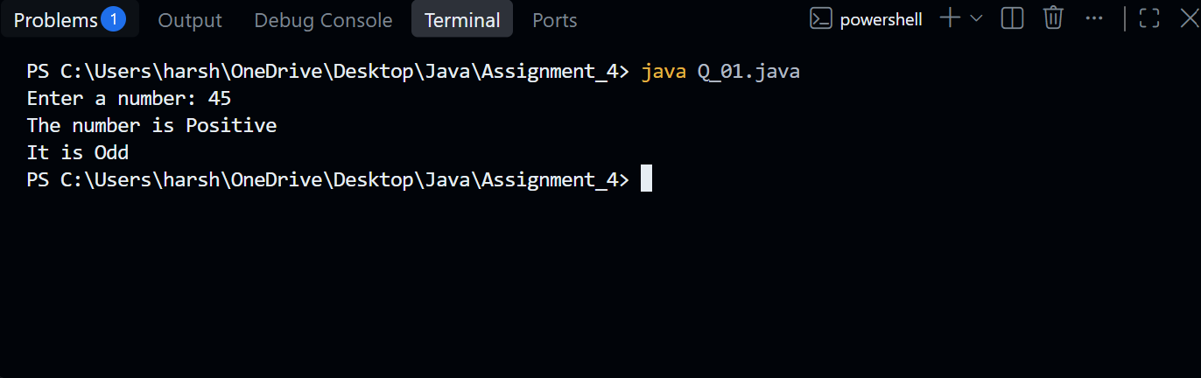

// Q2. Largest of three numbers

import java.util.Scanner;

public class Q_02 {
public static void main(String[] args) {
Scanner sc = new Scanner(System.in);
System.out.print("Enter first number: ");
int a = sc.nextInt();
System.out.print("Enter second number: ");
int b = sc.nextInt();
System.out.print("Enter third number: ");
int c = sc.nextInt();
if (a >= b && a >= c) {
System.out.println("Largest number is: " + a);
}
else if (b >= a && b >= c) {
System.out.println("Largest number is: " + b);
}
else {
System.out.println("Largest number is: " + c);
}
sc.close();
}
}

Output:
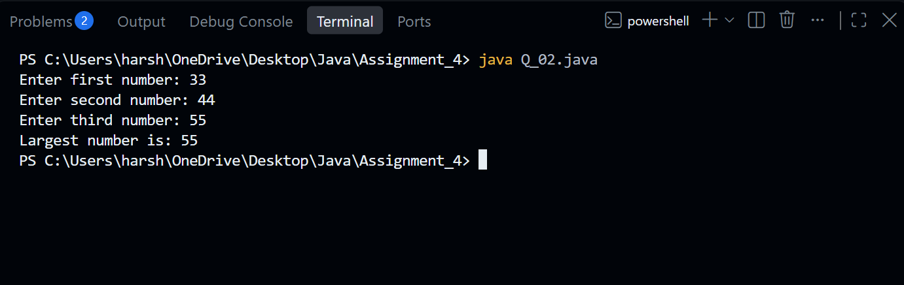

// Q3. Number divisibility check

import java.util.Scanner;
public class Q_03 {
public static void main(String[] args) {
Scanner sc = new Scanner(System.in);
System.out.print("Enter a number: ");
int num = sc.nextInt();
if (num % 5 == 0) {
System.out.println(num + " is divisible by 5");

if (num % 10 == 0) {
System.out.println(num + " is also divisible by 10");
} else {
System.out.println(num + " is not divisible by 10");
}
} else {
System.out.println(num + " is not divisible by 5");
}
sc.close();
}
}

Output:
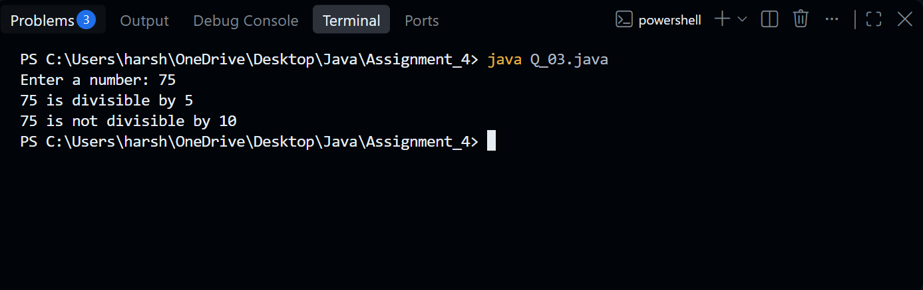

// Q4. Check working day

import java.util.Scanner;

public class Q_04 {
public static void main(String[] args) {
Scanner sc = new Scanner(System.in);
System.out.print("Enter day number (1-7): ");
int day = sc.nextInt();
if (day >= 1 && day <= 5) {
System.out.println("It is a Working Day");
}
else if (day == 6 || day == 7) {
System.out.println("It is a Weekend");
}
else {
System.out.println("Invalid day number");
}
sc.close();
}
}
Output:
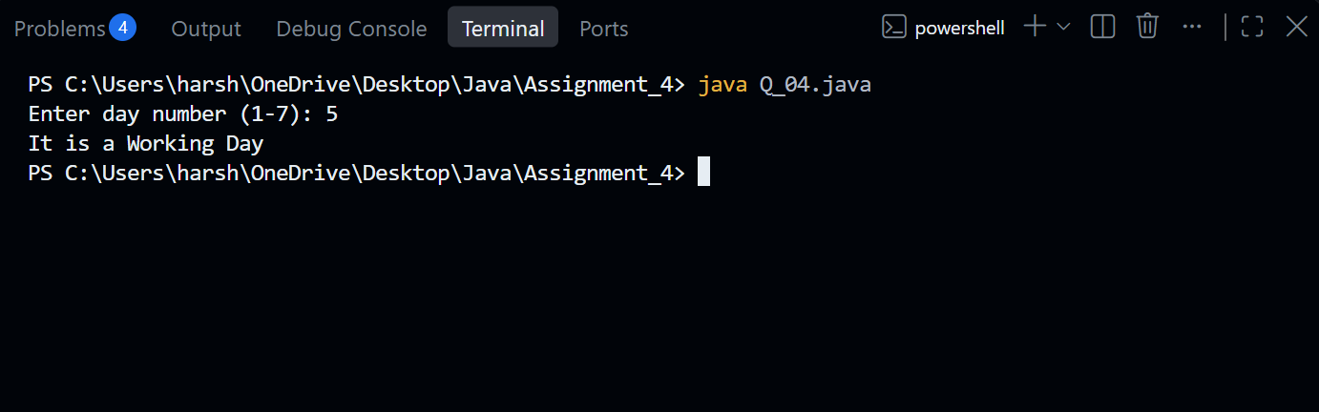
// Q.5 Password length checker

import java.util.Scanner;
public class Q_05 {
public static void main(String[] args) {
Scanner sc = new Scanner(System.in);
System.out.print("Enter your password: ");
String password = sc.nextLine();
int length = password.length();
if (length < 8) {
System.out.println("Password is too short");
}
else if (length >= 8 && length < 12) {
System.out.println("Password is Acceptable");
}
else {
System.out.println("Password is Strong");
}
sc.close();
}
}
Output:
