**Survey for Analysis of Emotions to predict depression**

**in person using Machine Learning techniques**

Rashmi Mishra

**What exactly is depression?**

As per World Health Organization (WHO), depression is the most common illness worldwide and a leading cause of mental disability.

Some of the wordings of WHO:

**“Depression is a common mental disorder. Globally, more than 264 million people of all ages suffer from depression.”**

“**Depression is a leading cause of disability worldwide and is a major contributor to the overall global burden of disease.”**

**“There are effective psychological and pharmacological treatments for moderate and severe depression.”**

**India most depressed country**

A study reported in WHO, conducted for the NCMH (National Care Of Medical Health), states that at least 6.5 per cent of the Indian population suffers from some serious form of mental disorder, with no discernible rural-urban differences. Though there are effective measures and treatments, there is an extreme shortage of mental health workers like psychologists, psychiatrists, and doctors. As reported latest in 2014, it was as low as ''one in 100,000 people''.

The average suicide rate in India is 10.9 for every lakh people; a majority of people who commit suicide are below 44 years of age.

**Some shocking stats regarding depression:**

* One in six people aged 10-19 years is suffering from depression
* Mental health conditions account for 16 per cent of the global burden of disease and injury in people aged 10-19 years
* Half of all mental health conditions start by the age of 14 years; most cases are undetected and untreated
* Globally, depression is one of the leading causes of illness and disability among adolescents
* Suicide is the third leading cause of death among 15-19-year-olds.
* The consequences of not addressing adolescent mental health conditions extend to adulthood, impairing both physical as well as mental health, limiting opportunities to lead fulfilling lives as adults.
* Mental health promotion and prevention are key to helping adolescents thrive.

**Story of Deepika Padukone suffered from depression**

“In early 2014, while I was being appreciated for my work, one morning, I woke up feeling different. A day earlier, I had fainted due to exhaustion; it was all downhill from there. I felt a strange emptiness in my stomach. I thought it was stress, so I tried to distract myself by focusing on work, and surrounding myself with people, which helped for a while. But the nagging feeling didn’t go away. My breath was shallow, I suffered from lack of concentration and I broke down often,"

**Questions asked for the survey :**

* What is the age of the person?
* What is the gender of the person?
* What is the sexuality of the person?
* What is the income of the person?
* Does he/she laugh?
* Does he/she overthink?
* Is he/she supervising someone?
* How many friends they have?
* Do they have social fear?
* Are they virgin?
* What is their weight?
* Are they employed?
* Did they attempt suicide?
* What is their education level?
* How active are they on social media?
* How much do they interact with people
* ?
* Are they comfortable with a camera?
* Do they share things?
* What shows do they watch on Television?

We can observe the dependence of factors from the graph.

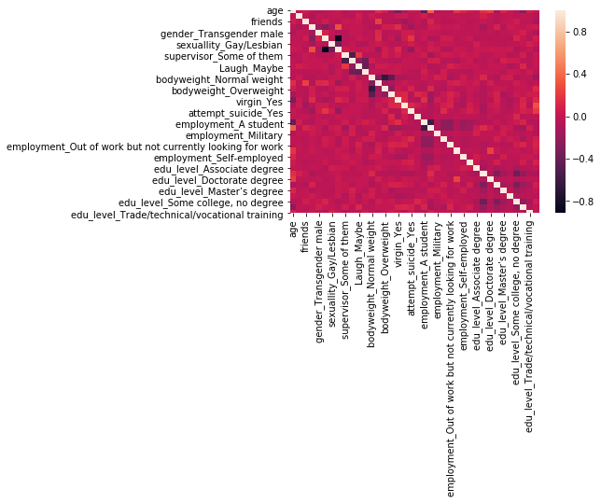

After analysing the data, we

observe that more than 300 women and less than 100 men suffer from depression.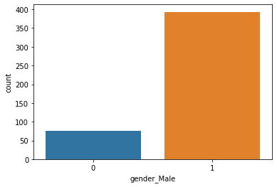

The above graph shows that people who have no friends or stay alone are more likely to suffer from depression.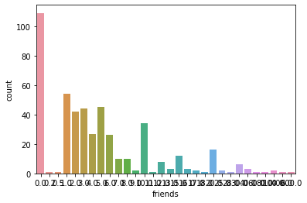

We can say a person who has social fear is more likely to be suffering from depression.

Nearly 300 people have social fear out of 500, 150 don't experience any social fear while 50 are at an intermediate level.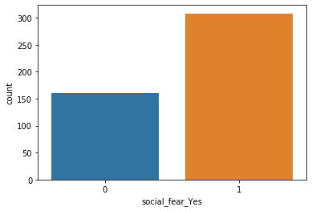

We can see the age group 15-29 is more likely to suffer from depression, i.e., the younger generation.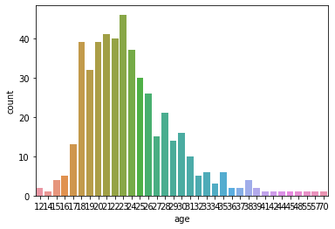

Each model was tested by 10-fold cross-validation. Specifically, the data was randomly divided into ten subgroups of equal size. Each subgroup was then used to test the model that was built using the opposing four subgroups. After ten rounds of model training, the results of model training were integrated into a final model.

And we got the accuracy of the model to be 83.33.

These values were used to compute the following metrics to

further gauge the model performance:

a) Accuracy: TP + TN / (TP + TN + FP + FN)

b) Precision: TP / (TP + FP)

c) Recall (Sensitivity): TP / (TP + FN )

d) Specificity: TN / (TN + FP)

According to the metrics, the described models exhibited satisfactory performance levels.

|  |  |
| --- | --- |
| Accuracy | 0.97872340425 |
| Precision | 1.0 |
| Recall | 0.5 |

**Conclusion**

There are different methods to detect a person suffering from depression based on age, income, friends, jobs, etc.

The way we are using is analysing their semantic emotions, answers to some questions to predict the depression levels among various age groups.

The algorithms are designed to analyse the data we got from the survey and emotion dataset as well as for the detection of suicidal thoughts among people.

Social interaction is an open platform where many people refrain from telling their true emotions that might relate to the depression they are facing, meaning that the model analysis here is mostly based on the prediction of a suffering person by the data and using it by machine learning algorithms.

The main requirement of the model is to be perfectly able to predict the result as several implementations require verification of data before predicting the thoughts of the person as suicidal or non-suicidal.

The accuracy of the model we got is 0.83333333334