**Survey for Analysis of Emotions to predict Depression**

**in person using Machine Learning techniques**

Rashmi Mishra

**What exactly is Depression?**

As per World Health Organization (WHO), depression is the most common illness worldwide and a leading cause of mental disability.

Some of the wordings of WHO:

**“Depression is a common mental disorder. Globally, more than 264 million people of all ages suffer from depression.”**

“**Depression is a leading cause of disability worldwide and is a major contributor to the overall global burden of disease.”**

**“There are effective psychological and pharmacological treatments for moderate and severe depression.”**

**India most depressed Country**

A study reported in WHO, conducted for the NCMH (National Care Of Medical Health), states that at least 6.5 per cent of the Indian population suffers from some form of serious mental disorder, with no discernible rural-urban differences. Though there are effective measures and treatments, there is an extreme shortage of mental health workers like psychologists, psychiatrists, and doctors. As reported latest in 2014, it was as low as ''one in 100,000 people''.  
The average suicide rate in India is 10.9 for every lakh people and the majority of people who commit suicide are below 44 years of age.

**Some shocking stats regarding depression:**

* One in six people aged 10-19 years is suffering from depression
* Mental health conditions account for 16 per cent of the global burden of disease and injury in people aged 10-19 years
* Half of all mental health conditions start by the age of 14 years and most cases are undetected and untreated
* Globally, depression is one of the leading causes of illness and disability among adolescents
* Suicide is the third leading cause of death among 15-19-year-olds.
* The consequences of not addressing adolescent mental health conditions extend to adulthood, impairing both physical and mental health and limiting opportunities to lead fulfilling lives as adults
* Mental health promotion and prevention are key to helping adolescents thrive

**Story of Deepika Padukone suffered from Depression**

“In early 2014, while I was being appreciated for my work, one morning, I woke up feeling different. A day earlier, I had fainted due to exhaustion; it was all downhill from there. I felt a strange emptiness in my stomach. I thought it was stress, so I tried to distract myself by focusing on work, and surrounding myself with people, which helped for a while. But the nagging feeling didn’t go away. My breath was shallow, I suffered from lack of concentration and I broke down often,"

**Questions asked for the survey :**

* What is the age of person?
* What is Gender of person?
* What is Sexuality of person?
* What is the Income of person?
* Is He/she used to laugh?
* He/she used to overthink?
* Is he/she supervising someone?
* How any friends they have?
* Do they have social fear?
* Are they Virgin?
* What is their weight?
* Are they employed?
* Do they attempt suicide?
* What is their education level?
* How active they are on social media?
* How much they interact with peoples?
* What their education level is?
* Are they comfortable to camera?
* Do they use to share things?
* What shows they watch on Television?

We can observe the dependence of factors from the graph.

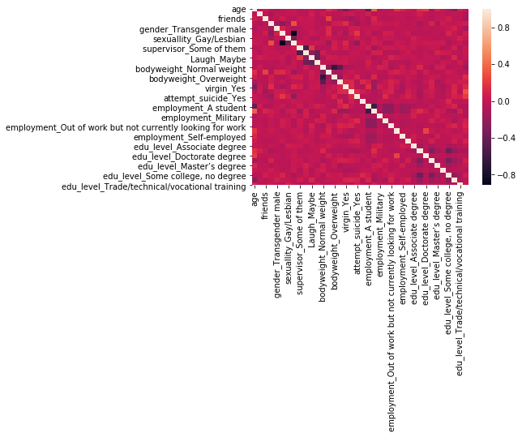

By analysing the data we get to know that person suffering from depression have high number of females, number of females have depression is much higher that males.

This can be observed from the graph, there are 300 above women have depression and near 100 men have depression.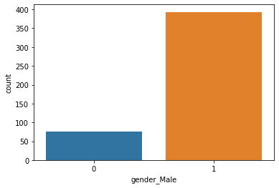

By plotting the graph we can see that person having no friends or who stays alone have more likely to suffer from depression.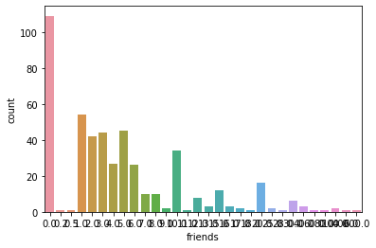

We can say person having depression less interacts with person and their social interaction is very low.

We can say the person who have social fear is more likely to be suffered from Depression.

Nearly 300 person have social fear out of 500 and 150 are those who don’t have, 50 who are at intermediate.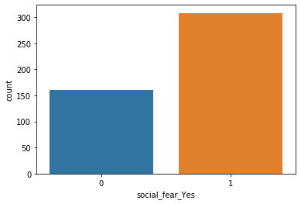

We can see the age group 15-29 are more likely to suffer from Depression, we can observe that the young generation is highly possible to have Depression.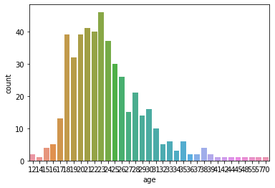

Each model was tested by 10-fold cross-validation. Specifically, the data was randomly divided into ten subgroups with equal size. Each subgroup was then used to test the model that was built using the opposing four subgroups. After ten rounds of model training, results of model training were integrated into a final model.

And we got the accuracy of model as 83.33.

These values were used to compute the following metrics to

further gauge the model performance:

a) Accuracy: TP + TN / (TP + TN + FP + FN)

b) Precision: TP / (TP + FP)

c) Recall (Sensitivity): TP / (TP + FN )

d) Specificity: TN / (TN + FP)

According to the utilized metrics, the described models exhibited satisfactory performance levels.

|  |  |
| --- | --- |
| Accuracy | 0.97872340425 |
| Precision | 1.0 |
| Recall | 0.5 |

**Conclusion**

There are different methods to detect person suffering from depression among peoples on the basis of ages, income, friends, jobs, etc.

The way we are using is analysing their semantic emotions, answers to some questions so as to predict the depression levels among various age groups.

The algorithms are designed to analyse the data we got from survey and emotion dataset as well as for detection of suicidal thoughts among people .

Social interaction is an open platform where many people refrain from telling their true emotions that might relate to depression they are facing, and so the model analysis here are mostly based on the prediction of person suffering by the data and using it by machine learning algorithms.

The main requirement of model is to be perfectly able to predict the result as there are a number of implementations that require verification of data before predicting the thoughts of the person as suicidal or non-suicidal.

Accuracy of model we got is 0.83333333334