**Assignment 2**

**1. Write a program that calculates and prints the area and the perimeter of a square when the size of one side is given.**

**Code:-**

**/**/Program to print the area and perimeter of a square

//AC-1216 Harsh Bamotra

#include <iostream>

using namespace std;

int main()

{

int side , area , peri; //Declaring variable side

cout << "Enter the side of the square::"; //Printing input message

cin >> side; //Taking input side

cout << "You entered::" << side << endl;

area=side*side; //Calculating the area

peri=side*4; //Calculating the perimeter

cout << "The perimeter of the square is::" << peri << endl; //Printing the perimeter

cout << "The area of the square is::" << area << endl; //Printing the area

return 0;

}

**Output:-**

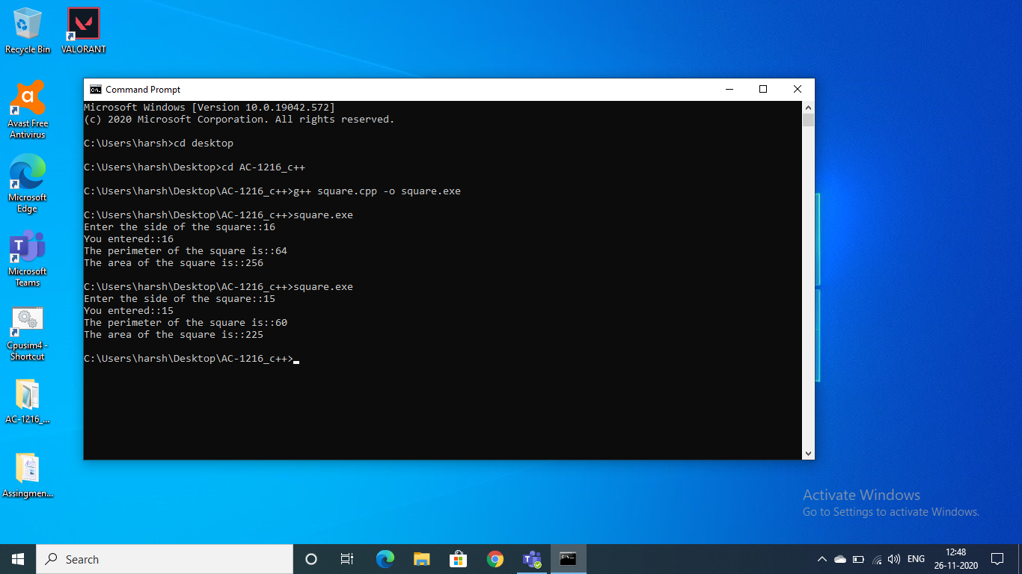

**2. Write a program that calculates the sales tax of a transaction given the sale amount. Assume that the tax is 9 percent. Use a constant to define the tax rate. Run your program several times, each with different values for sale amount. Use the following format for output.**

**Sale amount: …**

**Tax amount: …**

**Total amount due: …**

**Code:-**

//Program to calculate the sales tax of a transaction

//AC-1216 Harsh Bamotra

#include <iostream>

using namespace std;

int main()

{

double tax_amount, s_amount , t_amount; //declaring variables

const int tax=9; //declaring contant

cout << "Enter the value of sale amount::"; //input message

cin >> s_amount; //taking input

tax_amount=(s_amount*tax)/100; //calculating the tax

t_amount=tax_amount+s_amount; //calculating the total

cout << "Sales amount::" << s_amount << endl; //printing the sales amount

cout << "Tax amount::" << tax_amount << endl; //printing the tax amount

cout << "Total amount::" << t_amount << endl; //printing the total amount

return 0;

}

**Output:-**

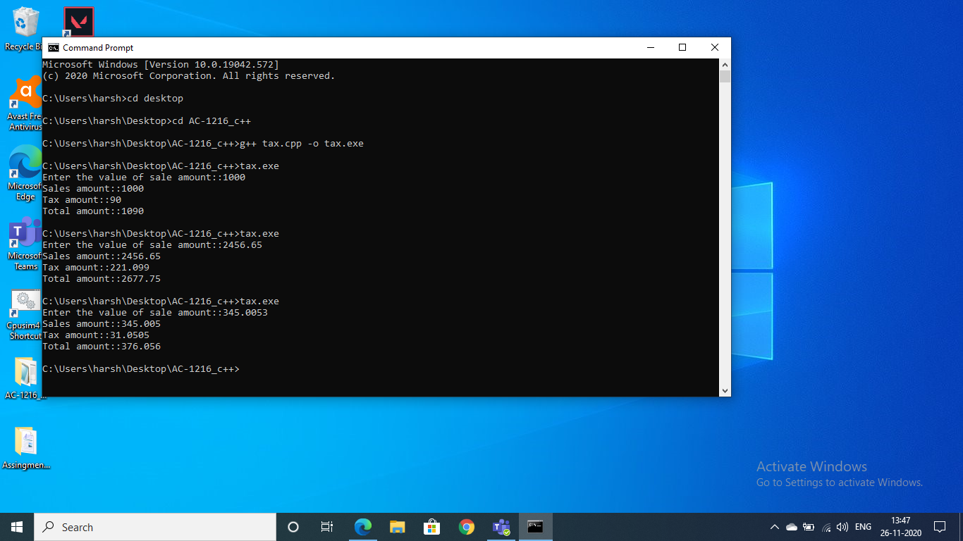

**3. Write a program that, given street number, street name, city name, state name, and zip code, prints the address in the following format**

**street-number, street city, state zip-code**

**Code:-**

//Program to input and print the address

//AC-1216 Harsh Bamotra

#include <iostream>

using namespace std;

int main()

{

int s_number , zip; //declaring variables

string s_name , state , city;

cout << "Enter the street number::";

cin >> s_number; //s_number stands for street number

cout << "Enter the street name::";

cin >> s_name; //s_name stands for street name

cout << "Enter the zip number of your area::";

cin >> zip;

cout << "Enter the state you live::";

cin >> state; //taking different inputs

cout << "Enter the city you live::";

cin >> city;

cout <<" Your Adress::" << s_number << "," << s_name

<< " " << city << "," << state << " " << zip; //printing the adress

return 0;

}

**Output:-**

