SHRI RAMDEOBABA COLLEGE OF ENGINEERING AND MANAGEMENT, NAGPUR
Name :Harsh K. Barewar
Branch : CSE (AIML)
Date: 27/05/2025
----------------------------------------------------------------------------------------------------------------------------------
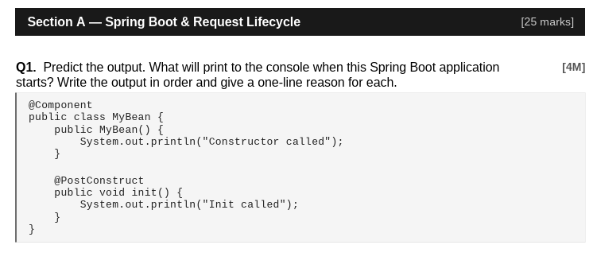Ans:
Constructor called
Init called
Constructor called
Init called
Reasons:
- Constructor called → Spring creates the bean by calling its constructor first
- Init called → After the bean is created, Spring calls the @PostConstruct method automatically
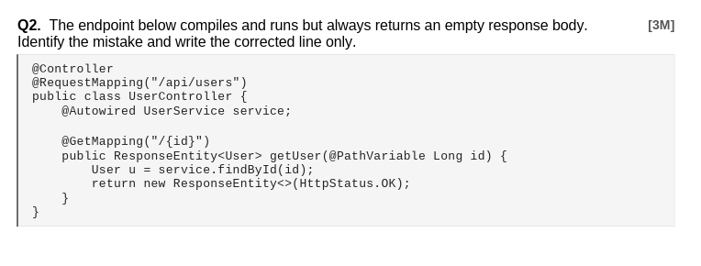
Ans : Mistake: The User object u is never passed into the ResponseEntity. Also @GetMapping is outside the class because of wrong braces.
// WRONG LINE:
return new ResponseEntity<>(HttpStatus.OK);

// CORRECTED LINE:
return new ResponseEntity<>(u, HttpStatus.OK);
Two fixes:
Fix 1 — add @ResponseBody or change @Controller to @RestController
Fix 2 — pass u into the response
Java Fix :
return new ResponseEntity<>(u, HttpStatus.OK);

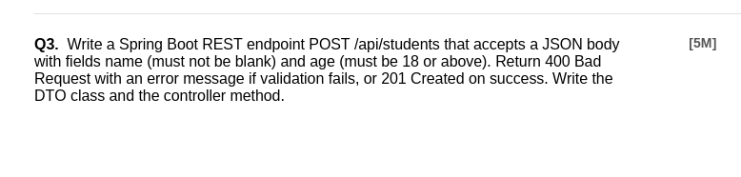
// DTO
import jakarta.validation.constraints.*;

public class StudentDTO {
@NotBlank(message = "Name must not be blank")
private String name;

@Min(value = 18, message = "Age must be 18 or above")
private int age;

// Getters & Setters
public String getName() { return name; }
public void setName(String name) { this.name = name; }
public int getAge() { return age; }
public void setAge(int age) { this.age = age; }
}

// Controller
@RestController
@RequestMapping("/api/students")
public class StudentController {

@PostMapping
public ResponseEntity addStudent(
@Valid @RequestBody StudentDTO dto,
BindingResult result) {

if (result.hasErrors()) {
String errorMsg = result.getFieldErrors().stream()
.map(e -> e.getField() + ": " + e.getDefaultMessage())
.collect(Collectors.joining(", "));
return ResponseEntity.badRequest().body(errorMsg);
}
// Save logic here...
return ResponseEntity.status(HttpStatus.CREATED).body("Student created");
}
}

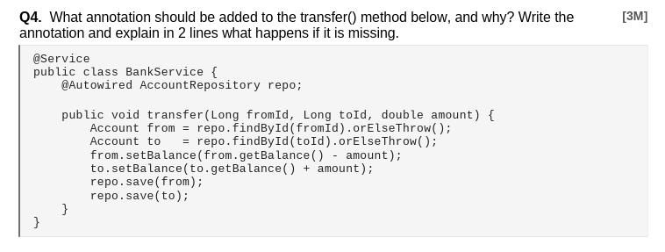
Ans : Missing annotation on transfer()
Add @Transactional. Without it, if repo.save(to) throws an exception after repo.save(from) succeeds, the debit is committed but the credit is not — leaving the accounts in an inconsistent state.
Public class BankService{
@Autowired AccuntRepository repo;
}
@Transactional
public void transfer(Long fromId, Long toId, double amount) {
Account from = repo.findById(fromId).orElseThrow();
Account to = repo.findById(toId).orElseThrow();
from.setBalance(from.getBalance() - amount);
to.setBalance(to.getBalance() + amount);
repo.save(from);
repo.save(to);
}

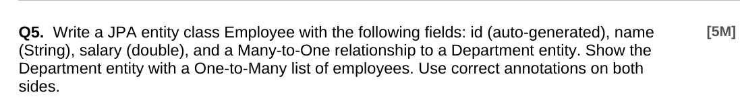
@Entity
public class Department {
@Id @GeneratedValue(strategy = GenerationType.IDENTITY)
private Long id;

private String name;

@OneToMany(mappedBy = "department", cascade = CascadeType.ALL)
private List<Employee> employees = new ArrayList<>();
// Getters & Setters...
}

@Entity
public class Employee {
@Id @GeneratedValue(strategy = GenerationType.IDENTITY)
private Long id;

private String name;
private double salary;

@ManyToOne
@JoinColumn(name = "department_id")
private Department department;
// Getters & Setters...
}

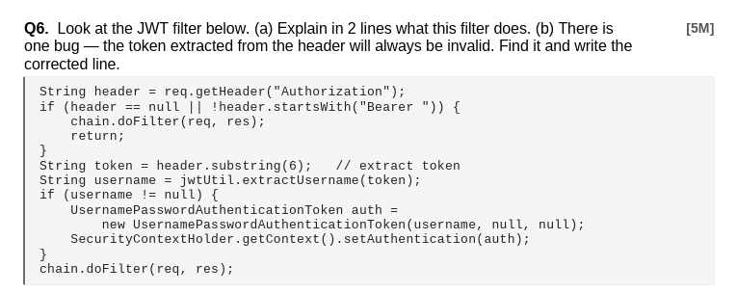
(a) What this filter does (2 lines):
It checks the incoming HTTP request for an Authorization header with a Bearer token. If a valid token is found, it extracts the username and sets that user as authenticated in Spring Security's context so the request is allowed through.
(b) The Bug:
“Bearer” is 7 characters (B-e-a-r-e-r-space), so the token starts at index 7, not 6.
Java code correction:
// Wrong line:
String token = header.substring(6);

// Corrected line:
String token = header.substring(7);

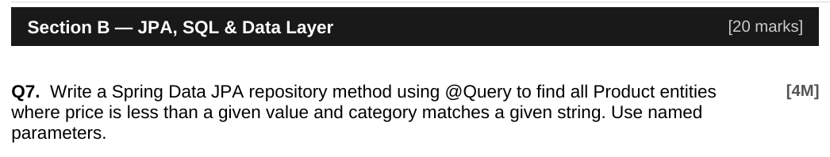

public interface ProductRepository extends JpaRepository<Product, Long> {
@Query("SELECT p FROM Product p WHERE p.price < :maxPrice AND p.category = :category")
List<Product> findByPriceAndCategory(
@Param("maxPrice") double maxPrice,
@Param("category") String category
);
}

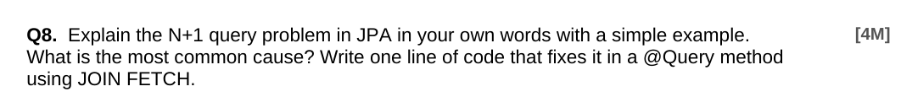
N+1 problem: When you load N parent entities (e.g. 10 Authors) and then access a lazy-loaded collection on each (e.g. author.getBooks()), JPA fires 1 query for the authors + N separate queries for each author's books = N+1 total queries. Most common cause: @OneToMany or @ManyToMany with default LAZY fetch type, iterated in a loop.
// Fix using JOIN FETCH in @Query:
@Query("SELECT a FROM Author a JOIN FETCH a.books")
List<Author> findAllWithBooks();

-- SQL (subquery approach):
SELECT MAX(salary)
FROM employees
WHERE salary < (SELECT MAX(salary) FROM employees);

-- JPQL in JPA repository:
public interface EmployeeRepository extends JpaRepository<Employee, Long> {

@Query("SELECT MAX(e.salary) FROM Employee e WHERE e.salary < " +
"(SELECT MAX(e2.salary) FROM Employee e2)")
Double findSecondHighestSalary();
}

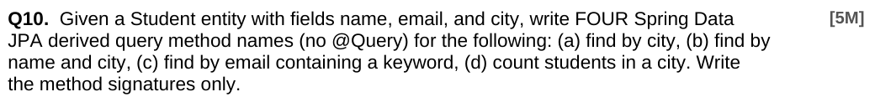
// (a) find by city
List<Student> findByCity(String city);

// (b) find by name and city
List<Student> findByNameAndCity(String name, String city);

// (c) find by email containing a keyword
List<Student> findByEmailContaining(String keyword);

// (d) count students in a city
long countByCity(String city);
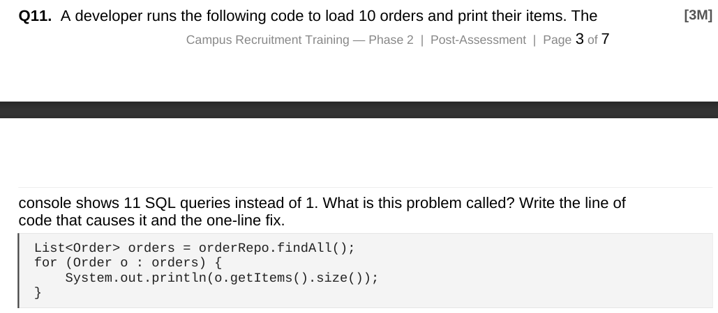
This is the N+1 query problem. findAll() fires 1 query to load 10 orders. Then o.getItems().size() triggers 1 lazy-load query per order = 10 more = 11 total.
// LINE THAT CAUSES IT:
System.out.println(o.getItems().size());
// Each call to getItems() triggers a new lazy SELECT.

// FIX — use JOIN FETCH in the repository:
@Query("SELECT o FROM Order o JOIN FETCH o.items")
List<Order> findAllWithItems();

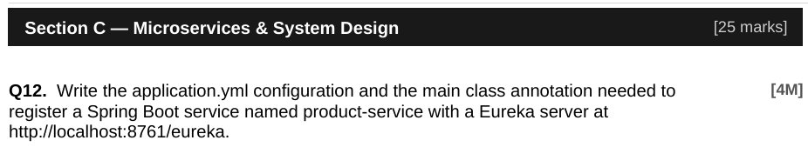
// application.yml
spring:
application:
name: product-service

eureka:
client:
service-url:
defaultZone: http://localhost:8761/eureka

// Main class annotation:
@SpringBootApplication
@EnableEurekaClient // or @EnableDiscoveryClient
public class ProductServiceApplication {
public static void main(String[] args) {
SpringApplication.run(ProductServiceApplication.class, args);
}
}

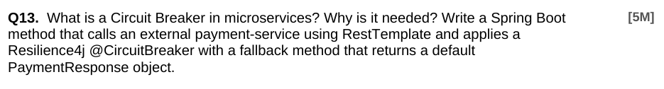
A Circuit Breaker monitors calls to an external service. When failures exceed a threshold, it "opens" and stops forwarding calls (returning a fallback instead), giving the failing service time to recover and preventing cascading failures across microservices. It is needed to improve system resilience and prevent one failing service from crashing the entire application.

@Service
public class PaymentService {

@Autowired
private RestTemplate restTemplate;

@CircuitBreaker(name = "paymentService", fallbackMethod = "paymentFallback")
public PaymentResponse processPayment(PaymentRequest request) {
return restTemplate.postForObject(
"http://payment-service/api/pay",
request,
PaymentResponse.class
);
}

public PaymentResponse paymentFallback(PaymentRequest request, Exception e) {
PaymentResponse fallback = new PaymentResponse();
fallback.setStatus("FAILED");
fallback.setMessage("Payment service is unavailable. Try again later.");
return fallback;
}
}

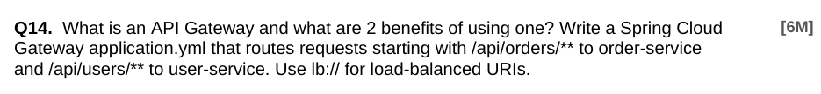
An API Gateway is a single entry point for all client requests to microservices. Benefits: (1) Centralised cross-cutting concerns (auth, rate limiting, logging) without duplicating them in each service. (2) Client simplicity — the frontend calls one URL and the gateway routes to the right service internally.

# application.yml for Spring Cloud Gateway
spring:
application:
name: api-gateway
cloud:
gateway:
routes:
- id: order-service
uri: lb://order-service
predicates:
- Path=/api/orders/**

- id: user-service
uri: lb://user-service
predicates:
- Path=/api/users/**

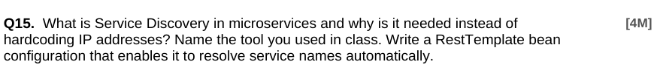
Service Discovery allows microservices to find each other by logical name instead of hardcoded IP:port. IPs change on restarts or scaling — dynamic discovery handles this automatically. The tool used in class is Eureka (Netflix Eureka / Spring Cloud Netflix).
@Configuration
public class AppConfig {

@Bean
@LoadBalanced // enables RestTemplate to resolve "service-name" via Eureka
public RestTemplate restTemplate() {
return new RestTemplate();
}
}

// Usage (no hardcoded IP needed):
restTemplate.getForObject("http://order-service/api/orders", Order[].class);
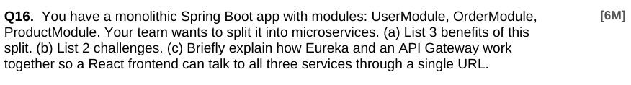
a) 3 benefits: Independent deployability — each service can be deployed/updated without touching others. Independent scalability — scale only the overloaded service (e.g. ProductModule) rather than the whole app. Technology flexibility — each service can use a different stack, database, or language best suited to its needs.
(b) 2 challenges: Distributed system complexity — network latency, partial failures, and eventual consistency are harder to handle than in-process calls. Operational overhead — you now need service discovery, API gateway, distributed tracing, and container orchestration.
(c) Eureka + API Gateway flow: Each service registers itself with Eureka on startup, advertising its name and IP. The API Gateway (also a Eureka client) looks up service locations dynamically. The React frontend only knows one URL (the gateway). When it calls /api/orders/*, the gateway resolves "order-service" via Eureka and routes the request — the frontend never needs to know individual service addresses.

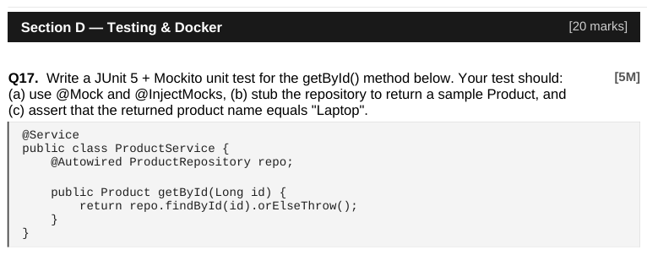
@ExtendWith(MockitoExtension.class)
class ProductServiceTest {

@Mock
private ProductRepository repo;

@InjectMocks
private ProductService productService;

@Test
void getById_shouldReturnProduct_whenFound() {
// Arrange
Product sample = new Product();
sample.setId(1L);
sample.setName("Laptop");

when(repo.findById(1L)).thenReturn(Optional.of(sample));

// Act
Product result = productService.getById(1L);

// Assert
assertEquals("Laptop", result.getName());
verify(repo, times(1)).findById(1L);
}

@Mock (Mockito): Creates a pure Mockito mock with no Spring context. Use when testing a single class in isolation (unit test) — fast, no context loading needed. @MockBean (Spring Boot Test): Creates a mock AND registers it as a bean in the Spring ApplicationContext, replacing the real bean. Use when you need the full Spring context to run (e.g. testing a controller with @SpringBootTest or @WebMvcTest) but want to mock a dependency like a service or repository
@SpringBootTest
class OrderControllerIntegrationTest {

@Autowired
private MockMvc mockMvc;

@MockBean // replaces the real OrderService in the context
private OrderService orderService;

@Test
void getOrder_returns200() throws Exception {
when(orderService.findById(1L)).thenReturn(new Order(1L, "PLACED"));
mockMvc.perform(get("/api/orders/1"))
.andExpect(status().isOk());
}
}

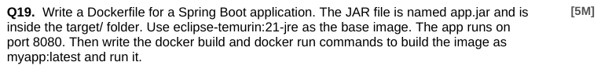

# Dockerfile
FROM eclipse-temurin:21-jre

WORKDIR /app

COPY target/app.jar app.jar

EXPOSE 8080

ENTRYPOINT ["java", "-jar", "app.jar"]

# Build the image:
docker build -t myapp:latest .

# Run the container:
docker run -d -p 8080:8080 --name myapp-container myapp:latest

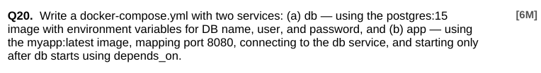

version: "3.9"

services:

db:
image: postgres:15
environment:
POSTGRES_DB: appdb
POSTGRES_USER: appuser
POSTGRES_PASSWORD: secret
ports:
- "5432:5432"

app:
image: myapp:latest
ports:
- "8080:8080"
environment:
SPRING_DATASOURCE_URL: jdbc:postgresql://db:5432/appdb
SPRING_DATASOURCE_USERNAME: appuser
SPRING_DATASOURCE_PASSWORD: secret
depends_on:
- db

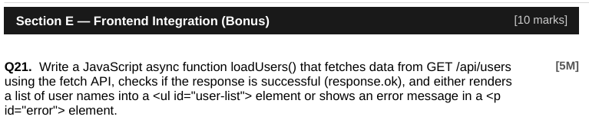
async function loadUsers() {
try {
const response = await fetch('/api/users');

if (!response.ok) {
throw new Error(`HTTP error: ${response.status}`);
}

const users = await response.json();
const ul = document.getElementById('user-list');
ul.innerHTML = ''; // clear previous content

users.forEach(user => {
const li = document.createElement('li');
li.textContent = user.name;
ul.appendChild(li);
});

} catch (error) {
const errorEl = document.getElementById('error');
errorEl.textContent = `Failed to load users: ${error.message}`;
}
}

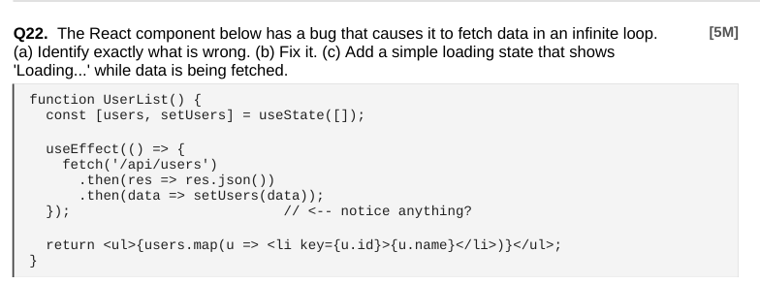
(a) Bug: useEffect has no dependency array []. Without it, the effect runs after EVERY render. setUsers(data) causes a re-render → effect runs again → infinite fetch loop.
(b) Fix: add an empty dependency array [] as the second argument to useEffect so it runs only once on mount.
(c) Loading state added below:
function UserList() {
const [users, setUsers] = useState([]);
const [loading, setLoading] = useState(true); // (c) loading state

useEffect(() => { // (b) FIXED — add []
fetch('/api/users')
.then(res => res.json())
.then(data => {
setUsers(data);
setLoading(false); // done loading
});
}, []); // <-- empty array = run once

if (loading) return <p>Loading...</p>; // (c) show while fetching

return (
<ul>
{users.map(u => <li key={u.id}>{u.name}</li>)}
</ul>
);
}

