ENTERPRISE DIAMOND ERP SYSTEM SPECIFICATION
SHREENATHJI DIAMONDS
Functional Architecture, Business Workflow & Database Blueprint
Surat Manufacturing & Mumbai Trading Operations
VERSION  1.0 (Production Edition) | OPERATIONAL HUBS  Surat Factory & Mumbai BDB | INDUSTRY DOMAIN  Diamond Manufacturing & Accounts

1. Executive Overview & Business Purpose
Historically, diamond manufacturing, rough cutting, and trading operations rely on disparate manual Excel spreadsheets. In traditional operations across Surat and Mumbai, diamond firms encounter critical challenges:
- Decimal Drift & Weight Loss: Carat calculations floating between Excel workbooks create unaccounted loss of stones and carat rounding discrepancies.
- Multi-Branch Disconnection: Surat (where rough procurement and cutting happen) and Mumbai Bharat Diamond Bourse (where polished trading and billing occur) operate on desynchronized books.
- Unreconciled Rough Stones: Difficulty in mathematically proving that opening rough carats minus cutting usage, sales, and rejections equals true physical vault inventory.
- Partner Loan Confusion: Partner drawings (Upad) and deposits (Jama) mixed with business expenses, leading to manual balancing errors.
- Overdue Receivables & Dalali: Lack of structured aging analysis (30, 60, 90+ days) and forgotten broker commissions.
The Shreenathji Diamond Management System replaces fragmented spreadsheets with an all-in-one, deterministic relational enterprise platform. It integrates procurement, rough reconciliation, princess cut manufacturing, choki processing, commercial sales invoicing, broker commissions, partner accounts, and automated double-entry accounting into one coherent system.

2. Core Business Capabilities (What We Built)

A. Multi-Branch Operations & Consolidated View
The system provides complete multi-branch operational control tailored for the diamond industry's real-world geography:
• Surat Manufacturing Unit: Dedicated to rough diamond procurement, inventory registers, Kapan processing, worker wages, and local cash book.
• Mumbai Trading Office (BDB): Located at Bharat Diamond Bourse for international and domestic polished diamond trading, commercial invoicing, customer receivables, and Dalali settlements.
• All-Branch Consolidated View: Super-administrators can view consolidated real-time carats, total vault valuation, and unified financials across both branches simultaneously.

B. Diamond Procurement & Purchase Management
• Lot Procurement: Logs rough diamond lots (કાચુ) with supplier details, invoice reference, and exact carat weights to 3 decimal places.
• Currency Conversion: Automatic conversion between USD per-carat rates and INR at the agreed daily dollar exchange rate.
• Credit Terms & Due Dates: Tracks payment credit periods (e.g., 30, 60, 90 days) with automated maturity calculations.

C. Inventory Register & Traceability
• Triple Diamond Categories: Dedicated live registers for Rough Diamonds (કાચુ), Princess Cut Polished (પ્રિન્સેસ), and Choki (ચોકી).
• Audit Trail: Every single carat movement (procurement in, kat issue, polished yield, rejection return, sales dispatch) logs an immutable inventory movement record.
• Stock Adjustments: Allows certified branch managers to record physical vault verification adjustments with mandatory audit justification.

D. Rough Diamond Stock Reconciliation (રફ મેળ)
A mathematical proof of diamond inventory that guarantees zero unaccounted stone loss:
• Total Available Rough = Opening Stock + New Purchases + Rejection Recoveries + Inward Transfers.
• Closing Vault Rough = Total Available - (Manufacturing Kat Usage + Rough Sales + Rejections Returned).
• Weighted Average Cost: Automatically updates the true inventory cost per carat across procurement batches.

E. Manufacturing & Production: Princess Cut Kapan (કાપન)
• Kapan Batch Lifecycle: Tracks rough stones assigned to a production lot, starting with raw Kat weight (કાટ વજન).
• Polished Output Yield: Computes the net finished polished carats (તૈયાર વજન) and the resulting yield percentage.
• Manufacturing Ghat / Loss: Measures exact cutting dust and loss (ઘાટ/ઘટ) during sawing, shaping, and polishing.
• Rejection Recovery: Unusable cleavage or flawed pieces are separated and credited back to rough stock at an assessed valuation.
• Worker Wages (મજૂરી): Automatically records worker labour costs per piece or per carat into production costs.

F. Choki & Rejection Processing (ચોકી)
• Specialized workflow for side cuts, cleaved pieces, and re-cuttable stones.
• Straight Kat valuation without standard commercial trade discount factors.
• Re-entry into finished goods or raw stock based on post-processing quality grading.

G. Sales, Invoicing & Dalali / Brokerage Engine
• Commercial Invoices: Generates professional invoices supporting the traditional diamond trade 'Less %' discount multiplier.
• Dalali (Brokerage) Engine: Automatically calculates broker commissions (e.g., 1%, 1.5%), generates Dalali liability records, and tracks pending vs paid broker payments.
• Accounts Receivable & Aging: Organizes outstanding party payments into 5 strict aging brackets (Not Due, 1–30 Days, 31–60 Days, 61–90 Days, 90+ Days Overdue).
• Payment Settlements: Records partial or full payment receipts, adjusting outstanding customer ledger balances in real time.

H. Double-Entry Financial Accounting & Ledgers
• Partner Ledgers (ભાગીદાર ઉપાડ-જમા): Maintains running accounts for business partners tracking personal drawings (Upad), capital deposits (Jama), and profit allocation.
• Cash Books (રોકડ મેળ - આવક / જાવક): Dedicated daily cash books for Surat and Mumbai offices recording all daily expenses, labour wages, and cash receipts.
• Bank Books: Reconciles deposits, RTGS, NEFT, and cheque payments against invoices and customer accounts.
• Automated Financial Statements: Generates real-time Trial Balance, Profit & Loss Statement (નફો-નુકસાન), and Balance Sheet (સરવૈયું).

I. User Security & Adaptive Themes
• Role-Based Access: Dedicated portals for Super Admin, Factory Manager, Sales Clerk, Procurement Clerk, and Branch Cashier.
• Workable Login & Password Management: Users can update or reset passwords directly from the login screen or via an in-app password modal, backed by secure hashing and session synchronization.
• Black Theme (Dark Mode): Sleek, dark high-contrast interface designed for diamond examination desks and eye-strain reduction.
• White-Green Theme: Crisp white workspace with vibrant emerald green branding, high-contrast black body text for maximum clarity, and pristine white text on green action buttons.

3. Gujarati Diamond Terminology Reference
To ensure seamless adoption by factory supervisors, sales brokers, and accountants in Surat and Mumbai, the system pairs every official English business module with authentic Gujarati industry terminology badges:
Gujarati Term | Transliteration | English Concept | System Role
કાચુ | Kachu | Rough Diamonds | Uncut raw diamond lots procured in carats
પ્રિન્સેસ | Princess | Princess Cut | Square modified brilliant polished diamonds
ચોકી | Choki | Choki Cut | Side cuts, cleaved stones, or re-cuttable diamonds
કાપન | Kapan | Production Lot | Tracked manufacturing batch of rough stones
કાટ વજન | Kat Vajan | Raw Kat Weight | Input weight of rough diamond fed to factory
તૈયાર / પોલીસ | Taiyar / Polish | Polished Yield | Finished polished diamond carats obtained
ઘાટ / ઘટ | Ghat | Cutting Loss / Dust | Carat loss during sawing, shaping & faceting
મજૂરી | Majuri | Worker Wages | Labour wages paid per stone or per carat
દલાલી | Dalali | Brokerage | Commission payable to intermediaries on transactions
ઉપાડ | Upad | Drawings / Inward | Partner drawings or cash inward withdrawals
જમા | Jama | Deposit / Outward | Customer payments or partner capital repayment
આવક | Avak | Cash Receipts | Daily cash receipts entered into the Cash Book
જાવક | Javak | Cash Outflow | Daily cash payments for expenses or labour

4. Database Architecture & Relational Schema
The system's database architecture is built on PostgreSQL with Prisma ORM. It consists of 34 normalized relational tables structured across 9 cohesive operational domains. Every table enforces strict relational integrity, foreign key cascading, and deterministic numerical precision:
• NUMERIC(10,3) for all Carat weights (supporting thousandths of a carat: 0.000 cts).
• NUMERIC(12,4) for Dollar exchange rates and per-carat valuations.
• NUMERIC(14,2) for all Currency amounts (INR and USD balances).

Entity-Relationship Flow Diagram
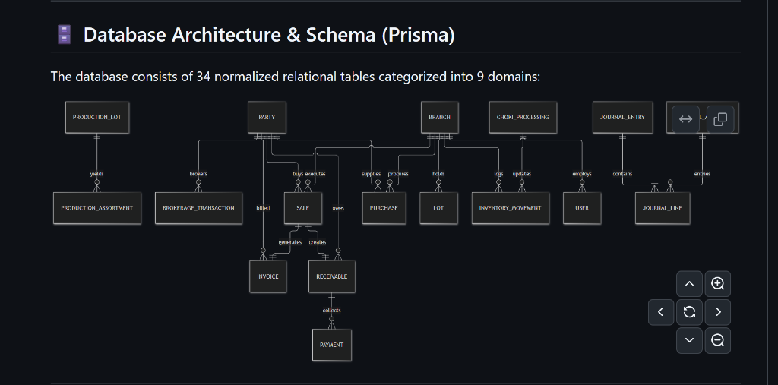
Figure 1: Core Entity-Relationship Diagram (34 Normalized Relational Tables Across 9 Domains)

The 9 Relational Database Domains

1. Multi-Branch & Identity Domain
• branches: Stores Surat factory and Mumbai trading units, address, GSTIN, active status.
• users: User accounts with secure password hashing, branch assignment, and role permissions.
• user_sessions: Tracks active user login sessions and authentication tokens.

2. Master Data Domain
• parties: Suppliers, buyers, and brokers with tax IDs, contact information, and account limits.
• partners: Business partners (capital holders) participating in firm drawings and profit sharing.
• products: Product master classifying ROUGH (કાચુ), PRINCESS (પ્રિન્સેસ), and CHOKI (ચોકી).

3. Diamond Procurement & Purchase Domain
• purchases: Procurement transactions recording party, branch, date, dollar rate, terms, and total amount.
• purchase_items: Detailed rough lots procured under each purchase with carats, rate, and less discount.

4. Inventory & Lot Tracking Domain
• lots: Physical and digital diamond lots with running available carat balance and status.
• lot_assortments: Detailed grade, color, clarity, and size breakdowns for each lot.
• inventory_movements: Immutable audit ledger of every carat inflow, outflow, and transfer.
• stock_adjustments: Periodic physical vault verification adjustments with management approval.

5. Manufacturing - Princess Kapan Domain
• production_lots: Kapan batches assigned rough kat weight, start date, target yield, and status.
• production_assortments: Polished output assortment categories obtained from the Kapan.
• production_worker_wages: Labour charges (Majuri) paid to cutters, polishers, and sorters.

6. Manufacturing - Choki Processing Domain
• choki_processings: Specialized processing batches for cleaved stones and side cuts.
• choki_movements: Carat transfers between rough rejection pool and choki inventory.

7. Sales, Invoicing & Dalali Domain
• sales: Polished and rough diamond sales contracts with buyer party, terms, and dollar rates.
• sale_items: Line items sold from specific inventory lots with carat weight and pricing.
• invoices: Official commercial invoices with GST, Less % factor, and payment due dates.
• brokerage_transactions: Accrued Dalali liabilities for brokers with status (UNPAID / PAID).

8. Receivables & Payments Domain
• receivables: Customer payment obligations tracked against invoices with live outstanding balances.
• payments: Payment receipts collected from buyers, updating invoice and receivable balances.

9. Financial Accounting & General Ledger Domain
• financial_accounts: Chart of Accounts categorized into Assets, Liabilities, Equity, Revenue, Expense.
• journal_entries: Double-entry balanced accounting transactions with date and reference.
• journal_lines: Individual Debit and Credit lines linking accounts to journal entries.
• cash_accounts: Physical cash drawers (Surat Cash and Mumbai Cash).
• cash_transactions: Daily Avak (receipts) and Javak (payments) for cash operations.
• bank_accounts: Current and overdraft bank accounts with account numbers and IFSC.
• bank_transactions: Bank inflows and outflows for RTGS, NEFT, Cheque, and deposits.
• partner_transactions: Partner Upad (drawings) and Jama (deposits) ledger entries.

5. Relational Transaction Flow & Workflow
Step 1 - Procurement: Rough diamond lot is purchased from a Party. System logs a Purchase, registers the new Lot in Inventory, and creates an Accounts Payable liability in the General Ledger.
Step 2 - Manufacturing Kat: The Surat factory consumes Kat Weight from the rough lot into a Production Kapan. System tracks sawing, shaping, and polishing stages.
Step 3 - Output & Reconciliation: Net Polished Output is yielded into Princess inventory. Manufacturing loss (Ghat) is recorded. Rejections are credited back into the rough stock pool, completing the mathematical Rough Reconciliation proof.
Step 4 - Sale Execution: The Mumbai trading office executes a Sale to a customer Party. System generates a Commercial Invoice applying the agreed 'Less %' trade discount.
Step 5 - Dalali Accrual: If an intermediary brokered the trade, Dalali commission is calculated and recorded as an automated liability.
Step 6 - Receivable Aging: The sale creates a Receivable tracked against the invoice date and credit terms, immediately appearing in aging buckets.
Step 7 - Settlement: Customer deposits payment via Bank or Cash. System credits Accounts Receivable, debits the Bank/Cash book, and updates the General Ledger trial balance.
— End of System Architecture Specification —
Shreenathji Diamond Management ERP | Surat & Mumbai Operations

