Digital Signature Mechanism

**Harsh Deswal 20BPS1145**

B.Tech CSE with CPS,Vellore Institute of Technology Chennai

***Abstract -* In today’s world every E-commerce, E-media, social media sites, etc are powered with some sort of security, authenticity and integrity mechanisms to ensure safe and secure communication between the sender and receiver. Digital signature is one amongst the cryptography mechanisms, which involves the digital signature signing by the sender and verified by the receiver.It provides the services like message authentication, key authentication It ensures the proper authentication and authorization of the message. The message will be delivered to the intended receiver only. This review paper presents a detailed overview about digital signature mechanism, advantages, disadvantages and its applications in today’s world.**

***Keyword— Cryptography, Digital - signature, public-key.***

**1. Introduction**

Digital signature involves the mathematics model which ensures the digital message or digital asset. A message's recipient has reason to agree, on the basis of a valid digital signature, that the message was made by means of an authorized sender and that it became authentic when it became sent, now unaffected by the journey's course. Digital signatures are often used in the distribution of software, the processing of financial transactions, and in other situations in which it is very important to detect instances of forgery or tampering. Internet use has grown ubiquitous in our day-to-day lives, making it an indispensable resource. In this context, the word "security" is quite significant. If a significant assault were to take place, key services including communication, commerce, and transaction would be disrupted.

A kind of encryption known as public key cryptography enables clients to communicate in a safe environment even if they do not have access to a secret key that has been previously disclosed. This is accomplished by using a set of cryptographic keys that are distinguished by their respective roles as public key and personal key. A public key may be thought of in the same way as an email address, and a private key can be thought of in the same way as the password for an email address. When we state that A encrypting the information, what A really does is run this file through a software programme that generates a hash function. The hash function software generates a fixed string of letters, numbers, and symbols for each and every record. The result of performing a hash on the data is referred to as the result in the hash. There will never be an instance in which the hash result for two separate documents will be identical. Any change, no matter how minute, made to the file will produce a hash that is completely different from the original. The result of a hash is that a certain message will always be generated by the programme using the same hash algorithm. The Digital signature Certificate contains, at its most fundamental level, the public key of the individual who has it, in addition to other features like contact information, and, perhaps most importantly, the digital signature of the Certifying Authority. The primary purpose of one of these is to disclose the fact that the data included in the Certificate have been confirmed by a reliable authority that was nominated and regulated by the government.

Algorithm flow-

1. Generate key
2. Sign the message at senders end
3. Verify the signature at the receiver end

**Advantages**

* Easy to implement, since it is just E-thumbprint (Electronic - Thumbprint).
* Sign the document electronically and the system will validate it quickly.
* A mathematics based code to authenticate the user and deliver the message to the intended receiver only.
* Implements the Public-key architecture, which ensures the high level of security which is difficult to crack.
* Makes manual paperwork automated.
* More standardization is made in E-signatures.

**2. Components of Digital Signature**

Digital signature works with following term:

**Hash-Function :** Often referred to simply as a "hash," a hash function is a series of numbers and characters of a certain length that is created by applying a mathematical procedure to a file of any size, for example an email, document, image, or other sort of data. A calculated hash is never reversed in order to locate additional files that may give the same hash value. The created string is exclusive to the file that is being hashed, and the function that generates the hash is a one-way process. To put it another way, a cryptographic hash feature should have the one-way property in addition to the collision-resistant attribute. A strong cryptographic value is applied to each of the aforementioned homes in order to determine whether or not the message that corresponds to it has been altered.

**Public-key cryptography:** A key pair system is used in the implementation of the cryptographic approach known as public key cryptography, which is also referred to as asymmetric encryption. The data is encrypted using only one key, which is referred to as the public key. The data may be decrypted using the other key, which is referred to as the private key. The confidentiality, integrity, and validity of data may all be protected by public key cryptography in a number of different ways.

**Public-key Infrastructure(PKI):** consists of the rules, protocols, laws, persons, and mechanisms that enable the distribution of the public keys as well as the identity verification of users with virtual certificates and a certificates authority.

**Certificate-Authority:** A Certificate Authority, often known as a CA, is a reliable institution that authenticates the identity of a person, organization, or piece of hardware by issuing digital certificates. These certificates may be used to either sign code or emails in order to verify the sender's validity. Secure connections (such as SSL/TLS) can also be established between a server and a client with the help of these certificates. A CA helps to guarantee that communication carried out over the internet is conducted in a secure manner by confirming the identities of the organizations involved.

**Digital-Certificate:** An authentication system is a piece of electronic documentation that verifies the identification of a person, organization, or piece of hardware by linking it to a public key. This process is carried out with the assistance of cryptography. It is possible to use it to create secure connections, verify the identity of the user, sign code and mails, and protect the integrity of information. It is issued by a reputable third party known as a Certification Authority (CA), and it is possible to use it in these ways. Digital certificates are put to use in a wide variety of contexts, including the SSL/TLS encryption of websites, the signing of code and documents, the signing of emails, and so on.

**3. Working**

A digital certificate is a numerical method that may be used to authenticate the genuineness of a computer resource or communication. This technique can also ensure that the document or message remains intact. The following procedures are frequently included during the process:

1. The sender is responsible for generating a document or document and determining a hash, which is a one-of-a-kind representation of the data.
2. After that, the sender uses their own private key to encrypt the hash in order to generate the digital signature.
3. The receiver will get both the document that has been physically signed and the digital signature.
4. Decryption of the unique identifier and generation of a hash of the data that was received both need the receiver to utilize the sender's public key.
5. In order to validate the genuineness of the information or document, the receiver validates it by comparing the hash that they have received to the hash that they have generated.

Only the recipient's sensitive information could have encoded the hash to start producing the digital signature, so if the two cryptographic hash match, the receiver can be convinced that the text or document hasn't been altered during transfer and that it originated from the sender. This is because only the sender's password vault could have produced the digital signature.

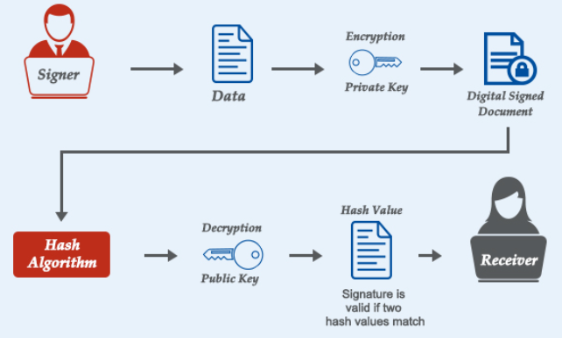

Fig. 1 . Process of Digital Signature

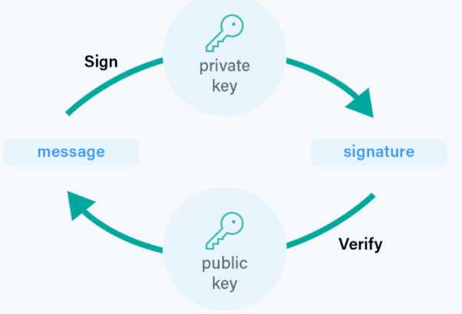

Fig. 2 . Workflow of Digital signature

**4. Scope of improvement**

The following are some areas in which digital signatures have need for improvement:

1. User experience shows that many users still find the process of establishing and validating digital signatures to be difficult to understand. Increasing adoption may be possible if the usability and customer experience are improved.
2. Integration with Mobile Devices and the Cloud Digital signatures are most often utilized on desktop computers at this time. Increasing the degree to which these services can integrate with mobile and cloud computing might make them accessible to a wider audience.
3. Compatibility: Digital certificates from various sources aren't always compatible with one another due to issues with interoperability. The use of digital signatures by companies would be facilitated by increased compatibility across the various signature systems now in use.
4. Authentication: If the public key that is used to validate the digital signature is not legitimate, then it is very easy to fake digital signatures. Digital signatures may provide a higher level of protection if the procedures used to validate public keys were made more robust.
5. Integration of Blockchain Technology: Integrating blockchain technology with digital signatures may be able to increase security while also lowering the cost and amount of time required to validate the legitimacy of signatures.

**5. Conclusion**

Signatures are a vital instrument for assuring the originality, consistency, and

confidentiality of digital communications. This may be accomplished via the use of digital signatures. They have already had a substantial influence in a number of sectors, including the safety of online transactions, the transmission of ideas through email, and the signing of computer programmes. However, there is still space for development in a variety of areas, including user experience, integration of mobile and cloud technologies, compatibility, authentication, and regulation.

**6.References**

* https://www.ijircst.org/DOC/7-a-comprehensive-study-on-digital-signature.pdf
* https://www.researchgate.net/publication/233391380_A_survey_on_digital_signatures_and_its_applications
* https://www.techtarget.com/searchsecurity/definition/digital-signature
* https://www.thesslstore.com/blog/how-do-digital-signatures-work-a-look-at-how-a-pki-signature-works/