Software Architecture and Design Specification
Hospital Management System
Version 1.0
Authors: Harsh Raj (PES2UG24CS184), Dasari Vinay (PES2UG24CS145), Diya J Marar (PES2UG24CS162), Chris Khushnam (PES2UG24CS139)
Date: 14-09-2026
Status: Draft

Team Member | USN
Harsh Raj | PES2UG24CS184
Dasari Vinay | PES2UG24CS145
Diya J Marar | PES2UG24CS162
Chris Khushnam | PES2UG24CS139

Revision History
Version | Date | Author | Change Summary | Approval
1.0 | 14-09-2026 | Team 2 | Initial SAD prepared from submitted HMS SRS

Approvals
Role | Name | Signature / Date
QA Lead | HARSH RAJ | HARSH RAJ
Test Engineer | DIYA J MARAR | DIYA J MARAR
Developer | DASARI VINAY | DASARI VINAY
Product Owner | CHRIS KHUSHNAM | CHRIS KHUSHNAM

Table of Contents
1. Introduction
2. Document Overview
3. Architecture
4. Design
5. Architecture Decision Records
6. Threat Model and Security Considerations
7. Open Issues and Next Steps
8. Appendices

1. Introduction

1.1 Purpose
This Software Architecture and Design (SAD) document defines the proposed architecture, major components, interfaces, design decisions, security considerations and key interaction flows of the Hospital Management System (HMS). It is derived from the team's submitted Software Requirements Specification (SRS).

1.2 Scope
The HMS is a standalone desktop/console-based C/C++ application for a single hospital or clinic. The submitted SRS covers patient registration and medical records, appointment scheduling, doctor/staff management and consultation, billing and payments, basic pharmacy/laboratory record-keeping, and administration/reporting. External insurance systems, national health-record registries and full ERP functions such as HR/payroll and procurement are outside scope.

1.3 Audience
The intended audience is the development team, QA/testers, hospital administrators, reception/billing staff, doctors/nurses, lab/pharmacy staff and assessment evaluators.

1.4 Definitions and Acronyms
Term | Meaning
HMS | Hospital Management System
UHID | Unique Hospital/Health ID
EMR | Electronic Medical Record
OPD | Out-Patient Department
IPD | In-Patient Department
UI | User Interface
API | Application Programming Interface
RBAC | Role-Based Access Control
DB | Database
PII | Personally Identifiable Information

2. Document Overview

2.1 Design Basis
The architecture is based on the submitted SRS, which specifies a menu-driven console interface (or simple desktop GUI if implemented), C/C++ implementation, local or networked database support, and single-machine operation for the mini-project scope.

2.2 Major System Functions
- Patient registration, UHID generation, patient search and medical-record maintenance.
- Appointment booking, rescheduling, cancellation and appointment reminders.
- Doctor/staff profile management, doctor queue and consultation recording.
- Itemized billing, payment recording and receipt generation/export.
- Laboratory result entry and pharmacy dispensing/inventory update.
- Hospital master-data management and management-level summary reporting.

2.3 External Interfaces
- User interface: menu-driven console or simple desktop GUI.
- Hardware: standard PC keyboard/display; optional receipt printer; optional ID/barcode scanner is a future enhancement.
- Software: local file-based or lightweight relational database through C/C++ file I/O or a DB library.
- Reports/receipts: optional text or CSV export.
- Communications: single-machine operation for the mini-project; a client-server variant may use a defined local protocol such as sockets.

3. Architecture

3.1 Goals & Constraints
Architecture goals:
- Separate user-interface, business-logic and data/infrastructure responsibilities.
- Support the functional modules defined in the submitted SRS without unnecessary enterprise complexity.
- Protect patient medical information and PII through authentication, authorization and controlled data access.
- Allow modules to be tested and modified independently, supporting the maintainability requirement.
- Provide reliable patient registration, appointment booking and record retrieval during hospital operating hours.
Architecture constraints:
- Implementation language is restricted to C/C++.
- The project is limited by academic-semester time and team size.
- No paid third-party services are required.
- Deployment is single-hospital/single-site for the mini-project.
- The database may be local file-based or a lightweight relational database, depending on the final implementation.

3.2 Stakeholders & Concerns
Stakeholder / Role | Architecture Concern
Patient | Correct registration, appointments and access to permitted patient-facing functions
Receptionist | Fast registration, search and appointment operations
Doctor | Fast access to daily OPD queue, patient history and consultation recording
Lab / Pharmacy Staff | Correct result entry, prescription-linked dispensing and stock updates
Hospital Admin | Staff accounts, master data, reporting and oversight
Billing Staff | Correct bills, payments, balances and receipts
Developers | Modularity, documented interfaces and maintainability
QA / Evaluators | Testability, traceability and measurable quality requirements

3.3 Component (UML) Diagram
The following component architecture matches the functional scope in the submitted SRS. It uses a Presentation Layer, Business Logic Layer and Data/Cross-cutting Layer. The modules include authentication, patient, appointment, consultation, laboratory, pharmacy, billing/payment, and administration/reporting.
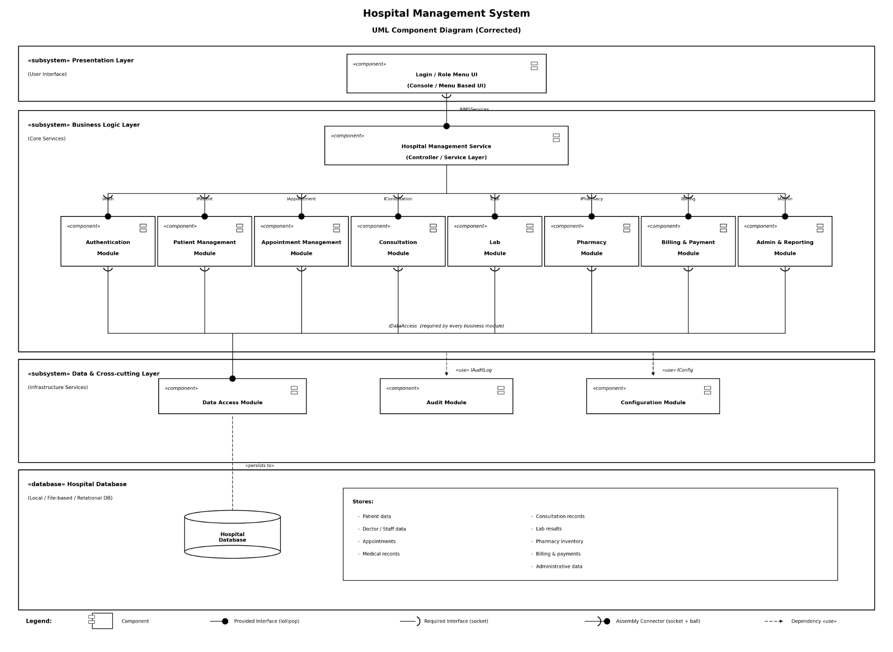
Figure 1. HMS UML Component Diagram. The database stores patient, doctor/staff, appointment, medical-record, consultation, laboratory, pharmacy, billing/payment and administrative data.

3.4 Component Descriptions
Component | Responsibility | Key SRS Coverage
Login / Role Menu UI | Presents role-specific menus, collects input, confirmations and errors. | External UI; all role-based functions
Authentication Module | Login, credential validation, RBAC and lockout handling. | HMS-SR-001 to HMS-SR-003
Patient Management Module | Registration, UHID, duplicate check, search and patient demographics. | HMS-F-001 to HMS-F-004
Appointment Management Module | Availability, booking, double-booking prevention, reschedule/cancel and reminders. | HMS-F-010 to HMS-F-013
Consultation Module | Doctor queue and consultation diagnosis, prescriptions and tests. | HMS-F-020 to HMS-F-023
Lab Module | Enter/update diagnostic results linked to patient visit/order. | HMS-F-040
Pharmacy Module | Check stock and dispense medicines against prescriptions. | HMS-F-041
Billing & Payment Module | Generate itemized bills, record payments and issue receipts. | HMS-F-030 to HMS-F-032
Admin & Reporting Module | Staff accounts, master data and summary reports. | HMS-F-023, HMS-F-050 to HMS-F-051
Data Access Module | Provides controlled persistence/retrieval for application modules. | Supports all persistent data
Audit Module | Records user ID, timestamp and action for required CRUD operations. | HMS-SR-004
Configuration Module | Stores configurable values such as appointment cancellation cutoff and thresholds. | Supports configurable SRS behavior

3.5 Chosen Architecture Pattern and Rationale
A layered architecture is selected. The Presentation Layer handles user interaction; the Business Logic Layer implements hospital workflows; and the Data/Cross-cutting Layer provides persistence, audit and configuration services. This is suitable for a small C/C++ application because it provides separation of concerns without the deployment and operational overhead of microservices.
- Presentation Layer: role menus, input validation, confirmations and result display.
- Business Logic Layer: authentication, patient, appointment, consultation, lab, pharmacy, billing and administration/reporting.
- Data & Cross-cutting Layer: data access, audit logging and configuration.
- Persistence: local file-based or lightweight relational database as permitted by the SRS.

3.6 Technology Stack & Data Stores
Area | Choice / Constraint
Language | C / C++
Application Type | Standalone desktop/console application
Operating Environment | Standard PC running Windows/Linux
UI | Menu-driven console; simple desktop GUI only if implemented
Persistence | Local file-based storage or lightweight relational database
Report Export | Text/CSV export where implemented
Hardware | Keyboard/display; optional receipt printer
External Services | No paid third-party services required

3.7 Architectural Risks & Mitigations
Risk | Impact | Mitigation
Unauthorized access | Exposure of medical records/PII | RBAC, authentication, lockout and audit logging
Double booking | Incorrect appointment schedule | Availability validation and transactional/atomic booking logic
Data corruption/loss | Loss of patient or billing records | Validation, controlled writes and regular backups
Module coupling | Changes break unrelated modules | Documented interfaces and layered/module boundaries
Performance degradation | Slow patient search/booking | Index/search optimization where supported; performance testing
Late defect discovery | Schedule impact | Unit and integration testing before system/UAT testing

3.8 Traceability to SRS Requirements
Req ID | Requirement / Design Responsibility | Module(s) | Test Ref
HMS-F-001 | Register patient | Patient Management | TC-Reg-01
HMS-F-002 | Generate unique UHID and prevent duplicate phone registration | Patient Management | TC-Reg-02
HMS-F-003 | Add/update medical history, allergies and medications | Patient + Audit | TC-Rec-01
HMS-F-004 | Search patient by ID/name/phone | Patient Management | TC-Rec-02
HMS-F-010 | Book doctor/department appointment | Appointment | TC-App-01
HMS-F-011 | Prevent double booking | Appointment + Data Access | TC-App-02
HMS-F-012 | Reschedule/cancel before configurable cutoff | Appointment + Configuration | TC-App-03
HMS-F-013 | Generate appointment reminder | Appointment + UI/Notification | TC-App-04
HMS-F-020 | Maintain doctor profile and availability | Consultation / Admin | TC-Doc-01
HMS-F-021 | Doctor views own daily/weekly OPD queue | Consultation + Auth | TC-Doc-02
HMS-F-022 | Record diagnosis, prescriptions and tests | Consultation | TC-Doc-03
HMS-F-023 | Admin manages staff accounts | Admin + Authentication + Audit | TC-Staff-01
HMS-F-030 | Generate itemized bill | Billing | TC-Bill-01
HMS-F-031 | Record payment and outstanding balance | Billing | TC-Bill-02
HMS-F-032 | Generate printable/exportable receipt | Billing | TC-Bill-03
HMS-F-040 | Record/update laboratory result | Lab | TC-Lab-01
HMS-F-041 | Dispense pharmacy items and decrement inventory | Pharmacy | TC-Pharm-01
HMS-F-050 | Manage departments, rooms/beds and doctor mapping | Admin | TC-Admin-01
HMS-F-051 | Generate summary reports | Admin & Reporting | TC-Rep-01
HMS-NF-001 | 90% of normal search/booking requests ≤ 3 seconds | UI/Core Modules | TC-Perf-01
HMS-NF-002 | ≥99% availability during 06:00–22:00 operating hours | System Operations | Ops log review
HMS-NF-003 | No plaintext storage/transmission of medical data/PII | Security/Data Access | TC-Sec-01
HMS-NF-004 | Independent documented C/C++ modules | Architecture/Interfaces | Code review checklist
HMS-NF-005 | New receptionist registration task ≤5 min after training | UI/Patient Module | TC-UX-01
HMS-SR-001 | RBAC by role | Authentication | TC-Sec-02
HMS-SR-002 | Unique staff credentials and salted password hash | Authentication | TC-Sec-03
HMS-SR-003 | Lock after 5 consecutive failed attempts | Authentication + Audit | TC-Sec-04
HMS-SR-004 | Audit create/update/delete on medical records and billing | Audit Module | TC-Sec-05
HMS-SR-005 | Restrict DB file access and encrypt sensitive fields at rest | Data Access | TC-Sec-06

3.9 Security Architecture
The submitted SRS defines three security objectives: confidentiality, integrity and availability. The architecture therefore uses authentication, RBAC, controlled persistence, audit logging and secure handling of sensitive fields.
Security Objective / Requirement | Architectural Control
Confidentiality | RBAC, authenticated access, protected storage, no plaintext PII/medical data
Integrity | Authorized write operations, validation, audit trail and controlled data access
Availability | Error handling, backups/recovery procedures and stable core workflows
HMS-SR-001 RBAC | Authentication module checks role before protected operations
HMS-SR-002 Password security | Salted password hashes; no plaintext passwords
HMS-SR-003 Account lockout | Authentication module tracks consecutive failures and cooldown
HMS-SR-004 Audit trail | Audit module records user ID, timestamp and action
HMS-SR-005 Data protection | Restrict DB/file access to application service context and encrypt sensitive fields at rest

4. Design

4.1 Design Overview
A user interacts through the role menu. The UI invokes the relevant business module. The business module validates the request, applies domain rules and calls the Data Access, Audit or Configuration services as needed. Persistent information is stored in the hospital database/file store. This design keeps business rules separate from storage and presentation concerns.

4.2 UML Sequence Diagrams

4.2.1 Appointment Booking
This flow verifies the patient/booking request, checks doctor availability, prevents an occupied slot from being booked, persists the appointment and displays confirmation.
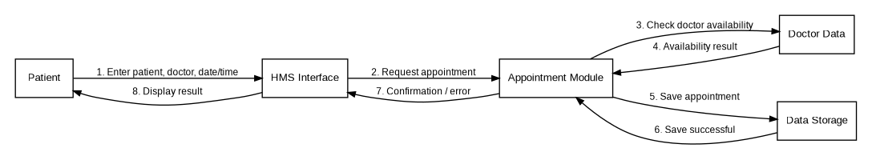
Figure 2. Sequence diagram — Appointment booking.

4.2.2 Patient Registration
This flow captures mandatory patient information, validates it, creates a unique patient record and returns the generated patient identifier.
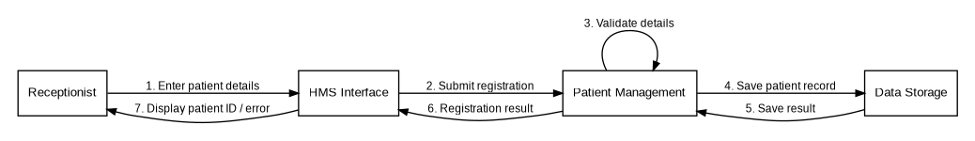
Figure 3. Sequence diagram — Patient registration.

4.3 Supporting UML Class Diagram
The following supporting class diagram shows the principal domain entities used by the system. It complements the component diagram by describing data-oriented classes and their relationships.
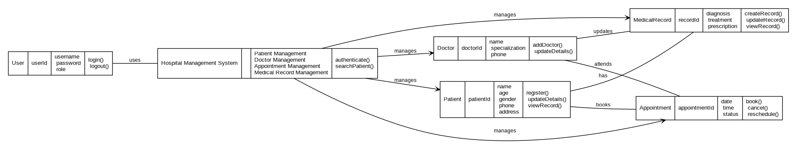
Figure 4. Supporting UML class diagram.

4.4 Module Interface / API Design
Because the mini-project is a C/C++ application rather than a required web service, the term API below refers to documented module/function interfaces. These interfaces separate business logic from callers and persistence.

4.4.1 Patient Management API
Function | Input | Output | Errors / Validation
registerPatient() | Name, age/DOB, gender, contact, address | UHID / success | Missing mandatory fields; duplicate phone
searchPatient() | UHID, name or phone | Matching patient record(s) | No match
updateMedicalRecord() | UHID + history/allergies/medications | Updated record | Patient not found; unauthorized role

4.4.2 Appointment Management API
Function | Input | Output | Errors / Validation
bookAppointment() | Patient ID, doctor/department, date/time | Appointment ID / confirmation | Invalid patient/doctor; unavailable slot
rescheduleAppointment() | Appointment ID + new slot | Updated appointment | Cutoff exceeded; slot unavailable
cancelAppointment() | Appointment ID | Cancellation status | Cutoff exceeded; appointment not found

4.5 Error Handling, Logging & Monitoring
- Validate all mandatory fields, IDs, dates, payment values and other input before changing data.
- Return meaningful errors such as 'Patient not found', 'Invalid credentials' and 'Appointment slot unavailable'.
- Use controlled failure handling so a failed write does not leave partially updated records.
- Log security-relevant events and required medical-record/billing CRUD actions through the Audit Module.
- Do not place passwords, full medical records or other sensitive PII in application/debug logs.
- Track performance and operational issues for patient search, appointment booking and critical workflows.

4.6 UX Design
- Use a simple role-based menu with clear numbered choices.
- Show confirmation prompts before data-changing operations.
- Use consistent input prompts and validation messages.
- Display the generated UHID/appointment/bill identifier after successful operations.
- Provide clear recovery instructions when an operation fails.
- Design the registration flow so a newly trained receptionist can complete registration within the SRS usability target.

4.7 Non-Functional Design Considerations
Quality Attribute | Design Response
Performance | Efficient patient search and appointment lookup; target 90th percentile ≤3s for normal load.
Reliability | Validation, controlled persistence, backups and error handling.
Availability | Keep registration, booking and record retrieval operational during stated hospital hours.
Security | RBAC, salted hashes, lockout, audit trail and protected sensitive storage.
Maintainability | Independent C/C++ modules with documented interfaces.
Usability | Role-based menus, confirmations, simple prompts and understandable errors.

5. Architecture Decision Records

ADR-001: Use Layered Architecture
Field | Decision
Status | Accepted
Context | The system contains UI, multiple business modules and persistent data.
Decision | Use Presentation, Business Logic, and Data/Cross-cutting layers.
Rationale | Separates responsibilities, improves testability and supports maintainability.
Alternatives | Monolithic unstructured design; microservices.
Consequences | Slight interface/plumbing overhead, but simpler maintenance and testing.

ADR-002: Use a Local / Lightweight Database
Field | Decision
Status | Accepted for mini-project scope
Context | The submitted SRS specifies a standalone single-site application and permits file-based or lightweight relational storage.
Decision | Use the team's selected local file-based or lightweight relational persistence mechanism.
Rationale | Fits the mini-project environment and avoids paid third-party dependencies.
Alternatives | Full enterprise DB/server deployment.
Consequences | Simpler deployment; future scaling may require migration to a stronger DB architecture.

ADR-003: Use C/C++ Modular Interfaces
Field | Decision
Status | Accepted
Context | The project brief restricts implementation to C/C++.
Decision | Organize functionality into independent C/C++ modules with documented interfaces.
Rationale | Directly satisfies the language constraint and supports HMS-NF-004 maintainability.
Alternatives | Other languages/frameworks are outside the project constraint.
Consequences | Requires disciplined module boundaries and interface documentation.

6. Threat Model and Security Considerations
A lightweight STRIDE-oriented threat model is used to identify threats relevant to patient data, staff accounts and transactional modules.
Threat | Example in HMS | Mitigation
Spoofing | Attacker attempts to use another staff account | Unique username/password, salted hashes, RBAC and lockout
Tampering | Unauthorized modification of medical/billing data | Authorization, validation, audit trail and controlled data access
Repudiation | User denies having changed a record | Audit log with user ID, timestamp and action
Information Disclosure | Unauthorized viewing of patient PII/medical data | RBAC, protected storage and no sensitive plaintext logging
Denial of Service | Repeated invalid requests or resource exhaustion | Input validation, lockout and robust error handling
Elevation of Privilege | Reception user attempts doctor/admin-only operation | Centralized role checks before protected operations

6.1 Security Verification Mapping
Security Requirement | Verification
HMS-SR-001 | Attempt out-of-role actions and verify denial plus audit entry.
HMS-SR-002 | Inspect credential storage and verify salted hashes; test password policy.
HMS-SR-003 | Perform five failed attempts and verify the next attempt is rejected during lockout.
HMS-SR-004 | Perform create/update/delete operations on records/billing and verify matching audit entries.
HMS-SR-005 | Review DB/file permissions and verify sensitive fields are protected at rest.

7. Open Issues and Next Steps
- Finalize the exact database technology/storage mechanism selected for implementation.
- Finalize the exact UI choice: console menu or simple desktop GUI.
- Implement all modules listed in the submitted SRS within the academic scope.
- Finalize the full requirements traceability matrix with actual test execution status.
- Add automated/unit tests where practical and complete integration/system testing.
- Validate performance against the SRS target under a representative test load.
- Verify all security requirements before final acceptance.
- Future enhancements outside the mini-project may include external integrations, mobile/web access, barcode scanning and richer notification mechanisms.

8. Appendices

8.1 Requirement Group Summary
Requirement Group | IDs | Primary Module(s)
Patient Registration & Records | HMS-F-001 to HMS-F-004 | Patient Management
Appointment Scheduling | HMS-F-010 to HMS-F-013 | Appointment Management
Doctor/Staff & Consultation | HMS-F-020 to HMS-F-023 | Consultation + Admin + Authentication
Billing & Payments | HMS-F-030 to HMS-F-032 | Billing & Payment
Pharmacy & Laboratory | HMS-F-040 to HMS-F-041 | Pharmacy + Lab
Administration & Reporting | HMS-F-050 to HMS-F-051 | Admin & Reporting
Non-functional Requirements | HMS-NF-001 to HMS-NF-005 | Cross-cutting
Security Requirements | HMS-SR-001 to HMS-SR-005 | Authentication + Audit + Data Access

8.2 Design-to-Test Reference
Design Area | Primary Test References
Patient registration | TC-Reg-01, TC-Reg-02
Patient records/search | TC-Rec-01, TC-Rec-02
Appointments | TC-App-01 to TC-App-04
Doctor/consultation | TC-Doc-01 to TC-Doc-03, TC-Staff-01
Billing | TC-Bill-01 to TC-Bill-03
Lab | TC-Lab-01
Pharmacy | TC-Pharm-01
Administration/reporting | TC-Admin-01, TC-Rep-01
Performance/usability | TC-Perf-01, TC-UX-01
Security | TC-Sec-01 to TC-Sec-06

8.3 References
- Team 2, Software Requirements Specification (SRS), Hospital Management System, Version 1.0, dated 03-09-2026.
- Team 2, Software Test Plan, Hospital Management System.
- Project UML models and design artefacts.

