**RESISTANCE COLOUR CODE**

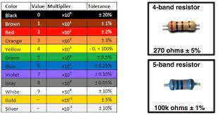

The colors of the resistance band rainbow are not just decorative. As you progress through your exercise/rehab, you will want to increase the resistance level of your exercise bands. The different colors of these exercise bands correlate to different resistance levels. A band’s resistance increases at the end of a move, so it’s important to use a band that will allow you to keep correct form through a full range of motion.

This Project is based on to calculate the Resistance Color Code as per the given specimen standards based on the C programming language and multifile processing system.