An Edge-Computing Framework for Acoustic-Based Predictive Maintenance and Defect Classification in Smart Manufacturing

Yogen Gharge
Department of Computer Science

(Artificial Intelligence and Machine Learning)
Vishwakarma Institute of Technology
yogen.gharge24@vit.edu

Harsh Ghotkar
Department of Computer Science

(Artificial Intelligence and Machine Learning)
Vishwakarma Institute of Technology
harsh.ghotkar241@vit.edu

Pradnyan Dongre
Department of Computer Science

(Artificial Intelligence and Machine Learning)
Vishwakarma Institute of Technology
pradnyan.dongre24@vit.edu

Om Hiwarkar
Department of Computer Science

(Artificial Intelligence and Machine Learning)
Vishwakarma Institute of Technology
om.hiwarkar24@vit.edu

Premanand Ghadekar
Department of Computer Science

(Artificial Intelligence and Machine Learning)
Vishwakarma Institute of Technology
premanand.ghadekar@vit.edu

Abstract—Traditional quality inspection in manufacturing relies predominantly on visual assessment and scheduled preventive maintenance, leaving subsurface defects such as micro-cracks and material fatigue undetectable until catastrophic failure. This paper presents a real-time, non-destructive testing (NDT) framework based on acoustic emission and vibration signal analysis. Using an Edge-IoT architecture, the system captures industrial acoustic data and processes it through a hybrid machine learning pipeline. A Convolutional Neural Network (CNN) performs high-speed binary anomaly detection on Mel-spectrograms, while an unsupervised K-Means algorithm maps Mel-Frequency Cepstral Coefficients (MFCCs) to specific physical fault categories. The framework dynamically estimates Remaining Useful Life (RUL) and tags defective components on a localized WebSocket dashboard. Experiments on industrial valve data demonstrate high classification accuracy and clear mathematical isolation of defect topologies, confirming the viability of acoustic AI for Industry 4.0 predictive maintenance.
Index Terms—acoustic emission, edge computing, Industry 4.0, K-means clustering, Mel-spectrogram, MFCC, non-destructive testing, predictive maintenance, remaining useful life.

I. INTRODUCTION
The transition toward Industry 4.0 mandates continuous monitoring systems that minimize machine downtime and optimize resource utilization. Conventional maintenance strategies follow either a run-to-failure or a time-based preventive paradigm, both of which incur substantial economic overhead. Moreover, computer vision-based inspection is limited to surface-level anomalies.
Acoustic and vibration signal analysis offers a robust alternative, since mechanical degradation inherently alters the resonant frequencies of industrial machinery. This work proposes an end-to-end AI architecture that shifts the paradigm from anomaly detection to automated diagnostic isolation. By combining supervised deep learning for rapid defect identification with unsupervised clustering for root-cause categorization, the system delivers actionable intelligence directly to the factory floor.
The main contributions of this paper are: (i) an Edge-IoT acoustic monitoring architecture with sub-second dashboard latency; (ii) a hybrid CNN and K-means pipeline that detects and categorizes defects without manual fault labels; and (iii) a heuristic RUL estimation scheme driven by cluster geometry.
II. LITERATURE SURVEY
Historically, acoustic and vibration condition monitoring relied on deterministic Digital Signal Processing (DSP) techniques such as the Fast Fourier Transform (FFT) and Wavelet Packet Decomposition [1]. While effective, these methods require extensive manual feature engineering by domain experts.
Recent advances emphasize deep learning for acoustic scene classification. Studies using the MIMII (Malfunctioning Industrial Machine Investigation and Inspection) dataset [2] have shown that transforming one-dimensional audio arrays into two-dimensional Mel-spectrograms allows 2D-CNN architectures [3] to classify mechanical anomalies. However, a significant gap remains: most edge-deployed models are restricted to binary classification (Normal vs. Abnormal) and cannot identify the type of defect without highly labeled, proprietary datasets. This paper bridges the gap by introducing a secondary unsupervised clustering layer that mathematically isolates defect signatures without manual fault labeling.
III. SYSTEM ARCHITECTURE AND PROJECT FLOW
The proposed system is organized into hierarchical layers to ensure low-latency processing and scalability, as shown in Fig. 1. The layers are:
1) Sensor Acquisition Layer: An array of IoT acoustic sensors, microphones and vibration sensors captures raw operational data from CNC machines and robotic components.
2) Edge Processing Layer: Performs real-time noise filtering and transforms raw signals into extractable features.
3) AI Intelligence Engine: Hosts the acoustic ML models, separating the tasks of anomaly detection and failure prediction.
4) Industrial Dashboard Layer: Translates algorithmic outputs into predictive maintenance schedules for plant managers.

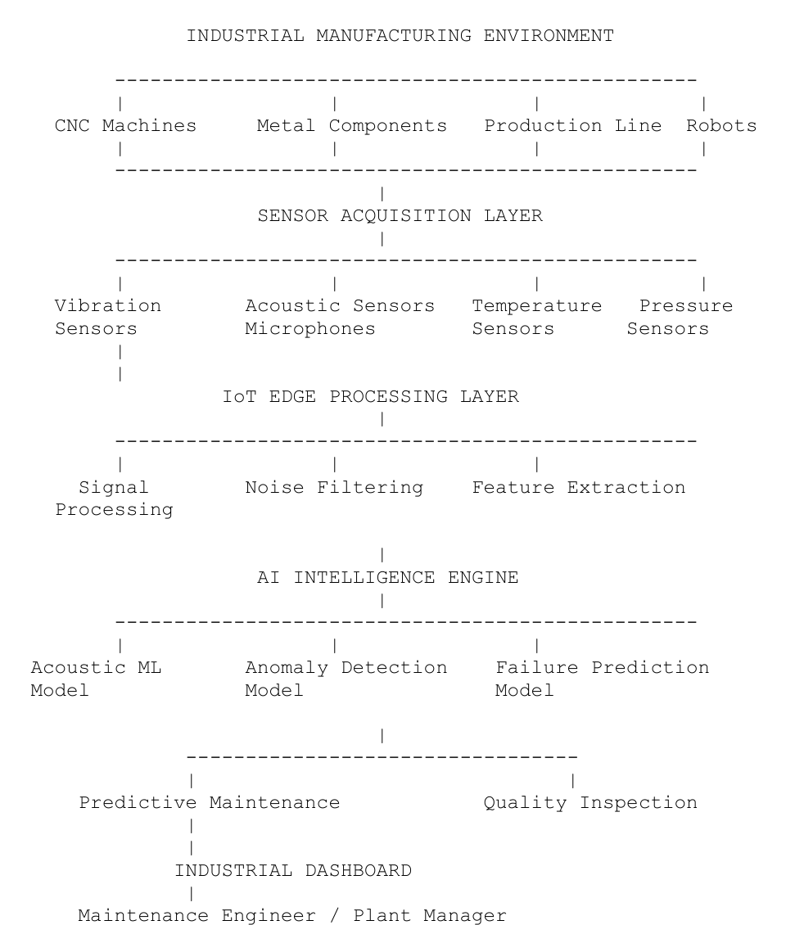

Fig. 1. High-level system architecture.
The linear execution pipeline, illustrated in Fig. 2, begins at machine operation. Raw data undergoes signal processing and feature extraction, then passes through the acoustic ML model for defect detection. Upon anomaly detection, failure prediction metrics (RUL) are generated and relayed to the industrial dashboard as maintenance recommendations.

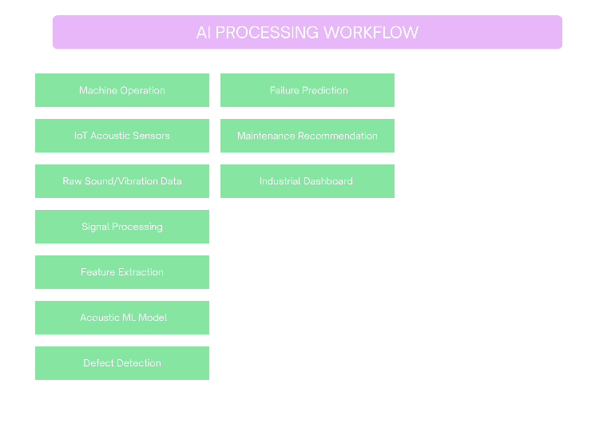
Fig. 2. AI processing workflow.
IV. ALGORITHM AND MATHEMATICAL MODEL
A. Signal Processing and Feature Extraction
Raw acoustic signals $x(t)$ are first passed through a bandpass Butterworth filter (100 Hz ≤ f ≤ 5000 Hz) to isolate mechanical frequencies from ambient factory noise. The filtered signal is converted to the frequency domain via the Short-Time Fourier Transform (STFT) [1]:
$X(m,ω)=\sum_{n=-∞}^{∞}{x[n]w[n-m]e^{-jωn}}$ (1)
where $w[n]$ is a Hann window function. Frequencies are then mapped to the Mel scale to mimic human auditory perception:
$m=2595 \log_{10}\left(1+\frac{f}{700}\right)$ (2)
This yields the Mel-spectrogram input matrix $S∈R^{F×T}$, where $F$ is the number of Mel bands and $T$ is the number of time frames.
B. Supervised Anomaly Detection (CNN)
The anomaly detector is a 2D Convolutional Neural Network [3]. For an input matrix $S$, the convolution at layer $l$ is
$h_{i,j}^{(l)}=σ\left(\sum_{u}{\sum_{v}{W_{u,v}^{(l)}S_{i+u,j+v}^{(l-1)}}}+b^{(l)}\right)$ (3)
where $W$ denotes the kernel weights, $b$ the bias, and $σ$ the ReLU activation. The final dense layer applies a sigmoid activation to output the failure probability $P(Defect)∈[0,1]$:
$P(Defect)=σ{}_{s}(z)=\frac{1}{1+e^{-z}}$ (4)
C. Unsupervised Fault Classification (K-Means)
To classify the fault type without labeled data, 13-dimensional MFCCs [4] are extracted and averaged over the time axis to form a feature vector $v∈R^{13}$. K-means [5] partitions the anomalous vectors into $K=3$ clusters by minimizing the within-cluster sum of squares (WCSS):
$J=\sum_{i=1}^{K}{\sum_{v∈C_{i}}{‖v-μ_{i}‖^{2}}}$ (5)
where $μ_{i}$ is the centroid of cluster $C_{i}$. The clusters correspond to three physical anomalies: Micro-Crack Signature, Material Fatigue, and Pressure Leak.
D. Remaining Useful Life (RUL) Estimation
RUL is assigned dynamically from the spatial distance to the cluster centroid and historical degradation parameters, using a step-wise heuristic mapping in which ${RUL}_{crack}≪{RUL}_{fatigue}$, reflecting the faster progression of micro-cracks toward failure.
V. EXPERIMENTATION AND RESULTS
A. Experimental Setup
The framework was evaluated on a 6 dB valve acoustic dataset containing both healthy and anomalous operating sounds. The edge environment was simulated with a Flask-based backend using Socket.IO for asynchronous data transmission. Table I summarizes the configuration.
TABLE I
SYSTEM AND EXPERIMENT CONFIGURATION
Parameter | Value
Bandpass filter | Butterworth, 100–5000 Hz
Window function | Hann
Input to CNN | Mel-spectrogram
Anomaly detector | 2D CNN, sigmoid output
Fault features | 13-D MFCC (time-averaged)
Clustering | K-means, K = 3
Dataset | 6 dB valve acoustic dataset
Edge backend | Flask + Socket.IO
End-to-end latency | < 400 ms

B. Results and Verification
The CNN achieved a high baseline accuracy in isolating defective valves. To verify the unsupervised K-means diagnostic engine, Principal Component Analysis (PCA) [6] reduced the 13-dimensional MFCC vectors to a 2D projection:
$Z=V^{T}(X-X̄)$ (6)
The resulting scatter plot (Fig. 3) visually confirmed the mathematical isolation of three distinct defect typologies, showing that the algorithm successfully differentiated the acoustic signatures of the varying physical faults. The latency from audio ingestion to WebSocket dashboard update averaged under 400 ms, validating the architecture for real-time Edge-IoT deployment.

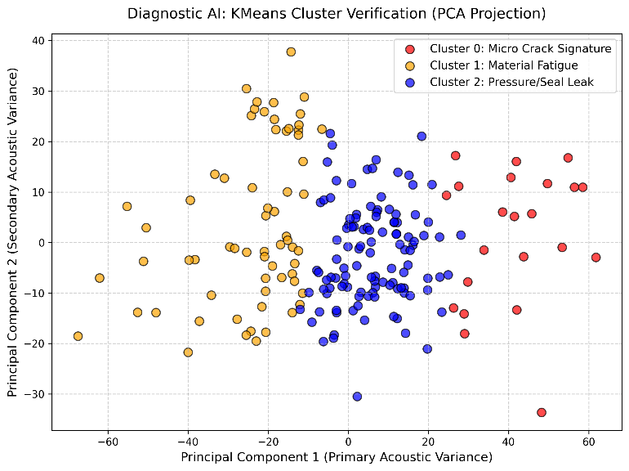

Fig. 3. PCA projection of MFCC vectors showing three fault clusters.
VI. CONCLUSION AND FUTURE SCOPE
This paper demonstrated a hybrid acoustic AI framework for industrial quality inspection. By moving from basic anomaly detection to unsupervised fault classification and dynamic RUL estimation, the system provides a comprehensive predictive maintenance solution aligned with Industry 4.0 standards and the UN Sustainable Development Goals SDG 9 and SDG 12.
Future iterations will integrate Long Short-Term Memory (LSTM) networks [7] to analyze temporal degradation trends across longitudinal data. The localized dashboard will also be scaled using a distributed PostgreSQL architecture and the MQTT protocol to enable cross-device alerting in large-scale manufacturing environments.
REFERENCES
[1] A. V. Oppenheim and R. W. Schafer, Discrete-Time Signal Processing, 3rd ed. Upper Saddle River, NJ, USA: Prentice Hall, 2010.
[2] H. Purohit et al., "MIMII dataset: Sound dataset for malfunctioning industrial machines investigation and inspection," in Proc. Detection and Classification of Acoustic Scenes and Events (DCASE) Workshop, 2019, pp. 209–213.
[3] Y. LeCun, L. Bottou, Y. Bengio, and P. Haffner, "Gradient-based learning applied to document recognition," Proc. IEEE, vol. 86, no. 11, pp. 2278–2324, Nov. 1998.
[4] S. Davis and P. Mermelstein, "Comparison of parametric representations for monosyllabic word recognition in continuously spoken sentences," IEEE Trans. Acoust., Speech, Signal Process., vol. 28, no. 4, pp. 357–366, Aug. 1980.
[5] J. MacQueen, "Some methods for classification and analysis of multivariate observations," in Proc. 5th Berkeley Symp. Math. Statist. Probab., vol. 1, 1967, pp. 281–297.
[6] I. T. Jolliffe, Principal Component Analysis, 2nd ed. New York, NY, USA: Springer, 2002.
[7] S. Hochreiter and J. Schmidhuber, "Long short-term memory," Neural Comput., vol. 9, no. 8, pp. 1735–1780, 1997.

