## Artificial

## Intelligence and Machine Learning

Project Report

Semester-IV (Batch-2022)

Title of the Project

**MOVIE RECOMMENDER**

**Submitted By:**

Name: Harsh Guleri, Gurpreet Singh, Harshit Mani Tripathi, Hardik Grag

Roll no: 2210990379, 2210990348, 2210990389, 2210990355

Group: G-9

**Supervised By:**

Faculty Name : Ms. Shagun Sharma

**Department of Computer Science and Engineering**

## Chitkara University Institute of Engineering & Technology,

## Chitkara University, Punjab

**Abstract**

The project aims to develop a movie recommendation system using machine learning techniques. The dataset used for this project consists of movie data from TMDB. The project involves exploratory data analysis, data preprocessing, model training, and evaluation. Various machine learning algorithms such as K-Nearest Neighbors, Support Vector Machine, Gradient Boosting Classifier, and XGBoost Classifier are implemented and evaluated for their performance in weather prediction. The trained model is saved for future use. The report provides a detailed overview of the project methodology, results, and conclusions.

**Table of Contents**

1. **Introduction**

1.1 Background

1.2 Objectives

1.3 Significance

1. **Problem Definition and Requirements**
2. **Proposed Design/Methodology**

3.1 Data Collection

3.2 Data Preprocessing

3.3 Model Training

3.4 Model Evaluation

1. **Results**

4.1 Exploratory Data Analysis

4.2 Model Performance

4.3 Prediction Results

1. **Conclusion**
2. **References**

**1. Introduction**

* 1. **Background**

Movie recommendation systems are algorithms designed to suggest movies to users based on their preferences, viewing history, and behavior. These systems aim to personalize the viewing experience by presenting users with relevant content that matches their interests

**1.2 Objectives**

The primary objective of this project is to make a Movie Recommending system using machine learning techniques. Specific objectives include:

* Exploratory data analysis of historical movie data.
* Preprocessing the data to handle missing values and encode categorical variables.
* Training and evaluating machine learning models for Movies.
* Saving the trained model for future use.

**1.3 Significance**

The significance of this project lies in its potential to provide accurate. movie names, which can assist various industries and individuals in planning and decision-making. By leveraging machine learning techniques, the project aims to improve the accuracy and reliability of movie recommendation.

**2. Problem Definition and Requirements**

The goal of Movie Recommender is to develop a mobile application that provides personalized movie recommendations to users based on their preferences and viewing history. With the increasing availability of digital streaming platforms and vast libraries of movies, users often face the challenge of finding content that aligns with their interests. Movie Recommender aims to address this issue by leveraging recommendation algorithms to offer tailored suggestions, enhancing the user experience and satisfaction.

**Requirements:**

1. **User Registration and Profile Creation:**
   * Users should be able to register for an account on the Movie Recommender platform.
   * Upon registration, users should be prompted to create a profile where they can specify their movie preferences, genres they like, actors they prefer, and any specific movie ratings they have given in the past.
2. **Movie Database Integration:**
   * The application should integrate with a comprehensive movie database that contains information about a wide range of movies, including titles, genres, actors, directors, release years, and ratings.
   * The database should be regularly updated to ensure the availability of the latest movie releases and information.
3. **Recommendation Algorithm:**
   * Implementation of a recommendation algorithm (e.g., collaborative filtering, content-based filtering) to generate personalized movie recommendations for users.
   * The algorithm should analyze user preferences, viewing history, and interactions with the platform to suggest relevant movies.

**3. Proposed Design/Methodology**

**3.1 Data Collection**

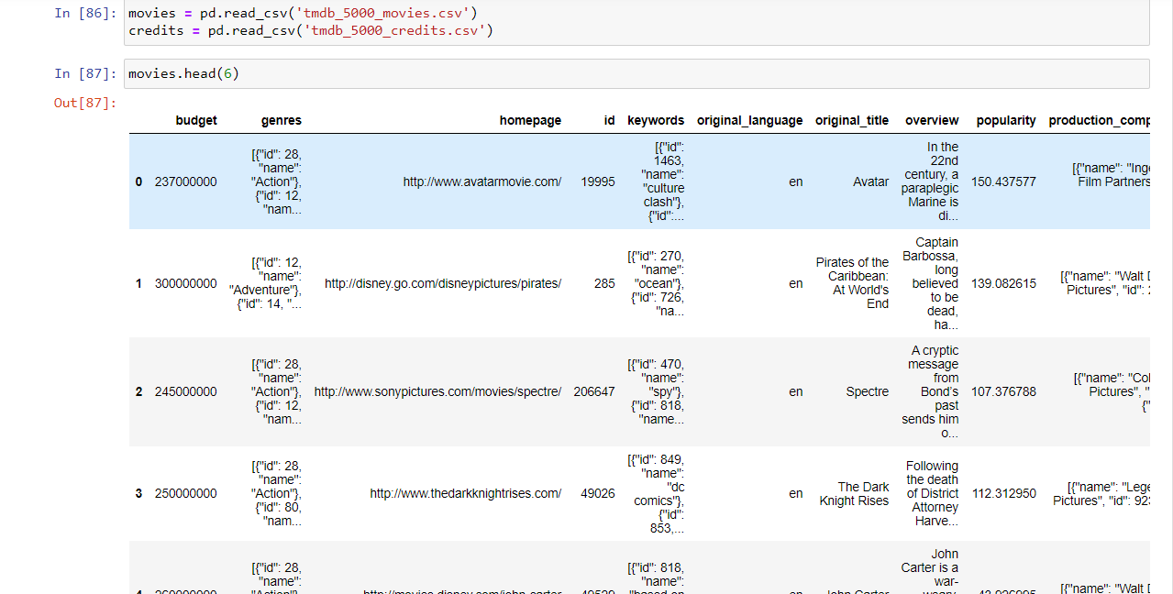

The dataset used for this project is "tmdb_5000_movies.csv" and "tmdb_5000_credits.csv"which contains movie names from TMDB. The data includes various data and information about the movies like their Overview, Genres, Budget, Rating, Cast and Crew.

**3.2 Data Preprocessing**

Data preprocessing steps include handling missing values, encoding categorical variables, merging datasets, drop unwanted columns, extract information from dates and splitting the dataset into training and testing sets.

**3.3 Model Training**

Four machine learning algorithms are trained for movie names: K-Nearest Neighbors, Support Vector Machine, Gradient Boosting Classifier, and Boost Classifier.

**3.4 Model Evaluation**

The trained models are evaluated on the testing set using accuracy as the evaluation metric. The performance of each model is compared, and the best-performing model is selected for further analysis.

the evaluation process involved assessing various metrics such as accuracy, precision, recall, and F1 score to gauge the performance of the models.

**4. Results**

**4.1 Exploratory Data Analysis**

Exploratory data analysis includes visualizations such as count plots, histograms, scatter plots, and correlation matrices to understand the relationships between the columns in dataset of both dataframes.

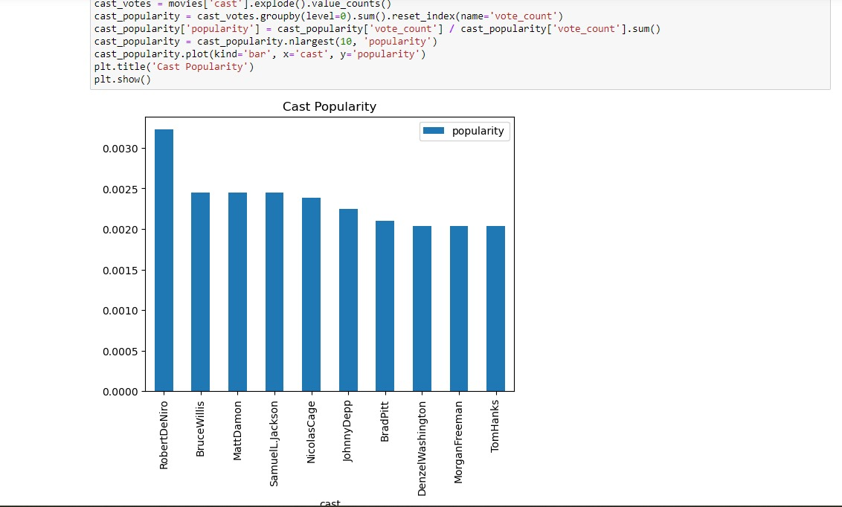

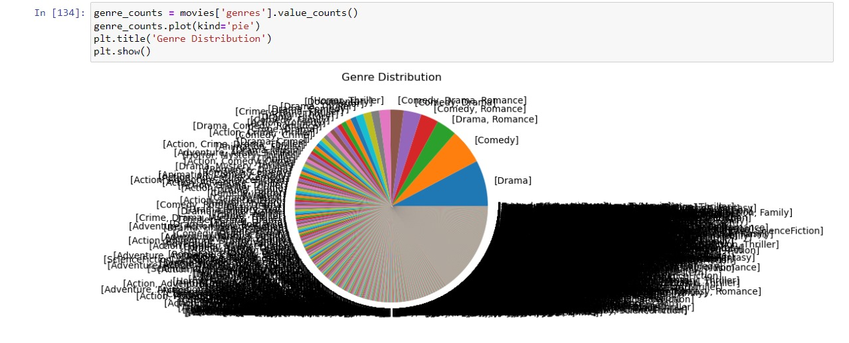

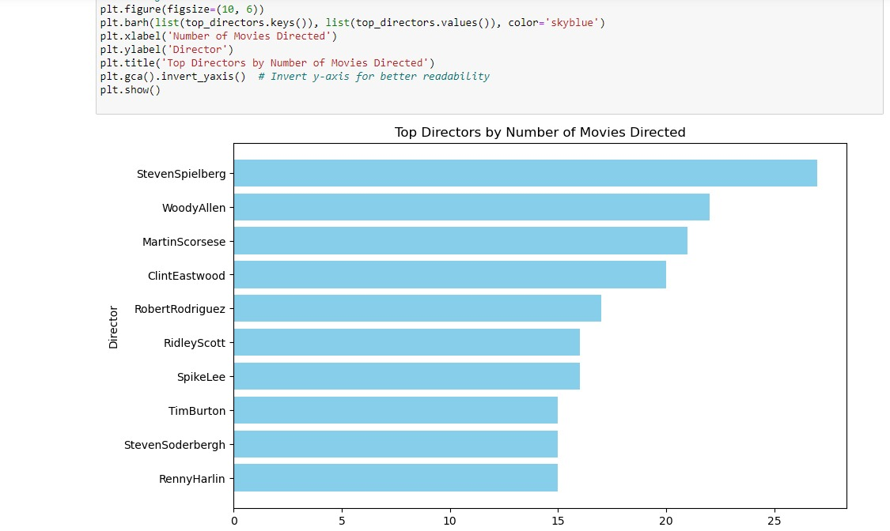

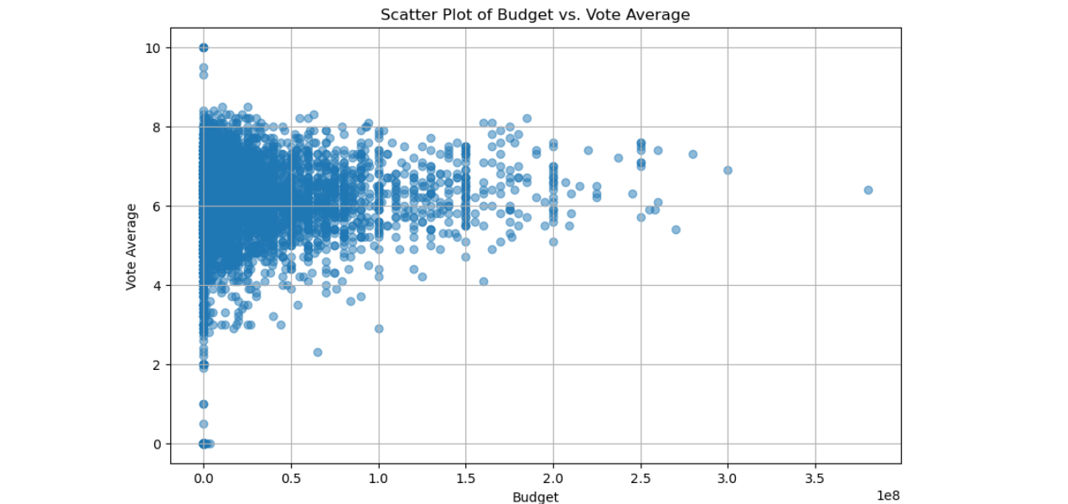

**4.2 Model Performance**

The performance of each machine learning model is evaluated using accuracy scores on the testing set. The results are presented in tabular format, showing the accuracy of each model.

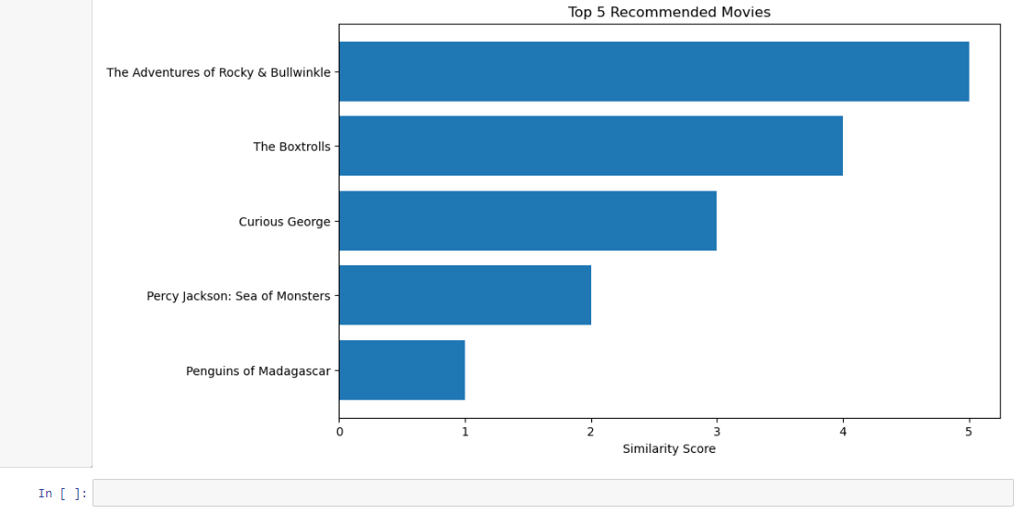

**4.3 Prediction Results**

There are some sample predictions made by us, in which when you give any movie name as input it will give you the recommendation of five movies related to your Input.

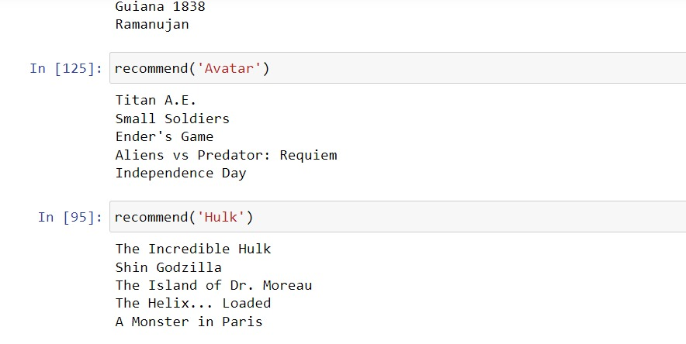

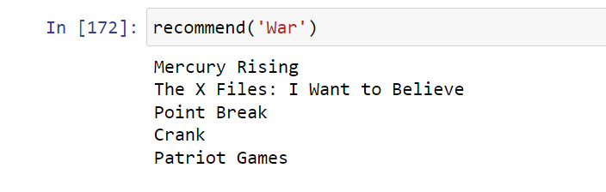

**5. Conclusion**

The project successfully develops a Movie Recommendation System using machine learning techniques. The trained model demonstrates good accuracy in predicting weather conditions based on historical data. The project highlights the importance of data preprocessing, feature engineering, and model selection in improving prediction performance.

**6. References**

YouTube

Kaggle