Practical - 7

Aim:
Implement a program for Recursive Descent Parser for the given grammar. E →T + E | T
T → F * T | F F→ id

Code

#include <iostream>

#include <string>

using namespace std;

string input;

size_t idx = 0;

char currentChar;

void parseE();

void parseT();

void parseF();

void match(char expectedChar);

int main() {

cout << "Enter the input string: ";

cin >> input;

idx = 0;

currentChar = input[idx];

try {

cout << "Parsing steps:" << endl;

parseE();

if (idx == input.length()) {

cout << "\nParsing successful." << endl;

} else {

cout << "\nError: Unexpected input after parsing." << endl;

}

} catch (const exception &e) {

cout << e.what() << endl;

}

return 0;

}

// E → T + E | T

void parseE() {

parseT();

if (currentChar == '+') {

cout << "E -> T + E" << endl;

match('+');

parseE();

}

}

// T → F * T | F

void parseT() {

parseF();

if (currentChar == '*') {

cout << "T -> F * T" << endl;

match('*');

parseT();

}

}

// F → id

void parseF() {

if (currentChar == 'i') {

cout << "F -> id" << endl;

match('i');

match('d');

} else {

throw runtime_error("Error: Expected id but found '" + string(1, currentChar) + "'");

}

}

void match(char expectedChar) {

if (currentChar == expectedChar) {

idx++;

if (idx < input.length()) {

currentChar = input[idx];

}

} else {

throw runtime_error("Error: Expected '" + string(1, expectedChar) + "' but found '" + string(1, currentChar) + "'");

}

}

Output:
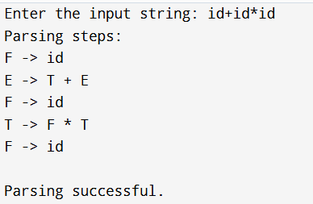

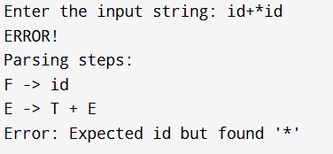

Conclusion:
In this practical I implemented a program for Recursive Descent Parser for the given grammar. This implementation handles basic arithmetic expressions involving identifiers, addition, and multiplication. I check different string which is parse or not from this parser.

