Ques 1: Simple HTML Document
<!DOCTYPE html>
<html lang="en">
<head>
<title> Simple HTML document </title>
</head>
<body>
<h1> Hello World! </h1>
<p> Hello</p>
<p> name</p>
</body>
</html>

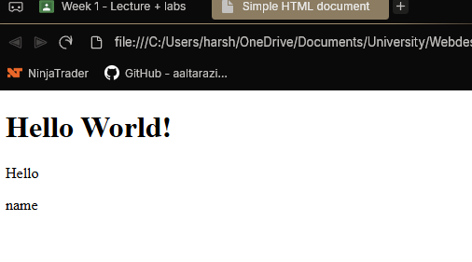
Ques 2: Specify headings for the contents
<!DOCTYPE html>
<html lang="en">
<head>
<meta charset="UTF-8">
<title>Example of HTML Heading tags </title>
</head>
<body>
<h1>Heading level 1 </h1>
<h2>Heading level 2</h2>
<h3>Heading level 3 </h3>
<h4>Heading level 4</h4>
<h5>Heading level 5 </h5>
<h6>Heading level 6</h6>
</body>
</html>

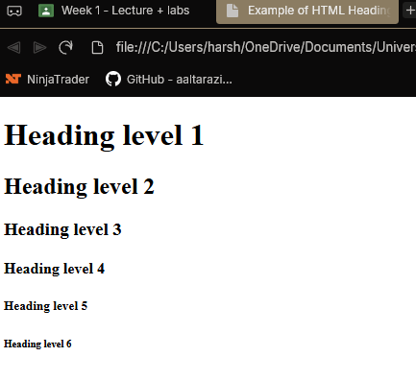
3. Insert Paragraphs
<!DOCTYPE html>
<html lang="en">
<meta charset="UTF-8">
<title> Example of HTML Paragraph </title>
<body>
<p> This is a paragraph </p>
<p> This is another paragraph </p>
</body>
</html>
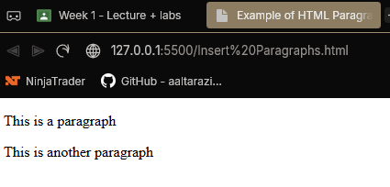

4. Creating links to other HTML documents or Web resources

