Experiment No. | 6
Aim | To Implement Single source shortest path
Name | Harsh Mukesh Jain
UID No. | 2021300048
Class & Division | SE Comps A ( C – Batch )
Date of Performance | 03-04-2023
Date of Submission | 10-04-2023

Theory/Experiment:

Dijkstra's Algorithm :
Dijkstra's algorithm allows us to find the shortest path between any two vertices of a graph.
It differs from the minimum spanning tree because the shortest distance between two vertices might not include all the vertices of the graph.

Djikstra used this property in the opposite direction i.e we overestimate the distance of each vertex from the starting vertex. Then we visit each node and its neighbors to find the shortest subpath to those neighbors.

The algorithm uses a greedy approach in the sense that we find the next best solution hoping that the end result is the best solution for the whole problem.

The very first step is to mark all nodes as unvisited, mark the picked starting node with a current distance of 0 and the rest nodes with infinity.
● Now, fix the starting node as the current node. For the current node, analyse all of its unvisited neighbours and measure their distances by adding the current distance of the current node to the weight of the edge that connects the neighbour node and current node
● Compare the recently measured distance with the current distance assigned to the neighbouring node and make it as the new current distance of the neighbouring node,
● After that, consider all of the unvisited neighbours of the current node, mark the current node as visited, If the destination node has been marked visited then stop, an algorithm has ended
● Else, choose the unvisited node that is marked with the least distance, fix it as the new current node, and repeat the process again from step 4.

Algorithm :
function Dijkstra(Graph, source):

for each vertex v in Graph.Vertices:
dist[v] ← INFINITY
prev[v] ← UNDEFINED
add v to Q
dist[source] ← 0

while Q is not empty:
u ← vertex in Q with min dist[u]
remove u from Q

for each neighbor v of u still in Q:
alt ← dist[u] + Graph.Edges(u, v)
if alt < dist[v]:
dist[v] ← alt
prev[v] ← u

return dist[], prev[]

Code :
#include <stdio.h>
#include <stdlib.h>
#include <limits.h>

void display(int vertex, int arr[][vertex]) {
printf("Displaying Graph:\n");
for(int i = 0; i < vertex; i++) {
for(int j = 0; j < vertex; j++) {
printf("%d\t", arr[i][j]);
}
printf("\n");
}
}
void displayAtInstant(int vertex,int *ans) {
printf("\n");
for(int i = 0; i < vertex; i++) {
if(ans[i] == INT_MAX) printf("inf\t");
else printf("%d\t",ans[i]);
}
printf("\n");
}
void checkShortest(int vertex, int Graph[][vertex], int *ans, int *flag, int i, int dist[][vertex]) {
int minIndex = -1;
for(int j = 0; j < vertex; j++) {
if(Graph[i][j] >= 1 && flag[j] == INT_MAX) {
if(ans[j] > ans[i] + dist[i][j]) {
ans[j] = ans[i] + dist[i][j];
minIndex = j;
}
}
}
if(minIndex != -1) flag[minIndex] = 0;
}
void shortestPath(int vertex, int Graph[][vertex], int dist[][vertex], int src) {
printf("\nisplaying Graph:\n");
display(vertex, Graph);
printf("\nDisplaying Distance between edges:\n");
display(vertex, dist);
int ans[vertex], minDist = INT_MAX, flag[vertex], i = src, j, minIndex;
for(int i = 0; i < vertex; i++) {
ans[i] = flag[i] = INT_MAX;
}
ans[src] = flag[src] = 0;
printf("\nShortest Minimum Index:%d\tMinimum Distance:%d",src,0);
displayAtInstant(vertex, ans);
for(int f = 0; f < vertex - 1; f++) {
for(j = 0; j < vertex; j++) {
if(Graph[i][j] >= 1 && flag[j] == INT_MAX) {
if(f == 0) {
ans[j] = dist[i][j];
if(minDist > ans[j]) {
minDist = ans[j];
minIndex = j;
}
}
else {
if(ans[j] > ans[i] + dist[i][j]) {
ans[j] = ans[i] + dist[i][j];
}

}
}
if(flag[j] == INT_MAX) {
if(minDist >= ans[j]) {
minDist = ans[j];
minIndex = j;
}
}
}
printf("\nShortest Minimum Index:%d\tMinimum Distance:%d",minIndex,minDist);
minDist = INT_MAX;
flag[minIndex] = 0;
displayAtInstant(vertex, ans);
// displayAtInstant(vertex, flag);
// for(j = 0; j < vertex; j++) {
// if(ans[j] == ans[minIndex] && flag[j] == INT_MAX) checkShortest(vertex,Graph,ans,flag,j,dist);
// }
i = minIndex;
}

}
int main()
{
int vertex = 5, edge = 10, v0, v1, distance, src;
printf("Enter number of vertex:");
scanf("%d",&vertex);
printf("Enter number of edges:");
scanf("%d",&edge);
int Graph[vertex][vertex];
int dist[vertex][vertex];

for(int i = 0; i < vertex; i++) {
for(int j = 0; j < vertex; j++) {
Graph[i][j] = 0;
dist[i][j] = 0;
}
}
printf("Assuming vertex starting from 0, 1, 2,...n\n");
char a, b;
for(int i = 0; i < edge; i++) {
printf("Enter edge from v0 to v1:");
scanf(" %c %c",&a, &b);
v0 = a - 65;
v1 = b - 65;
getchar();
Graph[v0][v1] = 1;

printf("Enter distance between %c and %c:",a,b);
scanf("%d",&distance);
dist[v0][v1] = distance;
}
getchar();
printf("Enter starting source:");
scanf("%c",&a);
src = a - 65;
shortestPath(vertex, Graph, dist, src);
return 0;
}

Output :

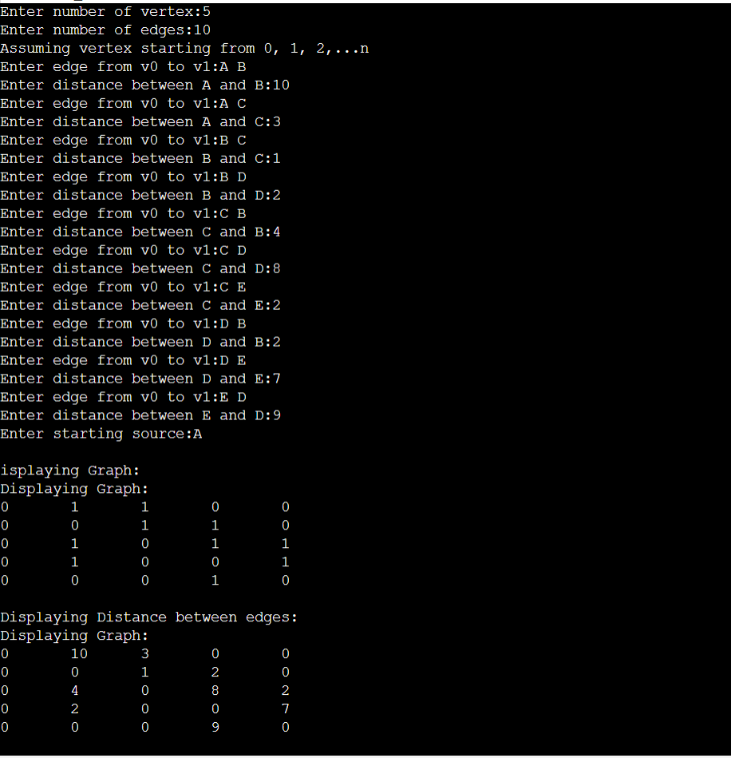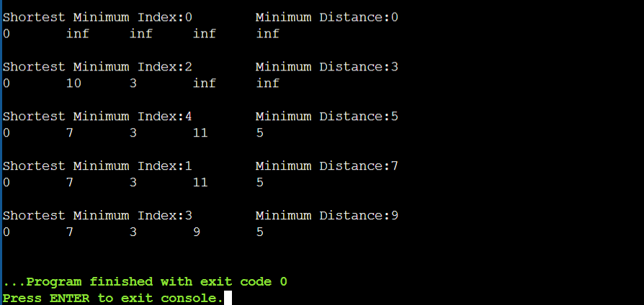

Running Time :
Bounds of the running time of Dijkstra’s algorithm on a graph with edges E and Vertices V can be expressed as a function of the number of edges, denoted, and the number of vertices, denoted, using Big-O notation. The complexity bound depends mainly on the data structure used to represent the set Q.
Time Complexity: O(E Log V)
where, E is the number of edges and V is the number of vertices.
Space Complexity: O(V)

CONCLUSION :
By performing this experiment, I was able to execute Dijkstra’s Algorithm by taking input as a Graph, representing it in the form of adjacency matrix and source node to find the shortest distance between each vertex and source node.

