

|  |  |  |  |  |  |  |  |  |  |  |  |
| --- | --- | --- | --- | --- | --- | --- | --- | --- | --- | --- | --- |
| 2014 POLY eRACING CAR  BMS Slave  Electrical Inputs/Outputs  Interface Control Document | | | | | | | | | | | |
| Responsible department:  <Power Electronics> | | | Document type:  Interface Control Document | | | | Confidentiality status:  Internal | | Document state:  In Preparation | | |
| **Prepared:** |  | Raphael Neveu | | |  |  | | | |  |  |
|  |  | System Responsible | | |  |  | | | |  | YYYY-MM-DD |
| **Verified:** |  | Simon Bellemare | | |  |  | | | |  |  |
|  |  | Director of Electrical Engineering | | |  |  | | | |  | YYYY-MM-DD |
|  | **Name / Title** | | |  | **Signature** | | | |  | **Date** |
| This document and its content is the property of Poly eRacing of Polytechnique Montréal.  2013. Poly eRacing, Polytechnique Montréal  www.eracing.polymtl.ca | | | | Document number:  ICD-0001 | | | | | | | |
| Effective:  <Date> | | | | Revision:  1.2 | | Language:  en | |

# Revision Log

|  |  |  |
| --- | --- | --- |
| **Revision** | **Date** | **Description of Changes** |
| 1.1 | 22 dec. 2013 | Pin out error corrected for temperature and voltage connector. |
| 1.2 | 2 jan. 2014 | Pin out changes for discharge connector.  MCU programmer connector changed.  Corrections in connector references to match with references in schematic and layout. |
|  |  |  |
|  |  |  |

Table of contents

Revision Log 2

List of figures 3

1. Introduction 4

1.1 Document Overview 4

1.2 Acronyms and definitions 4

2. References 4

3. System Components 5

3.1 Block Diagram, Schematic and/or PCB Layout 5

3.2 BMS Slave Inputs/Outputs 5

3.3 BMS Master Inputs/Outputs 9

3.4 Vtim Inputs/Outputs 10

# List of figures

Figure 1 : BMS Slave connection interfaces 5

Figure 2 : *X1* connections 8

Figure 3 : *X2* connections 8

Figure 4 : 3 x 2 pins jumper for *X4* 8

Figure 5 : Samtec IPL1 and IPD1 for *X3* 8

Figure 6 : Samtec IPD1 for *X1* and X*2* 8

Figure 7 : Samtec IPL1 for *X2* 8

Figure 8 : Samtec IPL1 for X*1* (right angle) 8

Figure 9 - TE Connectivity 6609208-4 for X01 10

# Introduction

## Document Overview

This document covers every connection interfaces of the BMS Slave circuit. It includes the pinout configuration of each connector, description of its functions and physical characteristics and limits.

## Acronyms and definitions

* **BMS** : Battery Management System, also known as Accumulator Management System (AMS)
* **CAN** : Controller Area Network (a communication protocol often used in automotive for communication between different modules (boards or systems))
* **MCU** : Micro controller
* **PCB** : Printed circuit board
* **LTC** :Refers to the LTC chip used in the circuit
* **SPI** : Serial Peripheral Interface (a communication protocol)
* **ICD** : Interface Control Document (this document)

# References

|  |  |  |
| --- | --- | --- |
| **Ref. #** | **Document ID** | **Description** |
| 1 | 2014_fsae_rules.pdf | Formula SAE Rules 2014 |
|  |  |  |
|  |  |  |
|  |  |  |

# System Components

## Block Diagram, Schematic and/or PCB Layout

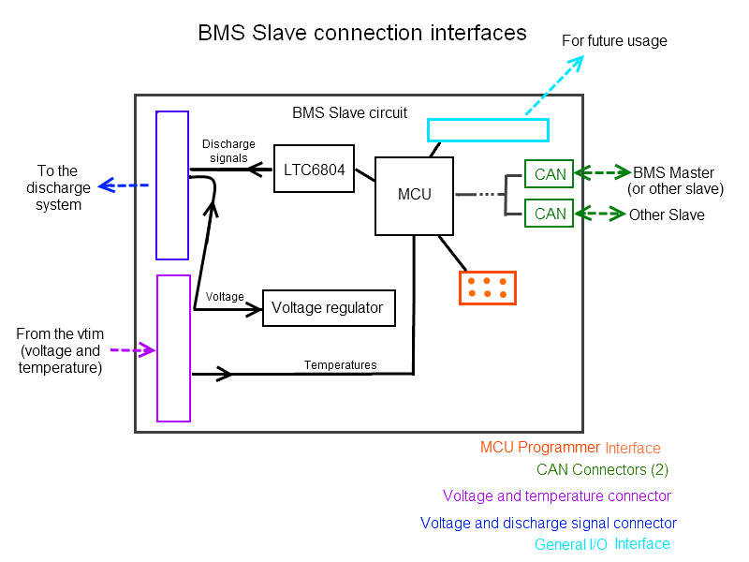

Figure 1 : BMS Slave connection interfaces

## BMS Slave Inputs/Outputs

List of necessary connectors:

***X1*** - 1 x 28 positions for **voltage** (14) and **discharge signal** output (12 or 14)

***X2*** - 1 x 28 positions for **voltage** (14) and **temperature** input (12)

***X3,X4*** - 2 x 6 positions (minimum) connectors for **CAN** (4 wires) and **shutdown signal** (2 wires)

***X5*** - 1 x 6 positions interface for **MCU programmer** (only used to program the MCU)

***X6*** - 1 x N positions **general inputs and outputs** interface

**Signal description**

**Temperatures (T0 to T11)**

T0 (thermistor signal of the last cell), T1, T2,…, T10, T11 (thermistor signal of the last cell, higher voltage).

**Voltage (V0 to V12)**

V0 (lower voltage of the battery pack, GND), V1, V2, …, V11, V12 (higher voltage of the pack)

**Discharge signal (S1 to S12)**

Outputs of the LTC6804 chip. These signals indicate which cell needs to be discharged.

***Discharge circuit plugged* signal**

This signal gives the possibility to the BMS Slave to see if the discharge circuit is plugged to the slave or not.

|  |  |  |  |  |
| --- | --- | --- | --- | --- |
| **Con-nector ref.** | **Destination** | **Description** | **Type of component** | **Pinout** |
| X1 | Discharge circuit | Brings the voltage and discharge signals (from LTC chip) to the discharge circuit. | Samtec  IPL1-116-01-L-D-K2 | Pin 21 to 32 : S1 to S21  Pin 4 to 16 : V0 to V12  Pin 1 and 10 : Tight to GND (V0)  Pin 16 : *Discharge circuit plugged* signal  Other : unused  (see figure 3) |
| X2 | Vtim board | Voltage and temperature inputs. | Samtec  IPL1-115-01-L-D-RA-K1 | Pin 4 to 15 : T0 to T11  Pin 18 to 30 : V0 to V12  Other : unused  (see figure 2) |
| X3,X4 | BMS Master / other BMS slave | Connectors used for CAN signals | IPL1-102-01-L-D-RA-K3 | Pin 1 : VCC (5V)  Pin 2 : GND  Pin 3 : CAN Low  Pin 4 : CAN High |
| X5 | Programmer | This connection is used to program the MCU with a specific programmer board | Harting 09185066324 | Pin 1: BKGD  Pin 2: GND (Ground)  Pin 3: -  Pin 4: Reset  Pin 5: -  Pin 6: VCC (Power) |
| X6 | General I/O | General I/O reserved | 4-array jumper | N/A |

1 Use with IPD1-15-D-K-M or MMSD (with wires)

2 Use with IPD1-16-D-K-M or MMSD (with wires)

3 Use with IPD1-02-D-K-M

4 Use with Samtec IDSD-03-D-XX.XX-T

**Notes**

**X1:** On the discharge circuit, pins 1 (GND) and 17 (*Discharge circuit plugged* signal) must be tight together.

**X2:** During the discharge, the current will be around 2.1 A. The connectors are rated for 3A and the circuit traces will be thick enough to support this current.

**X3, X4:** The VCC (pin 1) has two functions. It powers an isolated CAN transceiver (ISO1050) and is used as a shutdown signal for the slaves (VCC = 5V >> slaves are ON, VCC = 0V >> slaves are OFF). The current in the pin 1 varies a lot depending on the transmission. We can estimate the maximum current to about 100 mA.

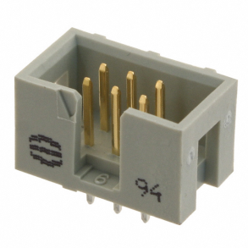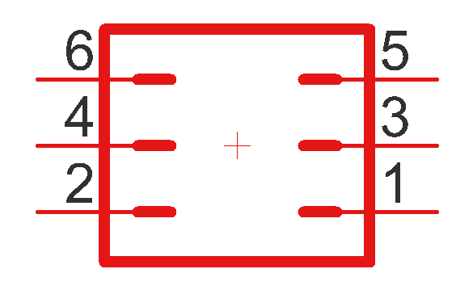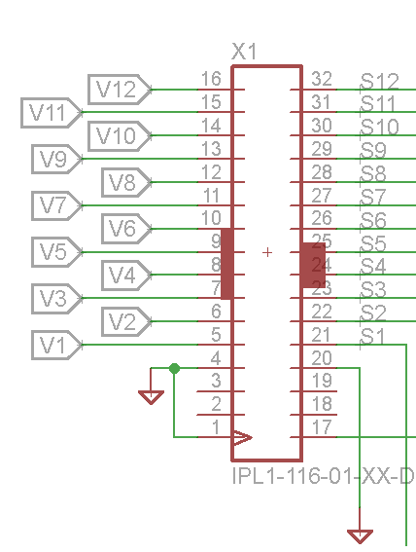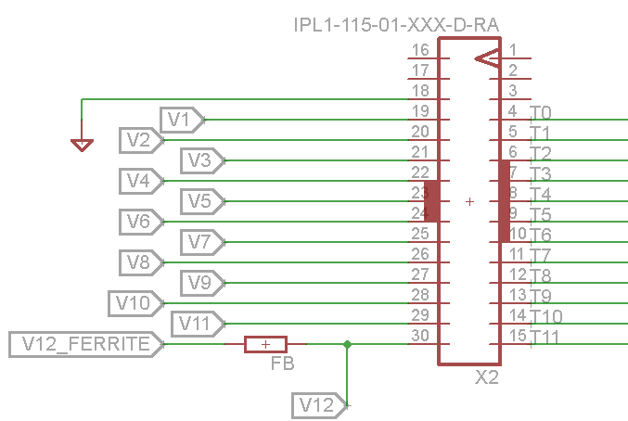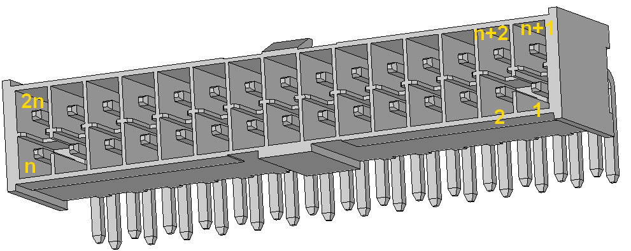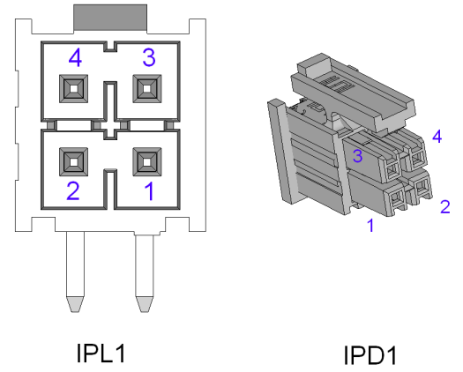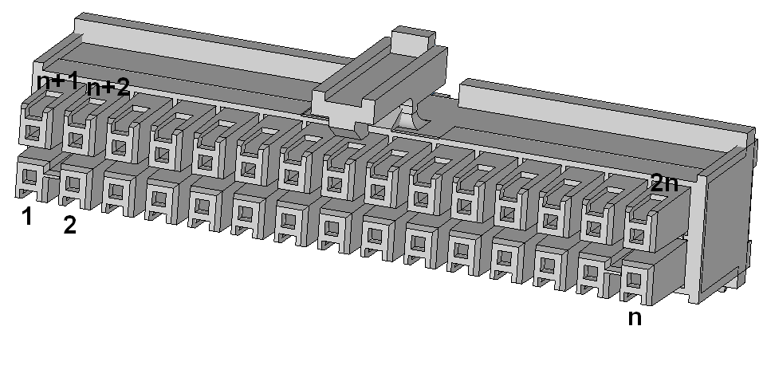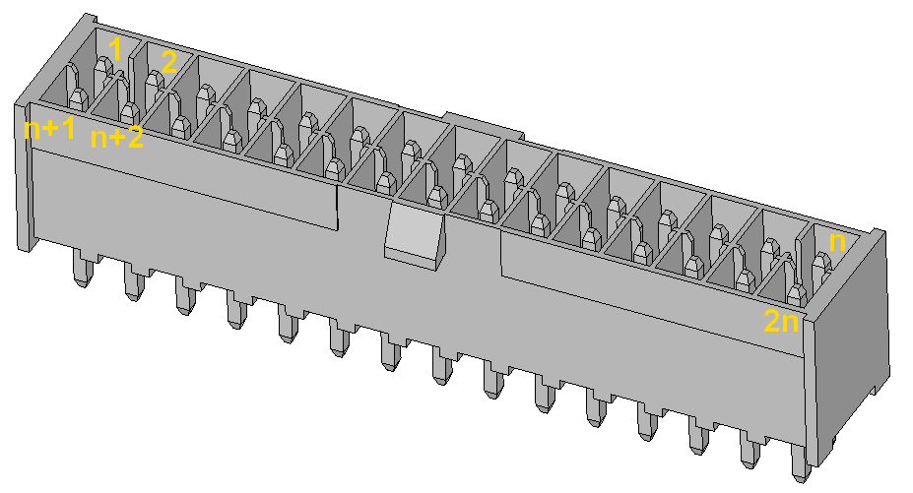

Figure 2 : Harting 09185066324 for *X5*

Figure 3 : *X2* connections

Figure 4 : *X1* connections

Figure 5 : Samtec IPL1 and IPD1 for *X3* and *X4*

Figure 6 : Samtec IPD1 for *X1* and X*2*

Figure 7 : Samtec IPL1 for *X1*

Figure 8 : Samtec IPL1 for X2 (right angle)

## BMS Master Inputs/Outputs

***Note :*** References in this section are proper only to this document. The connector reference in the circuit schematic and layout may not be the same.

In this section, only the relevant connectors of the BMS Master will be presented.

* CAN connector (*X01*)
* Shutdown signal interface (X0*1\**)

|  |  |  |  |
| --- | --- | --- | --- |
| **Connector Reference** | **Destination** | **Type of connector** | **Pinout** |
| X01 | CAN Bus | TE Connectivity 6609208-4 | Pin 1: -  Pin 2: Vcc* (Power) +5V (10 mA**)  Pin 3: CAN High +5V (< 1mA)  Pin 4: CAN Low 0V (<1mA)  Pin 5: GND* (Ground) 0V (10 mA**)  Pin 6: - |

***Note :*** *Pin 1 and 6 are unused*

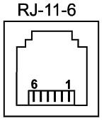

*These signals will also be used to power off the Slave automatically when the master is off.

** May be more (~ 50 mA) considering these pins will power an optoisolator and a isolated CAN Transceiver on each Slave circuit.

**Description:** CAN bus 2.0 information signal

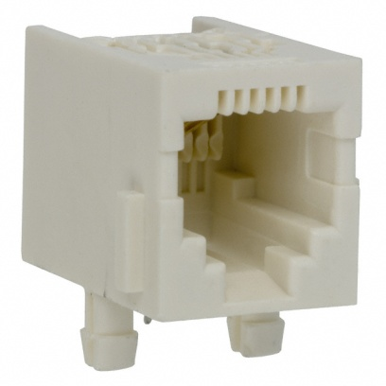

Figure 9 - TE Connectivity 6609208-4 for X01

## Vtim Inputs/Outputs

Refer to *X1* connector and connections in part 3.2. Use surface mount or trough hole version.