Coversheet
Formula SAE Electrical System Form Template for Electric Vehicles

For 2014 FSAE Electric, SAE International’s form may be different from international competitions however this form is produced in cooperation with Formula Student Germany.

The Coversheet has to contain the following:
- Heading “Electrical System Form FSAE-E2013”
- University and Team Name
- Car number
- Main Team Contact for ESF related questions
Feel free to add team logo, car picture, and the like.
Requirements (delete this section after you have read and understood it):
Read the document “How to pass ESF&FMEA” which is available at http://www.formulastudent.de/uploads/media/FSE2011_How_to_pass_ESF_FMEA_01.pdf
Maximum number of pages for the complete ESF is 100 pages!
Links to video or audio data are prohibited.
If you did not fill out the tables or if you changed the format of the ESF Template, you will fail by default.
Every single part/heading of the ESF Template must be filled with content. If the respective part is not relevant for your concept, describe shortly why not.
The table of contents must be hyperlinked.
The generated PDF must contain hyperlinked bookmarks (an example can be found in the FSAE Electric 2014 rules for example).
Use internal reference links. For example when describing wiring and mentioning a figure in the text then link it to the figure.
Do not just copy all of your datasheets in the appendix, e.g. we do not need to know what you have to do to program your motor controller; we do not need the whole user manuals of microcontrollers to review your ESF, etc.
Single pages/figures/tables extracted from the complete datasheet showing the important parameters, figures, etc. are usually sufficient, but the source/link to the complete datasheet has to be provided. If the datasheet describes more than one type, clearly mark in the datasheet to which type you are referring / which type you plan to use.
Datasheets should only be used as a reference. Please cover the important data in your text by using tables, figures, etc.
If you refer to parts of a data sheet, then you need to provide an internal document links from the text to the respective datasheet and another internal document link back from the datasheet to the text section.
For example a link in the motor controller section “The datasheet can be found here (clickable)” and a link above the motor controller datasheet in the appendix “The section covering the motor controller can be found here (clickable)”.
If you are unsure with respect to feedback of the reviewer, do not hesitate to write an e-mail and ask.
Parts of the ESF which are changed because of reviewer’s feedback have to be marked in red.
Following these guidelines will guarantee a swift review process.

Table of Contents

Table of Contents iii
I List of Figures vii
II List of Tables viii
III List of Abbreviations ix
1 System Overview 2
2 Electrical Systems 3
2.1 Shutdown Circuit 3
2.1.1 Description/concept 3
2.1.2 Wiring / additional circuitry 3
2.1.3 Position in car 4
2.2 IMD 4
2.2.1 Description (type, operation parameters) 4
2.2.2 Wiring/cables/connectors/ 4
2.2.3 Position in car 5
2.3 Inertia Switch 5
2.3.1 Description (type, operation parameters) 5
2.3.2 Wiring/cables/connectors/ 5
2.3.3 Position in car 5
2.4 Brake Plausibility Device 5
2.4.1 Description/additional circuitry 5
2.4.2 Wiring 6
2.4.3 Position in car/mechanical fastening/mechanical connection 6
2.4.4 Wiring/cables/connectors/ 6
2.4.5 Position in car 6
2.5 Reset / Latching for IMD and BMS 6
2.5.1 Description/circuitry 6
2.5.2 Wiring/cables/connectors 6
2.5.3 Position in car 6
2.6 Shutdown System Interlocks 7
2.6.1 Description/circuitry 7
2.6.2 Wiring/cables/connectors 7
2.6.3 Position in car 7
2.7 Tractive system active light 7
2.7.1 Description/circuitry 7
2.7.2 Wiring/cables/connectors 7
2.7.3 Position in car 8
2.8 Measurement points 8
2.8.1 Description 8
2.8.2 Wiring, connectors, cables 8
2.8.3 Position in car 8
2.9 Pre-Charge circuitry 8
2.9.1 Description 8
2.9.2 Wiring, cables, current calculations, connectors 8
2.9.3 Position in car 9
2.10 Discharge circuitry 9
2.10.1 Description 9
2.10.2 Wiring, cables, current calculations, connectors 9
2.10.3 Position in car 10
2.11 HV Disconnect (HVD) 10
2.11.1 Description 10
2.11.2 Wiring, cables, current calculations, connectors 10
2.11.3 Position in car 10
2.12 Ready-To-Drive-Sound (RTDS) 10
2.12.1 Description 10
2.12.2 Wiring, cables, current calculations, connectors 11
2.12.3 Position in car 11
3 Accumulator 12
3.1 Accumulator pack 1 12
3.1.1 Overview/description/parameters 12
3.1.2 Cell description 12
3.1.3 Cell configuration 13
3.1.4 Cell temperature monitoring 13
3.1.5 Accumulator insulation relays 13
3.1.6 Fusing 14
3.1.7 Battery management system 14
3.1.8 Accumulator indicator 15
3.1.9 Wiring, cables, current calculations, connectors 15
3.1.10 Charging 15
3.1.11 Mechanical Configuration/materials 16
3.1.12 Position in car 16
3.2 Accumulator pack 2 16
4 Energy meter mounting 17
4.1 Description 17
4.2 Wiring, cables, current calculations, connectors 17
4.3 Position in car 17
5 Motor controller 18
5.1 Motor controller 1 18
5.1.1 Description, type, operation parameters 18
5.1.2 Wiring, cables, current calculations, connectors 18
5.1.3 Position in car 19
5.2 Motor controller 2 19
6 Motors 20
6.1 Motor 1 20
6.1.1 Description, type, operating parameters 20
6.1.2 Wiring, cables, current calculations, connectors 20
6.1.3 Position in car 21
6.2 Motor 2 21
7 Torque encoder 22
7.1 Description/additional circuitry 22
7.2 Torque Encoder Plausibility Check 22
7.3 Wiring 22
7.4 Position in car/mechanical fastening/mechanical connection 22
8 Additional LV-parts interfering with the tractive system 23
8.1 LV part 1 23
8.1.1 Description 23
8.1.2 Wiring, cables, 23
8.1.3 Position in car 23
8.2 LV part 2 23
9 Overall Grounding Concept 24
9.1 Description of the Grounding Concept 24
9.2 Grounding Measurements 24
10 Firewall(s) 25
10.1 Firewall 1 25
10.1.1 Description/materials 25
10.1.2 Position in car 25
10.2 Firewall 2 25
11 Appendix 26

List of Figures

Has to be hyperlinked!

List of Tables
Table 1.1 General parameters 1
Table 2.1 List of switches in the shutdown circuit 2
Table 2.2 Wiring – Shutdown circuit 3
Table 2.3 Parameters of the IMD 3
Table 2.4 Parameters of the Inertia Switch 4
Table 7.1 Torque encoder data 5
Table 2.6 Parameters of the TSAL 6
Table 2.7 General data of the pre-charge resistor 7
Table 2.8 General data of the pre-charge relay 8
Table 2.9 General data of the discharge circuit 9
Table 3.1 Main accumulator parameters 10
Table 3.2 Main cell specification 11
Table 3.3 Basic AIR data 12
Table 3.4 Basic fuse data 12
Table 3.5 Wire data of company A, 0.205 mm² 13
Table 3.6 General charger data 14
Table 5.1 General motor controller data 16
Table 6.1 General motor data 18
Table 7.1 Torque encoder data 20
Table 7.1 Torque encoder data 21
Has to be hyperlinked!

List of Abbreviations

System Overview
- Short description of the system’s concept
- Rough Schematic (blocks) showing all parts affected with the electrical systems and function of the tractive-system
- No detailed wiring
- Additionally fill out the following table, replacing the values with your specifications:
Maximum Tractive-system voltage: | 600VDC
Nominal Tractive-system voltage: | 560VDC
Control-system voltage: | 12VDC, 24VDC
Accumulator configuration: | 200s3p
Total Accumulator capacity: | 200Ah
Motor type: | Permanent excitated synchronous motor
Number of motors: | Total 4, one per wheel
Maximum combined motor power in kW | 150
Table 1.1 General parameters

Electrical Systems

Shutdown Circuit

Description/concept
Describe your concept of the shutdown circuit, the master switches, shut down buttons, brake over travel switch, etc.
Additionally fill out the following table replacing the values with your specification and append additional switches from your setup:
Part | Function
Main Switch (for control and tractive-system; CSMS, TSMS) | Normally open
Brake over travel switch (BOTS) | Normally closed
Shutdown buttons (SDB) | Normally closed
Insulation Monitoring Device (IMD) | Normally open
Battery Management System (BMS) | Normally open
Inertia Switch | Normally closed
Interlocks | Closed when circuits are connected
Brake Panic Switch | Normally Closed
Table 2.2 List of switches in the shutdown circuit

Wiring / additional circuitry
Describe wiring and additional circuitry, show extra schematics for example if additional transistors etc. are used, also describe the function of additional circuitry and make good use of figures.
Additionally fill out and add information to the following table:
Total Number of AIRs: | 10
Current per AIR: | 0.5A
Additional parts consumption within the shutdown circuit: | 2A
Total current: | 7A
Cross sectional area of the wiring used: | 0.205 mm²
Table 2.3 Wiring – Shutdown circuit

Position in car
Provide CAD-renderings showing the relevant parts. Mark the parts in the renderings, if necessary.

IMD

Description (type, operation parameters)
Describe the IMD used and use a table for the common operation parameters, like supply voltage, temperature, etc. Also describe how the IMD indicator light is wired, etc.
Additionally fill out the following table replacing the values with your specification:
Supply voltage range: | 10..36VDC
Supply voltage | 24VDC
Environmental temperature range: | -40..105°C
Selftest interval: | Always at startup, then every 20 minutes
High voltage range: | DC 0..1000V
Set response value: | 300kΩ (500Ω/Volt)
Max. operation current: | 500mA
Approximate time to shut down at 50% of the response value: | 27s
Table 2.4 Parameters of the IMD

Wiring/cables/connectors/
Describe wiring, show schematics, describe connectors and cables used and show useful data regarding the wiring.

Position in car
Provide CAD-renderings showing the relevant parts. Mark the parts in the rendering, if necessary.

Inertia Switch

Description (type, operation parameters)
Describe the Inertia Switch used and use a table for the common operation parameters, like supply voltage, temperature, etc.
Additionally fill out the following table replacing the values with your specification:
Inertia Switch type: | Sensata XYZ
Supply voltage range: | 10..36VDC
Supply voltage: | 12VDC
Environmental temperature range: | -40..105°C
Max. operation current: | 500mA
Trigger characteristics: | 6g for 50ms / 11g for 15ms
Table 2.5 Parameters of the Inertia Switch

Wiring/cables/connectors/
Describe wiring, show schematics, describe connectors and cables used and show useful data regarding the wiring.

Position in car
Provide CAD-renderings showing the relevant parts. Mark the parts in the rendering, if necessary.

Brake Plausibility Device

Description/additional circuitry
Describe the how your electronic hardware brake plausibility system works (this is in addition to your ECU controlled brake plausibility software), provide tables with main operation parameters, and describe additional circuitry used to check or for an implausibility. Describe how the system reacts if an implausibility or error is detected.
Brake sensor used: | ABC Sensor
Torque encoder used: | potentiometer
Supply voltages: | 5V
Maximum supply currents: | 20mA
Operating temperature: | -20..180 °C
Output used to control AIRs: | Open a relay
Table 7.6 Torque encoder data

Wiring
Describe the wiring, show schematics including the circuit board, show data regarding the cables and connectors used.

Position in car/mechanical fastening/mechanical connection
Provide CAD-renderings showing all relevant parts and discuss the mechanical connection of the sensors to the pedal assembly. Mark the parts in the rendering, if necessary.

Wiring/cables/connectors/
Describe wiring, show schematics, describe connectors and cables used and show useful data regarding the wiring.

Position in car
Provide CAD-renderings showing the relevant parts. Mark the parts in the rendering, if necessary.

Reset / Latching for IMD and BMS

Description/circuitry
Describe the concept and circuitry of the latching/reset system for a tripped IMD or BMS.

Wiring/cables/connectors
Describe wiring, show schematics, describe connectors and cables used and show useful data regarding the wiring.

Position in car
Provide CAD-renderings showing the relevant parts. Mark the parts in the rendering, if necessary.

Shutdown System Interlocks

Description/circuitry
Describe the concept and circuitry of the Shutdown System Interlocks.

Wiring/cables/connectors
Describe wiring, show schematics, describe connectors and cables used and show useful data regarding the wiring.

Position in car
Provide CAD-renderings showing the relevant parts. Mark the parts in the rendering, if necessary.

Tractive system active light

Description/circuitry
Describe the tractive system active light and additional circuitry.
Additionally fill out the table:
Supply voltage: | 12VDC
Max. operational current: | 700mA
Lamp type | LED
Power consumption: | 4.5 W
Brightness | 100 Lumen
Frequency: | 1.5Hz
Size (length x height x width): | 20mm x 10mm x 50mm
Table 2.7 Parameters of the TSAL

Wiring/cables/connectors
Describe wiring, show schematics, describe connectors and cables used and show useful data regarding the wiring.

Position in car
Provide CAD-renderings showing the relevant parts. Mark the parts in the rendering, if necessary.

Measurement points

Description
Describe the housing used and how it can be accessed, etc.

Wiring, connectors, cables
Describe wiring, show schematics, and describe connectors and cables used and show useful data regarding the wiring.

Position in car
Provide CAD-renderings showing the relevant parts. Mark the parts in the rendering, if necessary.

Pre-Charge circuitry

Description
Describe your concept of the pre-charge circuitry.

Wiring, cables, current calculations, connectors
Describe wiring, show schematics, describe connectors and cables used and show useful data regarding the wiring.
- Give a plot “Percentage of Maximum Voltage” vs. time
- Give a plot Current vs. time
- For each plot, give the basic formula describing the plots
Additionally fill out the tables:
Resistor Type: | ABC Resistor
Resistance: | 680Ω
Continuous power rating: | 60W
Overload power rating: | 200W for 30 sec
Voltage rating: | 1500V
Cross-sectional area of the wire used: | 0.205 mm²
Table 2.8 General data of the pre-charge resistor

Relay Type: | DEF Relay
Contact arrangment: | SPDT, SPST, SPCO, SPTT, DPST, ….
Continuous DC current: | 25A
Voltage rating | 2000VDC
Cross-sectional area of the wire used: | 0.205 mm²
Table 2.9 General data of the pre-charge relay

Position in car
Provide CAD-renderings showing all relevant parts. Mark the parts in the rendering, if necessary.

Discharge circuitry

Description
Describe your concept of the discharge circuitry.

Wiring, cables, current calculations, connectors
Describe wiring, show schematics, describe connectors and cables used and show useful data regarding the wiring.
- Give a plot “Voltage” vs. time
- Give the formula describing this behavior
- Give a plot “Discharge current” vs. time
- Give the formula describing your plot
Additionally fill out the table:
Resistor Type: | ABC Resistor
Resistance: | 680Ω
Continuous power rating: | 350W
Overload power rating: | 600W for 20 sec
Voltage rating: | 1500V
Maximum expected current: | 0.7A
Average current: | 0.3A
Cross-sectional area of the wire used: | 0.205 mm²
Table 2.10 General data of the discharge circuit

Position in car
Provide CAD-renderings showing all relevant parts. Mark the parts in the rendering, if necessary.

HV Disconnect (HVD)
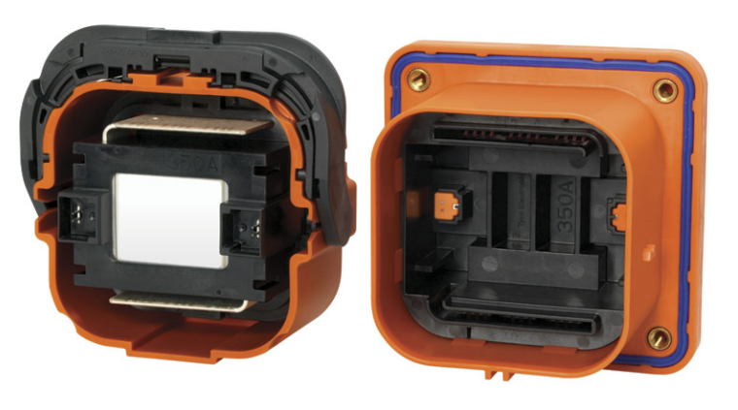
Figure 1 HVD

Description
To ensure maximum safety while servicing the car, the HV Disconnect (AMP+ Manual Service Disconnect ) is a split pack acting device that breaks the series paths of the cells’ battery pack. Since this connector does not require tools to get opened, it features an interlock which ensure the opening of the main contactors if the interlock is open.

Wiring, cables, current calculations, connectors
As our battery pack is composed of 6 modules (in the Lincoln configuration), our HVD is located between the 3rd and 4th. When opened, the HV series path is open and no difference of electrochemical potential is available outside of the battery pack.
As featured everywhere else in the DC bus, AWG#1 cable will be used to connect the HVD.

Position in car
Provide CAD-renderings showing all relevant parts. Mark the parts in the rendering, if necessary.

Ready-To-Drive-Sound (RTDS)

Description
Describe your concept of the RTDS, how is the sound produced, what are the parameters for activating the RTDS, etc.

Wiring, cables, current calculations, connectors
Describe wiring, show schematics, describe connectors and cables and show useful data regarding the wiring.

Position in car
Provide CAD-renderings showing all relevant parts. Mark the parts in the rendering, if necessary.

Accumulator

Accumulator pack 1

Overview/description/parameters

In the Lincoln configuration, our accumulator is composed of only 1 pack which contains 6 modules of 12 cells, for a total of 72 cells, all in series.
Fill out the following table:
Maximum Voltage: | 298.8VDC
Nominal Voltage: | 262.8VDC
Minimum Voltage: | 180 VDC
Maximum output current: | 290A for 10s @ 25˚C, 100% SOC
Maximum nominal current: | 100A
Maximum charging current: | 130A for 10s @ 25-55˚C, 0% SOC
Total numbers of cells: | 72 (Lincoln)
Cell configuration: | 72s1p
Total Capacity: | 19.2 MJ
Number of cell stacks < 120VDC | 6
Table 3.11 Main accumulator parameters

Cell description
Describe the cell type used and the chemistry, provide table with main parameters.
Fill out the following table:
Cell Manufacturer and Type | EIG
Cell nominal capacity: | 20 Ah
Maximum Voltage: | 4.15 V
Nominal Voltage: | 3.65V
Minimum Voltage: | 2.5V
Maximum output current: | 290A for 10s @ 25˚C, 100% SOC
Maximum nominal output current: | 5C
Maximum charging current: | 130A for 10s @ 25-55˚C, 0% SOC
Maximum Cell Temperature (discharging) | 55°C
Maximum Cell Temperature (charging) | 55°C
Cell chemistry: | B
Table 3.12 Main cell specification

Cell configuration
Describe cell configuration, show schematics, cover additional parts like internal cell fuses etc.

Cell temperature monitoring

The BMS slaves’ modules have 4 thermistors per module of 12 cells (one per 3 cells). The cells are connected together with a PCB, on which there are also the thermistors. Thermistors are taped to the cell tabs using 3M Polymide tape. As the tabs have a very good heat transfer, their temperature is very relevant (and close) of the cell’s temperature. We are using Semitec 103JT-025 thermistor, rated from -50 to 90˚C.

Accumulator insulation relays
The AIRs are Tyco EV200AAANA with the following characteristics.
Relay Type: | Tyco EV200AAANA
Contact arragment: | SPST-NO-DM
Continous DC current rating: | 500A @ 85˚C
Overload DC current rating: | 2000 A for 10 sec
Maximum operation voltage: | 900 VDC
Nominal coil voltage: | 9-36 VDC
Normal Load switching: | Make and break up to 200A (12 times)
Maximum Load switching | 2000A at 320VDC (1 time)
Table 3.13 Basic AIR data

Fusing
Describe the fuses used and their main operation parameters, use tables, etc.
Additionally fill out the following table:
Fuse type: | MNO Fuse
Continous current rating: | 150A
Maximum operating voltage | 500VDC
Type of fuse: | High speed
I2t rating: | 1500A2s at 450VDC
Interrupt Current (maximum current at which the fuse can interrupt the current) | 10000A
Table 3.14 Basic fuse data
Create a table with components and wires protected by the fuse(s) and the according continuous current rating. Ensure that the rating of all of the components is greater than the rating of the fuse such that none of the other components become the fuse.

Battery management system
*** Note pour la mise en page : les parties en gras sont references dans l’anexe
The BMS is made of a master circuit and multiple slave circuits. It is an in-house made system that is to its second revision, and that have been used in our 2012 and 2013 cars.
There is one slave circuit for each battery module of 12 cells. The slave circuit monitors each cell voltage and temperature and sends the data by CAN (Controller Area Network) to the master circuit. The master circuit compares all the data to the limit values and triggers errors if the limits are not respected.
The BMS master circuit has a direct control on the relays (AIR+, AIR-, pre-charge and discharge, see 3.1.5) via a power MOSFET transistor. The +24V of the relays comes from the Shutdown circuit, and if an error is triggered, the relays are tied to ground via the BMS master’s MOSFET transistors. BMS master enters in error mode and the relays opening sequence is launched. The BMS master also closes the relays when all necessary safety verifications have been done.
The BMS slave monitors each cell voltage of all the cells in the accumulator with the Linear LTC6804 chip. If the voltage of one of any cell in the accumulator is lower than the lower cell voltage specified by the manufacturer or higher than the maximum voltage specified (when considering the accuracy of the measurement), the BMS master circuit triggers a specific error and immediately open the AIRs. The connection between the cells and the LTC chip is fused by a 2.5A rated fuse. The maximum current flowing from the battery cell to the BMS slave is 2.1A approximately and occurs when balancing the cells.
The BMS slave also monitors each temperatures of each cell (see 3.1.4) and the BMS master triggers an error if the temperature of any cell is beyond the maximum or under the minimum specified by the cell’s manufacturer while considering the accuracy of the measurement.
Table: Minimum and maximum threshold parameters
Minimum cell voltage | 2.5 V + measurement error
Maximum cell voltage | 4.15 V - measurement error
Minimum cell temperature | - 30°C + measurement error
Maximum cell temperature | 50 °C - measurement error

If the connection between any slave and the master is lost, the master triggers an error and opens the AIRs. The communication between the master and the slave (CAN network physical link) is electrically isolated from high voltage by using the ISO1050 isolated CAN transceiver on each slave.
The BMS master also monitors the IMD state and the interlock state and consider these states in its verification prior to closing the AIRs. For instance, if an IMD fault occurs, the BMS master will keep the AIRs open until the system is reset correctly according to the rules.
The BMS has an external (removable) discharge circuit that can be connected to the slaves for cell balancing if necessary. The BMS master controls the balancing process by sending commands to the slave by CAN.
The BMS master circuit is powered by the GLV circuit. The BMS slaves are directly powered by the battery modules. The Texas Instrument TPS57060-Q1 DCDC converter is used to get 5V for powering the board.

Accumulator indicator
Describe the indicator, show wiring, provide tables with operation etc.

Wiring, cables, current calculations, connectors
Cells tabs are ultrasonically welded. Modules and packs are connected together with O-rings and AWG #1 welding cable (ExCELENE 105˚C, 600V), threw maintenance plugs or crimps.
Wire type | ExCELENE, AWG 1
Continuous current rating: | 211A
Cross-sectional area | 42.4 mm²
Maximum operating voltage: | 600VDC
Temperature rating: | 105°C
Wire connects the following components: | Cells modules → AIRs → HVD → Energy Meter → Motor controllers
Table 3.15 Wire data of ExCENELE, 42.4 mm²

Charging
The pack will be charged inside of the car, with a Brusa charger NLG513, we will connect with an Anderson power connector.
Charger Type: | Brusa NLG513
Maximum charging power: | 3.3kW
Maximum charging voltage: | 520V
Maximum charging current: | 20A
Interface with accumulator | CAN-Bus, TTL
Input voltage: | 100-264 VAC
Input current: | 16A
Table 3.16 General charger data

Mechanical Configuration/materials
Describe the concept of the container, show how the cells are mounted, use CAD-Renderings, show data regarding materials used, etc.

Position in car
Provide CAD-renderings showing the relevant parts. Mark the parts in the rendering, if necessary. Ensure that the required mechanical structure to protect the accumulator and other electrical components is clearly identified.

Accumulator pack 2
N/A

Energy meter mounting

Description
Describe where the energy meter is mounted and how, etc.

Wiring, cables, current calculations, connectors
Describe the wiring, show schematics, provide calculations for currents and voltages, and show data regarding the cables and connectors used.

Position in car
Provide CAD-renderings showing all relevant parts. Mark the parts in the rendering, if necessary.

Motor controller

Motor controller 1

Description, type, operation parameters
Describe important functions; provide table with main parameters like resulting voltages->minimum, maximum, nominal, currents etc.
Fill out the following table:
Motor controller type: | ABC Controller
Maximum continous power: | 60kW
Maximum peak power: | 75kW for 10s
Maximum Input voltage: | 600VDC
Output voltage: | 250VAC
Maximum continuous output current: | 100A
Maximum peak current: | 200A for 5s
Control method: | PWM, analog signal...
Cooling method: | Air, water, oil...
Auxiliary supply voltage: | 24VDC
Table 5.17 General motor controller data

Wiring, cables, current calculations, connectors
Describe the wiring, show schematics, provide calculations for currents and voltages and show data regarding the cables and connectors used.
Additionally fill out table:
Wire type: | Company A, 0.205 mm²
Current rating: | 150A
Maximum operating voltage: | 800V
Temperature rating: | 150 °C

Position in car
Provide CAD-renderings showing the relevant parts. Mark the parts in the rendering, if necessary.

Motor controller 2
…
If identical parts are used, just refer to the corresponding sections, don’t copy and paste.
.

Motors

Motor 1

Description, type, operating parameters
Describe the motor used, provide table with main parameters like resulting voltages->minimum, maximum, nominal, currents, resulting motor power, use figures to show important characteristics.
Additionally fill out table:
Motor Manufacturer and Type: | ABC Motor
Motor principle | Asynchronous, permanently excitated
Maximum continuous power: | 25kW
Peak power: | 70kW for 5s
Input voltage: | 250VAC
Nominal current: | 50A
Peak current: | 70A
Maximum torque: | 60Nm
Nominal torque: | 20Nm
Cooling method: | Water, oil, air,...
Table 6.18 General motor data
- Give a plot of power vs. Rpm including a line for nominal and maximum power
- give a plot of torque vs. rpm including a line for nominal and maximum torque

Wiring, cables, current calculations, connectors
Describe the wiring, show schematics, provide calculations for currents and voltages and show data regarding the cables and connectors used.

Position in car
Provide CAD-renderings showing all relevant parts. Mark the parts in the rendering, if necessary and clearly identify the structure used to protect all relevant parts.

Motor 2
…
If identical parts are used, just refer to the corresponding sections, don’t copy and paste.

Torque encoder

Description/additional circuitry
Describe the type of the torque encoder(s) used, provide tables with main operation parameters, and describe additional circuitry used to check or manipulate the signal going to the motor controller. Describe how the system reacts if an implausibility or error (e.g. short circuit or open circuit or equivalent) is detected.
Torque encoder manufacturer and type: | ABC Encoder
Torque encoder principle: | potentiometer
Supply voltage: | 5V
Maximum supply current: | 20mA
Operating temperature: | -20..180 °C
Used output: | 0-5V
Table 7.19 Torque encoder data

Torque Encoder Plausibility Check
Describe additional circuitry used to check or manipulate the signal going to the motor controller. Describe how failures (eg. Implausibility, short circuit or open circuit or equivalent) are detected and how the system reacts if an implausibility or errors is detected.

Wiring
Describe the wiring, show schematics, show data regarding the cables and connectors used.

Position in car/mechanical fastening/mechanical connection
Provide CAD-renderings showing all relevant parts and discuss the mechanical connection of the sensors to the pedal assembly. Mark the parts in the rendering, if necessary.

Additional LV-parts interfering with the tractive system

LV part 1
Describe those parts here which interfere or influence the tractive system, for example a controlling unit that measures wheel speeds and steering angle and calculates a target torque for each motor or a DC/DC-Converter providing power for the LV-system from the HV-system, etc.

Description
Describe the parts used and their circuitry, and provide main operation parameters, use tables or figures, etc.

Wiring, cables,
Describe the wiring, show schematics, etc.

Position in car
Provide CAD-renderings showing the relevant parts. Mark the parts in the rendering, if necessary.

LV part 2
…

Overall Grounding Concept

Description of the Grounding Concept
Describe how you intend to achieve the resistances between components at the required levels as defined in EV4.4.

Grounding Measurements
Describe which measurements you will take to ensure that EV4.4 is achieved

Firewall(s)

Firewall 1

Description/materials
Describe the concept, layer structure and the materials used for the firewall. Show how the low resistance Control System ground connection is achieved.

Position in car
Provide CAD-renderings showing all relevant parts. Mark the parts in the rendering, if necessary.

Firewall 2

Appendix

Numbering according to chapter 1 to 10
A datasheet for motor controller one for example has to have the numbering 10.5.1.1

3.1.7 BMS (datasheets)

LTC6804 datasheet
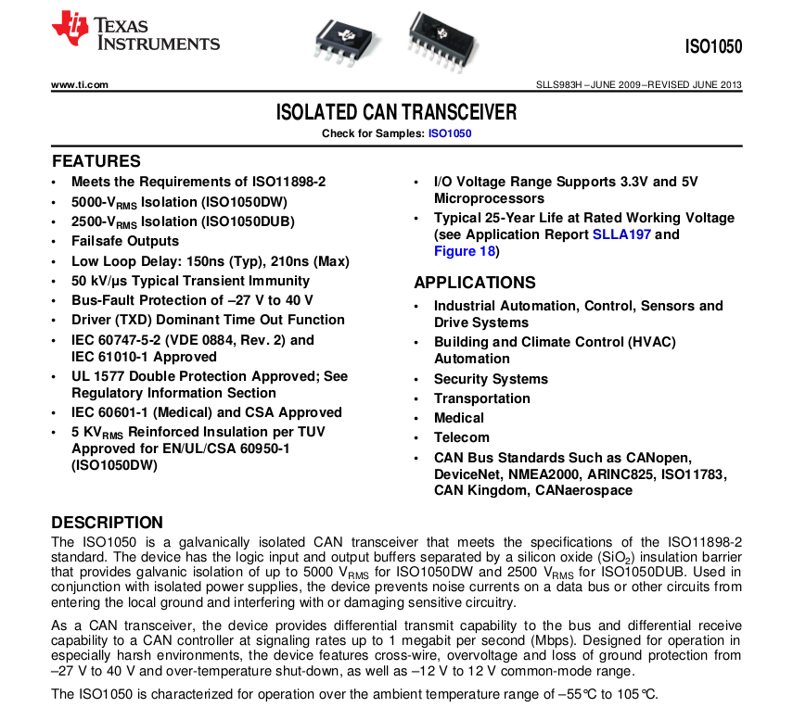
ISO1050 datasheet
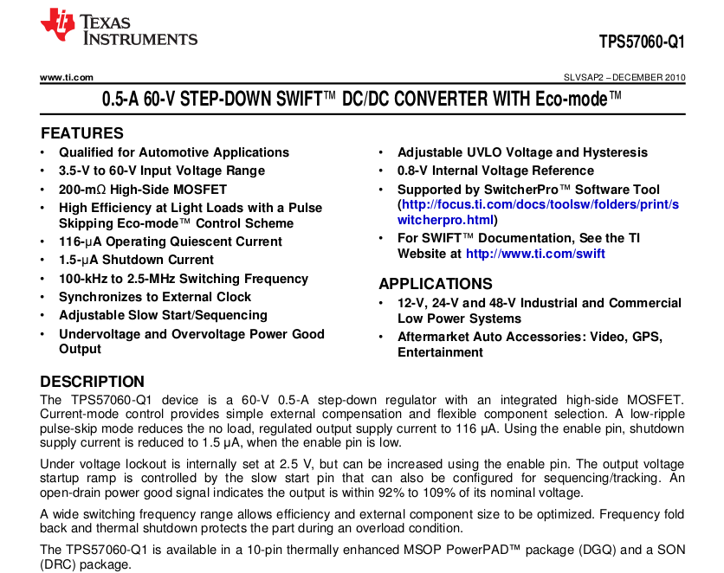
TPS57060-Q1 datasheet

