

|  |  |  |  |  |  |  |  |  |  |  |  |
| --- | --- | --- | --- | --- | --- | --- | --- | --- | --- | --- | --- |
| 2014 POLY eRACING CAR  BMS Slave  System Functional Description | | | | | | | | | | | |
| Responsible department:  Electrical | | | Document type:  System Functional Description | | | | Confidentiality status:  Internal | | Document state:  In Preparation | | |
| **Prepared:** |  | Raphael Neveu | | |  |  | | | |  |  |
|  |  | System Responsible | | |  |  | | | |  | YYYY-MM-DD |
| **Verified:** |  | Simon Bellemare | | |  |  | | | |  |  |
|  |  | Director of Electrical Engineering | | |  |  | | | |  | YYYY-MM-DD |
|  | **Name / Title** | | |  | **Signature** | | | |  | **Date** |
| This document and its content is the property of Poly eRacing of Polytechnique Montréal.  2013. Poly eRacing, Polytechnique Montréal  www.eracing.polymtl.ca | | | | Document number:  SFD-0000 | | | | | | | |
| Effective:  2013-09 | | | | Revision:  0 | | Language:  en | |

# Revision Log

|  |  |  |
| --- | --- | --- |
| **Revision** | **Date** | **Description of Changes** |
|  |  |  |
|  |  |  |
|  |  |  |
|  |  |  |

Table of contents

Revision Log 2

List of figures 3

1. Introduction 4

1.1 Document Overview 4

1.2 Acronyms and definitions 4

1.3 References 4

2. System Architecture 5

2.1 General Architecture 5

2.2 Hardware Components 6

3. System Interfaces 7

4. System Functions 9

4.1 Hardware Functions 9

4.2 Software Functions 9

# List of figures

Figure 1 (section 3.1) : System General Architecture

Figure 2 (section 4) : System interfaces

# Introduction

## Document Overview

This SFD describes the BMS Slave functionalities and design details. It presents its main functionalities, components, constraints and limits of the system. It also presents the software related main functions.

## Acronyms and definitions

* **ADC** : Analog to Digital Converter
* **BMS** : Battery Management System, also known as Accumulator Management System (AMS)
* **CAN** : Controller Area Network (a communication protocol often used in automotive for communication between different modules (boards or systems))
* **MCU** : Micro controller
* **PCB** : Printed circuit board
* **LTC** :Refers to the LTC chip used in the circuit
* **SPI** : Serial Peripheral Interface (a communication protocol)
* **SFD** : System Functional Description (this document)
* **TSC** : Traction system control (the system which controls the traction of the car)

# References

|  |  |  |
| --- | --- | --- |
| **Ref. #** | **Document ID** | **Description** |
| 1 | 2014_fsae_rules.pdf | Formula SAE Rules 2014 |
| 2 | 2013_fsae_rules.pdf | Formula SAE Rules 2013 |
| 3 | C020.pdf | Battery cell datasheet |
| 4 | 680412f.pdf | LTC6804 datasheet |

# System Architecture

## General Architecture

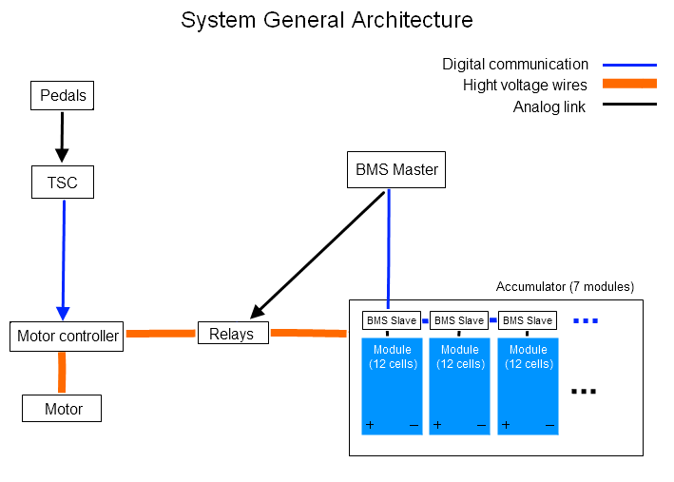

The BMS Slave PCB is located on each battery cell modules. It is used to monitor each cell voltage and temperature. The BMS slaves are connected together and to the BMS Master for CAN communication to transfer the acquired data (voltage and temperature) to the Master. The BMS Master performs security checks and has a control on the relays which allow or not the high voltage to the motor controller. The Motor controller is controlled by the TSC (Traction system control) which monitors the Pedals position. The TSC and Motor controller also use CAN to communicate. The high voltage pass through the motor controller and finally to the motor to make it turn. If a discharge system is added to the components, it will be located as the BMS Slave: one on each modules with an analog communication between the discharge system and the BMS Slave located on the same module.

## Hardware Components

This section lists the main components used in the design (e.g. MCU model, motor model, integrated circuit model) and their most significant (useful for the system) specifications (not the whole technical specification).

Put a link to the detailed technical specification.

It could be bullet-form or table-form. The usefulness of a component listed must be briefly described here, as well as its main task(s) and role.

**MCU** : Freescale MC9S12XDP512MAG (www.freescale.com/)

**LTC** : LTC6803 or LTC6804 (www.linear.com/)

**Voltage regulator** : TL2575-05 (www.ti.com/product/tl2575-05)

**CAN Transceiver** : TJA1040 (www.nxp.com/documents/data_sheet/TJA1040.pdf)

# System Interfaces

**Legend**

|  |
| --- |
| **External interfaces (high level)** |
| Data to acquire |
| Communication interface |
| **Main Internal interface** |
| Internal interface |
| *Other* |

**BMS Slave system interfaces**

|  |  |  |  |
| --- | --- | --- | --- |
|  |  | **BMS Master** | |
|  |  | CAN physical interface | |
|  |  | CAN Transceiver | |
|  |  | Digital Isolator | |
| *Power supply (5V) to the internal interfaces* | **Discharge system** | **MCU** | |
| Analog | SPI | Analog |
| **LTC chip** | |
| Voltage Regulator | Analog | |
| Cell Voltage | | | Temperature |

**Data acquisition**

The BMS slave is used to acquire voltage and temperature information from a battery module. The voltage is acquired firstly by an LTC chip which is an ADC chip that converts an analog signal to a voltage measure. The information is transferred to the MCU by an SPI bus (regardless of which LTC chip is chosen). The temperatures are measured directly by the MCU’s ADC which is connected to temperature sensors.

The LTC6803 chip offers a galvanic isolation for the SPI bus. The LTC6804 datasheet does not clearly specify it. It is always possible to use the new isoSPI protocole of the LTC6804 by adding a isoSPI to SPI chip (LTC6820).

**Discharge system**

The LTC chip has special outputs that are design to activate discharging for each battery cell separately. The Slave’s PCB does not take in charge the cell discharge. However, it exports these signals to a connector for another system to take in charge the discharge.

**Power supply**

The Slave PCB power supply comes from the battery modules. A voltage regulator converts the total module voltage (from 30V to 49.8V according to the maximum and minimum cell voltage of the cell) to a regulated 5V used to power the whole PCB. Note that the LTC chip is directly powered from the voltage it receives for its main components.

**CAN communication**

The BMS Slave is used to acquire the data. The data (voltage and temperature) is send to the BMS Master which performs security tests with this data. The communication between the BMS Slave and the BMS Master is made with CAN protocol. The MCU of the Slave support’s CAN as well as the Master’s MCU. The CAN data is send to a CAN Transceiver which sends the data to the physical layer. Between the CAN transceiver and the MCU, there is an isolator to ensure electrical isolation between the physical layer and the other system components.

# System Functions

## System Main Functions

**1) Monitor cell voltage**

The BMS Slaves are used to monitor each individual battery cell voltage of a module. A specialized LTC chip is used to convert the measured voltage to digital values. This is one of the most important functions of the whole BMS system. The FSAE rules require such a monitoring of all the battery cells. The data acquire is used for multiple security tests to ensure that all the constructor’s battery recommendations about voltage.

**2) Monitor temperature**

The BMS Slaves also monitor each battery cell temperature. The temperature is converted to digital values as the voltage data. The data acquire is used for multiple security tests to ensure that all the constructor’s battery recommendations about temperature.

## Software Functions

**1) Data communication**

The BMS Slave sends the monitored data directly to a BMS Master which performs the tests. This is done by using CAN communication between the interfaces and it is all programmed in the BMS MCU’s.

The CAN implementation of the MCU will be subject to a rewrite later. The implementation will have some standard protocol functions to:

* Send a CAN packet
* Get the information of a received packet
* Build a CAN packet
* Other…

# Constraints and limitations

**Input voltage**

The input voltage retrieved from the module will be between 30V and 49.8 V (12 cells from 2.5V to 4.15V).

A switch (probably a transistor) may be added to the board. This switch would act as a power supply ON/OFF that could be triggered from outside the car.

**LTC chip precision of voltage reading**

Depends on which model will be chosen (LTC6803 or LTC6804).

The *LTC6803* has a precision of 0.25 % on the total measurement of the voltage. The results are given in 12 bit numbers.

The *LTC6804* is the latest version of the chip and has a precision of 0.067 %. The results are on 16 bits.

**LTC chip power voltage required**

The LTC6803 chip can be powered by a voltage of 4V to 55V.

The LTC6804 needs 11V to 55V.

**Number of battery monitored**

A single LTC chip can monitor a maximum of 12 cells voltage. For more cells, it is possible to combine two or more LTC chips in different ways (see LTC documentation).

**MCU number of timers**

The version of the Freescale MCU used has only 4 interrupt timers. Since more than 4 operation use a delay, some of the interrupt timers are used for multiple tasks.

**MCU maximum clock speed**

40 MHz

**MCU program memory size**

512 kB