**Git Assignment 1 Documentation**

**Objective**

The purpose of this hands-on lab is to practice basic Git operations including repository initialization, file tracking, committing changes, and pushing to a remote GitLab repository. Additionally, configuring Notepad++ as the default Git editor is included.

**Prerequisites**

* Git Bash installed on your machine
* GitLab account
* Notepad++ installed

**Steps**

**Step 1: Configure Git**

1. Open Git Bash and check Git installation:
2. git --version
3. Set your global username and email:
4. git config --global user.name "Your Name"
5. git config --global user.email "youremail@example.com"
6. Verify configuration:
7. git config --list

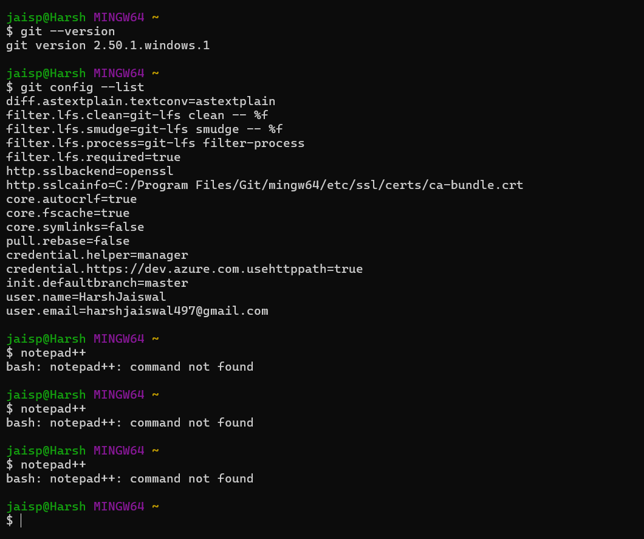

**Step 2: Configure Notepad++ as Git Editor**

1. Check if Notepad++ opens from Git Bash:
2. notepad++
3. If not recognized, add the installation path to your environment variables.
4. Set Notepad++ as default Git editor:
5. git config --global core.editor "notepad++ -multiInst -nosession"
6. Verify by opening Git config in Notepad++:
7. git config --global -e

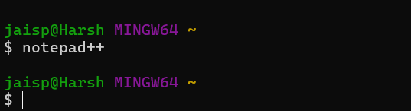

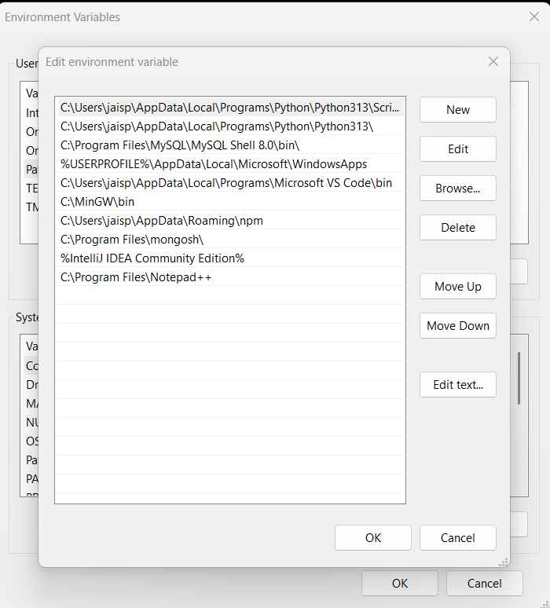

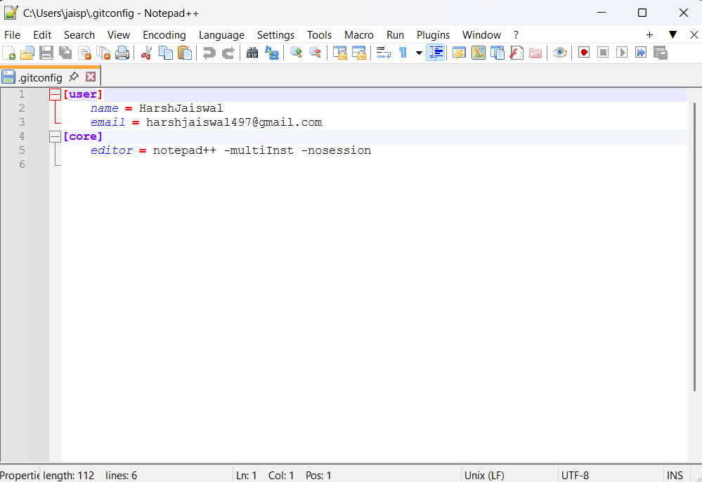

**Step 3: Create Local Repository**

1. Create a new folder and navigate into it:
2. mkdir GitDemo
3. cd GitDemo
4. Initialize the repository:
5. git init

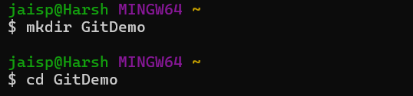

**Step 4: Add and Commit a File**

1. Create a file welcome.txt:
2. echo "Welcome to Git Demo" > welcome.txt
3. Check file list and content:
4. ls
5. cat welcome.txt
6. Stage the file:
7. git add welcome.txt
8. Commit the file:
9. git commit -m "Added welcome.txt file"

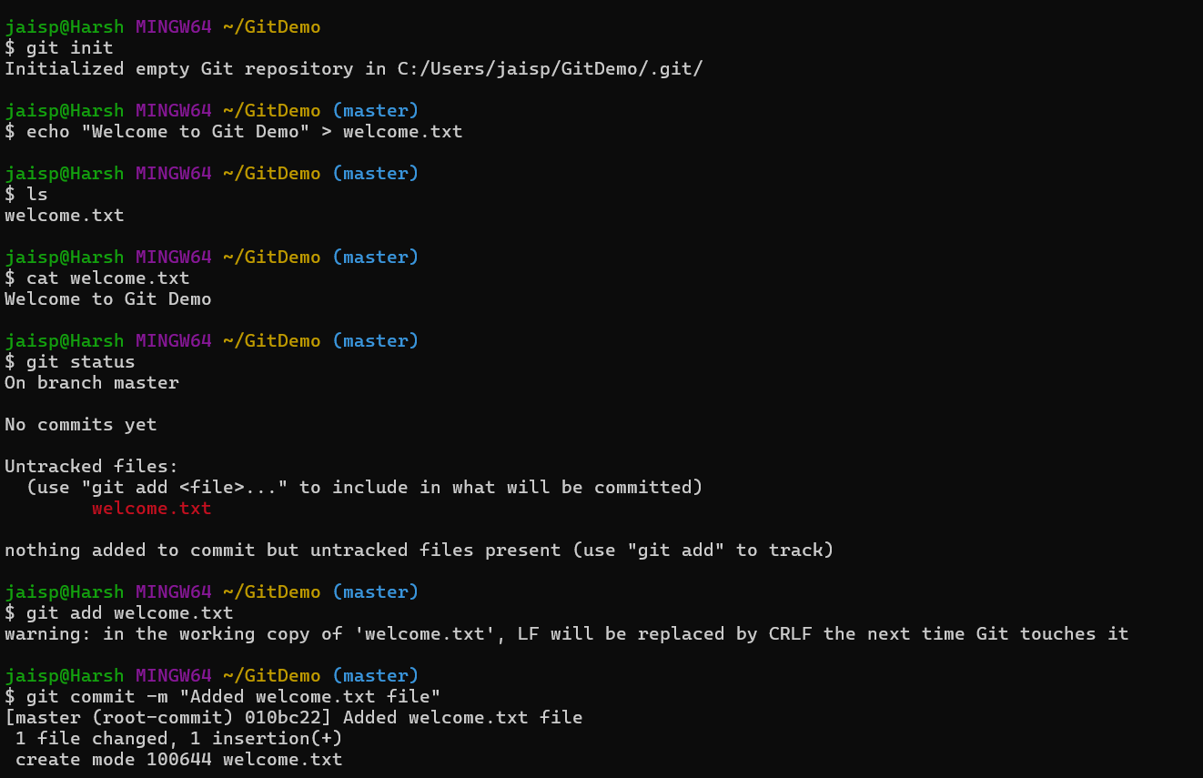

**Step 5: Create Remote Repository on GitLab**

1. Log in to GitLab and create a blank project named **GitDemo**.
2. Copy the repository HTTPS URL.

**Step 6: Link and Push to Remote**

1. Link local repository to remote:
2. git remote add origin <https://gitlab.com/jaiswalharsh460-group/gitdemo.git>
3. Pull from remote (optional if empty repo):
4. git pull origin master
5. Push to remote:
6. git push -u origin master

