**Git Assignment 2 Documentation**

**Objective**

The purpose of this hands-on lab is to practice using the .gitignore file to prevent unwanted files and folders from being tracked in a Git repository.

**Prerequisites**

* Git Bash installed on your machine
* GitLab account with a repository already linked
* Notepad++ integrated as the default Git editor
* Local repository (e.g., GitDemo) already set up

**Steps**

**Step 1: Navigate to Repository**

pwd

Ensure you are inside the Git repository folder (e.g., GitDemo).  
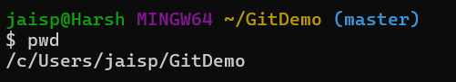

**Step 2: Create Unwanted Files and Folders**

echo "This is a log file" > debug.log

mkdir logs

echo "Inside logs folder" > logs/log1.txt

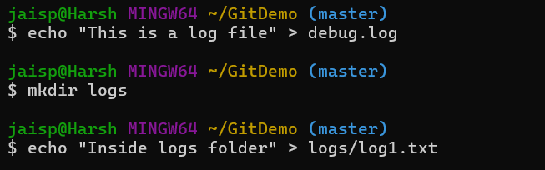

**Step 3: Create .gitignore File**

echo "*.log" > .gitignore

echo "logs/" >> .gitignore

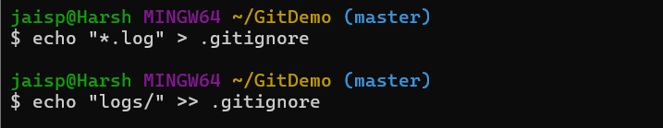

**Step 4: Check Git Status**

git status

Verifies that .gitignore is untracked, and debug.log and the logs folder do not appear in the status output.  
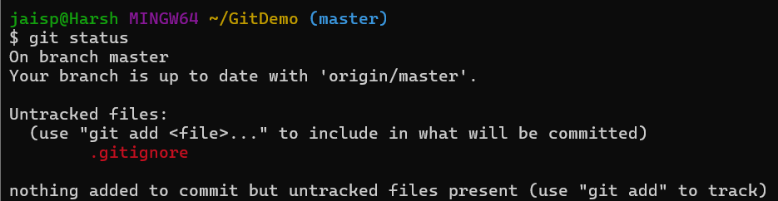

**Step 5: Stage and Commit .gitignore**

git add .gitignore

git commit -m "Added .gitignore to ignore .log files and logs folder"

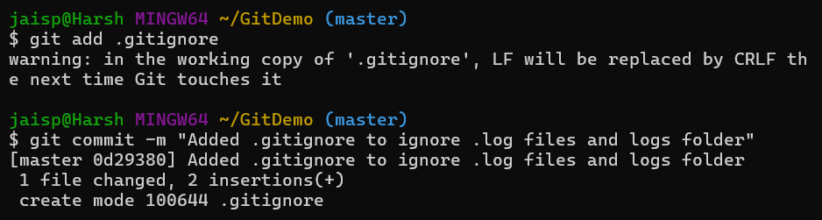

**Step 6: Push to Remote Repository**

git push origin master



