**Git Assignment 3 Documentation**

**Objective**

The purpose of this hands-on lab is to practice Git branching and merging, including creating a branch, making changes, merging into the master branch, and cleaning up.

**Prerequisites**

* Git Bash installed on your machine
* GitLab account with a repository already linked
* Local repository (e.g., GitDemo) set up
* P4Merge tool installed for visual diffs (optional)

**Steps**

**Step 1: Create a New Branch**

git branch GitNewBranch

git branch -a

git checkout GitNewBranch

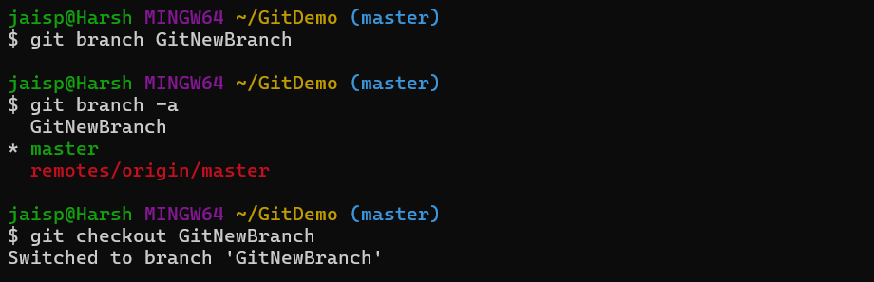

**Step 2: Add Changes in the New Branch**

echo "This file is created in GitNewBranch" > branchfile.txt

git add branchfile.txt

git commit -m "Added branchfile.txt in GitNewBranch"

git status

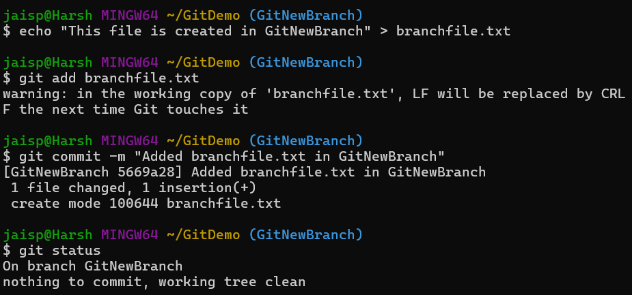

**Step 3: Switch Back to Master**

git checkout master

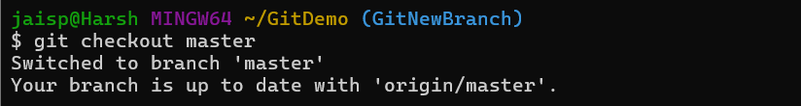

**Step 4: View Differences Between Branch & Master**

* Command-line diff:

git diff master GitNewBranch

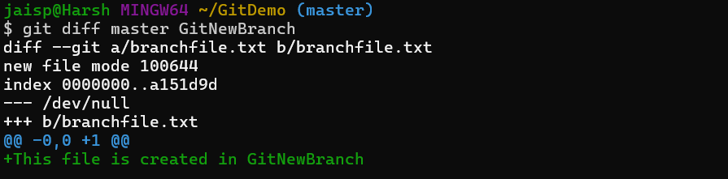

**Step 5: Merge Branch into Master**

git merge GitNewBranch

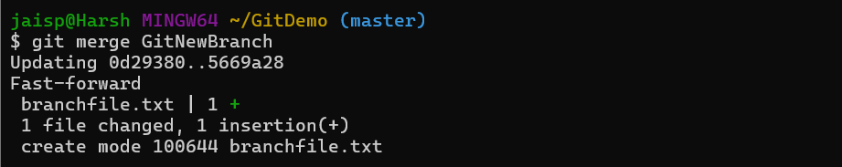

**Step 6: View Merge History**

git log --oneline --graph --decorate

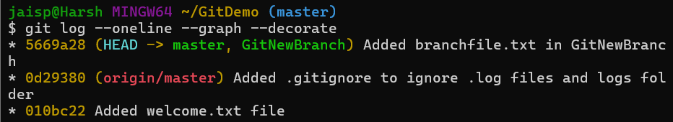

**Step 7: Delete the Branch**

git branch -d GitNewBranch

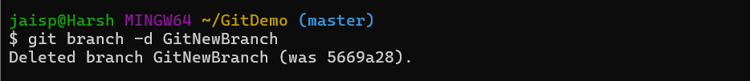

**Step 8: Push Changes to Remote**

git push origin master

