**Git Assignment 5 Documentation**

**Objective**

The purpose of this hands-on lab is to practice cleaning up a local repository and pushing changes to the remote repository to ensure synchronization.

**Prerequisites**

* Git Bash installed on your machine
* GitLab account with a repository already linked
* Local repository set up
* Changes from “Git-T03-HOL_002” already available locally

**Steps**

**Step 1: Verify Master is Clean**

git checkout master

git status

Confirm that the output shows the working tree is clean.  
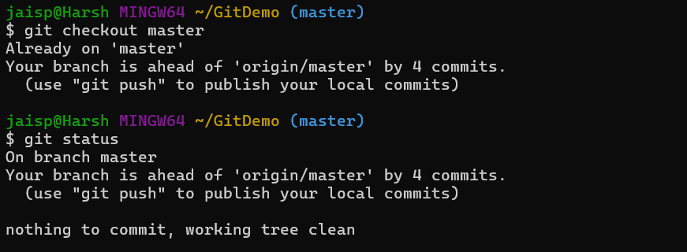

**Step 2: List All Available Branches**

git branch -a

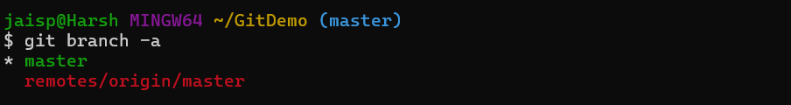

**Step 3: Pull Latest from Remote**

git pull origin master

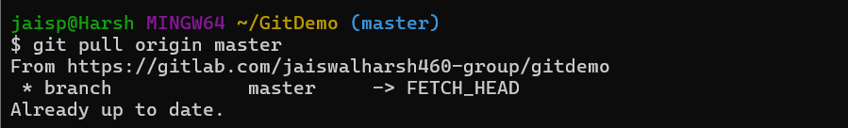

**Step 4: Push Any Pending Changes to Remote**

git push origin master

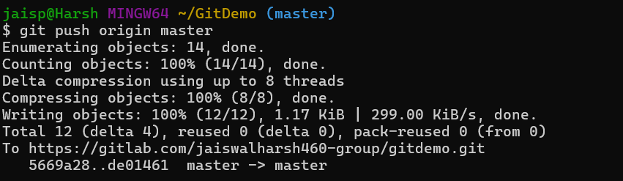

**Step 5: Verify on GitLab**

Open the repository in GitLab and confirm that changes from “Git-T03-HOL_002” are visible in the remote repository.  
