

Faculty of Technology and Engineering
Chandubhai S. Patel Institute of Technology (CSPIT)
Department of Computer Science & Engineering
Date: 19/08/2026
Laboratory Manul

Academic Year | : | 2026-27 | Semester | : | 3rd
Course code | : | ITUE203 | Course name | : | WEB DEVELOPMENT FRAMEWORKS

Practical – 1
Project Initiation, Requirement Analysis, Sitemap, Wireframe, and GitHub Setup
Problem Statement:- Initiate the semester-long StudentHub portal by identifying the problem scope, user roles, key modules, navigation flow, and minimum 10 pages. Create a sitemap, low-fidelity wireframe, project folder structure, README file, and GitHub repository.
Objective:- To initiate the development of a semester-long StudentHub Portal by analyzing the problem requirements, identifying the target users and their roles, designing the key functional modules, creating a clear navigation flow, and planning a minimum 10-page website. The project also aims to establish a structured development workflow by preparing a sitemap, low-fidelity wireframes, project folder structure, README documentation, and a GitHub repository for version control and collaborative development.
Github Repository Link:- https://github.com/HarshKathrotiya123/Student-Hub

Screenshots:-Site Map:-

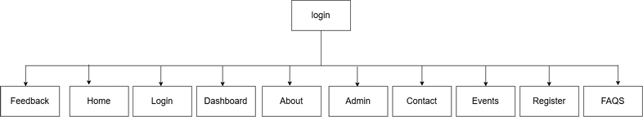

WireFrames:-

┌──────────────────────────────────────────────┐
│ ABOUT STUDENT HUB │
├──────────────────────────────────────────────┤
│ Home | Student Home | Register | Login | │
│ Contact │
├──────────────────────────────────────────────┤
│ WHO WE ARE │
│ │
│ Student Hub information paragraph │
├──────────────────────────────────────────────┤
│ OUR MISSION │
│ │
│ ┌────────────┐ ┌────────────┐ ┌────────────┐│
│ │ Learning │ │Communication│ │Development ││
│ │ Description│ │ Description │ │ Description││
│ └────────────┘ └────────────┘ └────────────┘│
├──────────────────────────────────────────────┤
│ WHY CHOOSE STUDENT HUB? │
│ │
│ • Simple interface │
│ • Student information │
│ • College announcements │
│ • Event registration │
├──────────────────────────────────────────────┤
│ DID YOU KNOW? │
│ Student Hub is available 24×7 │
├──────────────────────────────────────────────┤
│ © 2026 Student Hub - All Rights │
└──────────────────────────────────────────────┘

┌──────────────────────────────────────────────┐
│ STUDENT HUB ADMIN PANEL │
├──────────────────────────────────────────────┤
│ Home | Dashboard | Events | Feedback | │
│ Contact | Logout │
├──────────────────────────────────────────────┤
│ ADMINISTRATOR DASHBOARD │
│ │
│ ┌──────────────────────────────────────────┐ │
│ │ Website Statistics │ │
│ │ • Total Students │ │
│ │ • Registered Users │ │
│ │ • Upcoming Events │ │
│ │ • Feedback Received │ │
│ └──────────────────────────────────────────┘ │
├──────────────────────────────────────────────┤
│ ADMIN ACTIONS │
│ │
│ • Add New Student │
│ • Update Student Records │
│ • Delete Student Records │
│ • Manage Events │
│ • View Feedback │
│ • Send Notifications │
├──────────────────────────────────────────────┤
│ RECENT ACTIVITIES │
│ │
│ ┌──────────────┬───────────────────────────┐ │
│ │ Date │ Activity │ │
│ ├──────────────┼───────────────────────────┤ │
│ │ 01-08-2026 │ New student registered │ │
│ │ 03-08-2026 │ Hackathon event added │ │
│ │ 05-08-2026 │ Feedback reviewed │ │
│ └──────────────┴───────────────────────────┘ │
├──────────────────────────────────────────────┤
│ ADMIN NOTICE │
│ Keep records updated and monitor events │
├──────────────────────────────────────────────┤
│ © 2026 Student Hub. All Rights Reserved│
└──────────────────────────────────────────────┘

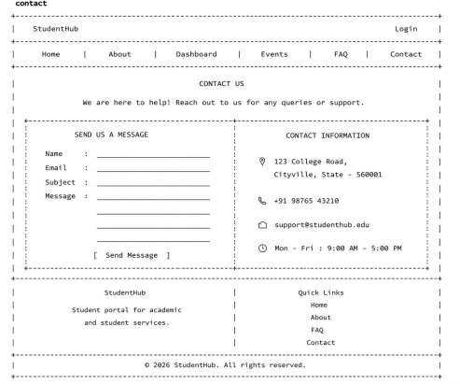

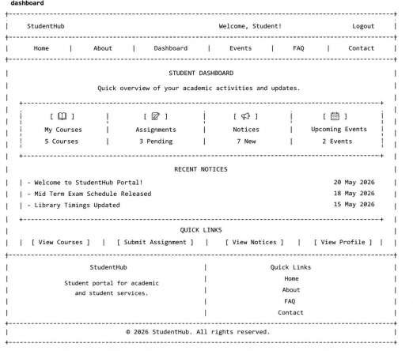

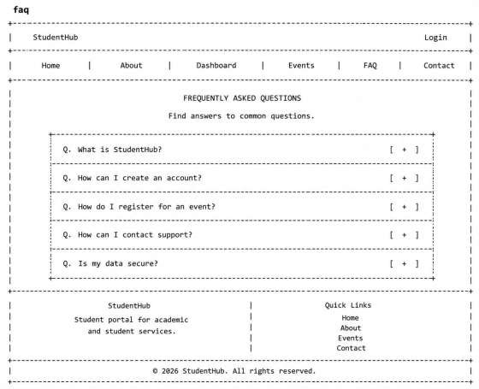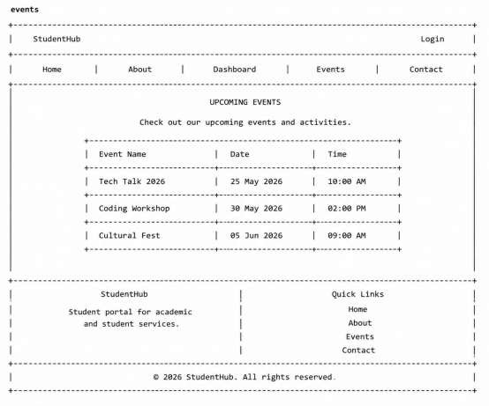

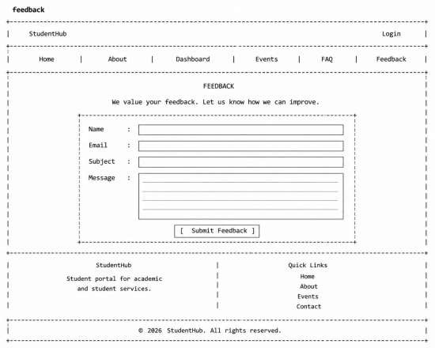
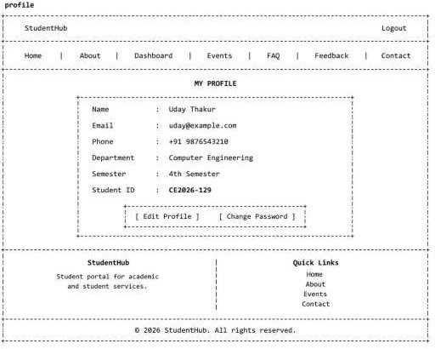

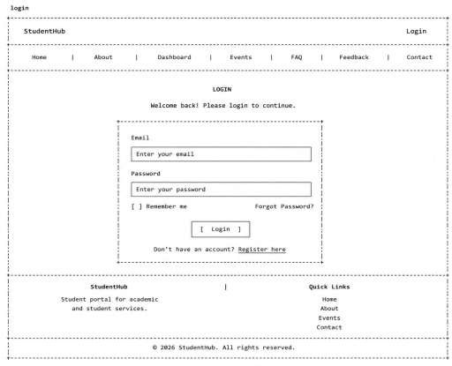
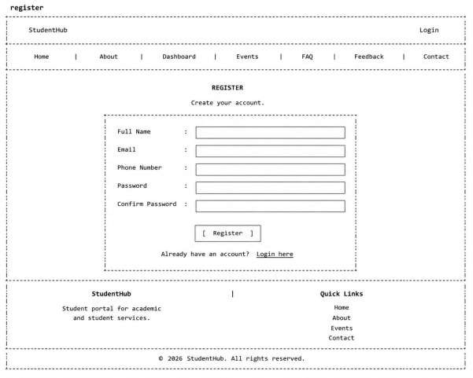

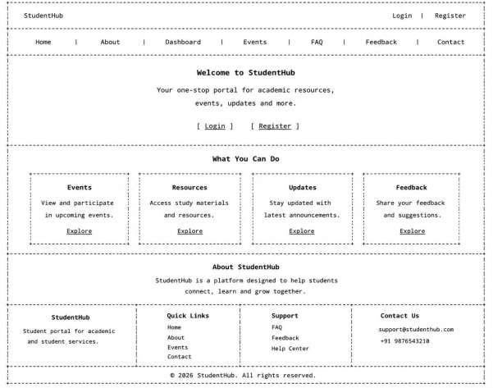

VsCode StudentHub Folder Structure:-
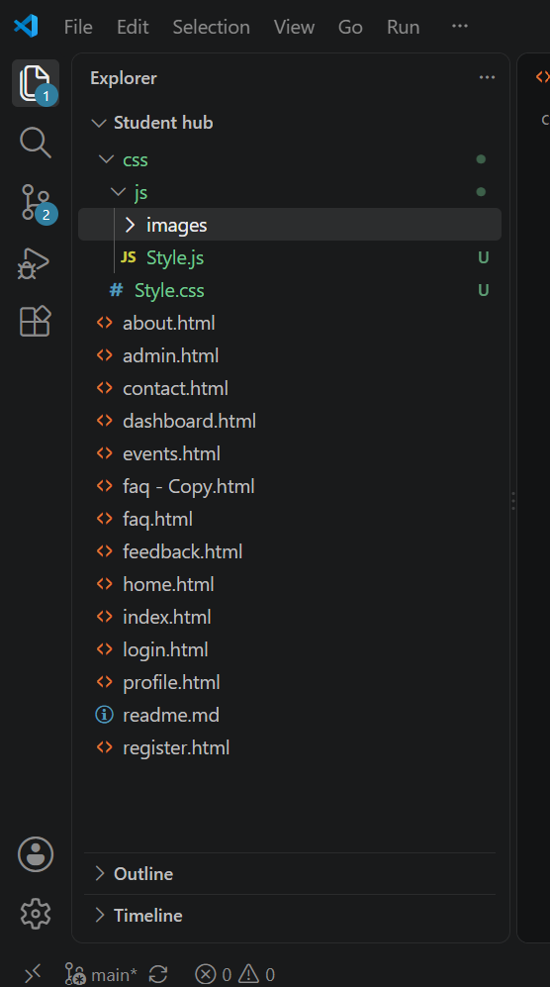

Github Repository Setup:-

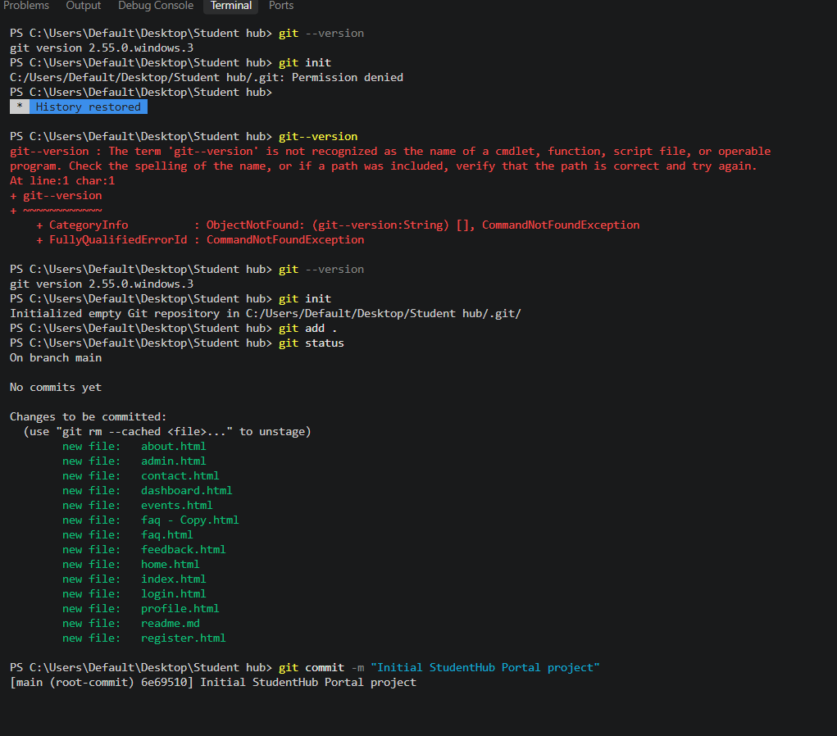

GitHub Repository :-

