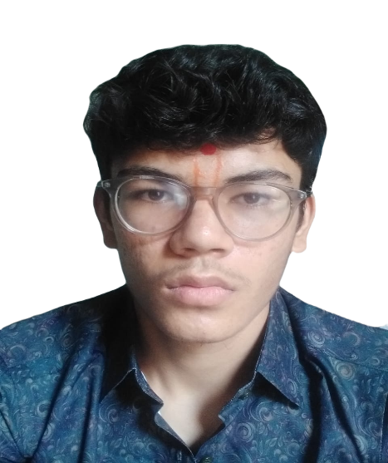

Harsh Koladiya

Web Developer

Amreli

9328742196

Professional Experience and Achievements

Website Project

Technologies Used: HTML, CSS, JavaScript, PHP

I developed a comprehensive website project utilizing HTML, CSS, JavaScript, and PHP. This project involved:

Frontend Development: Crafted a responsive and visually appealing user interface using HTML and CSS. Ensured cross-browser compatibility and optimized performance.

Interactive Features: Enhanced user experience by incorporating JavaScript to create dynamic and interactive elements. Implemented client-side validation and AJAX for seamless data handling.

Server-Side Scripting: Used PHP to handle server-side logic, manage sessions, and interact with the database. Developed secure and efficient backend functionalities to support various user interactions.

This project demonstrated my ability to integrate front-end and back-end technologies to create a functional and user-friendly website.

Database Project

Technology Used: PostgreSQL

I designed and implemented a small database project using PostgreSQL. Key aspects of this project included:

Database Design: Developed a normalized database schema to manage and organize data effectively. Ensured data integrity and minimized redundancy.

Data Management: Created efficient SQL queries for data insertion, retrieval, and updates. Focused on optimizing query performance to handle large datasets.

Security and Maintenance: Implemented access controls and encryption to protect sensitive information. Conducted regular maintenance and performance tuning to ensure the database operated smoothly.

This project enhanced my skills in database design, management, and optimization, particularly with PostgreSQL.

Achievements

PERSONAL INFORMATION

Address: , Amreli,

Nationality:

Driving License:

Hobbies: painting

play musical instruments

horse riding

swimming

bike riding

SOCIAL PROFILES

\* linkedin profile: https://www.linkedin.com/in/harshkoladiya

SKILLS

Programming

java

Postgresql

WORK EXPERIENCE

\* May 2024 – June 2024

web devloper at devloper,

"Hello! I'm a dynamic computer engineering student with a fervent curiosity for emerging technologies and a relentless drive for excellence. With a solid foundation in coding languages like Java, C++, and Python, coupled with hands-on experience in software development and hardware design, I bring versatility and adaptability to any project. My coursework has equipped me with a deep understanding of computer architecture, digital systems, and network protocols, enabling me to tackle complex engineering challenges with confidence. Beyond technical proficiency, I excel in collaborating with diverse teams, leveraging strong communication skills to foster productive relationships and drive projects to success. I thrive in fast-paced environments, where I can apply my analytical mindset and creative problem-solving skills to innovate and overcome obstacles. Whether it's optimizing algorithms for efficiency or designing intuitive user interfaces, I am committed to delivering solutions that exceed expectations. My passion for learning drives me to stay abreast of industry trends and continuously expand my skill set, ensuring that I remain at the forefront of technological advancements. I am eager to bring my enthusiasm, dedication, and expertise to a dynamic team where I can contribute to meaningful projects and make a tangible impact. Let's connect and explore how my unique blend of technical prowess and collaborative spirit can drive innovation and success for your organization."

EDUCATION

\*

Birlla Vishwakarma MahaVidyalaya, Vallabh Vidyanagar B.tech

Education

Bachelor of Technology in Computer Engineering

[Birlla Vishwkarma MahaVidalaya], [Vidyanagar, anand, Gujrat]

[Dates of Attendance]

- Relevant Coursework:

  - Web Technologies

  - 8085 Microprocessor

  - Database Management and Management Systems