|  |
| --- |
| An  Internship Project Report  on  **Twitter Analytics Dashboard**  At  **NullClass Private Limited**  *Submitted in partial fulfilment of the requirements for the award of the Internship completion certificate in*  **Data Analytics**  **A white square with a blue background  Description automatically generated**  **Submitted to - Submitted by-**  NullClass Private Limited Harsh Kumar  **DEPARTMENT OF DATA ANALYTICS**  **NULLCLASS, TAMIL NADU, INDIA**  **JUNE 2024** |

**Table of Contents**

|  |  |  |
| --- | --- | --- |
| **CHAPTER** | **PARTICULARS** | **PAGE NO.** |
| 1 | Introduction | 1 |
| 2 | Background | 2 |
| 3 | Learning Objectives | 4 |
| 4 | Activities & Tasks | 6 |
| 5 | Skills & Competencies | 13 |
| 6 | Evidence | 14 |
| 7 | Challenges & Solutions | 15 |
| 8 | Outcomes & Impact | 16 |
| 9 | Conclusion | 17 |

**Introduction**

During my internship at NullClass Pvt. Ltd., I had the opportunity to contribute to a project centred around Twitter engagement analysis using Power BI. This report details my experiences and learnings throughout the internship, which spanned from 19 July, 2024 to 19 August, 2024.

The focus of my project was to analyse Twitter engagement metrics and create interactive visualizations to help the marketing team understand user behaviour and engagement trends.

I chose this internship to gain hands-on experience in data analytics and to apply my academic knowledge in a real-world setting. I was eager to develop my technical skills in Power BI and data visualization, as well as to learn more about the practical applications of data analysis in a business context.

This report is structured to provide a comprehensive overview of my internship experience. It includes sections on the background of the project, my learning objectives, the activities and tasks I undertook, the skills and competencies I developed, the feedback I received, the challenges I faced and the solutions I found, the outcomes and impact of my work, and a concluding reflection on the overall experience.

**Background**

The internship at NullClass Pvt. Ltd. was a pivotal opportunity for me to bridge the gap between academic knowledge and practical application in the field of data analytics.

The project I was assigned to revolved around analysing Twitter engagement metrics and creating interactive visualizations using Power BI. This was aimed at helping the marketing teams better understand user engagement trends and improve their social media strategies.

The tasks assigned during the internship were designed to cover various aspects of data visualization and analysis:

1. **Trend Analysis of Engagement Rates**:
   * Created a line chart to show the trend of the average engagement rate over each month of the year, distinguishing between tweets with media content and those without.
   * Developed a visualization comparing the number of replies, retweets, and likes for tweets with media engagements greater than the median value, including a filter for tweets posted in the last six months.
2. **Engagement Comparison**:
   * Analysed tweets to compare the engagement rate for tweets with app opens versus tweets without app opens, focusing only on tweets posted between 9 AM and 5 PM on weekdays.
3. **Media Interaction Analysis**:
   * Created a dual-axis chart displaying the number of media views and media engagements by the day of the week for the last quarter, highlighting days with significant spikes in media interactions.
   * Built a pie chart to represent the proportion of total clicks (URL clicks, user profile clicks, and hashtag clicks) for tweets with more than 500 impressions, including a drill-down feature to view specific types of clicks for each tweet.

The technology stack for this project primarily involved Power BI, a leading business analytics tool by Microsoft. Power BI was chosen for its powerful data visualization capabilities, user-friendly interface, and robust data modelling features. This tool enabled the creation of dynamic and interactive visualizations, which were crucial for deriving actionable insights from the Twitter engagement data.

Overall, the internship project at NullClass provided a comprehensive learning experience in data analytics, combining theoretical knowledge with practical application using state-of-the-art technology.

**Learning Objectives**

During my internship at NullClass, I set forth several key learning objectives to enhance my professional skills and deepen my understanding of data analytics and visualization. These objectives were crafted to provide a comprehensive grasp of the tools, methodologies, and processes involved in analysing social media engagement metrics. The primary learning objectives were as follows:

1. **Mastery of Power BI:**
   * Acquire hands-on experience with Power BI to develop interactive and insightful visualizations.
   * Utilize various Power BI features, including data modelling, DAX functions, and advanced charting techniques.
   * Effectively leverage Power BI to transform raw data into actionable insights.
2. **Advanced Data Analysis Competence:**
   * Enhance my ability to clean, preprocess, and analyse large datasets efficiently.
   * Identify patterns, trends, and anomalies in data to support strategic decision-making.
   * Apply advanced analytical techniques to derive meaningful insights from social media data.
3. **Expertise in Social Media Analytics:**
   * Develop a deep understanding of key social media engagement metrics and their relevance.
   * Analyse and interpret data from social media platforms, particularly Twitter, to inform strategic decisions.
   * Assess the impact of various types of engagements (likes, retweets, replies) on overall social media strategy.
4. **Problem-Solving and Critical Thinking:**
   * Strengthen problem-solving skills by addressing real-world challenges in data analysis.
   * Enhance critical thinking abilities to derive insights and make data-driven recommendations.
   * Approach complex analytical tasks methodically and efficiently.
5. **Effective Communication and Presentation:**
   * Improve my ability to communicate analytical findings effectively through visualizations.
   * Present data insights clearly and compellingly to diverse stakeholders.
   * Create comprehensive reports and presentations to summarize analytical results.

**Activities & Tasks**

During my internship at Nullclass, I undertook a variety of activities and tasks that enabled me to apply and expand my data analytics skills in a professional setting. These tasks were primarily focused on the core project of analysing Twitter engagement metrics using Power BI. Below are the key activities and tasks I carried out:

1. **Data Collection:**
   * Retrieved data from Excel dataset, including metrics such as likes, retweets, replies, media views, and app opens.
   * Ensured data integrity and completeness by rigorously verifying the accuracy and relevance of the collected data.
2. **Data Cleaning and Preprocessing:**
   * Performed meticulous data cleaning to address missing values, duplicates, and inconsistencies.
   * Conducted data preprocessing to transform the data into an optimal format for analysis, including normalization and necessary transformations.
3. **Visualization Development:** 
   * **Task 1:** 
     + **Create a line chart showing the trend of the average engagement rate over each month of the year. Separate the lines for tweets with media content and those without.**

**I completed the task by using a line chart with X axis as Month Name, Y axis as average of engagement rate and legend as with or without media content.**

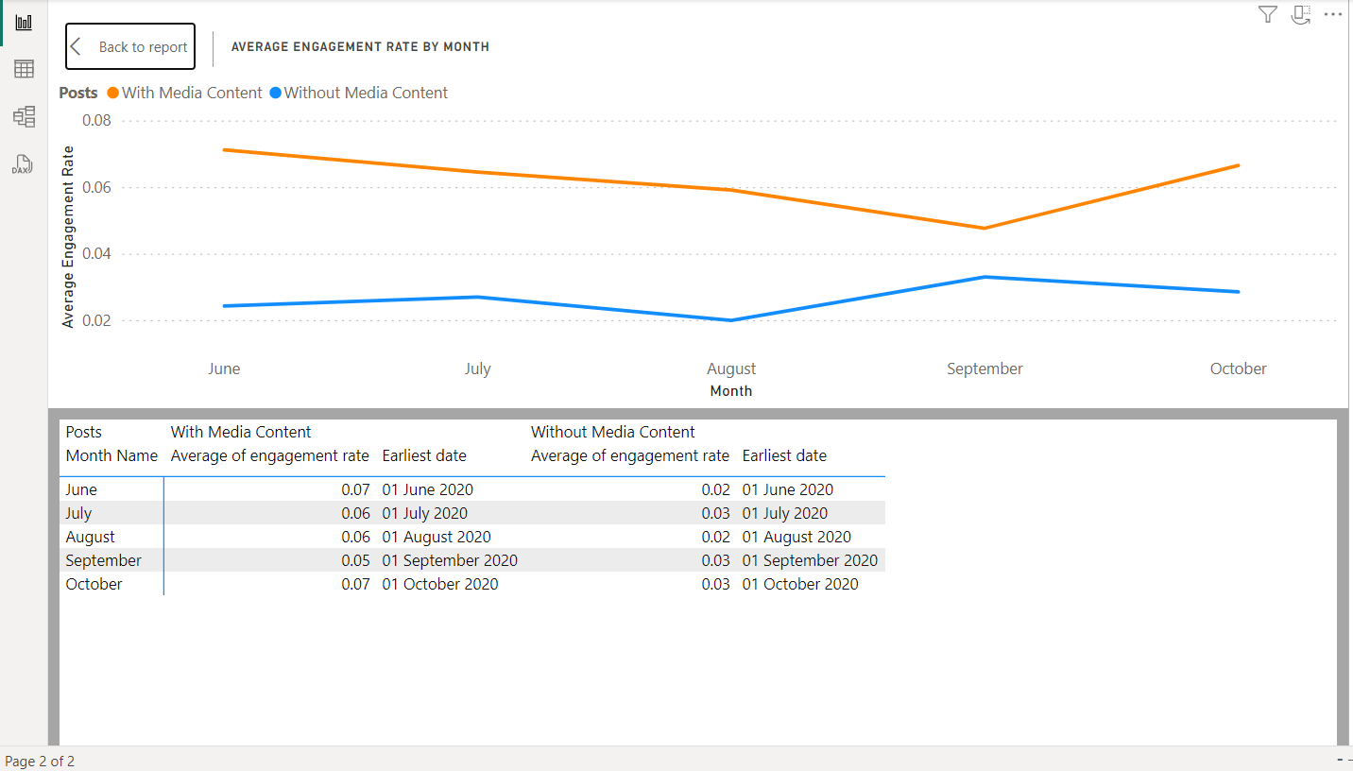

* + - Develop a visualization that compares the number of replies, retweets, and likes for tweets that have received media engagements greater than the median value. Include a filter for tweets posted in the last six months.

I completed this task by first separating the tweets with media engagements greater than median value & then using a pie chart with three values: Replies, Retweets & Likes for those specific tweets only. After creation of the pie chart, I have applied the filter for tweets posted in last six months.

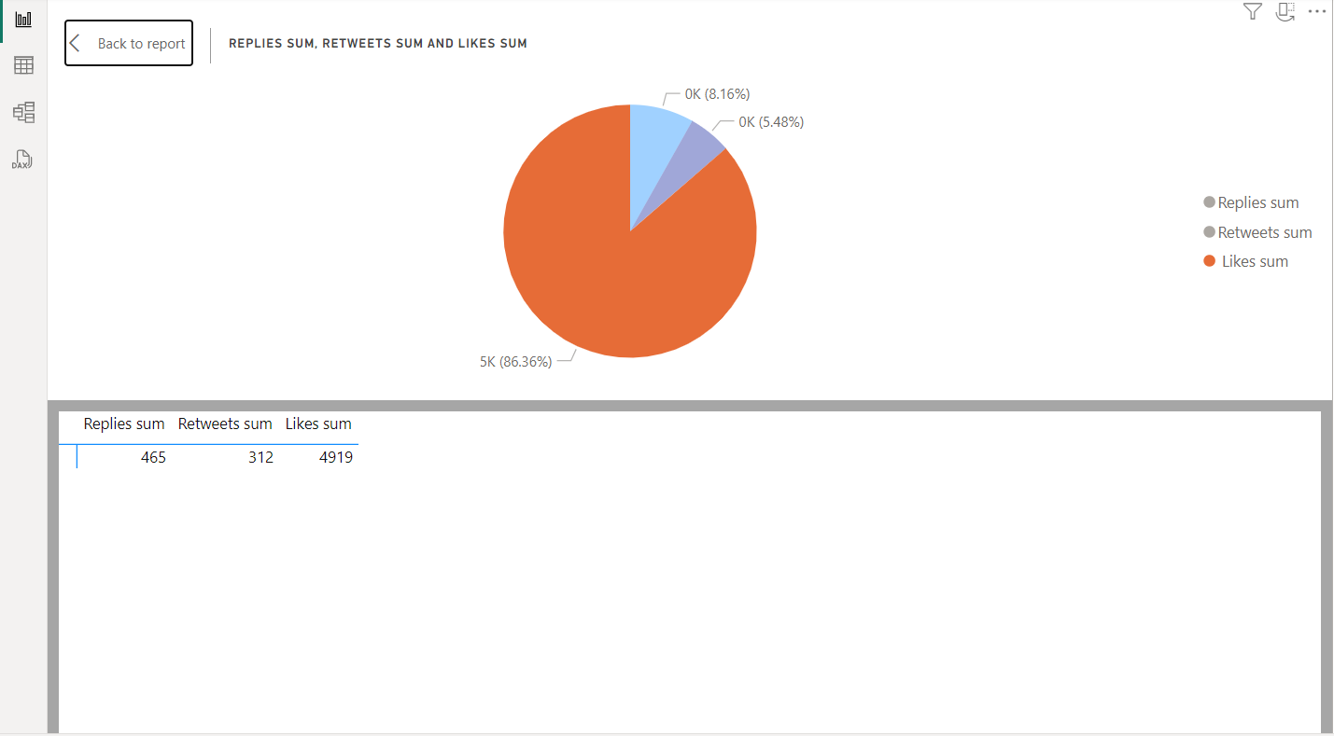

* + Task 2:
    - Analyse tweets to show a comparison of the engagement rate for tweets with app opens versus tweets without app opens. Include only tweets posted between 9 AM and 5 PM on weekdays.

I completed this task by first separating the tweets posted in given time frame on weekdays (Mon-Fri) and then using an area chart with X axis as Tweets, Y axis as Engagement Rate & legend as App open or app not opened status. Though in the given dataset there was no tweet in given timeframe that had app open status.

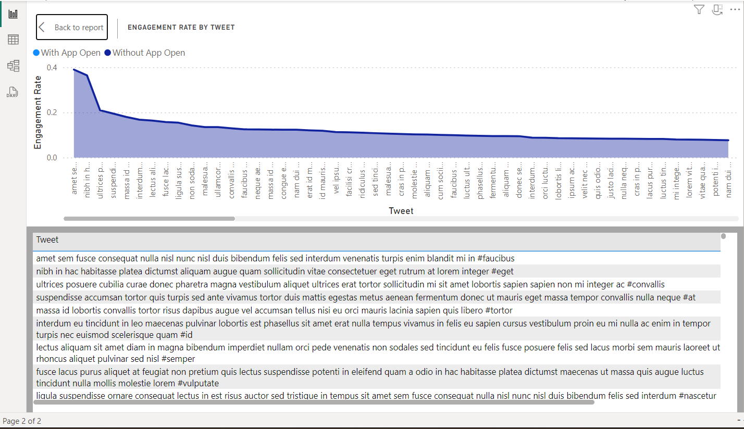

* + Task 3:
    - Create a dual-axis chart that shows the number of media views and media engagements by the day of the week for the last quarter. Highlight days with significant spikes in media interactions.

I completed this task using a special Line & Stacked Column Chart while keeping the task requirements in mind. Here I used X axis as day name, Column Y axis as Media Views, Line Y axis as Media Engagements. Here the line visual shows the highlighted spikes in media interactions.

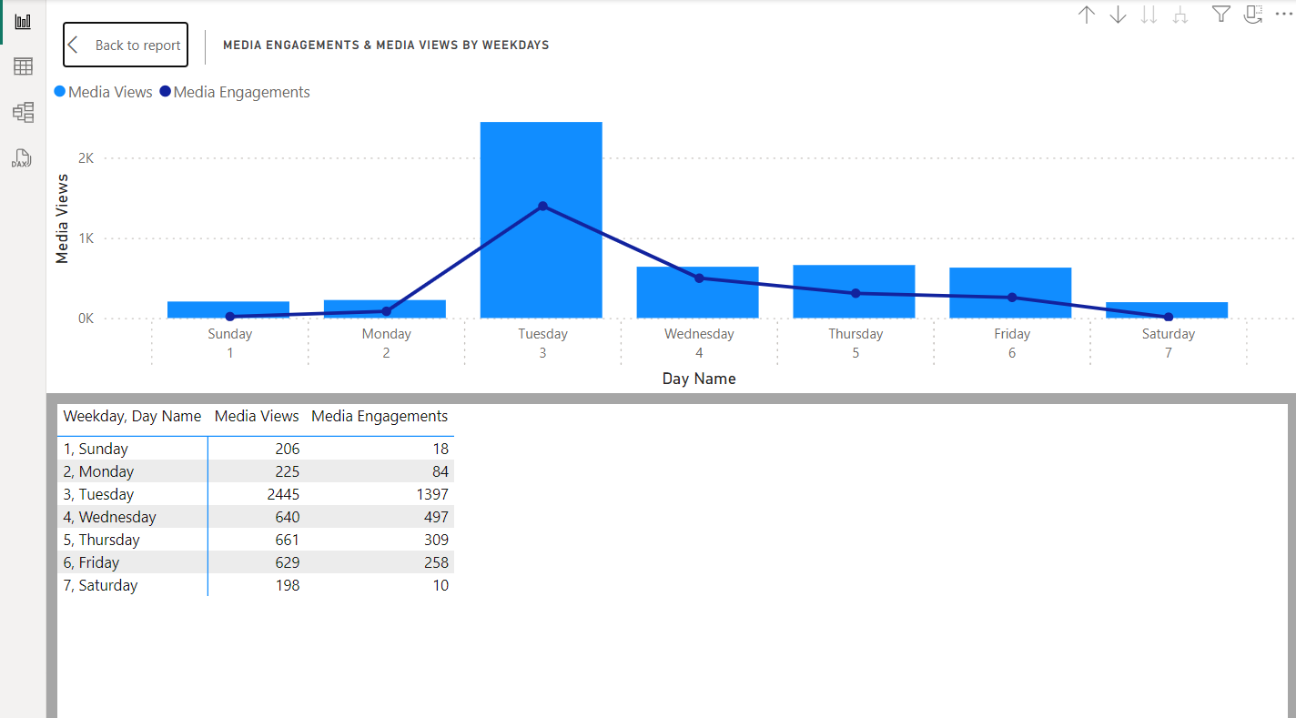

Build a pie chart that represents the proportion of total clicks (URL clicks, user profile clicks, and hashtag clicks) for tweets with more than 500 impressions.Include a drill-down to view the specific types of clicks for each tweet.

I completed this task by first separating the high impression tweets (Tweets with impressions>500) and then from that I created another table which is used to find click type for each tweet. Now I use a pie chart to show proportion of total clicks (URL clicks, user profile clicks, and hashtag clicks) & then I added a drill down so as when one expands all down one level in hierarchy, they will get the required drill down feature to view specific type of click for each tweet.

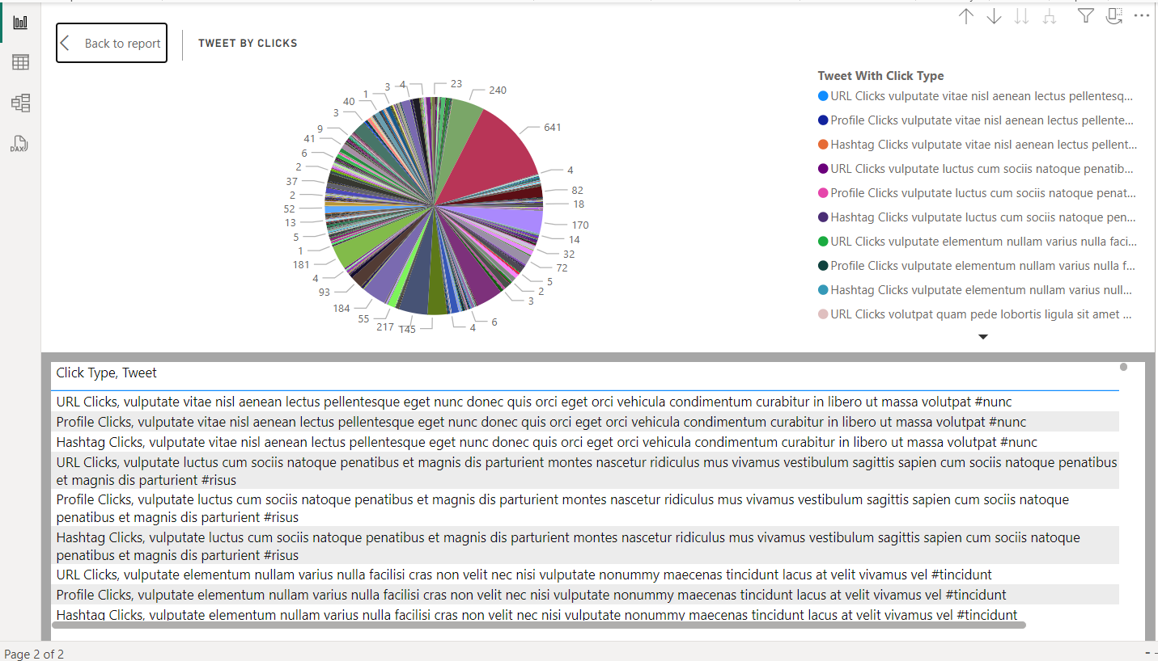

1. **Data Analysis and Insight Generation:**
   * Conducted in-depth data analysis to extract meaningful insights from the visualizations.
   * Identified patterns, trends, and anomalies in engagement metrics.
   * Formulated actionable recommendations for the marketing team based on the analytical findings.
2. **Report Compilation:**
   * Compiled a comprehensive report detailing the project scope, methodologies, and key findings.
   * Documented the processes of data collection, cleaning, and analysis.
   * Presented visualizations and insights in a structured and coherent format.

These activities and tasks provided me with invaluable practical experience in data analytics, from data collection and cleaning to visualization and reporting. They also deepened my understanding of social media analytics and underscored the importance of data-driven decision-making in a business context.

**Skills and Competencies**

During the internship, I developed several key skills and competencies, including:

* **Technical Skills**:
  + Proficiency in Power BI for data visualization and analysis.
  + Advanced data cleaning and preprocessing techniques.
  + Expertise in analysing social media engagement metrics.
* **Analytical Skills**:
  + Ability to identify patterns, trends, and anomalies in data.
  + Proficiency in deriving actionable insights from data.
  + Strong problem-solving and critical thinking skills.
* **Communication Skills**:
  + Effective communication of analytical findings through visualizations.
  + Clear and compelling presentation of data insights to stakeholders.
  + Creation of comprehensive reports and presentations.

**Evidence**

Evidence of my work includes the completed visualizations, the comprehensive report, and positive feedback from the team.

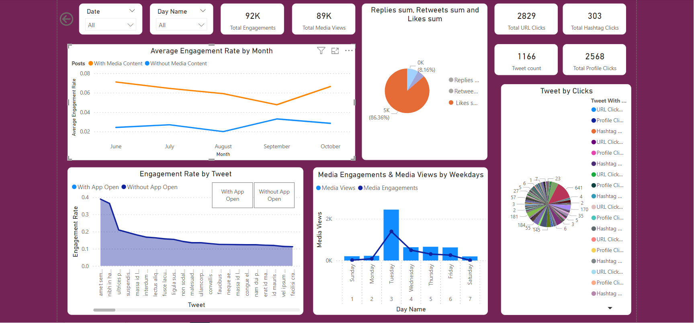

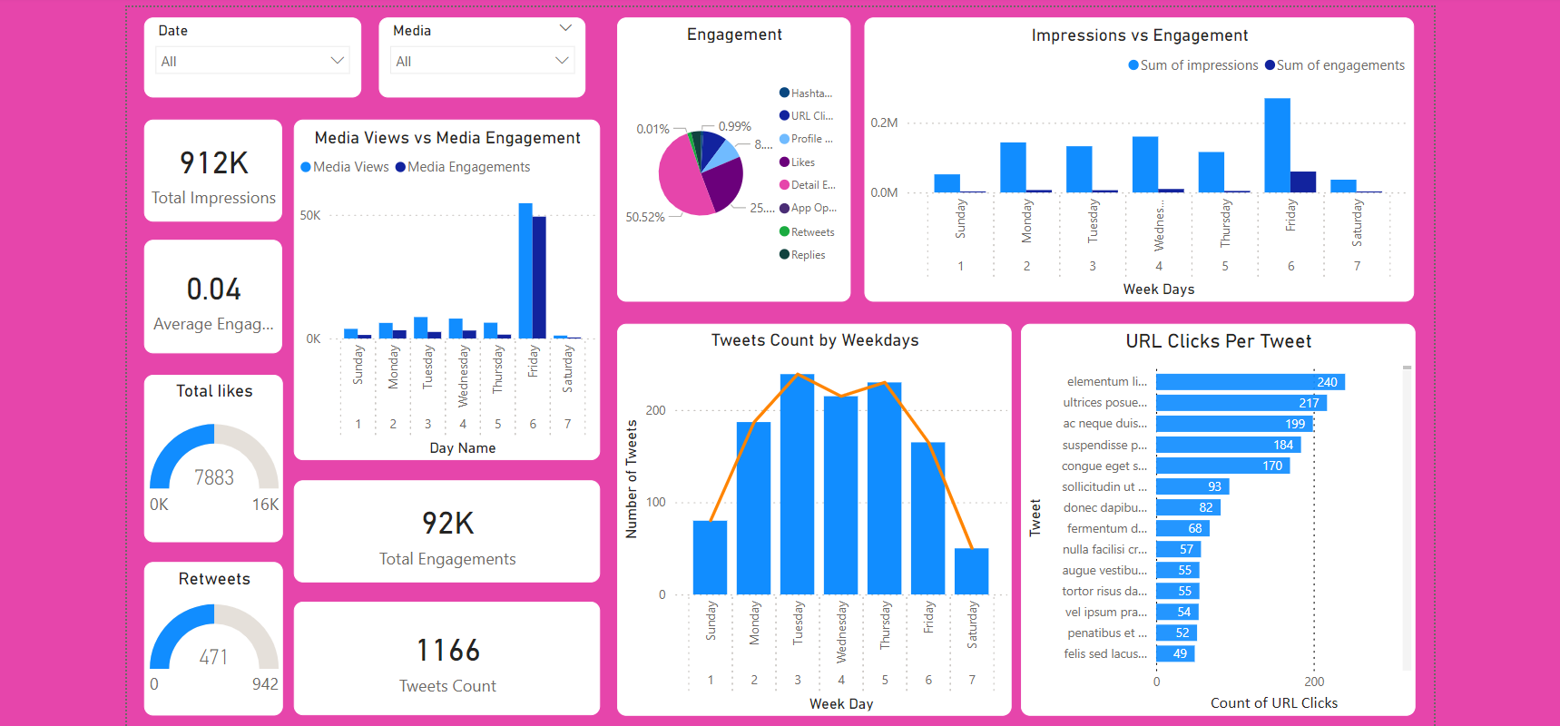

**Challenges and Solutions**

1. **Challenges:**

* Encountered missing values, duplicates, and inconsistencies in the dataset.
* Faced difficulties in deriving the median of media engagements using measure as for some reason it showed zero.
* Highlighting media interactions in dual axis chart as conditional formatting cannot be applied to Dual axis charts.

1. **Solutions:**

* Applied meticulous data cleaning and preprocessing techniques to address data quality issues.
* Instead of using a measure for comparison used the median function in DAX for comparison.
* Used the line visual in Line Stacked Column chart to highlight Media interaction with the spike in media engagements.

**Outcomes and Impact**

The internship project had several positive outcomes and impacts, including:

* **Enhanced Data-Driven Decision-Making**: Provided actionable insights to improve social media strategy.
* **Improved Social Media Engagement**: Helped myself understand user behaviour and engagement trends, leading to better understanding of engagement on Twitter.
* **Personal and Professional Growth**: Enhanced my technical skills in Power BI, data analysis, and communication, contributing to my professional development.

**Conclusion**

The internship at NullClass Pvt. Ltd. provided me with invaluable practical experience in data analytics. I gained hands-on experience in analysing social media engagement metrics, developing interactive visualizations, and deriving actionable insights. The project helped me enhance my technical and analytical skills, improve my problem-solving abilities, and strengthen my communication skills. Overall, the internship was a highly rewarding and impactful experience that significantly contributed to my professional growth.