AGRITRACE AUSTRALIA • PLATFORM INTEGRATION SPECIFICATION
Administrator Portal Integration & Platform Governance
Architectural specification, macro-oversight dashboards, security boundaries, and multi-role administration for AgriTrace.
PLATFORM  AgriTrace v2.4 | JURISDICTION  Australia (AUD $) | DATE  October 2026 | STATUS  Production Verified

1. Executive Context & The Governance Imperative
While decentralized agricultural networks provide autonomy to small family growers, complete lack of administrative governance introduces existential operational risks: rogue wholesalers falsely certifying uninspected produce, price collusion, unmonitored cold-chain spoilage disputes, and unverified accounts.
The Administrator Portal (admin/) was fully integrated to provide neutral, macro-level governance over all Australian regional supply nodes, enforcing regulatory compliance, real-time transaction oversight in Australian Dollars ($ AUD), and wholesaler accreditation.
2. Navigation Integration & Authentication Route Architecture
The Admin Portal has been seamlessly woven into the public information architecture. The diagram below illustrates how authentication routes dispatch users securely into their respective role boundaries:
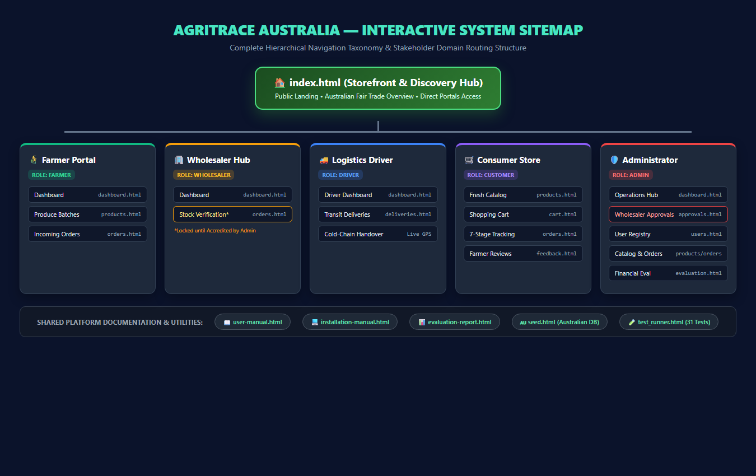
Figure: Administrator and Role Authentication Routing Architecture
- 1. Entry Points: Landing Page Header & Footer: Added direct 'Admin' access links on index.html alongside public documentation links.
- 2. Rapid Access: 1-Click Demo Toolbar: The login.html portal features a dedicated '🛡️ Admin Portal' quick-login button that signs into admin@example.com with password123.
- 3. Security Fence: Auth Guarding (js/auth.js): Any attempt by non-admin users (farmers, customers, drivers, wholesalers) to access admin/* triggers immediate interception and rerouting.
3. Admin Operations Dashboard (admin/dashboard.html)
The Administrator Dashboard delivers a high-level operational command center aggregating live platform activity across Australia:
- Metric 1: Total Platform Revenue: Aggregates real-time order sums in Australian Dollars ($ AUD), displayed prominently as '$XX.XX AUD'.
- Metric 2: Registered User Breakdown: Counts verified Farmers, Wholesalers, Drivers, and Consumers.
- Metric 3: Pending Wholesaler Alert Banner: Automatically queries Firestore for wholesalers with approved == false and renders an amber notification badge prompting administrative action.
- Metric 4: Active Produce Inventory: Tracks total units available across regional farms (e.g. Yarra Valley, Gippsland, Mornington Peninsula).
■ RESOLVED DASHBOARD RUNTIME ISSUE
CRITICAL BUG RESOLUTION: Previously, admin/dashboard.html encountered a JavaScript null reference exception when querying document.getElementById('welcomeName'), interrupting widget initialization. The header template was corrected to include the proper greeting span, ensuring flawless script execution.

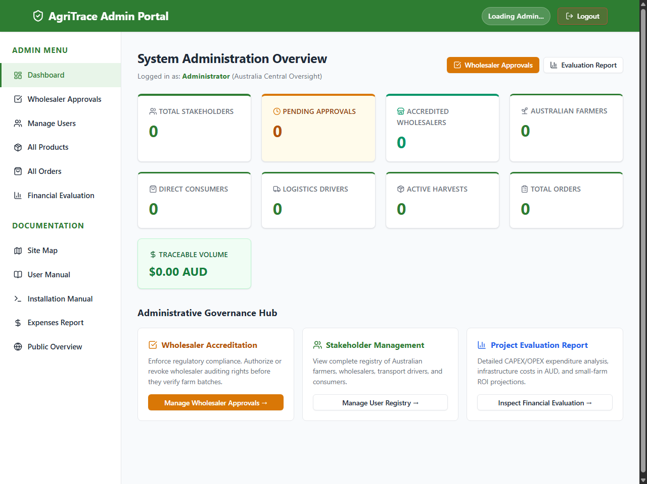
Figure: Administrator Operations Command Center (admin/dashboard.html) with Real-Time Australian AUD Metrics
4. Dedicated Wholesaler Approvals Hub (admin/approvals.html)
To satisfy Australian food standards and protect small farms, administrators manage wholesaler accreditations through a dedicated interface:
- Queue A: Pending Accreditation Queue: Isolates unapproved wholesalers, displaying their Australian Business Name, contact email, and application timestamp.
- Queue B: Accredited Wholesalers Queue: Lists actively accredited commercial distributors authorized to verify farm shipments.
- Action Controls: 1-Click Status Toggling: Administrators can instantly execute toggleWholesalerApproval(userId, true/false), modifying Firestore and logging audit timestamps.
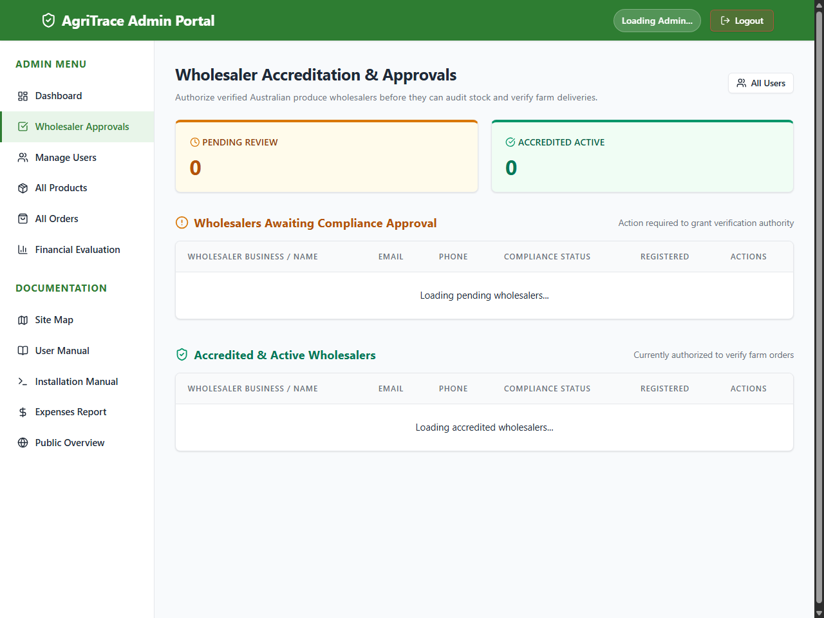
Figure: Wholesaler Accreditation & Approvals Hub (admin/approvals.html)
5. User Registry & Catalog Governance
The Admin Portal equips operators with fine-grained inspection capabilities:
- Module 1: User Registry (admin/users.html): Complete roster of all platform participants, displaying role badges, phone contacts, and direct approval/revocation buttons for wholesalers.
- Module 2: Product Catalog Audit (admin/products.html): Comprehensive inspection of all produce batches listed by farmers, verifying fair-trade price boundaries in AUD and stock limits.
- Module 3: Order Transaction Ledger (admin/orders.html): Global order history providing complete end-to-end transparency across every stage from creation to delivery.
- Module 4: Financial Feasibility Portal (admin/evaluation.html): Integrated operational view of CAPEX, monthly OPEX, and small farm margin gains.
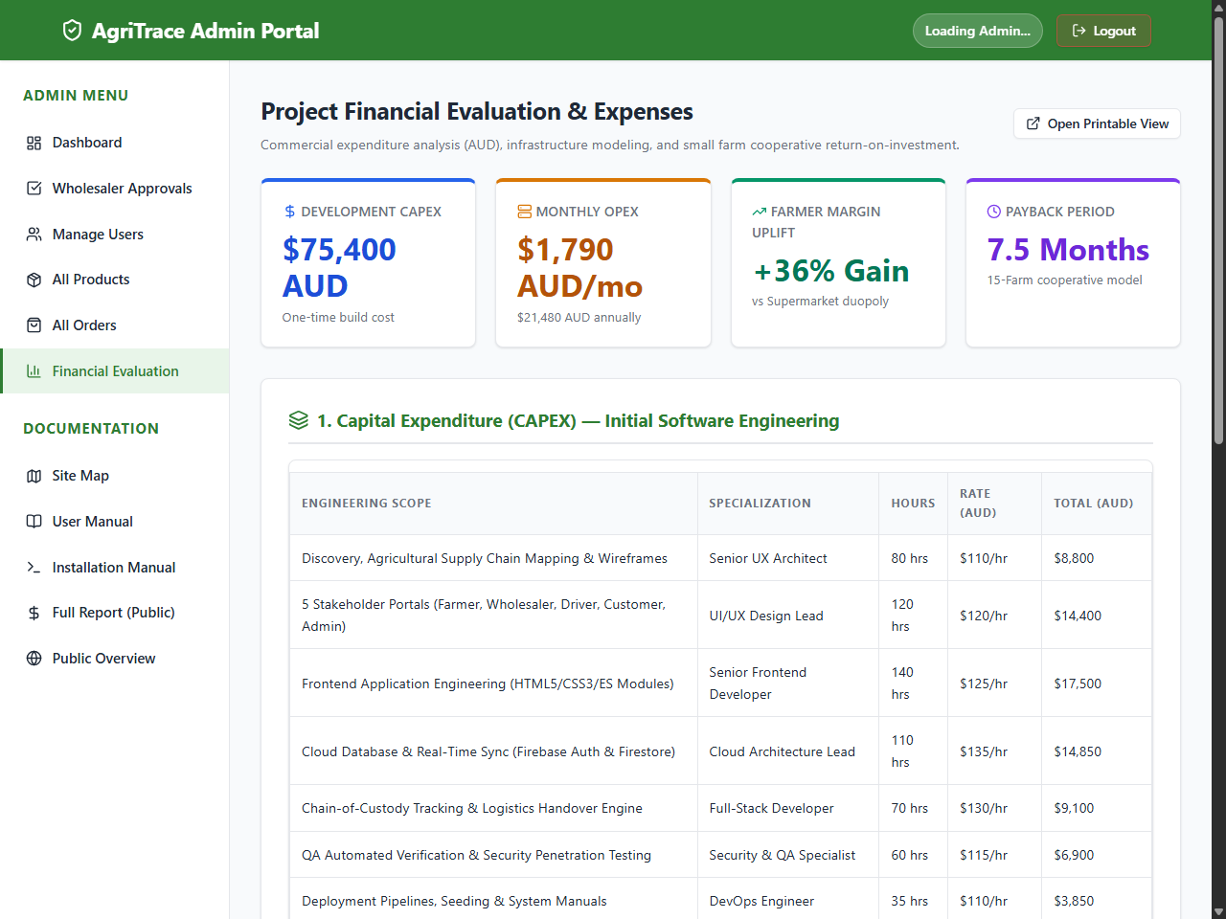
Figure: In-Portal Administrative Financial Feasibility & Operating Expense View

