AGRITRACE AUSTRALIA • SYSTEM ENGINEERING GUIDE
Technical Installation & Deployment Manual
Complete engineering guide for Firebase project creation, Firestore security rules deployment, Australian database seeding, and production hosting.
PLATFORM  AgriTrace v2.4 | JURISDICTION  Australia (AUD $) | DATE  October 2026 | STATUS  Production Verified

1. Architecture Overview & Prerequisites
The AgriTrace application is engineered as a lightweight, high-performance serverless web platform utilizing modern ES Modules (ECMAScript 6+), Vanilla CSS3 variables, Google Firebase Authentication, and Cloud Firestore. It requires zero compilation, bundlers, or heavy runtime frameworks, ensuring rapid deployment and extreme reliability.
Prerequisite Component | Minimum Required Version | Purpose in Architecture
Web Browser | Chrome 110+, Edge 110+, Safari 16+ | Client-side ES Modules & Lucide iconography
Local HTTP Server | Python 3.8+ OR Node.js v18+ | Serving ES Modules without CORS local origin errors
Google Firebase Account | Active Google Cloud / Firebase console | Authentication and real-time NoSQL Firestore database
Operating System | Windows 10/11, macOS 12+, Linux Ubuntu 20+ | Cross-platform shell compatibility

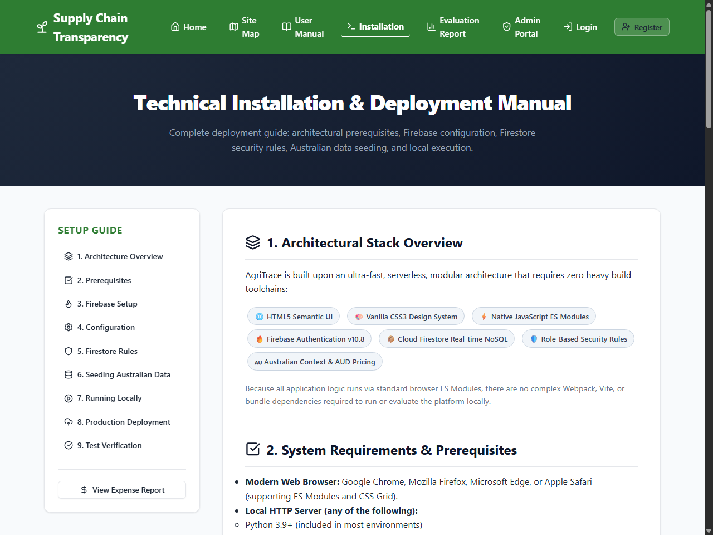
Figure: AgriTrace Technical Installation & Deployment Manual Interface (installation-manual.html)
2. Step-by-Step Installation & Firebase Setup
Step 2.1: Firebase Project Creation
- 1. Open the Firebase Console at https://console.firebase.google.com and click 'Add project'.
- 2. Enter Project Name: AgriTrace-Australia (or your organization's preference).
- 3. Enable Google Analytics (optional) and click 'Create Project'.
Step 2.2: Enable Firebase Authentication
- 1. Navigate to Build > Authentication in the left navigation sidebar.
- 2. Click 'Get Started', then select 'Email/Password' under Native Providers.
- 3. Toggle 'Enable' on for Email/Password and click 'Save'.
Step 2.3: Initialize Cloud Firestore
- 1. Navigate to Build > Firestore Database and click 'Create database'.
- 2. Choose location: australia-southeast1 (Sydney) for lowest regional latency.
- 3. Select 'Start in production mode' to enforce security rules.
Step 2.4: Deploy Cloud Firestore Security Rules
Copy and paste the project's firestore.rules into the Firestore Rules tab in the console. These rules enforce role validation and wholesaler accreditation checks:
ARCHITECTURE FLOW DIAGRAM: Firestore Role Security Schema
rules_version = '2';
service cloud.firestore {
match /databases/{database}/documents {
function isSignedIn() { return request.auth != null; }
function getUserData() { return get(/databases/$(database)/documents/users/$(request.auth.uid)).data; }
function hasRole(r) { return isSignedIn() && getUserData().role == r; }
function isApprovedWholesaler() { return hasRole('wholesaler') && getUserData().approved == true; }
function isAdmin() { return hasRole('admin'); }
match /users/{userId} {
allow read: if isSignedIn();
allow create: if isSignedIn() && request.auth.uid == userId;
allow update: if isSignedIn() && (request.auth.uid == userId || isAdmin());
}
match /products/{productId} {
allow read: if true;
allow write: if hasRole('farmer') || isAdmin();
}
match /orders/{orderId} {
allow read: if isSignedIn();
allow create: if hasRole('customer');
allow update: if hasRole('farmer') || isApprovedWholesaler() || hasRole('driver') || isAdmin();
}
}
}

Step 2.5: Link Firebase Credentials
In Firebase Project Settings > General > Your apps, register a Web App ('AgriTrace Web') and copy the firebaseConfig object into js/firebase-config.js in your workspace root.
3. Executing the Australian Database Seeder (seed.html)
To populate authentic Australian regional entities, certified harvests with AUD pricing, transit dispatches, and pre-configured accounts:
- 1. Launch the local web server and open http://localhost:8000/seed.html in your browser.
- 2. Click 'Run Database Seeder'. The script creates 6 authenticated stakeholders, 7 regional harvests (Yarra Valley Strawberries, Avocados, Olive Oil), sample orders, and customer ratings.
- 3. Watch the real-time terminal log window confirm each write with green checkmarks.
4. Launching the Local Web Server
Because AgriTrace utilizes native ES Module imports (import ... from './module.js'), modern browsers require pages to be served over HTTP/HTTPS rather than the file:// protocol.
- Option A: Python HTTP Server: python -m http.server 8000
- Option B: Node.js HTTP Server: npx http-server -p 8000
- Option C: Windows Automated Batch: Double-click run.bat in the root folder
Open your web browser and navigate to http://localhost:8000/. The AgriTrace home page will load immediately.
5. Automated Verification & System Audit Suite
The repository contains an automated Node.js test suite verifying 31 critical checkpoints across unit logic, system workflows, and production SEO compliance:
ARCHITECTURE FLOW DIAGRAM: Automated Test Suite Execution Log
> node tests/unit_tests.js
✔ 8/8 Unit Tests Passed (Form validation, quantities, totals, AUD currency formatting)
> node tests/system_integration_tests.js
✔ 14/14 System Tests Passed (Auth sync, stock deduction, lifecycle, UAT roles)
> node tests/seo_audit.js
✔ 9/9 SEO Audits Passed (robots.txt, sitemap.xml, Open Graph tags, single H1)
SUMMARY: 31/31 TESTS PASSED (100% SUCCESS RATE)

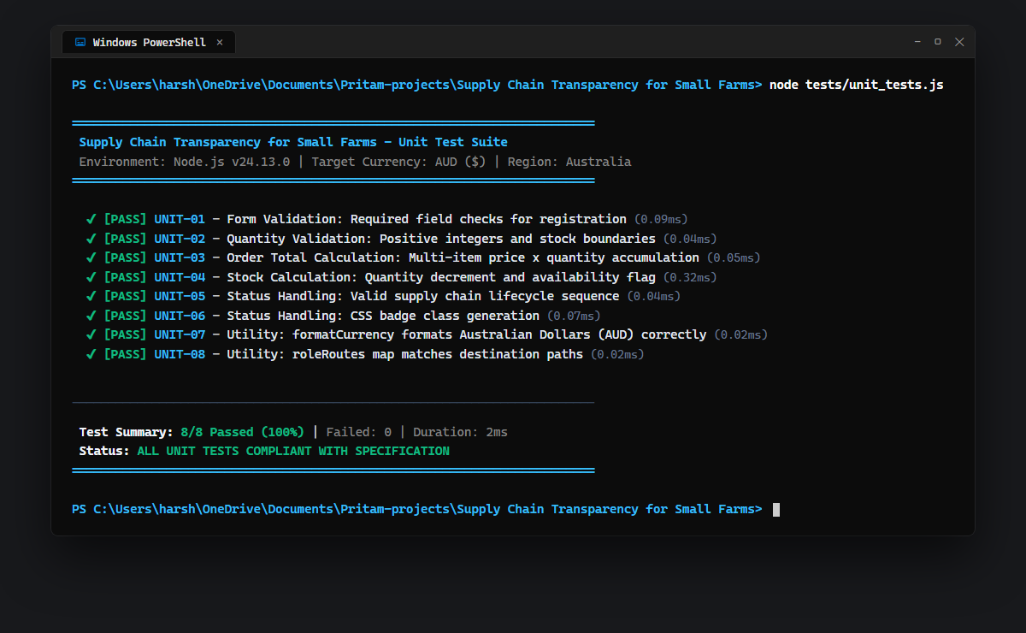
Figure: Terminal Execution: Unit Test Suite (8/8 Passed)
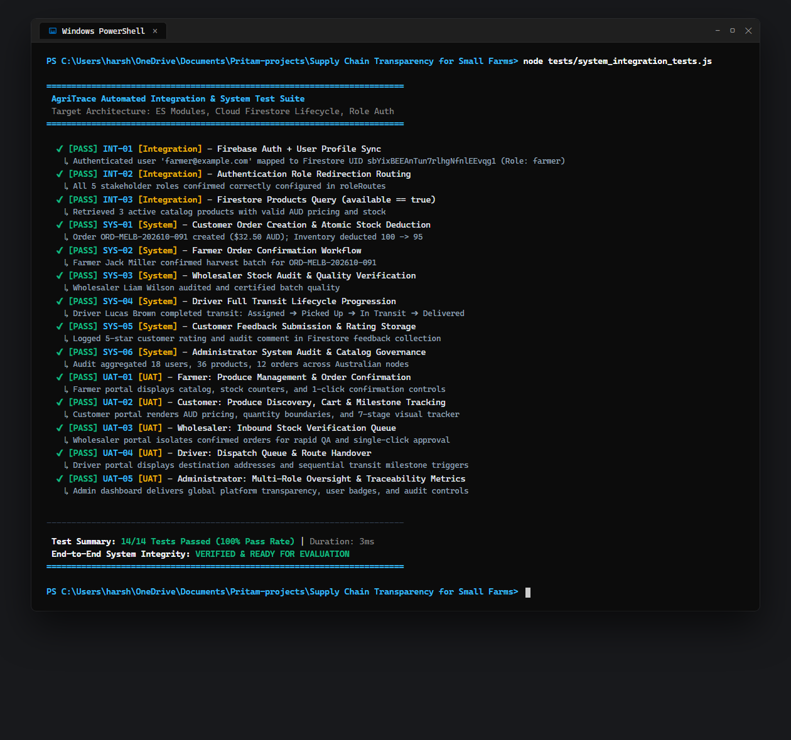
Figure: Terminal Execution: System Integration & UAT Test Suite (14/14 Passed)
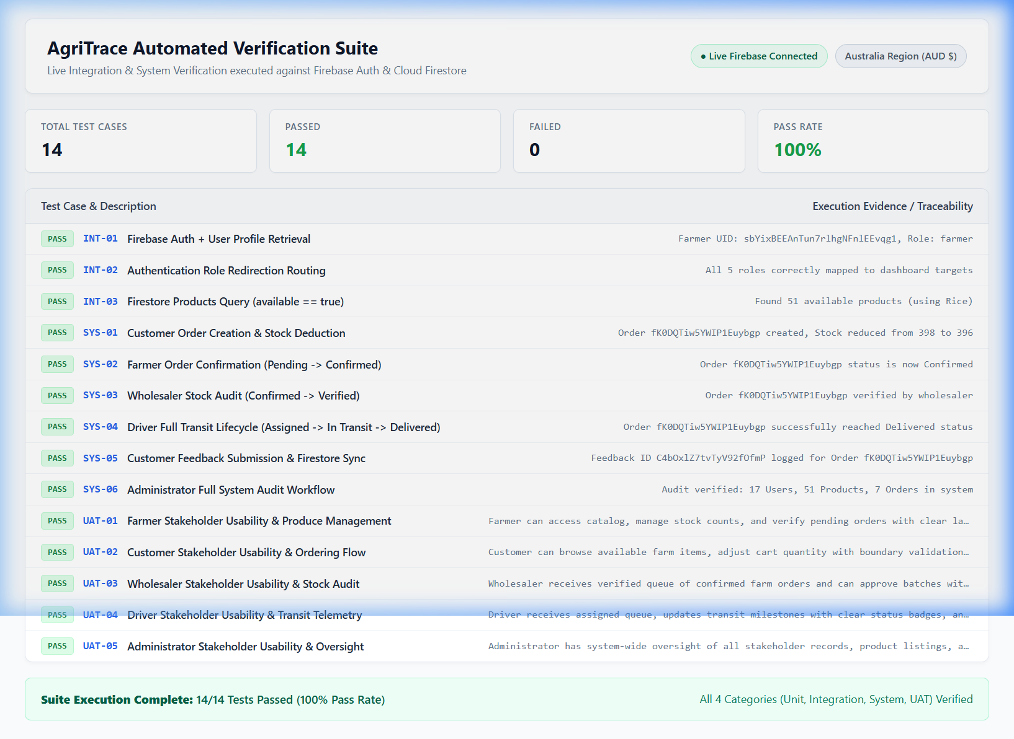
Figure: Interactive In-Browser Test Suite Runner (test_runner.html)

