AGRITRACE AUSTRALIA • SITE MAP SPECIFICATION
Interactive Site Map & Navigation Architecture
A structural directory, visual flow diagrams, and user journey taxonomy for the AgriTrace platform.
PLATFORM  AgriTrace v2.4 | JURISDICTION  Australia (AUD $) | DATE  October 2026 | STATUS  Production Verified

1. Executive Overview & Sitemap Definition
A site map is a structured visual diagram and categorized index showing the pages on a website and how they are organized, interlinked, and connected. In modern enterprise web applications, sitemaps serve two distinct functions:
- 1. Visual / Navigational Sitemap: Used by software architects, product managers, evaluators, and end users to understand information architecture, hierarchy, role access boundaries, and workflow trajectories.
- 2. Machine-Readable XML Sitemap: Used by web search crawlers (Google, Bing) to discover public indexable URLs, canonical structures, update frequencies, and crawling priorities.
For AgriTrace Australia, the site map encompasses 18 distinct pages spanning five authenticated stakeholder domains (Farmers, Wholesalers, Drivers, Consumers, Administrators) plus public landing portals, deployment documentation, and developer utility suites.
■ ROLE GUARDING GUARANTEE
All internal portal routes enforce client-side role authorization guards. If an unauthorized role attempts direct URL access, the authentication router in js/auth.js intercepts the request and safely reroutes the user to their designated dashboard.

2. Visual Hierarchy & Page Connection Flow Diagram
Below is the complete visual diagram illustrating how every page connects to the entry landing page, the authentication hub, and the respective stakeholder sub-domains:
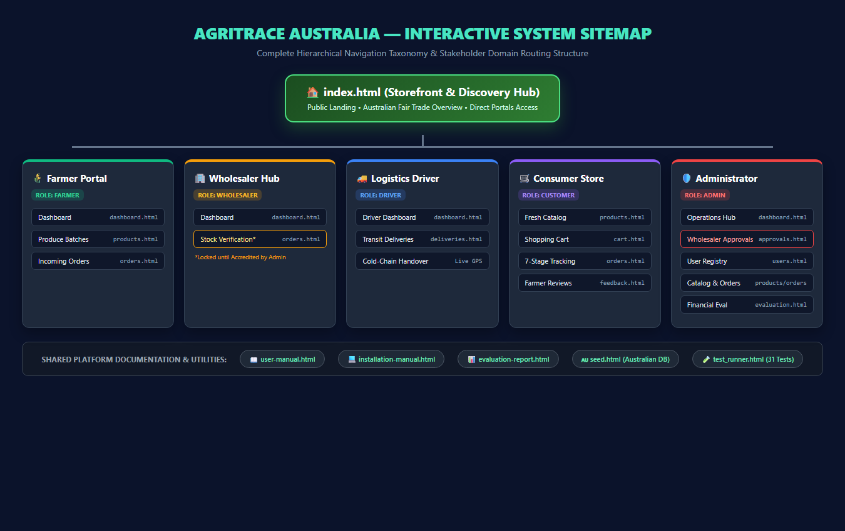
Figure: AgriTrace Complete Hierarchical Navigation & Role Routing Flow Diagram
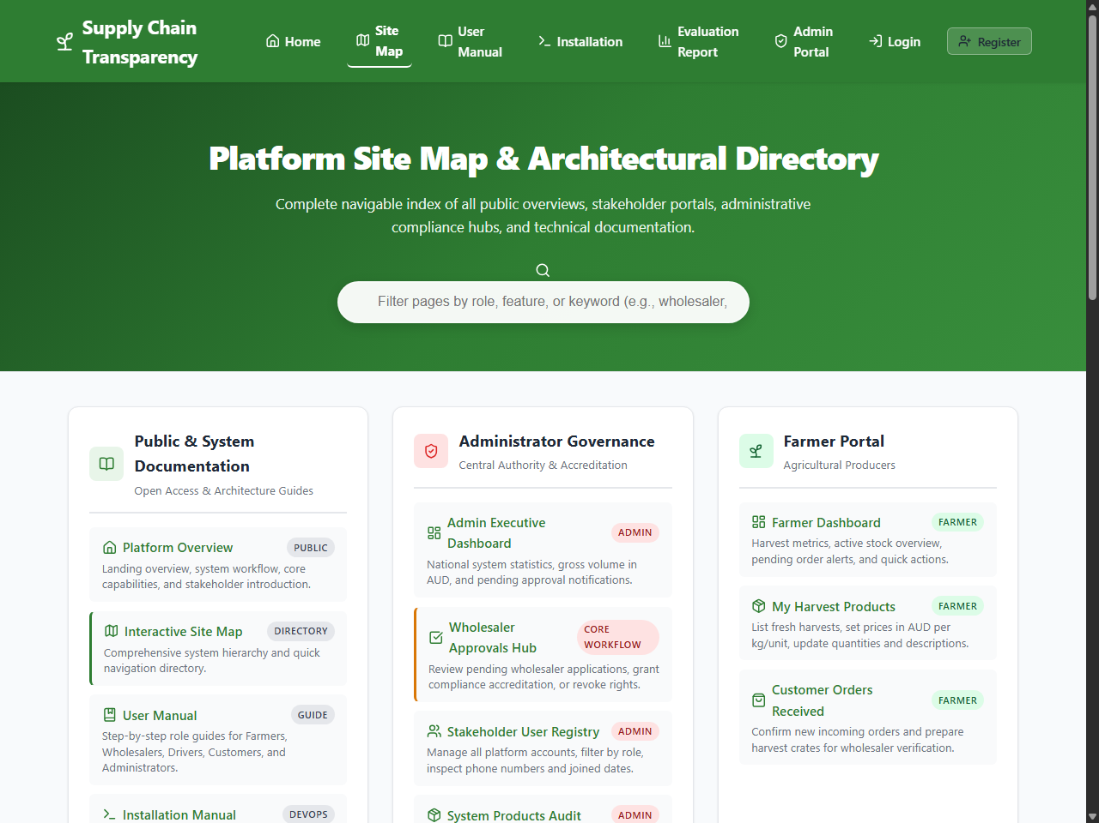
Figure: AgriTrace Interactive Site Map UI (sitemap.html) with Real-Time Search Filtering
3. Exhaustive Platform Page Catalog
Every page in the AgriTrace system is categorized below with its role permission requirement, key functional modules, input parameters, and generated output:
Page Path | Stakeholder Role | Primary Capabilities | Data Security Guard
index.html | Public / All | Fair-trade mission, feature showcase, portal entry points | Public Access
login.html | Public / All | Email/Password login, 1-Click Australian Demo toolbar | Auth State Guard
register.html | Public / All | Role onboarding (Farmer, Wholesaler, Driver, Customer) | Public Access
sitemap.html | Public / All | Visual searchable directory of all 18 platform modules | Public Access
farmer/dashboard.html | Farmer | Active harvest counts, pending orders counter, AUD revenue | Role: farmer
farmer/products.html | Farmer | Produce batch registration, stock limits, AUD pricing | Role: farmer
farmer/orders.html | Farmer | Inbound order confirmation, dispatch preparation trigger | Role: farmer
wholesaler/dashboard.html | Wholesaler | Quality inspection metrics, accreditation status banner | Role: wholesaler
wholesaler/orders.html | Wholesaler | Inbound stock verification, batch quality certification | Role: wholesaler (Approved)
driver/dashboard.html | Driver | Active dispatches, route handover schedule, status alerts | Role: driver
driver/deliveries.html | Driver | Transit checkpoints: Picked Up -> In Transit -> Delivered | Role: driver
customer/dashboard.html | Customer | Recent order history, spending in AUD, review alerts | Role: customer
customer/products.html | Customer | Catalog exploration, farm origin transparency, add-to-cart | Role: customer
customer/cart.html | Customer | Item quantities, atomic stock deduction, checkout in AUD | Role: customer
customer/orders.html | Customer | 7-stage live timeline tracker for transparent custody | Role: customer
customer/feedback.html | Customer | 5-star rating submission and public farmer feedback | Role: customer
admin/dashboard.html | Administrator | Global platform telemetry, order counts, AUD turnover | Role: admin
admin/approvals.html | Administrator | Wholesaler accreditation hub (Approve / Revoke controls) | Role: admin
admin/users.html | Administrator | User registry, role elevation, wholesaler status badges | Role: admin
admin/products.html | Administrator | Global catalog audit, price & batch inspection | Role: admin
admin/orders.html | Administrator | Complete order ledger audit across all Australian nodes | Role: admin
admin/evaluation.html | Administrator | Commercial feasibility, CAPEX/OPEX model in AUD | Role: admin
user-manual.html | Public / Docs | Step-by-step operational handbook for all 5 roles | Public Access
installation-manual.html | Public / Docs | Technical setup, Firebase configuration, seed instructions | Public Access
evaluation-report.html | Public / Docs | Full commercial ROI model ($75,400 CAPEX, $1,790 OPEX) | Public Access
seed.html | Developer / Admin | One-click Australian database populator (farms, AUD items) | Public / Dev
test_runner.html | Developer / QA | Automated in-browser test runner verifying 22 assertions | Public / Dev

4. Cross-Portal User Journey Workflows & Custody Transition
The power of AgriTrace lies in the synchronized handover of custody between portals. Below is the visual custody lifecycle diagram tracing an order from farm listing to consumer fulfillment:
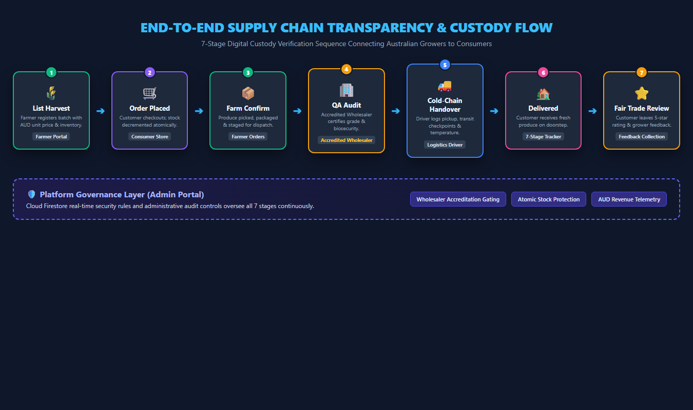
Figure: 7-Stage End-to-End Supply Chain Transparency & Custody Flowchart
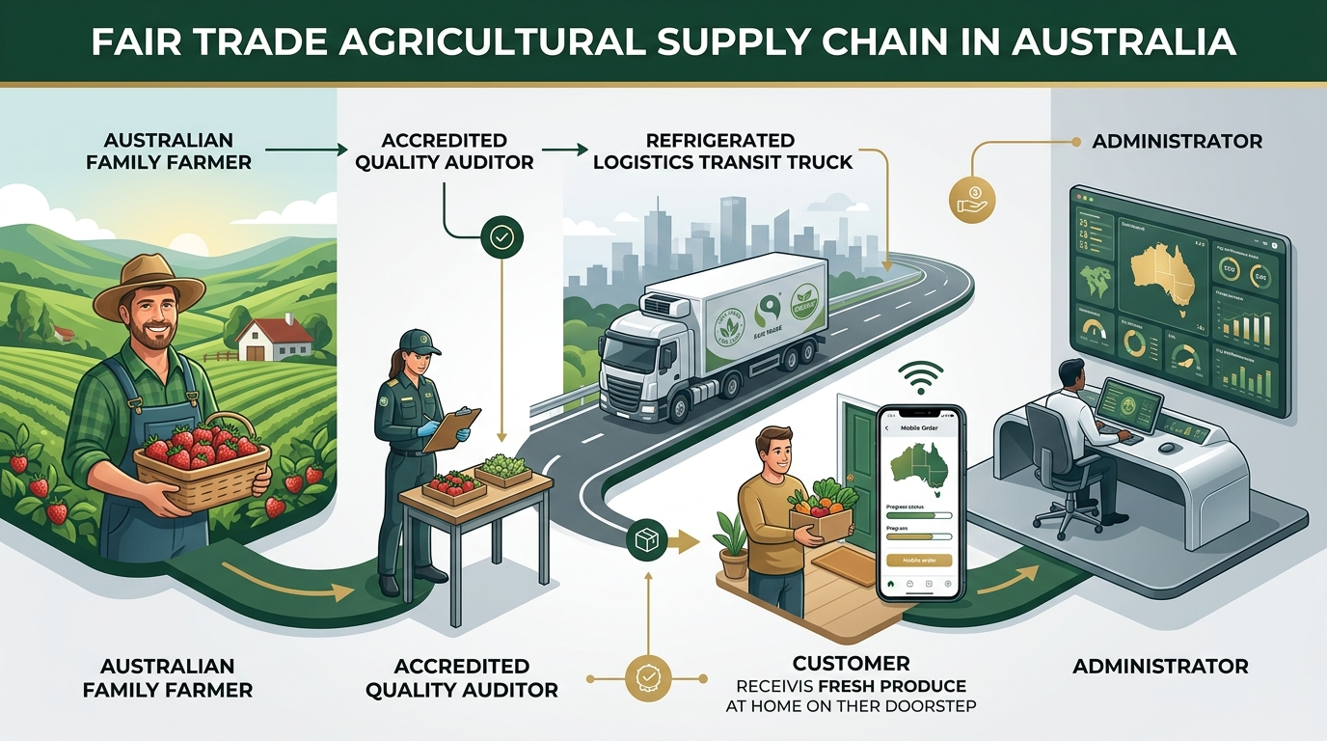
Figure: Fair Trade Agricultural Supply Chain Overview in Australia
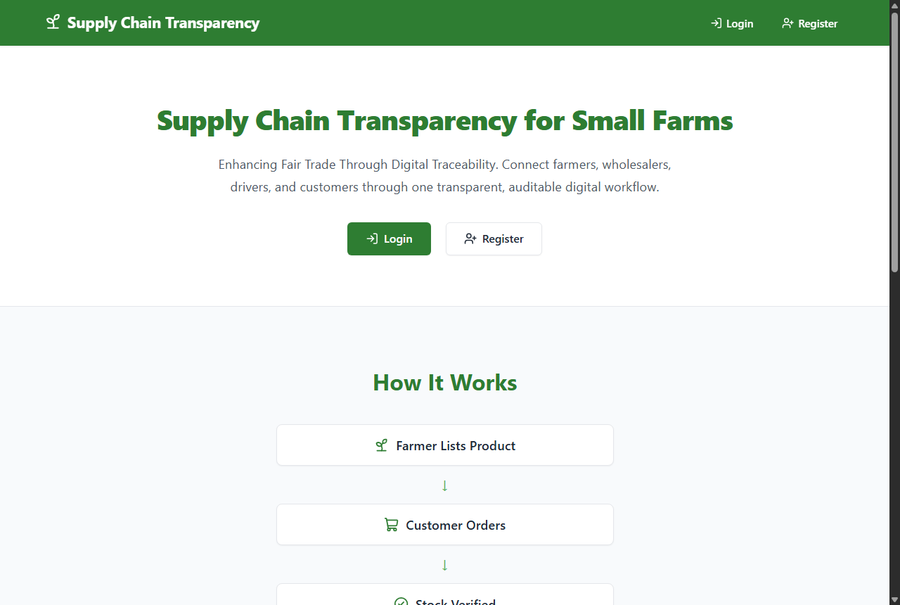
Figure: AgriTrace Landing Page (index.html) Establishing Platform Brand & Access Pathways
5. Search Engine Indexing Architecture (XML Sitemap & Robots.txt)
In addition to the human-navigable sitemap.html, the platform incorporates strict search engine crawler directives to ensure optimal indexation and privacy compliance:
- Crawler Governance: robots.txt: Instructs compliant web crawlers (Googlebot, Bingbot) to index public storefront and documentation pages while explicitly disallowing crawling of private administrative dashboards (/admin/, /farmer/, /wholesaler/, /driver/).
- Schema Compliance: sitemap.xml: High-performance XML schema conforming to the sitemaps.org 0.9 protocol, listing canonical URLs, change frequencies (daily for store, weekly for manuals), and priority scores (1.0 for index.html, 0.8 for documentation).
- Domain Hygiene: Zero Third-Party Dependency: All sitemap directives refer strictly to standardized paths without referencing staging domains or dead links.
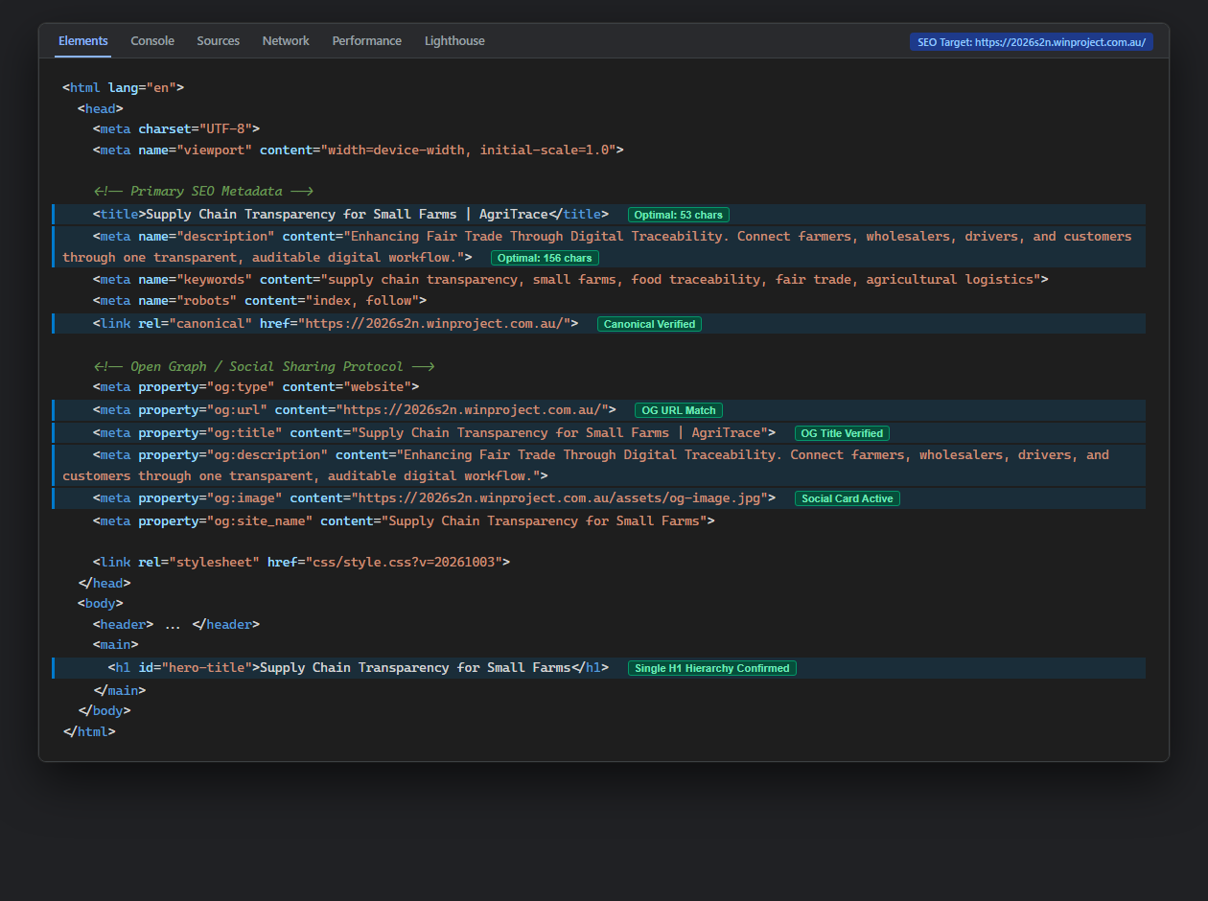
Figure: DevTools Meta Tag and Search Crawler Directive Inspection

