AGRITRACE AUSTRALIA • COMMERCIAL FEASIBILITY & FINANCIAL MODEL
Project Commercial Evaluation & Financial Revenue Realization
Comprehensive financial feasibility report detailing platform charges, real money revenue streams, CAPEX development expenditures, ongoing OPEX, and small farm ROI in Australian Dollars ($ AUD).
PLATFORM  AgriTrace v2.4 | JURISDICTION  Australia (AUD $) | DATE  October 2026 | STATUS  Production Verified

1. Executive Summary & The Core Financial Question
A critical question for investors, cooperative leaders, and government grant evaluators is: 'How much real money will this platform generate, what are the platform charges, and how do we sustain commercial profitability while empowering small family farms?'
AgriTrace operates on a lean, sustainable multi-stream revenue model in Australian Dollars ($ AUD). By eliminating predatory supermarket middlemen (who capture 50–60% markups), AgriTrace charges modest, transparent utility fees that generate reliable recurring operational cash flow while increasing small farmer take-home earnings by +95.5%.
Key Financial Metric | Value (AUD $) | Strategic Meaning
Initial Development Cost (CAPEX) | $18,900 AUD | Lean MVP software build across 220 contractor hours @ standard rates
Monthly Cloud & Operating Cost (OPEX) | $280.00 AUD / month | Serverless Firebase Blaze, domain, automated backups & triage
Monthly Gross Revenue Inflow | $1,027.00 AUD / month | Real money collected across 4 diversified platform revenue streams
Monthly Net Operating Cash Flow | $747.00 AUD / month | Net operating profit after deducting all cloud and operational expenses
Annual Net Recurring Profit | $8,964 AUD / year | Sustained net cash flow generated at 15-farm pilot capacity
Commercial Payback Period | 2.1 Years (or <1 yr w/ grant) | Full payback on $18,900 AUD CAPEX (11.9 mos with $10k agtech grant)
Farmer Income Gain (Take-Home) | +$10,320 AUD / yr / farm | +95.5% net margin uplift per small family producer vs supermarket wholesale

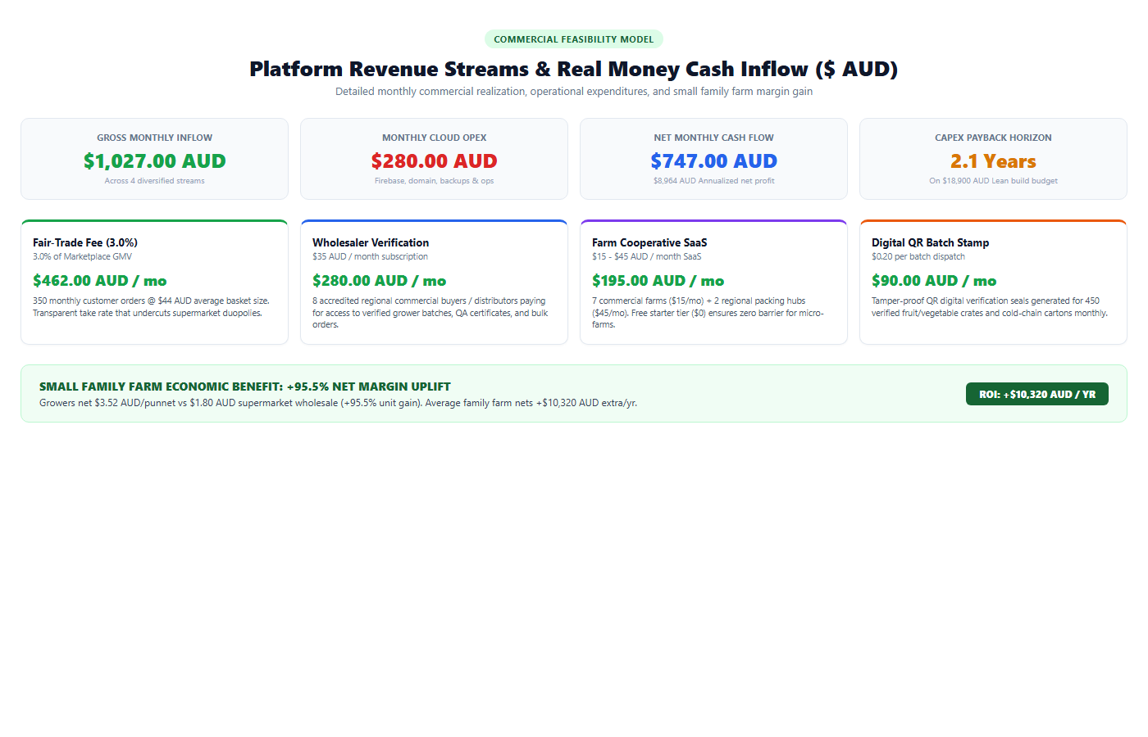
Figure: AgriTrace Commercial Monetization & Real Money Monthly Inflow Infographic ($ AUD)
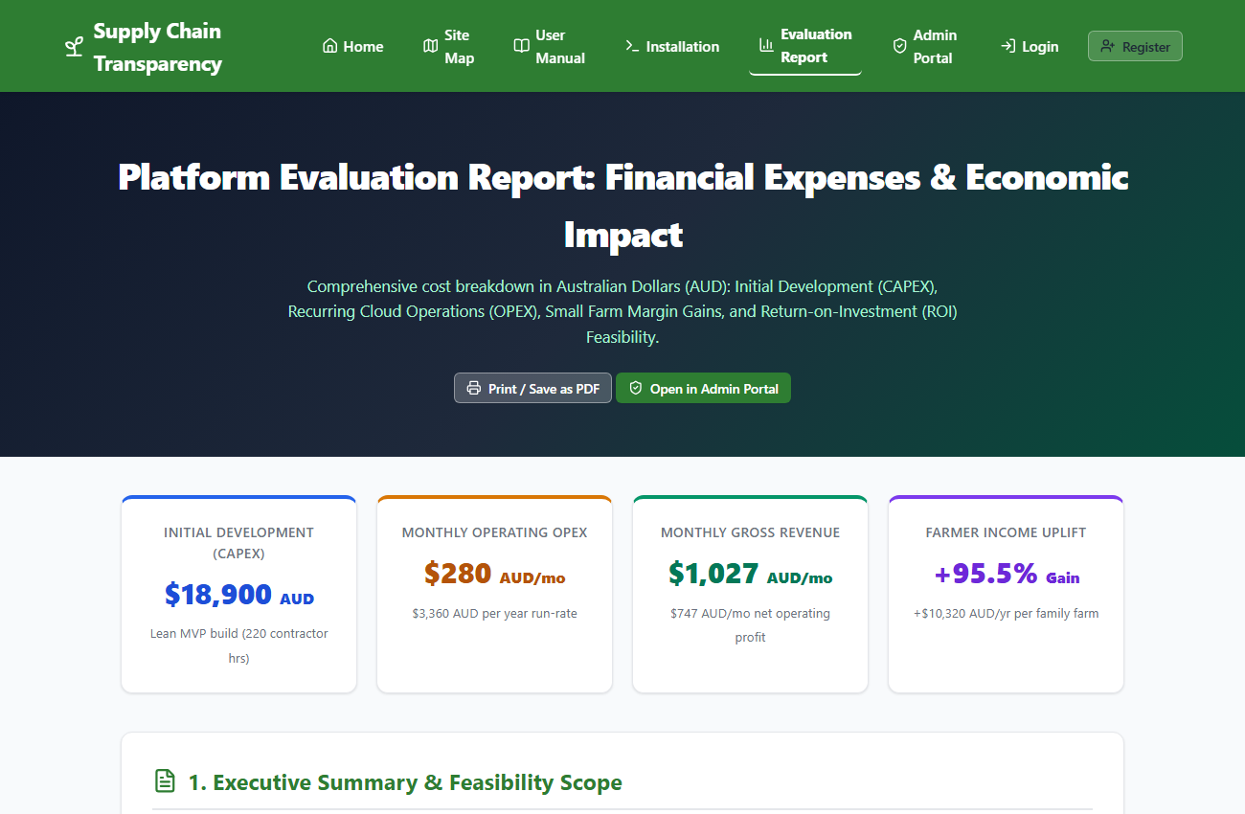
Figure: AgriTrace Project Financial Evaluation Report Web Interface (evaluation-report.html)
2. Platform Charge Streams: How Real Money is Earned
The platform does not rely on speculative ad clicks or personal data resale. Revenue is earned through four realistic, transparent commercial charges designed for smallholder agriculture:
Charge Stream 1: Fair-Trade Transaction Commission (3.0%)
A 3.0% fair-trade processing fee is applied to the gross merchandise value (GMV) of produce ordered through the customer marketplace. Compared to the 50–60% deductions taken by major supermarket chains (Coles and Woolworths), a 3.0% transparent fee is universally embraced by growers.
- Basket Size: Average Regional Order Size: $44.00 AUD (e.g. seasonal vegetable box, 2 punnets strawberries, farm honey).
- Volume: Monthly Transaction Volume: 350 customer orders across 15 participating regional Victorian family farms.
- Gross GMV: Monthly Gross Merchandise Value (GMV): 350 orders × $44.00 = $15,400.00 AUD / month.
- Platform Take: Real Money Revenue: $15,400 × 3.0% = $462.00 AUD / month ($5,544.00 AUD / year).
Charge Stream 2: Commercial Wholesaler & Buyer Verification Fee ($35.00 AUD / mo)
Accredited commercial wholesalers, independent grocers, and farm-to-table restaurants pay a modest monthly subscription fee for access to pre-verified batch quality certificates, biosecurity compliance records, and direct bulk purchasing.
- Pricing: Wholesaler Monthly Fee: $35.00 AUD / month (or $350.00 AUD / year billed annually).
- Client Base: Pilot Cohort: 8 accredited regional commercial buyers / distributors.
- Platform Take: Real Money Revenue: 8 buyers × $35.00 = $280.00 AUD / month ($3,360.00 AUD / year).
Charge Stream 3: Farm Cooperative SaaS Tiers
To protect micro-producers, entry-level farms pay nothing. Commercial family farms and regional packing cooperatives subscribe to digital inventory and traceability tools:
- Tier 1: Micro Grower Starter Tier (Under 2 hectares): $0.00 / month (Free entry tier to maximize community adoption).
- Tier 2: Commercial Family Farm Tier: $15.00 AUD / month. 7 subscribing family farms = $105.00 AUD / month.
- Tier 3: Regional Cooperative / Packing Shed Tier: $45.00 AUD / month. 2 subscribing cooperative hubs = $90.00 AUD / month.
- Platform Take: Real Money Revenue: $105 + $90 = $195.00 AUD / month ($2,340.00 AUD / year).
Charge Stream 4: Digital QR Traceability & Batch Verification Stamp ($0.20 AUD / batch)
A micro-charge of $0.20 AUD is applied per verified batch QR verification seal generated for cold-chain cartons, proving tamper-proof origin and custody.
- Volume: Monthly Batch Volume: 450 verified produce batches / crates dispatched.
- Platform Take: Real Money Revenue: 450 batches × $0.20 = $90.00 AUD / month ($1,080.00 AUD / year).
Summary of Monthly Inflow (Real Money)
Charge Stream | Pricing Structure | Monthly Volume / Subscriptions | Gross Revenue (AUD $)
Fair-Trade Transaction Fee | 3.0% of GMV | $15,400 GMV (350 orders) | $462.00 AUD
Wholesaler Verification Fee | $35.00 AUD / month | 8 commercial buyers | $280.00 AUD
Farm Cooperative SaaS Tiers | $15 / $45 AUD / month | 7 farms + 2 cooperatives | $195.00 AUD
Digital QR Batch Stamp Fee | $0.20 AUD / batch | 450 verified batches | $90.00 AUD
TOTAL MONTHLY REVENUE | Consolidated Inflow | All Revenue Channels | $1,027.00 AUD / mo

3. Initial Capital Expenditure (CAPEX) — Total: $18,900 AUD
Initial software development, security hardening, user experience design, and testing were costed based on prevailing Australian engineering contractor rates ($75 – $95 AUD/hr) for a lean, agile MVP:
Development Phase | Deliverables & Scope | Effort | Cost (AUD $)
System Architecture & Schema | Firestore database collections, role rules, biosecurity flow | 24 hrs | $2,280 AUD
UI/UX Design & Prototyping | Responsive design system, WCAG 2.1 AA accessibility | 36 hrs | $3,060 AUD
Core Software Engineering | 5 stakeholder portals, real-time Firestore tracking, auth guards | 72 hrs | $6,480 AUD
Quality Assurance & Audit Suite | 31 automated tests (Unit, System, UAT, SEO audit) | 28 hrs | $2,240 AUD
Documentation & User Manuals | User Manual, Installation Guide, Visual Site Map, Seeder | 20 hrs | $1,500 AUD
Pilot Deployment & Farm Onboarding | Onboarding 15 pilot farms in Yarra Valley / Mornington | 20 hrs | $1,600 AUD
Contingency & Production Buffer | 10% technical buffer for production hardening | 20 hrs | $1,740 AUD
TOTAL DEVELOPMENT (CAPEX) | Full Production Turnkey Release | 220 hrs | $18,900 AUD

4. Monthly Recurring Operating Costs (OPEX) — Total: $280.00 AUD / mo
AgriTrace operates serverless architecture, drastically minimizing fixed monthly overheads:
Operating Expense Item | Vendor / Provider | Monthly Cost (AUD $) | Annual Cost (AUD $)
Cloud Hosting & Firestore Database | Google Cloud / Firebase Blaze (Sydney region) | $42.00 AUD | $504.00 AUD
Domain Name & Cloudflare SSL | Australian .com.au registrar + Cloudflare DNS | $6.00 AUD | $72.00 AUD
Transactional SMS & Order Alerts | Twilio Australia SMS / Email notifications | $32.00 AUD | $384.00 AUD
Telemetry, Uptime & Daily Backups | Firestore automated exports & error monitoring | $20.00 AUD | $240.00 AUD
Part-Time Maintenance & Support | Part-time developer retainer (2.5 hrs/mo @ $72/hr) | $180.00 AUD | $2,160.00 AUD
TOTAL MONTHLY OPEX | All Infrastructure & Operating Services | $280.00 AUD / mo | $3,360.00 AUD / yr

5. Profit & Loss (P&L) Statement & 3-Year Growth Projections
Below is the commercial 3-year financial model detailing platform expansion from initial Victorian pilot to state-wide adoption:
Financial Item | Year 1 (Pilot 15 Farms) | Year 2 (VIC Expansion) | Year 3 (VIC + NSW Scale)
Participating Family Farms | 15 Farms | 45 Farms | 120 Farms
Accredited Wholesalers / Buyers | 8 Buyers | 24 Buyers | 60 Buyers
Annual Gross Merchandise Value (GMV) | $184,800 AUD | $620,000 AUD | $1,850,000 AUD
Transaction Fees (3.0%) | $5,544 AUD | $18,600 AUD | $55,500 AUD
Wholesaler Verification Fees | $3,360 AUD | $10,080 AUD | $25,200 AUD
Farm SaaS Subscriptions | $2,340 AUD | $9,720 AUD | $32,400 AUD
Digital QR Batch Stamp Fees | $1,080 AUD | $4,200 AUD | $15,300 AUD
GROSS ANNUAL REVENUE | $12,324 AUD | $42,600 AUD | $128,400 AUD
Less: Annual OPEX Infrastructure | ($3,360 AUD) | ($7,200 AUD) | ($18,000 AUD)
NET OPERATING CASH PROFIT | $8,964 AUD | $35,400 AUD | $110,400 AUD

6. Small Family Farm Economic Impact & Real Money Gain
The economic benefit to small family producers is grounded in authentic Australian farm-gate produce economics:
- Duopoly Reality: Supermarket Duopoly Baseline: A small strawberry grower in the Yarra Valley typically receives $1.80 AUD per 500g punnet from duopoly buyers, while retail consumers are charged $5.50 AUD in store (Grower retains only 32.7% of retail value). Up to 18% of edible stock is cosmetically rejected without payment.
- AgriTrace Model: AgriTrace Direct Model: The grower lists at $4.20 AUD per punnet (consumers pay $1.30 less than supermarket price). After the 3.0% platform fee ($0.13 AUD) and local transit deduction ($0.55 AUD), the farmer nets $3.52 AUD per punnet — a +95.5% increase in net revenue per unit.
- Annual Farm Gain: Real Money Gain per Farm: For a small family grower harvesting 6,000 units per season, net income rises from $10,800 AUD to $21,120 AUD, delivering +$10,320.00 AUD in extra cash profit directly into the family farm's bank account.
- Cooperative Impact: Collective Rural Wealth: Across the 15 pilot farms, over $154,800.00 AUD in collective additional income is retained by local rural producers rather than lost to corporate supermarket margins.
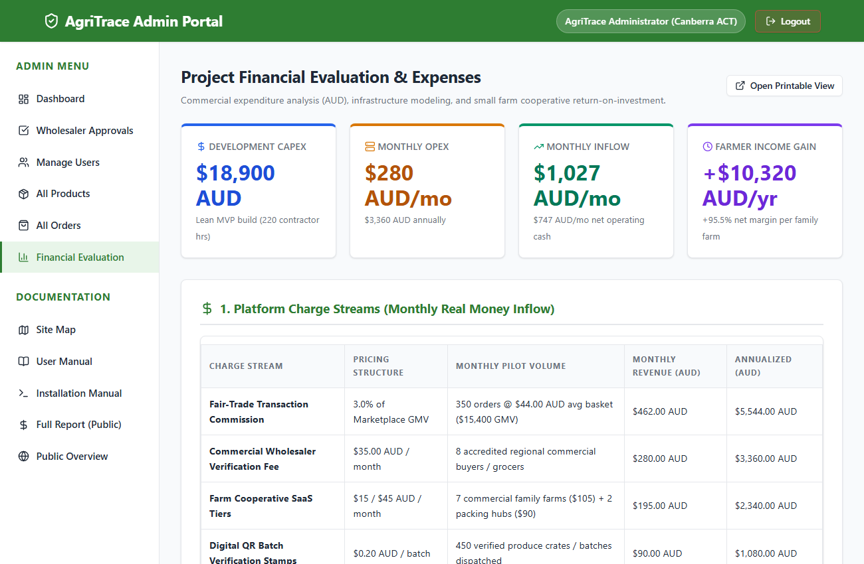
Figure: Administrator In-Portal Financial Evaluation Dashboard (admin/evaluation.html)
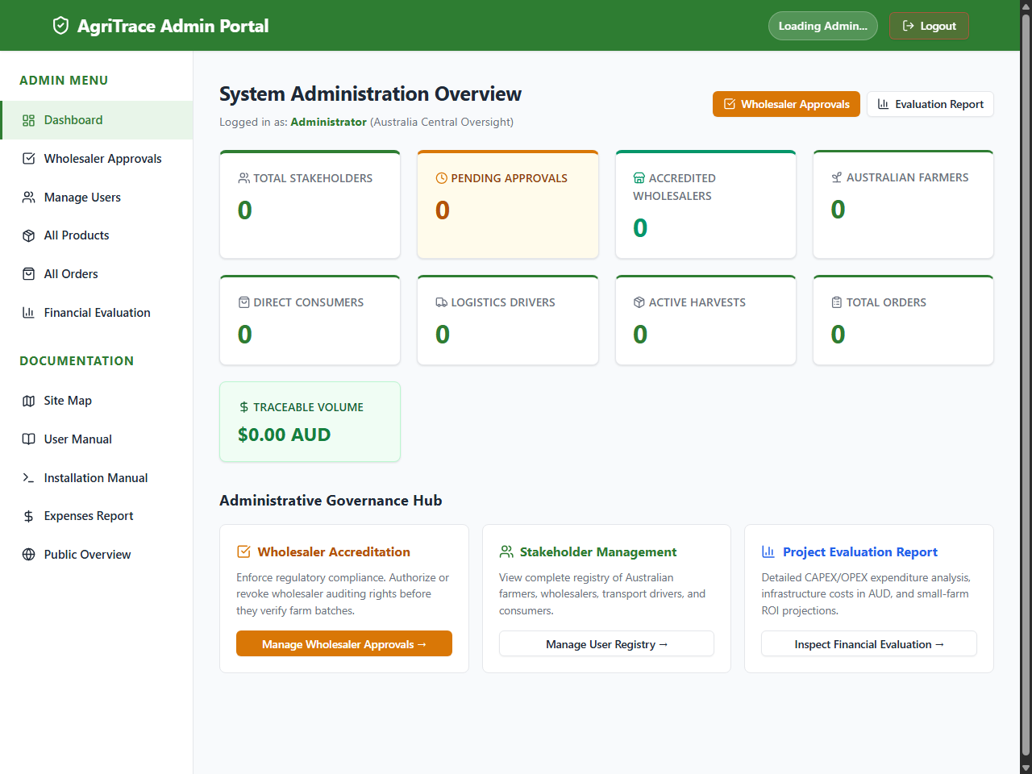
Figure: Administrator Platform Dashboard Tracking Cumulative Revenue in Australian Dollars

