**Brajendra Kishor Singh**

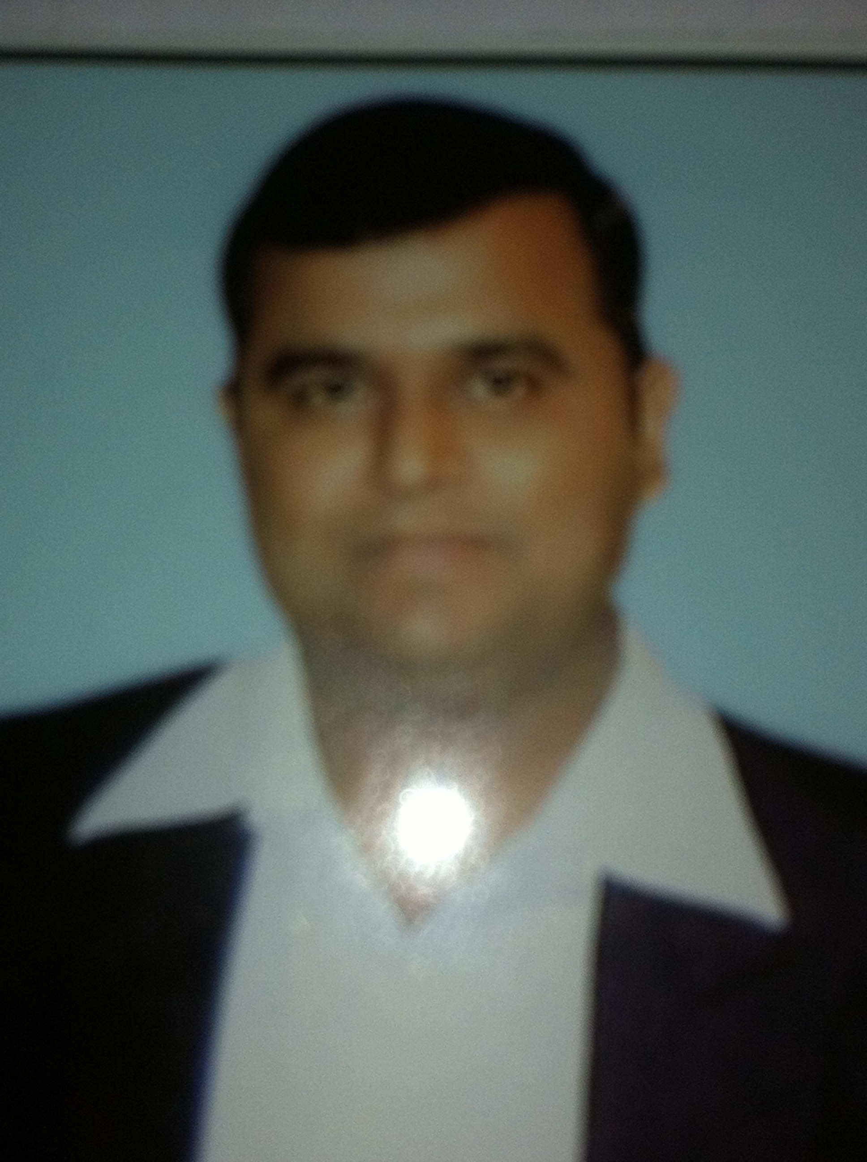

**Personal Info**: Address- HNO-580, MS BLOCK, RANAJI ENCLAVE .ND-110043.

Mail [id: Brajendrasingh66@gmail.com](mailto:id:%20Brajendrasingh66@gmail.com). Phone No: 09891666668

**Professional Profile**: Brajendra Kishor is a management graduate with 13.2 years of experience in

FMCG & TELECOM.

**Work Experience**

**I) Organization: - RELIANCE JIO.**

**Designation : -JIO CENTRE MANAGER**

**Duration** : - **Since 10 Nov 2014.**

**Reliance JIO is part of Reliance Industries Ltd which got the 4G License of Pan India.**

**Responsibilities/KRA**

1. Taking Care of P&L of Jio Centre with the Geography size of 307 Sq Km area.

2. Handling the Operation of Jio Centre and Business of Devices and Mobility .

3. Handling and Recruitment of the Team of Direct Repotee and Indirect Repotee (Sales, RE, RF ,Fin,,SCM JIO Store, )

4. Mapping of JC Boundary. Looking after the territory & Responsible for Network

5. Retail Mapping in terms of Telecom, Devices, Consumer Durable, Car Accessories,Automobiles,Tyre Showroom

6. Managing the HORECA/Hospital/Management Institute/Malls in the defined territory to provide the network solution for the 4G network for seamless service.

7. Appointment of RDS & ARD & Retailers at JIO Centre area.

8 Acquiring New Sites and also to resolve the Hold Sites. Coordination with GIS and Network Team

9.Building Acquisitions team- coordination for acquiring building for network for Fiber and Small Cell/Micro Cell.

**1I) Organization: - VODAFONE SPACETEL LTD.**

Designation : - Area Sales Manager

Duration : - December 2013 to 2 Nov 2014**.**

**Vodafone Group plc is a British multinational telecommunications company. Vodafone Ltd is the 2rd Largest GSM Operator of India.**

**Responsibilities/KRA**

1. Lead a team of 5 Channel Sales Managers, 25 Prepaid Sales Representatives, 11 SD/MD and 70 ADs.

2. Monthly Sales targets Phasing /Setting for Distributors.

3. Primary, Secondary, Tertiary and Activation Sales Management.

4. Training to Sales Team, Guiding and Motivation.

5. ROI Management.

6. Appraising Direct Reportee (S) as per HR Cycle, aligning them to organizational needs.

**1II)** Organization**: - DISH TV India Ltd. is part of Essel Group of Company. Its First DTH Company. Its Market leader in DTH Industry and Service having Pan India**

Designation : - Asst. Manager

Duration : -Nov 2012 to Nov2013

**Responsibilities/KRA**

1. Handling the Channel and Retails Sales.

2. Devising activation scheme. Increasing the width and depth of distributions.

3. Planning & appointing new channel partners

4 .Responsible for Revenues (EPRS), Recharge, STB Primary , Acquisition, STB Dealers , CD Dealers,

SD/HD Box Primary & Activations through Distributors channel.

5. Ensuring proper implementations of company plans and activates.

6. .MIS

7. To conduct regular Sales Team reviews

**IV)** Organization: **- Idea Cellular Ltd. (Delhi) Idea Cellular ltd is the Flagship company Aditya Birla Group. Its 3rd GSM Operator of India**

Designation : - Asst. Manager

Duration : -September 2007 to Oct 2012

**Responsibilities/KRA**

1) Establishment of Distribution and Dealer Network.

2).Handling the Channel Sales Like Distribution and Dealer Network and handling the off role Prepaid team.

3) Ensuring Primary and Secondary sales, FC, VLR, MOMT, CSS Norms.

4).Responsible for sales generation in the territory assigned

5) Sales planning, Forecasting and Indenting, Inventory Mgt

6) Team Management/Training and Development

7) Designing and implementing promotional activities

8) Tracking and analyzing competitors’ activities

**V)** Organization**: -Britannia industry ltd was setup in 1892 Calcutta. It is one of the oldest FMCG companies of India with a group turnover of more than 2200 crores**.

Designation: - Territory Sales In charge (Delhi & NCR)

Duration: - May 2004- August 2007

Products Handled: - It is no 1 co in biscuits in premium brands in bakery such as Good Day, Marie Gold, Nutrichoices,50-50, Tiger, Nice time & Time Pass and Good day Cakes

**Responsibilities/KRA:-**

1) CFA/Depot Management.

2) Handling the Distributors Channels, Retails Channel,.

2)Team Management/ Training and Development

3) Sales Forecasting/Inventory Management and Indenting, I

4) Indian Railway /Key A/Cs Management & ACD

5) Handling the Pilot Sales man and Distributors Sales man and give training & Merchandising.

6) Tracking and analyzing competitors’ activities.

4. Setting the targets of the month , weekly reviews, reporting the same, identifying the weaker area and work on them. Motivating and Monitoring the indoor and outdoor activity of the distributors sales force to achieve territory wise sales and distributors targets.

5 .Increasing profitability, organizing new launches, promo and scheme planning.

**V1)** Organization: - **Agro Tech Foods Ltd. (Delhi).It is the Indian subsidiary of ConAgra Foods Inc., the US-Canadian joint venture which also happens to be one of world’s largest food companies**.

Designation: Sales Officer

Duration: - **July 2001 – April 2004**

Brands Handled: -Sundrop Refined Oil and ACT II Popcorn ns

Sundrop, besides being India’s largest selling sunflower oil, is reckoned among the top 50 consumer brands of the country. It is one of Delhi’s largest revenue generating brands with a monthly turnover of more than 5 crores in Delhi markets only. ACT II is the worldwide leader in popcorns and corn snacks category.

**Responsibilities**/ **KRA:-**

1) Distribution Management & Channel Sales

2) Ensuring Primary and Secondary Sales in the Territory.

3) Availability and Visibility of Products.

4) Retail and Key Accounts/ Modern Trade Management.

5) Implementation and Supervision of Window Displays/ Merchandising Activities.

6) Imparting Training to the Sales Trainees, Salesmen and Merchandisers/ Promoters.

7) Tracking and analyzing competitors’ activities.

**Educations**:

1. Post Graduate Diploma in Management with Marketing as specialization from VSM Delhi (1999-2001)

2. Bachelor of Arts (Pass) from Delhi University, 1996 -1999.

3. Senior Secondary (Arts) from KV, Bhuj Gujarat in the year 1996.

4. Matriculation from KV Bhuj ,Gujarat in the year 1994.

BRAJENDRA KISHOR SINGH