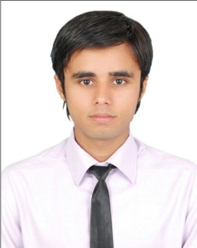

CURRICULUM VITAE

Mohammed Abdullah

UAE No: +919885581708

+917097117077

E-mail: abdullah.memon47@yahoo.com

**Objective:**

To attain the position of a **Sales** related post in an organization structured to optimize my interpersonal, communicative and organization skills in a progressive manner there by growing the company and my prospects in the organization.

**UAE Experience:**

Position: Sales Agent - Sama Deira Real Estate (Dubai, UAE)

(From February 2012 till August 2014)

Position: Sales Manager - Apex properties Brokers (Dubai, UAE)

(From September 2014 till September 2015)

Responsibilities: - Communication with Clients as positive behavior.

Making and Confirming Contracts of Apartments.

Dealing and convincing of clients.

Give confidential attitude during sales agreement.

Achieving sales profit for company.

**Indian Experience:**

Position: Mobile Shop - Mobile Technologies (India, HYD A.P.)

Partner (February 2009 till January 2012)

Responsibilities: - Discourse with customer.

Analyzing sales analyses.

Market price for promotion items.

Supporting customer to understand quality and after sales service.

Achievement of targets with good customer relation.

Analyzing daily sales report.

Achieving sales target for company.

Meeting and analyzing clients.

Co-ordination with sales staff.

Feeding Sales staff data.

Co-ordination with Sales staff.

Preparing Sales Report.

Project Management.

Project Paining.

Handling and Entering Invoices.

Inventory control of purchasing Mobiles.

**Interest:**

* Learning about new technology.
* Analyzing product before purchasing.
* Particular interest in Sailing.

**Personal Details:**

Nationality : Indian.

Visa status : Residential Visa

Date of Birth : 17th Oct 1990

Sex : Male

Marital status : Single

**Details of Passport:**

Passport No. : G7042075.

Date of Issue : 07th January 2008.

Date of Expiry : 06th January 2018.

Place of Issue : Hyderabad India.

**Conclusion:**

Having a good communicative and self-corresponding skills I would definitely be an asset to the right organization.Looking forward for favorable response.

**Will be render on your demand.**