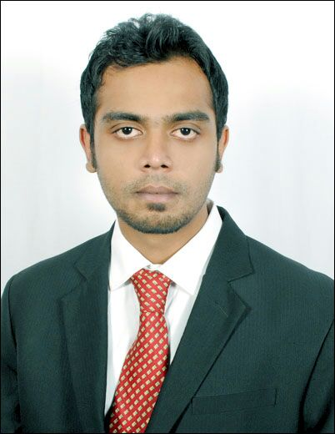

***MOHAMMED SHAHID***

**Position applied**: Corporate Sales Manager.

***Contact Details:***

**#4, 1st main opposite 4th cross,**

**Lalji nagar,**

**Bangalore – 560030**

**India**

**Mobile: +91 9019742775**

**Email: shaazz20@gmail.com**

**CAREER OBJECTIVE:**

Quest to work in a professional atmosphere, which will enable me to cope-up with emerging as well as latest technologies and provide scope for widening the spectrum of my knowledge and to dedicate myself to a reputed and progressive organization, work for its growth and in turn build up my own career path.

**EDUCATIONAL QUALIFICATIONS:**

**Professional:**

Bachelor of Engineering: **B.E (Biomedical)** from **B.M.S College of Engineering,**

**Visvesvaraya** Technological University (**2011, June**), Bangalore with **56%**.

**Academic:**

Pre University: **AL- Ameen Pre-University College** (**2005**), Bangalore with **55%**.

ICSE: **Bishop Cottons Boys’ School (2002),** Bangalore with **64%**.

**Work Experience:**

**Currently working for Tinyowl technology Pvt Limited (food ordering app) as a Senior Business Development Executive.**

**From March 31st 2015 till date.**

**Central Bureau recruitment services (Abu Dhabi)**

**As HR and Business development officer from September 2014 till February 2015.**

**Worked as a sales representative for Emirates NBD (DUBAI)**

**From March 25th 2014 – September 25th 2014.**

**Expedia (hotels.com)**

**Worked as a Senior Sales Executive from April 2012 till January 2014.**

**Awarded best quality service 3 months in a row.**

**Job Role** :

Manage accounts and meet or exceed targets relating   
to revenue growth, activities, profit margin, mix of products and   
services sales, customer retention and customer acquisition.

Develop effective working relationships with customers   
through regular meetings and identify and obtain further sales   
and business development opportunities

Work with and expand current prospect database within specified business sectors to generate effective leads & exceed sales targets for the business

Worked closely with company executives to identify new business opportunities and routinely participated in the sales process.

Retained and ensured proper handling and taking care of existing client accounts.

Convincing every client for a sale and giving them best knowledge about the company and rapport building so that they are with us for life.

To identify and create business opportunities in industry verticals and thereby promote direct sales.

Attend to customer complaints immediately and try resolving them on priority basis and thereby retain them.

Ensure new business development opportunities are explored with existing clients.

Acquire complete/in-depth product knowledge of all products and services.

Ensure timely maintenance of reports and feedback on status arising out of received leads.

**HOBBIES AND INTEREST:**

Learning new languages, snooker, swimming, traveling and internet surfing.

**LINGUISTIC PROFICIENCY:**

English, Hindi, Tamil, Kannada.

**PERSONAL DETAILS:**

**Father’s Name: Mr Mohammed Shafiulla**

**Nationality: Indian**

**Date-of-Birth: 20.05.1986**

**Marital Status: Single**