The logo on the top should be on the left side

**Dashboard:**

The client name should come in the dashboard

Add a dashboard for supervisor/Director to show all follow up with status as “Pending Approval” for their team members

**Recruitment Request Management:**

The grid should have **designation** also

**In view / mode:**

* The JD link should appear to view the JD document attached. In Edit mode also.
* The back button is not working

**Action:**

Remove inactive button for now

**Upload Recruitment Candidate:**

The upload screen should show following attributes:

* Client Name
* RR#
* Designation
* Location

The Upload is not working

**The Candidate List:**

* The grid should have client name, RR#, Designation, Approver Status in between recruiter and candidate status
* The history should come in a pop screen always in descending order of date and time

**Follow up Screen:**

Make the following screen layout as per php application given below:

The field sequence should be also same as php.

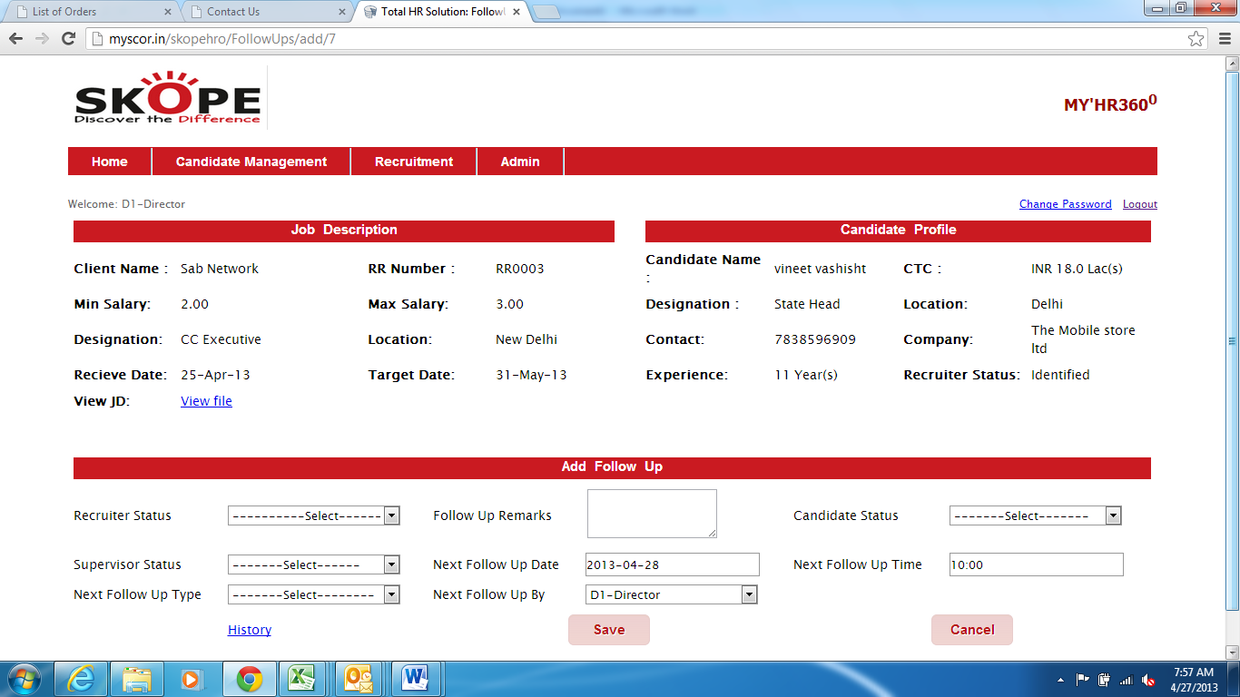

Add “Upload Resume” or View “Resume Link” link in candidate profile block. If resume is already uploaded then “View Resume” else “Upload Resume”.

The History button is missing from Add Follow up, the history should open up in a pop screen screen.