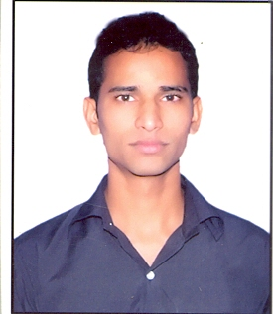

**Curriculum**-**Vitae**

|  |  |
| --- | --- |
| Ajay Kumar Rana  Mobile No.- +91-9899414044  e-mail Id – erajaykumarrana@gmail.com | 625, near shiva public School  Dundahera Road, VPO Bijwasan  New Delhi 110061 |

**CAREER OBJECTIVE**

Seeking a responsible position in your organization to use my skills and knowledge.

**EDUCATIONAL QUALIFICATION**

|  |  |  |  |
| --- | --- | --- | --- |
| **Examination** | **Board/University** | **Year of Passing** | **Percent age** |
| B. Tech. CSE | MDU Rohtak | 2011 | 63% |
| 12th | CBSE | 2007 | 67.6% |
| 10th | CBSE | 2005 | 66.33% |

**COMPUTER SKILLS**

Languages : PHP

Database :MySql, PostgreSQL.

**KEY SKILLS**

* Core PHP programming.
* Web Services, XML, Curl
* JAVA and Android (Basic knowledge)
* Drupal CMS (Basic knowledge)
* Knowledge of LINUX operating system
* Cleared security auditing of two projects.
* Good knowledge and experience in database.
* **EXPERIENCE**
* Working in Hinson IT Solution from July 4, 2011 to December 13, 2011 as a Software Engineer.
* Working in NIC (National informatics center) from December 14, 2011 as a Programmer.

**ACHIEVEMENT**

* Qualified in gate-2011 and having all India rank 10666.

**PROJECT WORK**

* Developed following websites:-

1. <http://nceg.gov.in>

This website is developed in drupal and database in MySql.

Its sub modules are:-

/oprs – this module for registration for attending NCEG, developed in core PHP with postgresql database

/awards – registration for NCEG awards, developed in core PHP with postgresql database

1. <http://harsamadhan.gov.in>

website developed for lodging grievance and grievance redressal for Haryana state.

1. <http://publicgrievancepb.gov.in> (developed in core PHP)

website developed for lodging grievance and grievance redressal for Punjab state

**PERSONAL PROFILE**

Name : Ajay Kumar Rana

Date of Birth : 2nd March 1990

Father’s Name : Mr. Ved Prakash. Sex : Male Marital Status : Married Nationality : Indian Hobbies : Playing Cricket, Reading technical books, browsing.

**Declaration:**

I hereby declare that the above-mentioned information is correct up to my knowledge and I bear the responsibility for the correctness of the above-mentioned particulars.

Date :

Place: New Delhi (Ajay Kumar Rana)